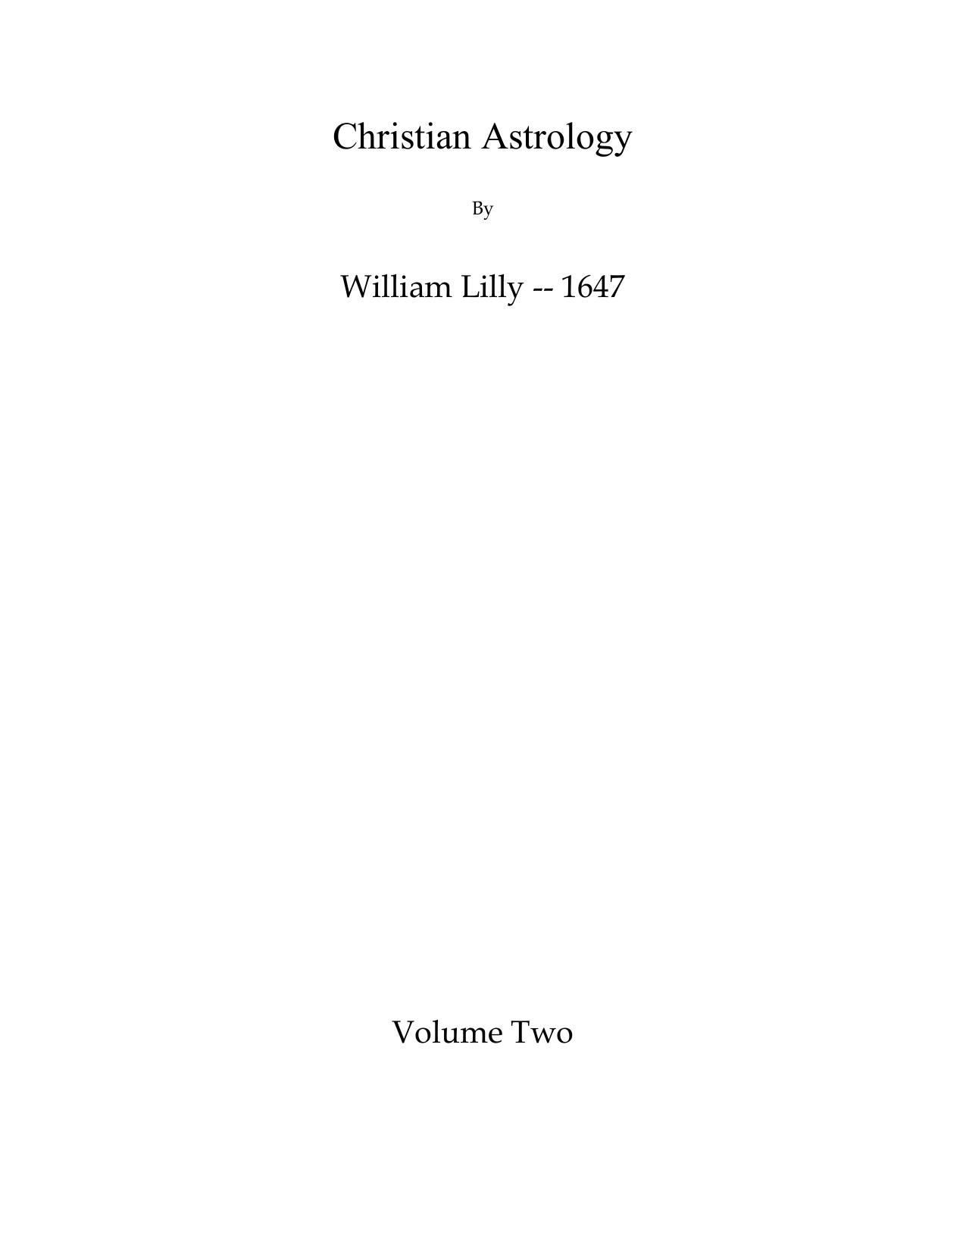

# Table of Contents

Saturn—His Accidentaial Dignities

Saturn—His Debilities

Peregrine 5

VirgoSigne of AscendingFeminine

All manner of QUESTIONS

The Resolution of

All manner of QUESTIONS

The Resolution of

DARIOT

The Resolution of

All manner of QUESTIONS

The Resolution of

The Resolution of

The Resolution of

The Resolution of

The Resolution of

all manner of QUESTIONS

Of the Signes and conjectures of the Disease, and of life or death

The Resolution of

The sicknessewill continue a great space oftime;

MOON IN VIRGO (CONJUNCT - SQUARE - OPPOSTION) SATURN

The Resolution of

all manner of QUESTIONS

MOON IN LEO (CONJUNCT - SQUARE - OPPOSITION)MARS

MOON IN VIRGO (CONJUNCT - SQUARE - OPPOSITION)MARS

MOON IN LIBRA (CONJUNCT - SQUARE - OPPOSITION)MARS

Astrologicall Aphorismes beneficial

The Resolution of

All manner of QUESTIONS

Whether the Disease would be long or short?

The Resolution of

The Resolution of

The Resolution of

FINIS SEXE DOMUS

Aphorismes ofA L K I N D U S Touching

Of Marriage, whether it shall take effect or no?

If a man ask, see the Lord of the 8th, or Planet in the 8th, for if they are strong, or Moon applying to the Lord of the 8th by a good aspect, then she is wealthy (&c., e contra, poor;) if the woman ask of the man, and of his estate, judge after the s

Which of the two shall live longest?

Hath she a Lover?

Another Judgment

Leane

If you see the Thief is domesticall, then

Whether one shall return: safe from Warre, or any

Christian Astrology

By

William Lilly -- 1647

Volume Two

CHRISTIAN

ASTROLOGY

MODESTLY

TREATED OF IN THREE BOOKS

THE FIRST CONTAINING THE USE OF AN EPHEMERIS,

the erecting of a scheam of Heaven; nature of

the twelve Signs of the Zodiack, of the

Planets; with a most easie Introduction

To the whole Art of Astrology.

THE SECOND, BY A MOST METHODICAL WAY INSTRUCTETH

the Student how to Judge or Resolve all manner of Questions contingent unto Man, viz. of Health, Sickness, Riches, Marriage, Preferment, Journies, &c.

Severall Questions inferred and Judged.

THE THIRD, CONTAINS AN EXACT MEOTH, WHEREBY TO

Judge upon Nativities; severall ways how to rectifie them; How to judge the generall fate of the Native by the twelve Houses of Heaven, according to the naturall influence of the STARS: How his particular and Annuall Accidents, by the Art of Direction, and its exact measure of Time by Profections, Revolutions, Transits.

A Nativity judged by the Method preceding.

The Second Edition Corrected, and Amended.

By WILLIAM LILLY Student of Astrology.

Omne meum nil meum. Nihil dictum, quod non dictum prius LONDON

Printed by John Macock 1659

Compliments of http://mithras93.tripod.com THE RESOLUTION

of all manner of Q U E S T I 0 N S

and D E M A N D S.

Chap. XXII.

Questions Concerning the First House.

If the Querent is likely to live long yea or not.

Many men and women have not the time of their Nativities, or know how to procure them, either their Parents being dead, or no rememberance being left thereof; and yet for divers weighty considerations they are desirous to know by a question of Astrology, whether they shall live long or not?, whether any sicknesse is neer them? , what part of their Life is like to be most happy?

together with many other such Queries people doe demand incident to this house.

Signs of Health or Long Life.

[SIGNES OF HEALTH.]

In the Question you must consider if the Sign ascending, the Lord thereof, and the Moon be free from misfortune, viz. if the Lord of the Ascendant be free from Combustion of the Sun, from the 129

Compliments of http://mithras93.tripod.com The Resolution Of

Square, Opposition or Conjunction of the Lord of the 8th, 12th, 6th or 4th House, if he be Direct, in Essentiall Dignity, Swift in Motion, or Angular, especially in the 1st house, (for in this question he is best placed therein) or 10th, or else in the 11th, or 9th House, and in a good aspect with Jupiter or Venus, or the Sun, or in the Termes of Jupiter and Venus, it’s an argument of Health and long life to the Querent, for the Lord of the Ascendant, or Ascendant it selfe unfortunate or Moon in bad houses afflicted, show mischiefe at hand; the aforesaid Significators tree, argue the contrary: for as you consider the Lord of the Ascendant, so the Ascendant is to be considered, and what aspect is cast unto it, viz. good or evil, and by what Planet or Planets, and of what house or houses they are Lords of.

[SIGNES CONTRARY, VIZ. OF SICKNESSE, DEATH, &C. MISFORTUNE.]

It’s generally received, that if the Lord of the Ascendant be under the Sunbeams, or going to Combustion, which is worse then when he is departing, or the Moon cadent and unfortunated by any of those Planets who have dominion in the 8th or 6th, and either the South Node, Saturn or Mars in the Ascendant or 7th House, peregrine or in detriments, or retrograde, or if there be in the degree ascending, or in that degree of the Signe wherein the Lord of the Ascendant is, or with the Moon, or with that Planet who afflicts any of those; I say, any Fixed Starre of violent influence or nature of the Planet afflicting, or nature of the Lord of the 8th or 6th House, then you may judge the Querent is not long lived, but neer some danger, or shall undergoe some misfortune in one kind or other, according to the quality of the Significator and Signification of that or those houses they are Lords of.

The Time When Any of These ACCIDENTS Shall Happen.

You must see if the Lord of the Ascendant be going to Combustion, or to Opposition or Conjunction of the Lord of the 8th or 4th, how many degrees he is distant from the Sun, or Lord of the 8th or 4th, and in what Signe either of them are in; if the space betwixt them be eight degrees, and in a common Signe, it denotes so many moneths; if in a fixed signe, so many yeers; if in a moveable, so many weeks: this is onely for example, and in 130

Compliments of http://mithras93.tripod.com all manner of QUESTIONS.

generall; for the measure of time must be limited according to the other Significators concurring in judgment herein..

Secondly, having considered the Lord of the Ascendant, see how many degrees the Moon is also distant from any Infortune, or from the Lords of the 6th or 8th, and in what Signe or Signes, their Nature, Quality and House wherein they are posited..

Thirdly, consider if there be an Infortune in the Ascendant, how many degrees the Cusp of the house wants of that degree the unfortunate Planet is in, or if the unfortunating Planet be in the 7th, how many degrees the Ascendant wants of his true Opposition, and compute the time of Death, Sicknesses or Misfortune according to the dimension of degrees in Signes moveable, common, or fixed..

If you find the Lord of the Ascendant afflicted most of all by the Lord of the 6th, and in the 6th, or if the Lord of the Ascendant comes to Combustion in the 6th, you may judge the Querent will have very many and tedious sicknesses, which will scarce leave him till his death; and the more certain your judgment will be, if the Lord of the Ascendant, and the Lord of the 8th and the Moon be all placed in the 6th.

If you find the Lord of the Ascendant, the Signe ascending, or Moon most principally impedited or unfortunated by the Lord of the 8th, or that Planet who afflicts your Significators out of the 8th, then you may judge that the sicknesse with which he is now afflicted, or is shortly to be troubled withall, will end him, and that his death is approaching or that death is threatened..

But if you can find that the Lord of the Ascendant, or Signe of the Ascendant, or the Moon are chiefly afficted by the Lords of some other houses, you shall judge his misfortune from the nature of the house or houses whereof the Planet or Planets afflicting are Lords; and the first original thereof, or discovery, shall be signified from something, Man or Woman, &c. belonging to that house wherein you find the Planet afflicting posited, and thereby you shall judge a misfortune and not death: The Fixed Starres I mentioned, being of the nature of Mars, show sudden distempers of

131

Compliments of http://mithras93.tripod.com The Resolution of

body, or Feavers, Murders, Quarrels &c. of the nature of Saturn, quartan Agues, Poverty, casuall hurts by fals &c..., of the nature of Mercury, they declare Consumptions,Madness, cozenage by false Evidence or Writings: of the nature of the Moon, Tumults, Commotions, Wind-chollick, danger by Water, &c, of the nature of the Sun, envy of Magistrates, hurt in the Eyes, &c. of the nature of Jupiter, oppression by domineering Priests, or by some Gentleman: of the nature of Venus, then prejudice by some Woman, the Pox, or Cards, Dice and Wantonnesse.

[CAUTION.]

You must carefully avoid pronouncing Death rashly, and upon one single testimony, you must observe, though the Lord of the Ascendant be going to Combustion, whether either Jupiter or Venus cast not some Sextile or Trine to the Lord of the Ascendant, ere he come to perfect Combustion, or any other infortune, for that is an argument that either Medicine or Strength of Nature will contradict that malignant influence, or take off part of that misfortune; but when you find two or more of the rules asforesaid concurring to death, you may be more bold in your Judgement; yet concerning the absolute time of death of any party, I have found it best to be wary, and have as much as I could, refrained this manner of judgement; onely this much by the Question may be knowne, that if you find the Significators, as aforesaid, afflicted, you may judge the man or party inquiring to be no long lived man, or subject to many miseries and calamities, and this I know by many verified examples; the knowledge hereof is of excellent use for such as would purchase any Lease or Office, or thing for Life or Lives, &c. or for those who would carefully in a naturall way prevent those casualties their natures or inclinations would run them into.

To What Part of Heaven its Best the Querent Direct His Affairs, or Wherein He May Live Most Happily.

You must know that the twelve Houses are divided into the East, West, North and South quarters of Heaven.

The Cusp of the first house is the beginning of the East, and its 132

Compliments of http://mithras93.tripod.com all manner of QUESTIONS.

called the East Angle, from the Degree of the first house to the Degree or Cusp of the 10th House or Medium Coeli, containing the 12,11 and 10th houses, are East, inclining to the South: from the Cuspe of the 10 house to the Cusp of the 7th house, containing the 9,8, and 7, is South, verging toward the West: from the degree of the 7th house to the Cusp of the 4th, consisting of the 6,5, and 4th houses, is the West, tending to the North: from the Degree of the 4th house to the degrees of the Ascendant, containing the 3,2,and 1st houses, is North inclining to the East..

Having viewed the several quarters of Heaven, see in which of them you finde the Planet that promiseth the Querent most good, and where you find Jupiter, Venus, Moon and Part of Fortune, or two or more of them, the quarter that direct your affaires; and if you have the Part of Fortune and the Moon free from Combustion and other misfortunes, go that wayes, or to that quarter of Heaven where you finde her; for you must consider, that though Jupiter and Venus be Fortunes, yet casually they may be Infortunes, when they are Lords of the 8,12,or 6th, in that case you must avoyd the quarter they are in, and observe the Part of Fortune and the Moon and the Lord of the Ascendant; and as neere as you can avoyd that quarter of Heaven where the infortunes are, especially when they are Significators of mischiefe, otherwayes either Mars or Saturn being Lord of the Ascendant or 2nd house, 10th or 11th, may (being essentially strong) prove friendly. The general way of resolving this Question is thus; If the Querent does onely desire to live where he may most enjoy most health, look in what signe and quarter of Heaven the Lord of the Ascendant and the Moon are in, and which of them are strongest, and does cast his or her more friendly Aspect to the Degree ascending; to that quarter of Heaven repaire for Heavens sake: If the Querent desire to know to what part he may steer his course for obtaining of an Estate or Fortune, then see where and ‘in what quarter of Heaven the Lord of the 2nd is placed, and the Part of Fortune, and his Dispositor or two of them; for where and in what quarter they are best fortified, from thence may he expect his most advantage, &c. Of this I shall speak casually in subsequent Judgments.

133

Compliments of http://mithras93.tripod.com The Resolution of

What Part of His LIFE is Like to be Best.

See either in what Angle or quarter of Heaven the fortunate and promising Planets are posited in; for in this way of Judicature, we give usually to every house five yeers, but sometimes more or lesse, according as you see the Significators promising Life or Death, (but commonly five yeers we give) beginning with the 12th, and so to the 11th, then the 10th, the 9th, &c. and so to the Ascendant; as if in your question you find Jupiter or Venus in the 11th or 10th house, you may judge the Man or Woman to have lived happily from the 5th yeer of his age to the 15th, or in his youth: if they, or either of them, be in the 8th or 7th, they declare that from 20 to 30 he will, or hath lived, and may live contentedly: if Jupiter or Venus be in the 6th, 5th, or 4th, then judge after his middle age, or from 30 to 45, he may do well: If you find Jupiter or Venus in the 3rd, 2nd, or 1st, then his best days, or his greatest happinesse will be towards his old age, or after he is forty five until sixty; if you find the Significators of Life very strong, and signifying long life, you may adde one yeer to every house, for it’s then possible the Querent may live more than sixty years, or until seventy, or more, as many we know doe.

Lastly, you must observe at the time of your Question, how the Lord of the Ascendant and the Moon are separated, from what Planet, and by what Planet, and by what aspect; the seperation of those shew the manner of Accidents which have preceeded the Question; their next application, what in the future may be expected; if you consider what house or houses, the Planet or Planets they separated from are Lords of, it aquaints you with the matter, nature, person and quality of the thing already happened: ill, if the aspect was ill; Good, if the aspect was good; and if you observe the quality of the next aspect by application, and the well or ill being and position of the Planet or Planets applied unto, it delivers the quality of the next succeeding Accidents and Casualities, their nature, proportion, time when they will happen or come upon the Querent.

134

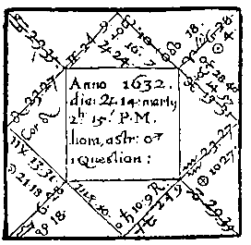

Compliments of http://mithras93.tripod.com

all manner of QUESTIONS.

[Note: Modern copies of all charts

appear in Appendix A.]

An Astrologicall Judgment Concerning These Demands Propounded by the Querent.

1.

If he were like to live long, yea or not.

2.

To what part of the world he were best direct his course of life.

3.

What part of his life, was in possibility like to be most fortunate.

4.

He desired I would relate (if possible by a figure) some of the general Accidents

had happened unto him already.

5.

What Accidents in future he might expect, good or evil.

6.

The time when.

The Stature of the Querent is signified by Leo, the Signe Ascendant; there is a Fixed star called Cor Leonis neer the cuspe of the 1st house, viz., in 24:34 of Leo, of the nature of Mars and Jupiter, and 1st magnitude; both the cuspe of the 1st house and degree of the signe wherein Sun, Lord of the Ascendant is in, are

135

Compliments of http://mithras93.tripod.com The Resolution of

the termes of Jupiter; the Moon is in Trine aspect with both Jupiter and Venus, and they in the 10th house; so that the form and Stature of the Querents body are decent, of middle stature strongly compacted, neither fat or fleshy, but comely, wanting no gracefulnesse in its composure; a fair Visage, reddish haire, cleere Skin, some cuts on his right Cheek, (for he was a Soldier;) but certainly the presence of the Fixed star in the Ascendant, which represents the Face, occasioned those hurts or scarres.

As the signe ascending is fiery, and as the Lord of the Ascendant is in a fiery signe, and by nature is Hot and Dry, so was this gentlemans temper and condition, being exceeding Valiant, Cholerick, high Minded, and of great spirit; for Sun, Lord of the Ascendant is in his Exaltation; yet in regard the Moon is in Trine with the two Fortunes, he is sober, modest, and by Education excellently qualified, and thereby had great command of his Passion; but as the Moon was in Opposition to Mercury, he had his times of Anger and Folly, whereby he much prejudiced his affaires. But to our question.

If Live Long, &c.

Finding the Ascendant not vitiated with the presence of either Saturne, who is Lord of the 6th, or of Jupiter who is Lord of the 8th.

Seeing the Lord of the Ascendant was in exaltation, no ways impedited, pretty quick in motion, in the 9th house, and in the Termes of Jupiter.

Observing the Moon separated from Trine of Venus applying to Trine of Jupiter, and he posited in the mid heaven, and thereby the malice of Mars restrained by the interposition of Jupiter.

Considering the Sun was above the earth, the fortunate Planets, viz. Jupiter and Venus Angular, and more potent than the infortunates, viz. Saturn or Mars: from hence I concluded, that according to naturall causes, he might live many yeers; and that Nature was strong, and he subject to few Diseases, This hath hitherto proved true; he being yet alive this present, March 1646.

136

Compliments of http://mithras93.tripod.com all manner of QUESTIONS.

To What Part of the WORLD, or of the KINGDOM, he Might Best Apply Himself to Live in.

The Lord of the Ascendant is Sun, who being neer the Cuspe of the 9th house,(signifying long journeys) and the signe thereof Moveable; I intimated he was resolving sodainly upon a Journey South-East, or to those parts of the World which lye from London South-East: South, because the quarter of Heaven wherein the Lord of the Ascendant is in, is South: East, because the Signe where Sun is in is East (this be confessed:) And as the Sun was but 2 degrees 10 min. distant from the cusp of the 9th, he went away within two months; for Sun was 4:18 Aries.

I judged those Countries subject to the Signe of Aries, might be suitable and propitious to his Affaires; which you may see in the nature of Aries, pag. 95 and what their Names are, to which I now refer.

Had his resolution been to have staid in England, the North Node and Sun being both in Aries, show it might have been good for him, for England is subject to Aries; I would have advised him to have steered his court life towards Kent, Essex, Suffex or Suffolk, for they lye East or by South from London; but if sometimes you find that a city, towne or kingdome subject to the Celestiall Signe which promises you good, stands not, as to the quarter of Heaven, directly as you would have it, or as the Signe points it out; herein you must observe this generall rule; That if your occasions enforce you, or you shall and must live in that Country, City, or Towne, so directed unto you in Art, that then you must lead your life, or direct your actions, or manage your employments to those parts of that city or country which lye East, West, North or South, as in the Figure you were directed as for Example; You may see France is subject to the Signe Aries, it lyeth from London South-west: had this gentleman gone into France, it would have been best for him to have seated himself towards the South-east part, or East part of France, &c, Now because the Moon applied so strongly to the Trine of Jupiter, and that he and Venus were in Taurus, and the Signe signifies Ireland.

137

Compliments of http://mithras93.tripod.com The Resolution of

I advised him that Ireland would well agree with his constitution, and that he might get Honour there, because the Planet to whom the Moon applies is in the house of Honour.

And verily the Querent did go into Ireland, and there performed good service and obtained a notable Victory against the rebels; as I could manifest, but that I will not mention the Name of the Gentleman,

What Part of His Life Would be Left.

Considering the two Fortunes were placed in the 10th house, and that North Node and Sun were in the 9th, I judged his younger yeers would be the most pleasant of all his whole life; feeling also Mars in the 8th house, Which according to our owne direction of time comes to be about 24,25 or 26 of his age; I judged that about those times he had many crosses, or first of all his afflictions then began; and seeing further no fortunate Planet was either in the 7th, 6th, 5th, 4th or 3rd houses, I judged those Calamities or Misfortunes should not suddenly come upon him, because the Moon was in application to a Trifle of Jupiter, and wanted almost 3 degrees of comming to his perfect aspect; wherefore I conceived by means of some man in authority represented

by Jupiter,

or some Courtier or person of quality, for almost 3 years after the proposal of the Question, he should be supported and affiliated in his affaires, or else get Imployment answerableto his desires; had Jupiter been Essentially fortified, I should have judged him a more durable fortune.

What General Accidents Had Happened Already.

Although it is not usuall to be so nice or inquisitive, yet seeing the question so radical, I first considered from what Planet or Planets the Sun, who is Lord of the Ascendant, had last separated; if you look into the Ephemeris of that yeer, you shall find, that the Sun had lately, during his passage

138

Compliments of http://mithras93.tripod.com All manner of QUESTIONS.

through the Signe Pisces, been first in Conjunction with Mars, then in Square of Saturn, lately in Sextile of Jupiter; now, for that Mars in our Figure is Lord of the 4th house, signifying Lands, etc. and was now locally in the 8th, which signifies the substance of Women, I judged he had been molested of late concerning some lands, or the Jointure or Portion of his Wife or a Woman; wherein I was confirmed the more, because the Moon was also applying to an Opposition of Mars, in this Figure placed in the 8th house; for the Moon being in the Querents house of substance, viz. the 2nd, intimated the quarrell or strife should be for, or concerning Money, for such things as are significated by that house: (and this was very true.) Because Sun had already been in Square of Saturn, who is Significator of the Querent’s Wife, I told him I feared his Wife and he had lately been at great variance; and because Saturn her Significator did dispose of his Part of Fortune, I judged she had no mind he should have any of her estate, or manage it, but kept it to her own use; for Saturn is Retrograde, a superior Planet, and in a fiery signe, and that signe of the 7th is Fixed; these show her a Virago, or gallant spirited woman, and not willing to be curbed, or else to submit: (This was confessed.)

[IT WAS THE LORD COVENTRY.]

Lastly, because Sun was lately in Sextile with Jupiter and Jupiter was in the 10th; I told him, either some great Lawyer or Courtier had endeavoured to reconcile the differences betwixt them; and forasmuch as both the Sun who was his Significator, and Saturn who was hers, did now both apply to a Trine aspect, there seemed to be at present a willingnesse in both parties to be reconciled; nor did I see any great obstruction in the matter, except Mercury who is in Square aspect with Saturn, did impedite it; I judged Mercury in the general, to signifie either some attorney, or lawyer, or writings; but as he is Lord of the Querent’s 2nd, it might be because the Querent would not consent to give or allow such a summe of money as might be demanded, or that the Querents purse was to weak, he had not wherewithall to solicite his cause lustily; or as Mercury is Lord of the 11th house, some pretended friend would impedite her, or advise the contrary, or some of her Lawyers; or as the 11th is in the 5th from the 7th, a child of the Querent’s wife might be occasion of continuing the breach. ( I believe every particular herein proved true; however, this was the way to find the occasion or thing disturbing their unity or concord. )

139

Compliments of http://mithras93.tripod.com The Resolution of

Observe as Venus Lady of the 10th, doth dispose of Jupiter Lord of the 8th, viz. the wife’s Fortune, so she had entrusted her estate to a great Nobleman..

That Accidents in Future He Might Expect; Time When, In this Quere, I first considered the Sun Lord of the Ascendant, who being no ways unfortunated, or in any evill aspect with any Planet, which might impeach or impedite him, but on the contrary excellently fortified, I judged, he had the wide world to ramble in, (for a Planet strong, and in no aspect with others shewes a man at liberty to doe what he will;) and that for many yeers he might (quoad capax) live in a prosperous condition (according to the preceding limitation) and traverse much ground, or see many Countries; because Aries, the Signe wherein the Sun is in, is moveable, placed on the cusp of the 9th, signifying long journeys, which prenoted many turnings and shiftings, variety of action in sundry parts.

Secondly, I observed the Moon in the Querent’s house of substance, viz. the 2nd, did apply to Jupiter in the 10th house, and that Jupiter was Lord Of the 5th house and 8th: the 5th house signifies Children; the 8th denoted the substance of the Wife: From hence I gathered, that the Querent was very desirious to treat with some Nobleman (because Jupiter is in the 10th) about the Education of his Child or Children, and that there might be a Salary payable for their breeding and education, out of the Wife’s Jointure or annuall Revennue:(such a thing as this in one kind or another, he did settle before he went out of England.)

Thirdly, I found the Moon in the signe Virgo (Peregrine) it being a Diurnal Question, else she hath a Triplicity in that Trygon by night.

Fourthly, I found Mercury Lord of the 2nd house, viz. signifying his Fortune and Estate, in Pisces, which is his Detriment, yet in his own Termes, afflicted by Mars, from whose Opposition the Moon lately had separated.

From hence I collected, that he had been in great want of Money a little before the Question asked; and if we look how many degrees

140

Compliments of http://mithras93.tripod.com all manner of QUESTIONS.

there is distant betwixt Moon and Mercury, since their Opposition last past, we shall find them to be 6 degrees, 21 min., viz. 6 degrees and 21 minutes which noted, that he had been in some want of Money for about 6 months and somewhat more, or thereabouts, before the time of demanding the Question: (this was confessed.)

Fiftly, feeling the Moon was applying to a Trine of Jupiter, of which signification I spoke before, and then before she got out of the Signe Virgo, did occur the Opposition of Mars: I did aquaint the Querent, that after some yeers or times of pleasure, he would be in great danger of losing his Life, Goods, Lands and Fortune. His life, because Mars is in the 8th: His Goods and Estate, because Moon is in the 2nd: His Lands or Inheritance, because Mars is Lord of the 4th, now placed in the 8th. For the 4th house signifies Lands, &c.

The Time When.

In this quere I considered the application of the Moon to a Trine of Jupiter, which wanting about 3 degrees from the true aspect, I judged for some times succeeding the Question, or for 3 yeers, he might live pleasantly.

Secondly, feeling the Sun Lord of the Ascendant, during his motion through the Signe Aries, did not meet with any malevolent aspect, and had 26 degrees to run through of the Sign, ere he got into Taurus; I gave in this nature of judgment, for every degree 1 moneth, and so told him, That for about 26 moneths following, or untill after 2 yeers, or much about that time, I judged he should live in a free condition in those parts into which he intended his Journey, &c.

Last of all, I considered how many degrees the Moon wanted ere she came to the true Opposition of Mars.

Longitude of Mars

28

40

Longitude of Moon

21

l8

Difference

7

22

The difference is 7 degrees and 22 minutes; which if I proportion into time, and neither give yeers, because the Significators are in Common Signes, and not in Fixed ; or moneths, because the Signes doe signifie somewhat more; but doe proportion a meane between both: the time limited in this way of Judicature, will

141

Compliments of http://mithras93.tripod.com The Resolution of

amount to about 3 yeers and 3 quarters (3 3/4 years) from the time of asking the Question, ere the malevolent Opposition of the Moon to Mars shall take effect: But in regard his quere was generall, I might have allowed for every degree 1 yeer: After, or about which time, he was in severall actions both dangerous to his Person and Fortune; and since that time, till the time of publishing hereof, he hath had his Intervals of good and 111, but is now under the frowne of Fortune, &c.

But as the Sun at time of the Question was strong, he did overcome all mannerof difficulties

for many yeers, and subsisted, and hath in our unlucky differences had honorable Imployment on his Majesties part: but as the Moon is in Opposition to Mars, so it was not without the generall out-cry and exclamations of the people; nor was it his fortune, though in great Commands, ever to doe his Majesty any notable piece of Service; yet is he now forever, by just Sentence of the Parliament, deprived of so much happinesse as to end his dayes in England; which, though in some measure, might have been forseen, by the Moon her Opposition to Mars, being Lord of the 4th, viz. the end of all things.

Yet we must herein admire Providence, and acknowledge according to that strong Maxime of Astrologers; That the generall Fate of any Kingdome is more prevalent, then the private geniture or question of any Subject or King whatsoever.

Very little of this Judgment hath already failed; I have heen herein somewhat large, because young Students might thereby benefit the more; and if my Judgments doe vary from the common Rules of the ANCIENTS, let the Candid Reader excuse me, sith he may still follow their Principles if he please; and he must know, that from my Conversation in their Writings, I have attained the Method I follow.

142

Compliments of http://mithras93.tripod.com ALL MANNER OF QUESTIONS

CHAPTER XXIII.

Of the Part of Fortune, and How to Take it,

Either by Day or Night.

Ptolomy doth not more consider a Planet then the Part of Fortune, it hath no aspect, but any Planets cast their aspects unto it.

The greatest use of it, that hitherto I have either read or made of it for, is thus; That if we find it well placed in the Heaven, in a good house, or in a good aspect of a benevolent Planet, we judge the Fortune or estate of the Querent to be correspondent unto its strength, viz. if it be wel posited or in an angle, or in those Signes wherein it’s fortunated, we judge the estate of the Querent to be sound and firm, if Part of Fortune is otherwayes placed, we do the contrary.

The Manner Either Night or Day to Take it is Thus: First, consider the Signe, degree and minute of the Moon.

Secondly, the Signe, degree and minute of the Sun.

Thirdly, subtract the place of the Sun from the Moon, by adding 12 Signes to the Moon if you cannot do it otherwise; what remains, reserve and add to the Signe and degrees of the Ascendant; if both added together make more than 12 Signes, cast away 12, and what Signes, degrees and minutes remain, let your Part of Fortune be there: For example in our present Figure: The Moon is in 21:18 of Virgo, or after 5 Signes, in 21 degrees 18 minutes Virgo.

The Sun is 00 Signes, 4 degrees 18 minutes of Aries. Set them together thus: Place of the Moon

5s

21d

18m

Place of the Sun

0s

4d

18m

I subtract the Sun from the Moon thus: I begin with minutes, 18m from 18m, remains nothing.

Next I subtract degrees, 4d from 21d, reflects 17 degrees.

Then 0s from 5s, remains 5s: All put together, there does rest in Signes and degrees as follows:

5s

17d

00m

To these 5, Signes 17degrees, I adde the Signe ascending which is 4 Signes 23.degrees, 27.minutes, or the 23:27 of Leo.

143

Compliments of http://mithras93.tripod.com The Resolution of

Sig

Deg

Min

Then it is thus:

5s

17d

00m (distance of sun from Moon)

4s

23d

27m (Signes/degrees of the Asc.)

Added together

l0s

10d

27m

they make:

Viz. 10 Signes, 10 degrees and 27 minutes, which direct you to know, that after 10 Signes numbered from Aries, you must place the Part of Fortune, viz. in 10 degrees and 27 minutes of Aquarius, for Aries, Taurus, Gemini, Cancer, Leo, Virgo, Scorpio, Sagittarius, Capricorn are 10

Signes, etc. and Aquarius the 11th in order.

Whether your Figure be by day or night, observe this Method; for how many degrees the Sun is distant from the Moon, so many is the Part of Fortune from the Ascendant; but because this may not be thoroughly understood by every Learner upon a sudden, let him observe this generall rule, the better to guide him.

If the Part of Fortune be taken upon a New Moon, it will be in the Ascendant..

If upon the 1st Quarter, in the 4th house.

If upon the Full Moon, in the 7th house.

If upon the Last Quarter, in the 10th house.

After the change, and before the 1st Quarter, you shall ever have her in the 1st, 2nd or 3rd house.

After the 1st Quarter until the Full Moon, in the 4th, 5th or 6th house.

After the Full Moon until the Last Quarter, in the 7th, 8th or 9th house.

After the Last Quarter, either in the 10th, 11th or 12th house So that if the Learner doe mistake, he may by this method easily see his errour; ever remembering, that the more dayes are passed after the Change or Quarter, &c, the more remote the Part of Fortune is from the Angle preceeding.

Some have used to take Part of Fortune in the night from the Moon to the Sun; which if you doe, you must then make the place of your Sun your first place, and adde the Ascendant as in the former method. Ptolomie, day and night takes it as above directed, with whom all practicioners at this day consent.

Here follows a Table, by help whereof you may examine the strength of the Part of Fortune in any Figure you erect.

144

Compliments of http://mithras93.tripod.com all manner of QUESTIONS.

The Part of

In the

Taurus, Pisces

5

Fortune

is

Signs Lib,Sag,Leo,Cancer

4

strong

and

of

Gemini

3

fortunate

Virgo (terms Jup.

2

or Venus )

If in Conjunct.. w/Jup or Venus, has Dignities

5

In Trine with Jupiter or Venus

4

In Sextile with Jupiter or Venus

2

In Conjunction with North Node

3

1st or 10th, has dignities

5

P.O.F. is

7th, 4th, 11th

4

strong in

2nd or 5th

3

houses,

viz..

9th

2

If

in:

3rd

1

In Conjunct

with Regulus(24:34 Leo)

6

with any of

with Spica Virginis(18:33 Lib)

5

these Fixed

not Combust, or under Sun Beams

5

Stars.

The P.O.F. is

Vir,Cap,Aqu (dibilities)

5

weak in:

Aries (neither gets or loses)

5

Conjunct Saturn or Mars (dibil.)

5

Conjunct South Node

3

P.O.F. is weak

Opposition Saturn or Mars

4

by conjunction

Square of Saturn or Mars

3

or aspect..

In Termes of Saturn or Mars

2

In the 12th house

5

As also by being

In the 8th house

4

in Houses, viz.

In the 6th house

4

With Caput Algol in 20 degrees 54 minutes Taurus 4

Combust 5

There are many other Parts which the Arabians have mentioned frequently in their Writings, of which we make very little use in this Age: I shall, as occasion offers, teach the finding them out, and what they said, they did signifie: Sometimes the Part Of Fortune hath signification of Life, and sometimes of Sicknesse; which occasionally I shall teach, as matter and occasion offer, addhereing to the true observation of the Ancients: but I am little hitherto satisfied concerning Part Of Fortune its true effects; intending to take paines therein hereafter, and publish my intentions..

*P.O.F.} Part of Fortune

145

Compliments of http://mithras93.tripod.com The Resolution of

The Preceding Figure Judged by a More Short Method.

1.

The Ascendant not afflicted, Lord of the Ascendant Essentially fortified, the Moon Trine with both the Fortunes; Signes of long life..

2.

Jupiter and Venus in the South Angle, in Taurus, a Southeast Signe; Sun in Aries, an Easterly Signe; Moon in Virgo, a Southern or South-west Signe; best to travel Southward, or a little East.

3.

Jupiter and Venus in the Midheaven, North Node and Sun in the 9th; his younger years are most full of pleasure..

4.

Sun Lord of the Ascendant, lately separated from good and ill aspects; Moon also separated as well from Opposition of Mercury as Trine of Venus; shew both good and ill had happened of late; Good, because of the good aspects: ill, by reaction of the malevolent: but the evill aspects being more in number than the good, and signified by superiour Planets; augment the evil and lessen the Good..

5.

Moon applying to Trine of Jupiter the Sun Lord of the Ascendant in Exaltation promise Preferment..

Moon weak in the 2nd, and after her trine with Jupiter going to Opposition of Mars; shows, after a little time of Joy, great danger.

6.

The small distance of degrees between the Trine of Moon to Jupiter, and he Angular; denotes a present happinesse or fortune neer to the Querent.

Her greater distance from Opposition of Mars, shew his miseries to succeed some yeers after his times of honor are expired, &c.. In such a nature I ever contract my Judgment..

I with all young Beginners at first to write down their Judgments in length, and the reasons in ART, as fully as they can, and afterward to contract their opinions into a narrow compasse: by following these directions, they will have the Rules of ART perfectly in their memory: I also wish them in delivering their Judgment to the Querent, to avoid termes of ART in their Discourse, unless it be to one understands the ART..

146

Compliments of http://mithras93.tripod.com all manner of QUESTIONS.

CHAPTER XXIV.

If One Shall Find the Party at Home He Would Speak Withall.

The Ascendant and his Lord are for the Querent, the 7th house and his Lord from him you would speak withall; this is understood, if you goe to speak with one you familiarly deale withall, or are much conversant with, and is not allied unto you, &c, but if you would goe speak with the Father, you must take the Lord of the 4th; if with the Mother, the Lord of the 10th; if the Father would speak with his Child, the Lord of the 5th, and so in the rest; vary your rule and it serves for all.

If the Lord of the 7th house be in any of the 4 Angles, you may conclude the party is at home with whom you would speak with; but if the Lord of the 7th, or Lord of that house from whom judgment is required, be in a Succeedant house, viz. 11th, 2nd, 5th or 8th, then he is not far from home; but if his Significator be in a Cadent house, then he is far from home.

If you find the Lord of the Ascendant applying to the Lord of the 7th house by any perfect aspect, the same day that you intend to goe visit him, you may assured either to meet him going to his house, or heare of him by the way where he is, for he cannot be farre absent; or if any Planet, or the Moon, separate from the Lord of the 7th house, and transfere his light unto the Lord of the Ascendant, he shall know where and in what place the Party is, by such a one as is signified by that Planet who transfers his light; describe the Planet, and it personates the Man or Woman accordingly; but whether it will be Man or Woman, you must know by the nature of the Planet, Signe and quarter of Heaven he is in, wherein plurality of masculine Testimonies argue a man, the contrary a woman.

147

Compliments of http://mithras93.tripod.com The Resolution of

Of A Thing Suddenly Happening, Whether it

Signifies Good or Evil.

Erect your Figure of Heaven at what time the Accident happened, else when you first heard of it; then consider who is Lord of the Signe wherein the Sunne is, and the Lord of that Signe wherein the Moon is, and the Lord of the house of Life, which is ever the Ascendant, and see which of these is most powerfull in the Ascendant, let his position be considered, and if he be in Sextile or Trifle with the Sun, Jupiter or Venus, there will no evill chance upon the preceding Accident, Rumour or Report; but if you find that Planet weak in the scheame, combust or in Square, Opposition or Conjunction of Mars, Saturn or Mercury, there will some misfortune follow after that accident, in one kind or other; if you consider the Planet afflicting your Significator; his posture and nature, it may easily be discovered, in what nature the evill will chance or upon what occasion; as if the Lord of the 3rd, from or by some neighbour or Kinsman; if the Lord of the 2nd impedite them, then losse in substance; if Lord of the 4th, expect discontent with one of your Parents, or about Land or Houses; if the Lord of the 5th, some difference or discord in an Alehouse or Taverne, or in Company keeping, or by meanes of some child, &c. and so of the rest.

What Mark, Mole or Scarre the Querent Has in Any Member of His Body.

I have many times admired at the verity hereof, and it hath been one maine argument of my engaging so farre in all the parts of Astrology, for very rarely shall you find these rules faile, When you have upon any demand erected the Querent’s Figure, consider the Signe Ascending, what member of man’s body it represents, and tell the Querent he hath a Mole, Scarre or Marke on that part of his body represented by that Signe; as if the Signe Ascending be Taurus, it’s on the Neck: if in Gemini, on the Arms, &c., also in which of the 12 Signe of the Zodiac the Lord 148

Compliments of http://mithras93.tripod.com all manner of QUESTIONS.

of the Ascendant is in, and in that member represented by that Signe, he or she hath another.

Then observe the Signe descending on the cusp of the 6th house, and what part of man’s body it personates, for in that member shall you find another; so shall you discover another in that member which is signified by the Signe wherein the Lord of the 6th is.

Last of all, consider what Signe the Moon is in, and what member of mans body it denotes, therein shall you also find a Mark, Mole or Scarre; if Saturn signifies the Mark, it’s a darkest, obscure, black one; if Mars, then it’s usually some Scarre or Cut if he be in a Fire Signe, or else in any other Signe, a red Mole; and you must always know, that if either the Signe, or the Planet signifying the Mole, Mark or Scar, be much afflicted, the Mark or Scarre is the greater and more eminent.

If the Signe be Masculine, and the Planet Masculine, the Mole or Scarre is on the right side of the body.

The contrary judge, if the Signe be Feminine, and the Lord thereof in a Feminine Signe.

If the Significator of the Scarre or Mole be above the earth, (that is, from the Cusp of the Ascendant to the Cusp of the 7th, as either in the 12th, 11th, 10th, 9th, 8th or 7th) the Mark is on the fore part of the body, or visible to the eye, or on the out-side of the member; but if the Significator be under the earth, viz., in the 1st, 2nd, 3rd, 4th, 5th or 6th, the Mole or Scarre is on the back part of the body, not visible, but on the inside of the member.

If few degrees of a Signe doe ascend, or if the Lord of the Signe be in a few degrees, the Mole, Mark or Scarre is in the upper part of the member; if the middle of the Signe ascend, or the Lord thereof in the middle, or neer the middle of the Signe, the Mole or Mark is so in the member, viz.

in the middle: If the latter degrees ascend, or the Moon, or Lord of the 1st or 6th house be neer the last degrees of the Sign, the Mole Mark or Scarre is neere the lower part of the member.

If your Question be radicall, the time rightly taken, and the party enquiring be of sufficient age, or no Infant, you shall rarely find error in this rule: I have many times upon a sudden 149

Compliments of http://mithras93.tripod.com The Resolution of

in company, trying this experiment upon some of the company, and ever found it true, as many in this city well know. In November and December, when Signes of short ascenscions are in the Ascendant, you must be wary, for in regard many times the Sun is not then visible, and Clocks may faile, it’s possible to be deceived, and misse of a right Ascendant, for Pisces and Aries doe each of them ascend in the space of 3 quarters of an hour, and some few minutes; Aquarius and Taurus in 1 hour and some odde minutes; but if you have the time of the day exact, you need not ever mistrust the verity of your Judgment: which will infinitely satisfie any that are students herein, and cause them to take great pleasure in the ART, and make them sensible, that there is as much sincerity in all the whole ART OF ASTROLOGIE, when it is rightly understood and practized, which at this day I must confesse it is by very few.

As these rules will hold certaine upon the body of every Querent, and in every question, so will they upon the body of the quesited, (mutatis, mutandis;) as if one enquires somewhat concerning his Wife, then the Signe of the 7th house, and the Signe wherein the Lord of the 7th is, shall show the Woman’s Marks; so shall the Signe upon the Cusp of the 12th, for that is the 6th from the 7th, and the Signe wherein the Lord of the 12th is in, shew two more Moles or Marks of the woman.

Usually an Infortune in the Ascendant blemishes the Face with some Mole or Scarre according to his nature, for the 1st house signifies the Face, the 2nd the Neck, the 3rd the Arms and Shoulders, the 4th the Breast and Paps, the 5th the Heart, &c.. and so every house and Signe in order, according to succession; for what Signe soever is in the Ascendant, yet in every Question the 1st house represents the Face: Many times if the Moon be in Conjunction or Opposition of the Sun, the Querent hath some blemish or the like near one of his Eyes; and this is ever true, if the Opposition or Conjunction be in Angles, and either of them have any ill aspect to Mars.

150

Compliments of http://mithras93.tripod.com all manner of QUESTIONS.

Whether One Absent be Dead or Alive.

If a Question be demanded of one absent in a generall way, and the Querent hath no relation to the party; then the 1st house, the Lord of that house and the Moon shall signify the absent party; the Lord of the 8th House or Planet posited in the House or within five degrees of the Cuspe of the 8th House shall shew his death or its quality.

In judging this Question, see first whether the Lord of the Ascendant, the Moon and the Lord of the 8th House or Planet in the 8th house be corporally joined together; or that the Moon, Lord of the Ascendant and the Lord of the 8th are in Opposition either in the 8th and 2nd, or 12th and 6th, for these are arguments the party is deceased, or sick, and very neer death.

See also if there be any translation of the light of the Lord of the Ascendant unto the Lord of the 8th, especially in degrees deepe, lame or deficient; or on the contrary, that there be any translation or carrying the vertue or influence of the Lord of the 8th unto the Lord of the Ascendant; or if the Lord of the 8th be posited in the Ascendant, or if the Lord of the Ascendant and the Moon be placed in the 4th house, these are testimonies the party absent be dead.

If the Lord of the Ascendant be separated from a bad Aspect of the Lord of the 6th, you may say the absent hath been lately sicke; if from the Lord of the 8th, he hath been in danger of death, but is not dead; if from the Lord of the 12th, he hath been lately much troubled in mind, in feare of imprisonment, arrests, &c., if from the Lord of the 2nd, he hath been hard put to it for money, or in distresse for want; if from the Lord of the 7th, in some quarrell or contention; if from the Lord of the 9th or 3rd, he hath been crossed in his journey (if he was at Sea by contrary windes or Pyrats) if at land by Theives, bad Ways &c., and so of the rest. In judging this question, I have ever found, that if the Lord of the Ascendant be in the 9th, 10th, or 11th (though many reports went the absent was dead) yet I have found him to live. Now if you find the absent alive, and you would know, when happily you may heare of him; see in your 151

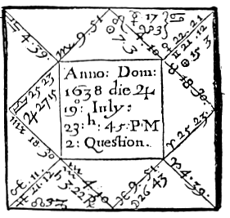

Compliments of http://mithras93.tripod.com

The Resolution of

Ephemerides when the Lord of 11th and the Lord of the Ascendant come to a Trine or Sextile Aspect and about that time, if not that day, newes will be had of him; or if the Moon apply to a sextile or trine of the Lord of the Ascendant See how many degrees shee wants of the Aspect, and give dayes, weekes or moneths, viz. For every degree in MOVEABLE Signes -- DAY,

in COMMON Signes -- WEEKS,

in FIXED Signes -- MONTHS.

A Further Explanation of the Preceding Judgments by the Figure Succeeding.

RESOLUTION OF THESE QUESTIONS FOLLOWING:

1. If find the party inquired of at home.

2. A thing suddenly happening, whether good or bad is intended?

3. What Moles or Marks the Querent has?

4. If one absent be dead or alive?

152

Compliments of http://mithras93.tripod.com all manner of QUESTIONS.

CHAPTER XXV.

Viz. A Woman being at my House in the country, demanded if her Sonne were with his Master, or at her owne House.

In this Figure Venus is Lady of the Ascendant, and shall signifie her that asked the Question; the matter quesited after must be required from that house which signifies Children, and that is the 5th: I considered Jupiter who is Lord of the Signe Pisces, for Pisces is the house of Jupiter, and I found Jupiter, the Youths Significator, in the Angle of the East, or Ascendant; one argument, that the Party sought after was at home at his Mother’s house at time of the Question: I observed further, that the Moon did apply to a Sextile Dexter of Saturn, Lord of the 4th, which signifies the house or dwelling place of the Querent; from which two testimonies, I judged the Youth was at his Mothers, and that she should find him there at her comming home, as indeed she did: now had I found Jupiter, Lord of the 5th, in the 10th, because that is the house which signifies the Master, or had the Moon separated from Jupiter, Significator of the youth, and presently applied to a good or indifferent aspect of the Sun, and she, viz. Moon been in an Angle, I would have adjudged him at his Master’s house, &c. I did further consider that the 25 of July following, at two hours after noon, Jupiter and Venus being both their Significators, viz. both the Mothers and the Sons came to a Trifle aspect, and therefore I judged she should see him that very day, but hardly any sooner, or before; (and indeed she stayed in the country till that very morning; but when the strength of the influence grew powerful, and as well her Significatrix, as his, were so neer their perfect aspect, she could not be induced to stay any longer, and so (volens nolens) went away, and it was about three in the afternoon the same day before she could get home, where she found her Sonne in her owne house, abiding her comming; for usually about that day when the Significators came to a Trine or Sextile aspect (which you may know by your ephemeris) it’s very probably you shall have a Letter, or newes of the Party quesited after (if the distance of places betwixt you can afford it,) but if the Party enquiring, and Person inquired after be not farre asunder, without question they meet 153

Compliments of http://mithras93.tripod.com The Resolution of

that very day, though neither of them formerly thought any such matter.

Had this Woman enquired, if she should have found a Neighbor or Brother or Sister at home, or not;

You must have taken signification from Jupiter, who is Lord of the 3rd house; for you may see in the signification of the houses, pag.52, that the 3rd house signifies Brethern, Sisters, Kindred and Neighbors; you might safely have adjudged, she should have found any one of these at home, because Jupiter their Significator is in an Angle, But if she had enquired, whether she should have found a Party at home, yea or not, to whom she had no relation, but as to a stranger; then Mars the Lord of the 7th; had been his Significator, whom I find to be in the Signe of Sagittarius, and in the 2nd house of Heaven, for wanting more than 5 degrees of the Cusp of the 3rd, he is not admitted to have signification in that house. In the first place therefore, I find Mars in the 2nd house, and in a Northerne quarter of Heaven, (for the Cusp of the 4th house to the Cusp of the 5th, or Ascendant, is so, as you may see pag. 48) next I find Mars, who is Significator of the Party with whom she would speak with, is in Sagittarius, which is an Easterly Signe, (as you may see pag. 97.) Being Mars is not in an Angle, I say he is not at home; the 2nd house wherein he is being Succeedant, I say he is not far from home.

The quarter of Heaven wherein at present he is, is North-east, for so Signe and quarter import.

His distance from home may be a Furlong, or a Close or two, because his Significator is in a Succeedant house,

The quality of the place or ground where you may expect to find him, must be judged from the Signe wherein Mars his Significator is, viz. Sagittarius, a Fiery Signe; what manner of place that signifies, see in pag. 98 , and you shall there find, it represented in the Fields, Hills, or Grounds that rise a little:

so that the Party enquired after being absent, you must direct a messenger to find him, in such or such a Ground, or part of the Ground, as is of the nature and quality described, and butting or 154

Compliments of http://mithras93.tripod.com all manner or QUESTIONS

lying to that quarter of Heaven, as is formerly directed, viz. North-east, But had it been so, that you were informed, the man was in a Towne, and not in the Fields, then enquire in the Towne neer to some Smiths or Butchers shops, or the like, being North-east from his house, for you may read Mars delights in such places,(see pag. 68) Of a Thing Suddenly Happening, Whether Good or ill, Resolution Thereof by the Last Figure,

Let us admit the figure preceding to be set upon such an occasion; the Sun is the Lord of the Signe wherein he is; Jupiter is Lord of Pisces, the Signe wherein the Moon is, Venus is Lady of the Ascendant, or house of Life; Venus is most powerfull in the Ascendant, Libra being her house, and she having a Terme therein, and casting her Trine Sinister unto the Cusp of the house; as also, being in Trine with Jupiter, and he in the Ascendant; from hence one might have safely judged, had this been the very time of a sudden accident, or thing done, that it could not have redounded to the Querent’s disadvantage, but rather good: Now had Venus been neerer to the Opposition of Mars, he being in the 2nd , which signifies Riches, I should have judged the Querent would have received some losse shortly; and so of the rest or some falling out about Moneys.

What Marks the Querent Had.

I find the 25. of Libra Ascending, and Jupiter in the Ascendant; which as I aquainted you, signified the Face; this Querent had a Wart or Mole on the right side of her Face, neer her Mouth, for Jupiter is masculine, so is the Signe Libra; and as the later degrees of Libra ascend, so the Querent confessed a Mole on the lower part of her Reines, towards the Haunches; Aries being the Signe of the 6th, shewed she had one on the Fore-head, neer the Haire, for you see the Cusp of the house is but 4 degrees; Mars Lord or Aries, being in a Masculine Signe, viz. in Sagittarius but under the earth, shewed a Mole on the right Thigh, towards the middle of it, on the back part, or that part which is not

155

Compliments of http://mithras93.tripod.com The Resolution of

visible; the Moon being in Pisces, viz. 26 degrees 43 minutes in a Feminine Signe, and under the earth, I told her she had one Mole under her Foot, towards the extremity of her left Foot.

The Quesited Party being her Sonne, had Pisces in 9 degrees for his Ascendant, which denoted a Mole on the left side of his Cheek; and as Pisces signifies the Foot, so he had one on the left Foot, a little below the Ancle, for you see few degrees ascend. The 6th house from the 5th, is the 10th in the figure, where you see Leo 4 degrees, which signified, that neer his right Side, below his Breast, he had some Scarre, Mole or Mark, &c. follow these Directions, and they are sufficient Instructions in this kind of Judgment.

Whether One Absent be Dead or Alive, by the

Preceding Scheame of Heaven.

In the Figure abovesaid, let us admit the Question to have been demanded for one absent: The Ascendant Libra, Jupiter therein, Venus and Moon are Significators of the absent Party.

The ascending Signe manifests his Stature, Jupiter gives comliness unto it, Venus, Jupiter and Moon argue his Conditions.

Neither is the Moon or Lord of the Ascendant joyned to any Planet in the 8th by Conjunction but are all free from the malignant

and aspects of the Lords of the 8th or 6th, or is the Lord of the Ascendant or the Moon in Opposition with the Lord of the 8th.

Or is there translation of light from the Lord of the 8th to the Lord of the Ascendant, or is the Lord of the 8th in the Ascendant, but a Benevolent planet, or is Moon or the Lord of the Ascendant in the 4th house: I should therefore pronounce the absent in health; but because Venus Lady of the Ascendant, had not many dayes before been in Opposition with Mars, who is Lord of the 2nd and 6th; I should adjudge he had been lately discontented for want of Money, and also inclinable to a Feaver; but by Jupiter his positure in the Ascendant, and his Trifle to Venus, I should judge Medicine, or such a one as Jupiter had relieved him: and because Mercury Lord of the 11th, applies to a

156

Compliments of http://mithras93.tripod.com all manner of QUESTIONS.

Square of Jupiter in the Ascendant, both of them being in Signes of long ascention, which is equivalent to a Trine, I should judge the Querent to have newes of the absent about 10 weeks from the time of the Question, because Mercury wants 10 degrees of the Square of Jupiter; if the absent be known to be at a neer distance, I would have said in 10 days they should heare of him, because the Signes are moveable.

CHAPTER XXVI.

Of a Ship, and Whatever are in Her,

Her Safety or Destruction.

The Ancients do put this question to those concerning the 9th house, and I conceive for no other reason, than because it must be granted, that all Ships are made for travel and journeys: however, in regard the most part of the judgment concerning its safety or ruin is derived from the Ascendant and his Lord, and the Moon, I thought fit to place this judgment as belonging to the 1st house.

Generally, the Signe ascending and the Moon are Significators of the Ship, and what goods are in her: if in the question demanded you find all these unfortunate, that is, if a malevolent Planet by position be placed in the Ascendant, he having dignities in the 8th; or if you find the Lord of the Ascendant in the 8th, in any configuration with the Lord of the 8th, 12th, 4th or 6th, or the Moon combust, or under the earth, you may judge the Ship is lost, and the men drowned, (unless you find reception betwixt themselves) for then the Ship was casually Shipwrecked, and some of the sea men did escape: but if you find the preceding Significators all of them free from misfortune, both men and goods are all safe; the more safe if any reception be. But if the Ascendant and the Moon be infortunate, and the Lord of the Ascendant fortunate, the Ships like to be drowned, but the men will be saved: Some for better knowledge and discovery of what part of the Ship was like to be freest from danger, have divided the several parts of the Ship, and have assigned to every of the

157

Compliments of http://mithras93.tripod.com The Resolution of

twelve Signes, a part or place of the Ship, by which if any damage was to come to the Ship, they could or might better prevent it.

Unto Aries they give the Brest of the Ship.

To Taurus what is under the Brest a little towards the Water.

To Gemini the Roother or Sterne of the Ship.

To Cancer the Bottome or Floor of the Ship.

To Leo the top of the Ship above Water.

To Virgo the Belly of it.

To Libra that part which sometimes is above, and sometimes below the Water, or betwixt Wind and Water,

To Scorpio that part where the Seamen are lodged, or so their Office.

To Sagittarius the Mariners themselves,

To Capricorn the ends of the Ship.

To Aquarius the Master or Captaine of the Ship.

To Pisces the Oares.

At the time when the Question is asked concerning the well or ill being of the Ship, see which of these Signes, or how many of them are fortunate, or hath the Moon or the Lord thereof fortunate, it’s an argument those parts of the Ship so signified, will have no defect, or need repaire thereof, or the Ship will receive any detriment in those parts: but which of these Signes you find unfortunate, or in what Signes you find the Moon or Lord of the Signe where she is, unfortunate, in that place or part of the Ship assigne impediment and misfortune, and thereof give warning.

But when the Querent shall demand of any Ship which is setting forth, and the state of that Ship ere she return, and what may be hoped of her in her voyage, then behold the Angles of the Figure, and see if the fortunate Planets are therein posited, or falling into Angles, and the infortunes remote from Angles, Cadent, Combust or under the Sun Beams, then you may judge the Ship will goe safe to the place intended, with all the Goods and Loading in her: But if you find the infortunates in Angles, or Succeeding Houses, there will chance some hinderance unto the Ship, and it shall be in that part which the Signe signifies where the unfortunate Planet is; if the same infortunate be Saturn, the

158

Compliments of http://mithras93.tripod.com all manner of QUESTIONS.

Ship will be split, and all the men drowned, or receive hurt by some bruise, or running a ground: but if it be Mars, and he in any of his Essentiall Dignities, or behold a place where he hath any Dignity or be in an Earthly Signe, he shall then signify the same which Saturn did, or very great danger and damage to the Ship: But if the Fortunes cast their benevolent rayes or aspect to the places where Mars or Saturn are, and the Lords of the four Angles of the Figure, and especially, or more properly, the Ascendant, and the Lord of that house or Signe where the Moon is in be free, then it’s an argument, the Ship shall labor hard, and suffer much damage, yet notwithstanding the greater part both of Goods and Men shall be preserved. But if Mars does afflict the Lords of the Angles, the Dispositor of the Moon; the Mariners will be in great fear of their enemies, or of Pyrates or Sea-robbers, shall even tremble from feare of them: and if there also unto this evill configuration chance any other affliction in the Signes, there will happen among the Mariners Blood-shed, Controversies, quarrelling one with another, theeving and robbing each other, purloyning the Goods of the Ship; and this judgment will prove more certaine if the unfortunate Planets be in the Signes which fall to be in the Division of the upper part of the Ship, towards the height or top of her.

If Saturn in the like nature doe afflict, as was before recited of Mars, there will be many thefts committed in the Ship, but no bloodshed; the Goods of the Ship consume, no body knowing which way.

If the unfortunate Signes (viz. those which are afflicted by the presence of Saturn or South Node) be those which signifie the bottome or that part of the Ship which is under Water, it’s an argument of the breaking and drowning thereof, or receiving some dangerous Leak: if the Signes so unfortunate be in the Midheaven, and Mars unfortunating them, it’s like the Ship will be burned by fire, thunder or lightning, or matter falling out of the Aire into the Ship; this shall then take place when the Signes are Fiery, and near violent fixed Stars.

If that Signe wherein Mars or the unfortunate Planet be the Signe of the 4th house, it notes firing of the Ship in the bottome of her; but if Mars be there, and the Signe humane, viz. either 159

Compliments of http://mithras93.tripod.com The Resolution of

Gemini, Libra or Aquarius, that fire or burning of the Ship shall proceed from a fight with Enemies, or they shall cast into her or shall teare the Ship in pieces in grapling with her, and the fire shall in that part of the Ship first take hold, signified by the Signe wherein an Infortunate was at time of asking the Question.

If Saturn instead of Mars does denunciate dammage, and be placed in the Mid-heaven, the Ship shall receive prejudice by contrary Winds, and by leaks in the Ship, by rending or using of bad sailes; and this misfortune shall be greater or lesser, according to the potency of the Significator of that misfortune, and remotenesse of the Fortunes.

If the same Infortune be in the 7th house, and he be Saturn, the latter part of the Ship will be in danger of misfortune, and the Sterne of the Ship will be broke.

Moreover, if any infortune be in the Ascendant, some losse will be in the fore-part of the Ship, greater of lesse, according to the quality or strength of the Significator thereof; or if the Lord of the Ascendant be Retrograde, the Ship will proceed forward a while, but either returne or put into some harbor within a little time after her setting forth; and if the Lord of the Ascendant be in a Moveable Signe and Retrograde, and the Lord of the 4th also, viz. Retrograde, the Ship will returne againe crossed by contrary Winds, to the very Port from which she first set out: and if the Lord of the Ascendant have no other impediments than Retrogradation, there will be no losse by the returne of it; but if to Retrogradation some other misfortune happen, the Ship returnes to amend something amisse, and was also in danger.

Besides, if the Lord of the 8th shall infortunate the Lord of the Ascendant, especially if the Lord of the Ascendant be in the 8th, there will come hurt to the Ship according to the nature of the Planet afflicting: as if the same Planet that is Lord of the 8th house doe impedite the Lord of the house of the Moon, the Lord of the Ascendant and the Moon, it imports the death of the Master or Governour of the Ship, and of his Mate and principall Officers of the Ship: and if the Part of Fortune and the Lord of the 2nd house be unfortunate, it pronounceth losse in sale of those Goods in the Ship, or ill venting of them, or that they will not come 160

Compliments of http://mithras93.tripod.com all manner of QUESTIONS.

to a good market; but if either North Node, Jupiter or Venus be in the 2nd house, or Lord thereof, or Dispositors of the Signe the Part Of Fortune is in, there will be good profits from the Voyage of that Ship, and sale of Goods therein the more the Significators are essentially strong, the more profit may be expected.

If the Lord of the Ascendant and the Lord of the house of the Moon be slow of course, and those Planets that dispose of them, then it’s probable the Ship will be slow in her motion, and make a long Voyage of it: but if the aforesaid Significators be quick in motion, the Ship shall make good speed to the Port intended, and will returne home again in shorter time then is expected.

And if it happen that there be an Opposition or Square aspect betwixt the Lord of the Ascendant and the Lord of that Signe who disposeth the Moon, and this aspect be without reception, then will there be much discord among the Saylors, and much controversie betwixt the Merchant and them; wherein, he shall prevaile that is most dignified; that is, the Sea-men if the Lord of the Ascendant be strongest; the Merchant, if the Lord of the house where the Moon is be best fortified.

If the lord of the 2nd be removed from his 2nd (that is, if Taurus be the cusp of the 2nd, and Venus further removed then Gemini) or if the Lord of the 2nd be removed from the 2nd house wherein the Moon is in, (as if she be in Virgo, and the Lord of the 2nd not in Libra, or if the Disposer of the Part Of Fortune be not with it, then the Ship-men will have scarsity of Provisions of Victuals and Food: if these Planets or Part Of Fortune be in Watry Signes, want of fresh water will most annoy the Saylors: if the Significators be in Earthly or Airey Signes, want of Food, Victuals and Fire will oppresse them: This is the manner by which the Ancients did judge of the good or ill successe of a Ship, concerning her Voyage at her first going forth.

161

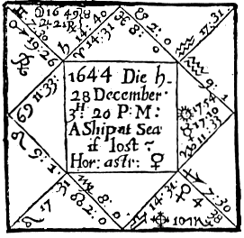

Compliments of http://mithras93.tripod.com

The Resolution of

An Example of A Ship At Sea.

In December 1644, a Merchant in London having sent out a Ship to the coast of Spaine for Trade, had severall times newes that his Ship was lost or cast away, there having been a little before very Tempestuous weather, in so much that many Shipps were sunk and Shipwrackt; he would have given 60 in the hundred for the assurance of her; but so generall was the report of her losse, that none of the Ensurance company would meddle, no not upon any termes. A Friend of the Merchants propounds the Question unto me, What I thought of the Ship, if sunk or living?

whereupon I erected the Figure preceding, and having well considered what was requisite in this manner of Judgment, I gave my Opinion. That the Ship was not lost, but did live, and though of late in some danger, yet was now recovered.. My Judgment was grounded upon the Considerations in Art following..

In the first place, the Ascendant being the 11 degree and 33 minute of Cancer, showed the Bulk or Body of the Ship; there doth also ascend with these degrees of Cancer 3 Fixed Starres in our Horizon, wholly almost of the nature of Saturn: I find Saturn castest his Square Sinister out of the 11th house, but from a Cardinall Signe to, or very neer the Cusp of the ascending degrees, thereby afflicting it: after his Square aspect, I found the Moon in her Exaltation, casting a Sextile Sinister to the degree ascending, interposing her Sextile betwixt the Ascendant and the Opposition of Mercury and Sun in the 7th, which otherwise had been dangerous, for all opposite aspects to the Ascendant in this Judgment are dangerous.

162

Compliments of http://mithras93.tripod.com all manner of QUESTIONS..

From the Ascendants affliction both by the Square of Saturn, and presence of fixed Stars of his like nature, I judged the Ship was much of the nature of Saturn, viz. a sluggish, heavy one, and of no good speed, or very sound; and Cancer being a weakly Signe, made me judge the condition, building and quality of the Ship was such; (and it was so confessed.) From hence, and for that South Node is in the 9th house, I judged the Ship had been in some affliction or distresse in her journey, occasioned from such casualties as are signified by Saturn, viz. had received some such casualties as are signified by Saturn, viz. had received some bruise, leak, dammage in or neer her Brest; because Aries, the Signe wherein Saturn is, represents that part, thereby afflicting it.

But in regard the Moon, who is Lady of the Ascendant, is posited in the 11th house, and in her Exaltation, is no manner of way impedited, but by a benevolent aspect applying to a Trine of Mercury and Sun, and is by bodily presence so neer unto Jupiter, and all the Significators above the Earth, (a thing very considerable in this Judgment.) Besides, I observed no Infortunes in Angles, which was one other good argument; for these considerations, I judged the Ship was not cast away, but living, and that the Saylors and Officers of the Ship were lively and in good condition.

The next quere was, Where the Ship was, upon what Coast, and when any newes would come of her?

Herein I considered the Moon was fixed, and locally in the 11th house; Taurus is a Southerne Signe, but in an East quarter of Heaven, verging towards the South: her application to a Trine of Mercury, and he in Capricorn, a South Signe and West Angle, made me judge the Ship was South-west from London, and upon our own Coast, or neer those which lye betwixt Ireland and Wales; I judged her at that time to be in some Harbor, because Taurus wherein the Moon is, is fixed, and in the 11th house, which is the house of Comfort and Relief; and that she was put into some Harbor to mend her Defects or Rents:(It proved true that she was in the West, and in an Harbor.)

Because the Moon applyed to a Trine of Mercury and Sun, and they in an Angle, and was her selfe as well as they, very swift in motion and did want but a few minutes of their perfect Trine; I 163

Compliments of http://mithras93.tripod.com The Resolution of

judged there would be newes or Letters, or a certaine discovery of the Ship in a very short time; the Significators so neer aspect, I said either that night, or in 2 days; (and so it proved:) And you must observe, that it gave me good encouragement when I saw Part Of Fortune Disposed by Mars, and Mercury to whom the Moon applyed to be in reception with Mars: as also, that the Moon, by so forcible an aspect, did apply to the Sun, who is Lord of the 2nd house, or of Substance, an argument, the Merchant should encrease his Stock, and not lose by that adventure: You shall also observe, that Jupiter has his Antiscion in the 9th of Leo, the very Cusp of the 2nd house, and Mars his Antiscion fals upon the very degree ascending: these were good testimonies of safety: Mars as being Lord of the 11th, and Dispositor of Part Of Fortune; and Jupiter as Lord of the 10th, viz. of Trade and Commerce.

Besides, usually when the Moon applies to a good aspect of a Retrograde Planet, it brings the matter to an end one way or another speedily, and when least suspected: and it’s a generall Maxime in such like cases, if the Moon apply to the Fortunes, or by good aspect to any Planet or Planets in Angles, then there is reason we hope well, etc.

The Ascendant free from presence of Infortunes, a good sign: Lord of the Ascendant above the Earth, and the Moon and their Dispositors, good signes: Lord of the Ascendant in 10th, 11th or 9th houses, good: Lord of the Ascendant in Trine or Sextile with Jupiter or Lord of the 11th, good.

164

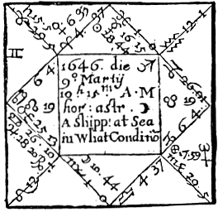

Compliments of http://mithras93.tripod.com

all manner of QUESTIONS.

Example of another Ship.

Here the Ascendant and the Moon are Significators of the Shippe, and those that saile in her: the Moon lately separated from a Square of Saturn, Lord of the 8th and 9th, then at time of the question voyd of course; but afterwards 1st applyed to a Trine of Saturn, then to Opposition of Mercury, Lord of the 12th and 4th; this shewed the Ship had lately been in danger (of Death) viz.

Shipwrack: and as the Moon had been voyd of course, so had no newes been heard of her; because the Moon was last in Square of Saturn, in fixed Signes, tortuous or odiously and malitiously aspecting each other, and falling into Cadent houses, and then did not presently apply to the good aspect of any benevolent Planet, but was voyd of course, and then againe continued her application out of the 4th to Saturn, who is still Lord of the 8th, although it was by good aspect; and then after seperation from him, applyed to Opposition Mercury, and that Mercury her Dispositor was in Detriment, and entering Combustion, and Jupiter Dispositor of Mercury Subterranean and in Conjunction with Mars, and termes of an Infortune; and forasmuch as I found Mars in his Fall, upon or neer the Cusp of the 2nd house, I judged losse was at hand to the Merchant; Part Of Fortune being in the 6th house, disposed by Jupiter, and he Retrograde in the 2nd, not beholding Part Of Fortune; the Moon also casting her Square Sinister to the Part Of Fortune, and so Mercury his Dexter Square: by meanes therefore of so many evill testimonies of receiving losse rather than benefit; I judged that the Merchant should lose much, if not all that was adventured in this Ship, and so consequently I doubted the Ship was cast away; (and so it proved.)

Principal Significators under the Earth, ill: worst of all, if in the 4th, for that is an assured testimony of sinking the Ship.

165

Compliments of http://mithras93.tripod.com The Resolution of

Of the Time of Receiving any QUESTION.

it hath been disputed largely amongst the Arabians, who were excellent in the resolution of Horary Questions, what time the Astrologer should take for the ground of his Question, whether that time when the Querent first comes into ones House or Closet, or first salutes the Artist, whether that is to be admitted for the most proper time of erecting a Figure, and giving Judgment thereupon.

Though some have consented to this opinion, yet I could never be satisfied herein either with reason or experience; for let us admit one comes to demand a Resolution of me, and we converse together a good while; but in the end, some occasion intervenes, and we depart: I hope no sound Judgment will allow of this time to be the Radix of a Question (whenas none is really demanded) viz. at what time he first saw me, or entered my house and spake with me.

Without doubt the true houre of receiving any Question is then, when the Querent propounds his desire unto the Astrologer, even that very moment of time, in my opinion, is to be accepted: for let us suppose a Letter is sent or delivered unto me, wherein I am desired to resolve some doubts; perhaps I receive the Letter into my hands at 3:00 in any day of the week, but in regard of some occassions, doe not read it untill 4 or 5 hours after; that very hour and minute of hour when I break it open, and perceive the intention of the Querent, is the time to which I ought to erect my Figure, and from thence to draw mine Astrological Judgment: This way and manner have I practiced, and found successe answerable: And whereas Bonatus and some others doe give warning that the Astrologian judge not his owne Question, and say he cannot tell how to accept of a question from himselfe; this I conceive was his reason, Because he thought the Artist would be partiall to himselfe in his judgment: Verily I am of a contrary opinion and have found by many experiments, that at what 166

Compliments of http://mithras93.tripod.com all manner of QUESTIONS.

hour the mind or intention of the Astrologer is heavily perplexed with or concerning the successe of any matter wherein himselfe is really concerned, I say he may with great reason accept of that hour for the true time of erecting his Scheame of Heaven, and he may (if not partiall) as well judge of that Figure erected by himselfe, as of any other; but herein I advise him to lay aside all love and partiality unto his owne Cause.

JUDGMENTS CONCERNING THE 2ND HOUSE.

CHAPTER XXVII.

Whether the Querent Shall be Rich, or Have a Competent Fortune? By What Meanes Attaine it? The Time When? Etc.

And if it Shall Continue?

Whoever interrogates, be his Condition what it will be, King, Noble, Priest or Layman, the Ascendant, the Lord thereof and the Moon are his Significators: and if the question be in generall termes, (viz. Whether he shall ever be rich yea or not?) without relation to any particular person from whom he may expect a Fortune, the resolution of it is in this nature: Consider the Signe ascending on the Cusp of the 2nd House, the Lord thereof, the Planet or Planets therein posited, or aspecting the Lord of that house or Cuspe thereof; the Part Of Fortune, the Signe and place of Heaven where it is placed and how aspected by the Planets, (for Part Of Fortune it selfe emitteth no rayes, or casteth any aspect to any Planet, no more doe the North Node or South Node.)

First, if you find the Planets all angular, it’s one good Signe of Substance; if they be in succeedant houses, direct and swift in motion, it’s a good Signe.

If Planets be in good houses, direct, and but moderately 167

Compliments of http://mithras93.tripod.com The Resolution of

dignified in essentiall Dignities, it’s an hopefull argument of an Estate: Those rules are generall: If the Lord of the Ascendant, or the Moon, and the Lord of the 2nd house, viz. of Substance, be corporally joyned together, or if they, viz. Lord of the Ascendant and Moon, have friendly aspects to the Lord of the 2nd, or if Jupiter and Venus cast their Trine or Sextile, or be in Conjunction with Part Of Fortune, or if the Lord of the 2nd be in the Ascendant, or the Moon, or Lord of the Ascendant in the 2nd, or if any Planet transfer the light and vertue of the Lord of the 2nd to the Lord of the Ascendant, or if benevolent Planets cast their Sextile or Trine to the Cuspe of the Ascendant or Part Of Fortune, or any fixed Starre of the nature of Jupiter and Venus, doe ascend with the Cuspe of the 2nd or Part Of Fortune be in Conjunction with or neer to such a fixed Starre; or if Jupiter who is naturall Significator of substance, or Venus who is naturally a fortune or North Node be in the 2nd, and no infortune cast his aspect unto them, or if you finde all Planets direct and swift in motion (viz.) if their daily motion be more then what is assigned for their meane or middle motion, which you may perceive by page 57.61.65.69.72.76.80. The Querent shall not feare poverty, for he will be competently rich or have a sufficient fortune to subsist on, and this his estate shall be greater or lesser according to the Major testimonies, which you are carefully to examine of those Significators which doe naturally resolve the question; and here in this demand you must remember to take notice of the quality of the person inquiring or demanding the question, for (Quoad capax) it shall happen to any Interrogant.

By What Means Attain It.

When you have sufficiently examined your Figure, and perceived that the Querent shall have a substance or will come to have riches, it will be demanded, how? by whom, or what meanes it may be obtained?

Herein you must observe, that if the Lord of the 2nd House be in the 2nd, the querent shall obtain an Estate by his owne labour and proper industry; if the Lord of the 2nd be placed in the Ascendant, he shall unexpectedly come to a Fortune or without 168

Compliments of http://mithras93.tripod.com all manner of QUESTIONS.

much labour attaine it. If that the Lord of the 2nd or the Moon do promise substance by any aspect they have to each other, you must consider from what House the aspect is, or what House the Moon is Lady of, or if neither of these promise substance; see to the Part Of Fortune, what house it is in, and what House of Heaven the Dispositor is Lord of.

If the Planet assisting or promising encrease of Fortune be Lord of the Ascendant, the Querent himself will by his owne diligence advance his owne Fortune; if he be a meane man or Mechanicall that interrogates, then by the sweat and labour of his owne hands, his owne Invention, Care and Pains, no King shall put him into a fortune: But if the Adjuvant Planet be Lord of the 2nd, he will augment his Estate by advance of his owne Stock, and well managing his private Fortune, and adventuring to Buy and Sell in such things as naturally he is addicted unto, or fals in his way in the course of his life, or are of the nature of that Planet (the Signe he is in considered.)

If the Lord of the 3rd fortunate the Lord of the 2nd, or the Cuspe of the House, or Part Of Fortune, he will be assisted in procuring an Estate by some honest Neighbour, or some one of his Kindred, Brethern or Sisters, if he have any, or by some Journey he shall undertake, or removing to that quarter of Heaven from whence the Lord of the 3rd calls his good aspect, or is corporally joined with the Significator of Substance.

If the fortunate Planet or significator be Lord of the 4th or placed in the 4th, the Querent will attaine Wealth by means of his Fathers assistance, (if he be living) or by some aged person, as Grandfather, etc. or by taking some Farme or Grounds, or purchase of Tenements, Lands or Hereditaments, or well managing the Stock his Ancestors have or shall leave him, or some Stock of Money his Kindred may lend him.

If the Lord of the 5th doe promise Wealth, then he obtaines meanes: if a Gentleman (by Play, Cards, Dice, Sports, Pastimes) if of Capacity, and a Courtier, by some Embassage, Message, etc.

If an ordinary man propounds the question, by keeping a Victualling-house, as Ale-house, Inne, Taverne, Bowling alley, or being a Door-keeper, Porter to some Gentleman; or be he who 169

Compliments of http://mithras93.tripod.com The Resolution of

will that enquires, if the Lord of the 5th House be strong, he promises somewhat out of the Estate of the Father, or by making Matches, etc..

If the Lord of the 6th, or Significator, or assistant Planet be in the 6th, and the Signe of the 6th be humane, the Querent may expect good Servants, and profit by their labours: If a King or Prince propounds the Question (as sometimes they doe) you may judge, his Subjects will assist him with many tumbling Subsidies, Privy-Seales, Loans of Money, etc..

If a Nobleman or Gentleman enquire, he shall augment his Estate by Letting Leases, and the discreet managing of his Estate by his Stewards, Bailiffs, and such as undertake for him..

If the question come from a Country-man, as a Farmer or Husband-man, tell him he may thrive by dealing in little Cattle, as Sheep, Goats, Hogs, Conies, etc..

If a Scholler propound the Question upon the like occasion, advise him to turne Physician, for he shall thrive by his Salary obtained from people infirme and diseased..

If the Lord of the 7th House fortunate the Lord of the 2nd House, or the Cuspe of the House, or the Part Of Fortune, or that Planet which is posited in the 2nd, let the Querent expect God’s Blessing, by meanes of a rich and good Wife, or the assistance of some loving Woman: As also, if a Gentleman propounds the Question, then by the Sword, or the Wars, or by Law recovering somewhat detained from him, by contracting of Bargains, by the common aquaintance he hath in his way of Trade or Commerce, if he be a Merchant..

If the Lord of the 8th be that Planet who fortunates the Significators above named; the Querent shall either have some Legacy bequeathed him by Testament of deceased party, or a further increase of his Wife’s Portion, little by him expected at time of his Question, or shall goe uncompelled, and reside in some Country, where increase of substance shall happen unto him,viz.. he shall unexpectedly settle himselfe where formerly he had no intention, and there shall thrive and grow rich..

If the Lord of the 9th gives vertue or fortunate the Part Of Fortune or Lord of the 2nd, or Cuspe of the House, the Querent

170

Compliments of http://mithras93.tripod.com all manner of QUESTIONS..

may thrive by some Voyage to Sea, if Cancer or Pisces descend on the Cuspe of the 9th, and the Lord of the same Signe be therein, or one of his Wife’s Brothers, or some allied unto her, or neer Nighbour, or the place where she did live when he first married her, of some religious man or Minister shall befriend him in the way of his Vocation or Calling, for the increase of his Fortune..

If an Earth Signe be on the Cuspe of the 9th, and the Lord of that House be therein posited, he may thrive by removing to that part of Heaven, or that Coast of the Kingdom or Country signified by the Signe and quarter of Heaven, and by dealing in the native Commodities of that County, City or Country to which the Heavens direct him..

If the Lord of the 2nd be fortunate in the 10th House, or the Lord of the 10th and 2nd be in reception, or the Lord of the 10th doe behold the Lord of the 2nd or Cuspe of the 2nd House, or a Planet therein, or the Part Of Fortune, with any benevolent configuration; let the Querent try the service or employment of some King, Prince, Nobleman, Gentleman, Master, or the like, and thereby he shall augment his estate or get a subsistence: if one inquires that is young and of small fortune, let him learne a Mechanicall trade, according to the nature of the Signe of the 10th and Planet who is Lord therof; for the Heavens intimate he shall doe well in his Magistery or Trade, if he be capable and fit for it; or if he be a man of any education and desirous of preferment, let him expect an Office or Publique imployment in the Common-wealth, in one kinde or other..

If the Lord of the 11th be that benevolent Planet who is Significator in the premises, viz. the Planet fortunating, then some friend shall commend the party inquiring to accept of some imployment very advantagious, or some Merchant, Courtier, or servant of a Nobleman, King, or great person shall be the meanes of raising the Querent to a Fortune, and then, shall unexpectedly happen unto the Querent which he never thought of: and this for good..

If the Fortunate Planet, who casts his Aspect as aforesaid, be in the 12th, the Querent shall advance his Fortune by great Cattle, Horse-races, by imprisonments, or men imprisoned, if the Signe of

171

Compliments of http://mithras93.tripod.com The Resolution of

the 12th be humain; if the Signe be Taurus or Capricorn or Aries by Cattle; if Virgo by Corn.

And herein mix your judgment with reason..

The most assured testimony in Astrology, and upon a Question onely propounded, that the Querent shall be rich and continue so, is this, if the Lord of the 1st and 2nd and Jupiter be joyned together in the 2nd House, 1st, 10th, 7th, 4th or 11th; but if they be not in Conjunction, then that they apply by Sextile or Trine with Mutual Reception: nay, although they apply by Square or Opposition, yet if it be with reception, the party will thrive or have an estate, though with much labour, and many intervening difficulties, yet will he ever more abound then want..

Of the Reason, or from whence it proceeds, or what is the Cause, why the Querent shall not obtaine Wealth.

When in any question you find your Figure signifies the Querent shall come to an estate, the resolution following is needlesse; but if you find that he shall not obtaine any great fortune, and the Interrogant would know the cause why, or thing impediting, that so he may the better direct his affaires, and be more wary in the course of his life, for better prevention of such difficulties: In this Judgment carefully observe the Planet obstructing, or who doth most afflict the Lord of the 2nd, or Part Of Fortune, or the Cuspe of the 2nd, the Moon, or Lord of Dispositor of the Part Of Fortune; if the Lord of the 1st be that Planet, then the Querent himselfe is the cause; if the Lord of the 2nd doe with Square or Opposition behold the Part Of Fortune, or the Cuspe of the 2nd, then want of money or a sufficient Stock to set himselfe in imployment is the cause: If Lord of the 3rd, his own Kindred will doe nothing for him, or will prove burdensome, or malicious Neighbours will get all the Trade from him, or so under-sell him, that he will be much kept under thereby: and so run through the 12 Houses, as in the Chapter mentioned before. I thought good here to give this generall caution, that if the Lord of the 2nd House, or Dispositor of the Part Of Fortune be infortunes, yet if they have Essentiall Dignities where they are, or aspects to good Planets, or be placed in such benelovent Houses as I formerly mentioned, 172

Compliments of http://mithras93.tripod.com all manner of QUESTIONS.

they may be Significators of position of Substance; and in like nature both Jupiter and Venus being afflicted or impedited, or Significators, as aforesaid, may be the Planets obstructing as well as any other, for every Planet must do the work for which he is by divine Providence assigned unto: Doe you also ever remember that in what House you can find Cauda Draconis, it prenotes detriment and impediment in such things as are signified by that House, as if he be in the 2nd, he denotes consumption of Estate by the Querent’s own folly or not thriving, by his owne proper neglect: in the 3rd, hinderance by evill, beggarly or peevish Kindred, etc.., and so judge in all the rest of the 12 Houses -

If the Querent shall obtaine the Substance which he demands, or hath lent, or the Goods he hath pawned.

If the demand of the Querent be, Whether or no he shall procure the money or substance from him of whom he intends to demand it?

The Lord of the Ascendant and the Moon are his Significators, the Lord of the 2nd House of his substance.

The 7th House, and the Lord thereof signify him or her of whom he intends to demand or borrow Money: In proceeding to Judgment,

See if the Lord of the Ascendant or the Moon be joyned to the Lord of the 8th, who is Lord of the Substance of the party quesited after, or see if either of them joyned, or in aspect to a Planet posited in the 8th; if the Planet in the 8th be a fortunate, or the aspect itself fortunate, he shall obtaine the money desired; or if he would borrow the money required will be lent him: if he have deposited any Pledge, it will be restored, whether the fortunate Planet in the 8th be received or not; yea, if an infortunate Planet in the 8th, or Lord of the 8th, and receive either the Lord of the Ascendant or the Moon, the Querent shall obtaine his desire; but if no reception be, he will hardly or ever procure his demands, and if ever, with so much difficulty and labour, as he would rather wish the thing had been undone..

In like manner, if the Lord of the 8th be in the 1st, or in the 173

Compliments of http://mithras93.tripod.com The Resolution of

2nd, and the Lord of the 2nd receive him, it’s probable the businesse will be effected; but is the Lord of the 7th, or of the 8th be in the 1st or 2nd, and neither have reception of the Lord of the 1st or 2nd House, or of the Moon, it’s an argument he shall not have his desire accomplished, but shall receive a deniall or more prejudice in the thing demanded.

If the Lord of the Ascendant and the Moon be joined to a Fortune that has Dignity in the Signe ascending, or Signe intercepted in the Ascendant, the matter will be effected; or if any of them be joyned to an Infortune who hath dignity in the Ascendant, and that Infortune receive the Lord of the Ascendant or the Moon, the business will be dispatched: Or if the Lord of the Ascendant or the Moon be joyned to a fortunate Planet, and he well placed either in the 10th or 11th, the matter shall be perfected, though there be no reception: The Judgments of this Chapter shall have place and prove true, when as the matter in question is amongst ordinary persons, or with such people as with whom there is a community, as Citizens with Citizens, Countrymen with Countrymen, one Tradesman with another; from this Judgment we exempt Kings, Princes, Noblemen and such, who pay Debts slowly, and on whom the Law takes little notice..

If one shall aquire that Gaine or Profit, Wages or Stripend of the King or Nobleman, Generall or Common-wealth, Lieutenant-Generall, or any great Person

which be Expects.

The resolution hereof will serve for any question of the like nature, where the Querent is much inferior to the Quesited, or the party or parties from whom he expects the accomplishment of his desires..

The Ascendant, Lord thereof and the Moon signifie him that askes the Question; the 10th House and Lord thereof, signifie the Quisited, or person sought after, or from whom the matter is to be required; the 2nd House and the Lord thereof are to be considered for the Querent, the 11th House and Lord thereof shall

174

Compliments of http://mithras93.tripod.com all manner of QUESTIONS.

signifie the Estate, Money or Substance of the King, Nobleman, Generall etc., or Party enquired after: If in the Question you doe find the Lord of the Ascendant or the Moon joyned to the Lord of the 11th House, or if any of them be joyned to any Planet in the 11th House, and that Planet be a Fortune, not in any measure impedited, or ill disposed, then you may affirme that the Querent shall obtaine what Salary, wages, debt or money the great person of what quality soever owes unto him; or if it happen that the Moon and the Lord of the Ascendant be joyned to an unfortunate Planet, and he receive them into some of his essentiall dignities, the Querent shall obtaine his Money, Wages, etc., but not without much solicitation, many weary addresses, feares and distrusts; if it happen any Aspect be betwixt the Significators, the one being an infortune and without reception, the Querent will never obtaine what he desires. In this manner of Judgment be very careful to observe the Planets true essentiall dignities, and their mutual receptions, and by which of their mutuall dignities they receive each other.

Of the time when the aforesaid accidents treated of in this Chapter may happen.

Herein you must diligently observe unto what Planet either the Lord of the Ascendant or Moon applyes unto, or is joyned by body., and doth signifie the effecting and performance of the matter quesited after, for if that Planet be in Sextile or Trine with the Lord of the Ascendant or the Moon, whether he be a Fortune or not, or receive the Lord of the Ascendant or Moon or not; consider well how both of them project their beames or rayes to each other, until they come to their perfect aspect, or see how many degrees at the time of the Question asking, they want of being in true Partill aspect or Conjunct, and you may answer that it shall be so many dayes as are the number of degrees betwixt the Significators, if they be both in Cadent Houses: if they be in Succeedant Houses of Heaven, it will be so many weeks; if in Angles, the time will be so many moneths: But here the Astrologer must use discretion, and consider if it be possible that the matter enquired of may be effected in dayes, weeks or 175

Compliments of http://mithras93.tripod.com The Resolution of

moneths; for if it be a businesse that may require much time, instead of moneths you may adde yeers, and this especially if the Lord of the Ascendant, and the Moon and other Significators be in Angles; but if one Planet be in an Angle, and the other in Succeedant, then they shall signifie Moneths; if one be in Succeedant and the other in a Cadent , then they shall denote weeks; but if one be in an Angle, and the other in a Cadent House, they prenote moneths.

Some of the Ancients have said, that if at the Houre of the Question the Planet which signifies the perfection of the thing demanded be in one Signe with the Lord of the Ascendant, the matter shall then be brought to conclusion when that Planet and the Lord of the Ascendant come to corporall Conjunction in Degrees and Minutes, if the Lord of the Ascendant be the more ponderous Planet, or weather there be reception yea or not; but if the Lord of the Ascendant be the more light Planet, so that he make haste to the conjunction of the Planet signifying the effecting of the matter, and that Planet receive the Lord of the Ascendant, the matter will be finished. But if that Planet shall not receive the Lord of the Ascendant, then the matter will not be effected, unlesse the foresaid significators be in an Angle when the Conjunction shall be, or in one of his owne Houses, and especially in that House which is called his joy; as Aquarius is the joy of Saturn, Sagittarius of Jupiter, Scorpio of Mars, Libra of Venus, Virgo of Mercury. What I have observed in resolving Questions of this nature, is this, that single reception by exaltation without other testimonies profiteth not; that reception by essential dignities of House, when benevolent Planets are significators, though by Square or Opposition do usually shew perfection, yea beyond exception, and therefore very certainly when by Sextile or Trine aspect it so fals out, And “for the time when”, I observe, if a fortune, or the Moon or Lord of the thing quesited be in the Ascendant, and have any essentiall dignity therein, the number of Degrees betwixt the Cuspe of the Ascendant and the body of the Planet, doth denote the time when, dayes if a moveable Signe, and the businesse capable of being perfected in dayes, moneths or yeers, according to the Signe, its quality and nature of the businesse.

176

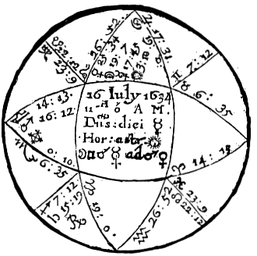

Compliments of http://mithras93.tripod.com

all manner of QUESTIONS.

A Tradesman of this City in the yeer 1634: propounded these severall Demands unto me: because I have seen the experience of my Judgment, and his Queries were pertinent for Resolutions of the Demands of this 2nd House; I have inferred his severall Queries, with the Reasons in Art of my so judging them. His Queries were; 1. If he should be rich, or subsist of himselfe without marriage?

2. By what meanes he should attain wealth?

3. The time when?

4. If it would continue?

177

Compliments of http://mithras93.tripod.com The Resolution of

CHAPTER XXVIII.

If the Querent Shall be Rich or Poor.

It’s first necessary for more exact judgments in this question, that you examine the Diurnall motion of the Planets, which I finde here to be as followeth: Viz. Saturn moveth in 24 houres, 2 minutes: and is therfore slow in motion.

Jupiter 13 min. Ergo, he moveth more in 24 houres, than his middle or meane motion: which is 4

min. 59 sec. is reputed swift, as you may see fol. 61.

The Diurnall motion of Mars is 35 min. this being more than his middle or meane motion, which you see in page 65., is 30 min. 27 sec. He is reputed swift.

Diurnall motion of the Sun 57 min. 00 sec. being lesse then his mean motion; he is slow.

Of Venus

1 degr.

13 min.

very swift

Of Mars

1 degr.

44 min

more swift

Of Moon

11 degr.

54 min.

slow

In the next place I am to examine the fortitudes and delibities of the Planets: by the Table of essentiall dignities, page 104, and the other Table of Page 115. I doe this more willingly that young Learners may better understand the use of both these Tables, which they will frequently have occasion to use,

True place of Saturn is 15.19 Sagittarius, Essentiall dignities he hath none in that degree of Sagittarius, where he is, as you may observe by the Table of essentiall dignities, page 104.

Saturn—His Accidentaial Dignities

Saturn—His Debilities

In the 3rd House 1

Peregrine 5

Free from Combustion 5

Retrograde 5

6

Slow in Motion 2

Occidentall 2

14

all manner of QUESTIONS.

178

Compliments of http://mithras93.tripod.com Jupiter- His Fortitudes

He has no Debilities,

either Accidentall or

In Exaltation

4

Essentiall, yet some

In the 10th house

5

Detriment it is unto him,

Direct

4

being in Square with Mars,

Swift in Motion

2

though the aspect be

Free from Combustion 5 Platick.

20

Mars In Those Degrees of Libra

he is in, has no Essentiall

Dignities.

Mars--Debilities

His Accidentall Fortitudes

In Detriment

5

In the Asc.

5

Peregrine 5

Direct 4

Occidentall of 2

Swift in Motion

2

the Sun 12

Free from Combustion

5

In Conjunct. with Spica

Virgo, or within 5 deg. 5

21

SUN

His Fortitudes, Essentiall and

Accidentall

Debilities

In his owne house

5

Slow in motion 2

In Mid-heaven 5

2

10

VENUS

Her Fortitudes

Debilities of Venus

In the 11th house

4

Peregrine 5

Direct 4

5

Swift in Motion

2

Occidentall of Sun

2

Free from Combustion

5

Conjunct with Regulus,

viz. within 6 degrees. 6

23

179

Compliments of http://mithras93.tripod.com MERCURY—His Fortitudes

Debilities

In the 10th house 5

Peregrine

5

Direct 4

5

Swift in motion

2

Occidentall

2

Free from Combustion

5

18

MOON—Her Fortitudes

Debilities

In the 10th house

5

Slow in Motion

2

Increasing in Light

2

Peregrine

5

Free from Combustion

5

7

12

Part of Fortune as you may observe, page 145, in Scorpio hath 5 Debilities, and as it is placed in our Figure, shall rather be admitted to be in the 2nd house, then in the 1st; and hath therefore but 3 testimonies of strength, which taken from 5 Debilities, Part Of Fortune is found weak by 2

testimonies: and though Part Of Fortune is some minutes more than 5 degrees removed from the Cusp of the 2nd, yet were it absurd to think it had signification in the 1st.

The Testimonies of all the Planets Collected Into One, Stand Thus.

Saturn

Weak by testimonies 8

therefore

Unfortunate

Jupiter

Hath Fortitudes

20

no imbecillity

Mars

Strong as having

9

Dignities:

(Disabilities

subtracted from

Fortitudes.

Sun Hath

Dignities

8

0

Venus

18

0

Mercury

13

0

Moon Hath

5

0

Part of

Fortune

Hath Disibilities

2

0

180

Compliments of http://mithras93.tripod.com all manner of QUESTIONS..

you must ever consider, whether your Planet have more Fortitudes or Debilities, and having subtracted the lesser number from the greater, make use of what remaines, whether they be Fortitudes or Debilities, and so judge.

The Antiscions of the Planets

Contrantiscions

Saturn in 14 41 Cap.

Saturn

in

14 41 Can.

Jupiter

12 29 Gem.

Jupiter

12

29

Sag

Mars 13 48

Pis.

Mars

13

48

Vir.

Sun 26 50

Tau.

Sun

26

50

Sco.

Venus

4 26 Tau.

Venus 4

26

Sco.

Mercury

12

15 Tau.

Mercury 12

15

Sco.

Moon

10 53

Tau.

Moon

10

53

Sco.

If the Querent Should be Rich or in a Capacity of Substance without Marriage.

Herein first I considered the generall disposition of the Planets, and found that the Major number of them (especially the 2 Fortunes) were swift in their motion, well posited in houses, no manner of wayes in a violent way, or by a forcible aspect afflicting each other.. I also well considered that Venus Lady of the Ascendant. was neer to Cor Leonis, a Star of great vertue and influence, the Moon increasing in light, Jupiter almost culminating: From hence I collected thus much in generall, that he should subsist in the Common-wealth, and live in good ranke and quality among his Neighbours, etc.. (quoad capax) according to his calling..

Secondly, whether he should be rich or not? In resolving this Question, I considered, that the Lord of the 2nd is posited in the Angle of the East, and that the Lord of the 2nd, viz.. Mars is Lord of the Part of Fortune or Dispositor thereof, and is neere Spica Virgo in 18 degrees of Libra.. Then I observed that Jupiter a generall Significator of wealth, was in his exaltation and Angular, casting his Square Sinister very neer to the degree ascending, which Square in signes of long ascensions, we usually repute a Trine. I also found the Moon separated newly from 181

Compliments of http://mithras93.tripod.com The Resolution of

Sextile of Mars Lord of the 2nd, and significator of the thing demanded, and immediately after separated from Conjunction of Mercury, then instantly applying to the Conjunction of Venus Significator of the Querent, transferring thereby both the vertue and influence of Mercury and Mars to the proper significator of the Querent; and the Moon is also disposed by the Sun and he is strong and powerful, and as she has a generall signification in every Question, so being no wayes unfortunate she promised the Querent much good.. Lastly, I considered that Part of Fortune was in a fixed sign and in Mars his own termes: from all which testimonies aforesaid, I judged that the Demandant would aquire an Estate, and have a competent future in this world, but attaine it with labour and care, because it is signified by an Infortune; so to the day hereof he hath; but because Mars Lord of the 7th (which is the house of Women and Wives) hath the most materiall signification of the thing demanded, viz.. Wealth and Riches. I advized to marry, and acquainted him, that without Marriage he should nothing so well subsist.

By what Meanes, or how attaine Riches.

Herein you must consider the Planet or Planets promising Wealth; Mars in our Scheame being Lord of the 2nd house and of Part Of Fortune is the Planet we must principally consider; for in the 2nd house you finde no Planet, as he is Lord of the 2nd and placed in the Ascendant, he intimates an estate to be got by the Querents owne industry, and because the Significator of the thing demanded is posited in the Ascendant, it argues that an estate or increase thereof would come somewhat easily or with lesse labor then expected, but Mars being an Infortune something lessens that point in our positure at this time; and as Mars is Lord of the 7th house, and thereby signifieth (Women, etc.) I acquainted him he would marry a Woman who would produce him a good fortune, and it fixed, and more then he could very well looke for; which I judged first by the Lord of the 7th his being in the Ascendant.. and neer so eminent a fixed Starre; as also because Venus who is Lady of the wives house of substance , viz. the 8th, is so well 182

Compliments of http://mithras93.tripod.com all manner of QUESTIONS..

fortified.. I afterwards considered the Moon was Lady of the 10th house (which signified his Trade) that she was transferring the light and nature of Mercury and Mars to the Querent; wherefore I advised him to diligence in his profession, and that he should thereby attaine a very good or competent Estate.. He hath, as he informs me, had a good fortune with he Wife, both Money and Land; and for his Trading it has been very good; for Jupiter in the 10th is a certaine and infallible argument (according to naturall causes) that the Querent shall have plenty of trading, or exercise a gainfull Profession..

The Time When.

All the Significators either in the Ascendant, or Orientall quarter of Heaven, and 5 of the Planets swift in their motion, promise Substance in a small compasse of time, after the proposall of the Question.. Mars Lord of the 2nd house, and of Part Of Fortune, the principall thing inquired of, being swift in motion argues the same..

The distance of the Ascendant. from Mars being about 2 degrees, did in this way of judgment signifie 2 yeers or there-abouts, as what time he had a Portion with his Wife: Some may wonder why Mars being peregrine shall signifie any good to the Querent. I say to that, he being Lord of the 2nd house and of the 7th, and the promising Planet of the thing demanded, shall as well shew the time When, as also the performance of what he signifies, (but not without some manner of obstruction;) and herein no question ought to be made, as in civill societies of men, the wicked or ungracious doe as well many good offices of love for their Friends, as others better qualified.. In the next place, I observed what quantity of degrees the Moon wanted of her perfect Conjunct with Venus, etc.., I found they were 6 degrees, 27min.; from hence and the former consideration, I concluded, that about 2 yeers after that Question propounded, or sooner, he should sensibly perceive a melioration in Estate by meanes of a Wife, or by his owne proper diligence and industry, and about 1640, which was 6 yeers after the Question, he should have very great trading, and live in excelent repute, have many good Friends and 183

Compliments of http://mithras93.tripod.com The Resolution of

Acquaintance, by whose meanes he should improve his Estate: And the reason why I judged augmentation of his Wealth by meanes of Friends was, because Venus is seated on the cusp of the 11th house, which signifies Friendship, etc., for in all Judgments you must warily consider the nature of the house wherein the application of your Significators are, &c.. as also, when you judge in this nature of things contingent, you must measure out the time when they shall happen according to reason, and mix Art and Reason together, and not too much rely upon the generall rules of Art, for Abs te & a Scientia..

Of that Planet or Planets impediting the effecting or performance of what is demanded in every Question.

It is considerable in all Demands, that you be carefull to know what that Planet is, who impedites the matter, or hinders it, that it shall take no effect, and we may justly call him Strong, Hurtfull, Destroyer, Abscissor, because he onely destroys and perverts the nature of the Question, when otherwayes it would come to a good conclusion: We receive judgment herein from that Planet with whom the Lord of the Ascendant. is joyned, or the Significator of the thing quesited after, whether it be the Moon her selfe, or that she is partaker with the Lord of the Ascendant, or not, or is Significatrix of the thing Demanded..

In resolving this you must consider the Planet unto whom the Significator of the Querent is joyned, or the Significator of the thing required, or the Moon, and observe how that Planet is disposed, and unto whom he is joyned; for if the Lord of the Ascendant, or Moon, or Significator of the matter propounded, is joyned to an evill Planet, evill disposed, without reception; or if he be not ill Disposed, but joyned to an Infortune, and he ill disposed, and receive him not, it prenotes the destruction of the thing quesited..

We understand a Planet to be ill disposed, when Peregrine, Retrograde, Combust, Cadent, from the Ascendant or house of the thing demanded, so that he beholds not the house, or at least the 184

Compliments of http://mithras93.tripod.com all manner of QUESTIONS..

Lord of the house, in this nature the aspect to the house is better than to the Lord thereof; so any Planet in his Fall or Detriment, may properly be called Destroyer or Obstructor, or Planet impediting.

Moreover, it the Significator of the Querent, or thing sought after, or Moon, or Planet to whom she is joyned, whether she is a Significatrix, or hath participation in the Question, be joyned to an unfortunate Planet, viz. Retrograde, Combust, Cadent, then observe if Reception intervene; which if therebe, it signifies the perfection of the matter, though with wearinesse and much solicitation: If no reception be, the matter will come to nothing, though there have been much probability of its performance.

If the Planet who receives the Lord of the Ascendant., or the Moon, or Lord of the thing Demended, or the Planet who receives any of them, be free from misfortunes, neither receiving or received, it perfects the matter with facility.

If the Planet to whom the Lord of the Ascendant., or the Moon, or Lord of the matter sought after, be free from Infortunes, and is joyned to any benevolent Planet who is in aspect with a malevolent, and he impedited and not receiving the former Planet, the matter will not then be brought to perfection, or come to any good conclusion.

Doe you still materially consider if the Planets aspects be without reception, for when they are in reception, things are brought to passe, though with some trouble; ever considering whether any Planet doe cut off the light and vertue of the Significators before their perfect Conjunction with an evill Planet; if such a thing happen, it hinders not, but that the matter may be perfected and accomplished: but if no abscission of light intervene, whereby the malevolence of the Infortune may be taken off, the matter is prohibited, and will not be effected.

You must notwithstanding judge if Reception doe intervene whether it be not by Square or Opposition aspect, for then if a Planet be evill disposed, then the reception profiteth nothing; the lesse when he that is received is impedited: but if reception be by Sextile or Trine, you may confide the matter will be effected; or if the Planet who receives be at that time well disposed, let the

185

Compliments of http://mithras93.tripod.com The Resolution of

reception be by any manner of aspect, the matter is performed, be the aspect Square or Opposition; if the aspect be Trine or Sextile, it performes the thing, whether the Significator be received or not; but provided, the aspect be not separated, but applying; if the Significator be joyned with a Fortune not impedited, the thing will be perfected..

If any Planet translate the light or vertue betwixt one Significator and another, and he to whom the light is translated be an Infortune, and impedited, the Question or matter is destroyed; unlesse the Infortune be againe received..

If the Significator of the Querent, or the Moon, and Significator of the thing looked after, be joyned to any Planet who collects the light of both Planets, be he an Infortune or infortunate, he destroyes the matter, and permits it not to be accomplished, unlesse himselfe receive both the Significators; if he receive onely one of them, it matters not, the matter will not be performed.

Consider likewise, whether the Significator of the Querent be in the house of the thing desired, or going to Conjunction of his Lord, this intimates the Querent is going to the thing quesited after; if the Significator of the thing demanded be found in the Ascendant, or hastening to the Conjunction of the Significator of the Querent, it imports the matter enquired of, or thing desired shall come to the Querent, receptions notwithstanding, the Moon and other aspects remaining in their proper being..

If the Querent should continue Rich.

This I resolved by the cusp of the and, which being a Sign fixed, and Part Of Fortune in it, and Jupiter in his exaltation and Angular, and Venus the Dispositor of Mars, and the Moon in Leo, a firme and stable Sign, I judged he would continue in a plentifull estate, and that the riches God should blesse him withall would be permanent; I meane, he would still have a competent fortune, and not be reduced to poverty or want.

The Antiscjons of the Planets could be made little use of in this Figure, because none of them fell exactly either upon the cusp of any materiall house, or with the exact degree of any Planet; 186

Compliments of http://mithras93.tripod.com all manner of QUESTIONS.

onely I observe the Contrantiscion of Saturn fals neer to the degree of Jupiter; from whence I judged, no great unity betwixt him and his kindred, or Brothers and Sisters, for you see Saturn personally in the 3rd, and Jupiter Lord of that house, disturbed by Saturn his Contrantiscion, nor did it promise lesse then prejudice by servants, or some vices or blemishes at least in their behaviour, let their outward demeanour be what it will be; for though Jupiter be in his exaltation, yet the foresaid Contrantiscion doth afflict him, and leaves a tincture of Saturn with Jupiter: Here are onely two things of which in the course of his life I advised him friendly of, which materially arise out of the Figure, viz. because Sun Lord of the 11th, beholds Part Of Fortune with a Square Sinister, as also, the cusp of the 2nd house, and that the Sun is Lord of the 11th, which signifies Friends, I dehorted him from engagements, or confiding in Solar men, though of much friendship with him, for all in such cases describe the Planet afflicting, and you give caution enough; what manner of men Sun signifies; see page 71.

Of the THIRD House, Viz. Of Brethern, Sisters, Kindred, Short Journeys.

Many are the Demands which may be made concerning Questions appertaining to this House; but in effect, the most principall and materiall of them, and which naturally doe arise from hence, concerne the Querents Brothers, Sisters, Kindred, or whether there is like to be Unity and Concord betwixt the Querent and them, yea or no; or if the Querent shall live in peace with his Neighbors, or what are their condition good or bad; or of a short Journey, whether prosperous, yea or not.

187

Compliments of http://mithras93.tripod.com The Resolution of

CHAPTER XXIX.

If the Querent and his Brother, Neighbour or Sister shall agree or love each other.

The Lord of the Ascendant is for him that asks the Question, the Lord of the 3rd for the Brother, Sister or Neighbour quesited after.

If the Lord of the 3rd be a benevolent Planet, or if he be in the Ascendant, or if a fortunate Planet be in the 3rd, or if the Lord of the 3rd and the Lord of the Ascendant be in Sextile or Trifle aspect within the orbs of either Planet, or if they be in mutuall reception, or if the Lord of the 3rd cast his Sextile or Trine to the cusp of the Ascendant, or the Lard of the Ascendant cast his Sextile or Trine to the 3rd house; theres then no doubt but unity and concord will be betwixt the Querent and Brother, Sister, Neighbor or Kinsman quesited after; if a Fortune be in the Ascendant or the Lord of the Ascendant behold the cusp of the 3rd, and the Lord of the Ascendant doe not aspect either the Ascendant, or be in aspect with the Lord thereof, you may judge the Querent to be of good condition, and that there will be no default in him, but that the defect will be in the Brother, Sister, Neighbor or Kinsman quesited after; when either Saturn or Mars or South Node are locally placed in the Ascendant, it shewes the Querent to be evill conditioned, and the fault in him, but if you find either Saturn, Mars or South Node in the 3rd, unlesse in their owne essentiall Dignities, it’s an assured evidence the Querent shall expect little good from his Brethern, Sisters, Neighbors, or Kindred, and less if they are Peregrine, Retrograde or Combust, or in any malevolent configuration with any other Planet; for though at the present time of the question, there is appearance of unity, yet will it not continue, but usually mortal hatred or untoward grumbling doth afterward arise.

When Saturn is in the 3rd, or South Node, it signifies the Neighbours are Clownes,the kindred covetous and sparing; if Mars, then Kindred are treacherous, Neighbors theiveish; and this most assuredly when either of them are out of their Dignities Essentiall.

188

Compliments of http://mithras93.tripod.com all manner of QUESTIONS..

Of A Brother That is Absent.

The Ascendant and his Lord are the Querents Significator, the cusp of the 3rd house shall be the Ascendant of the Brother that is absent, the 4th the absents house of Substance, and so in o rde r.

Consider in what condition the Lord of the 3rd is in, and in what house, and how the Planets do aspect him, and whether he be in the aspect of the good or evill Planets, and what that aspect is they have to each other, or whether they are in Corporall Conjunction; for if the Lord of the 3rd be in the 3rd and the unfortunate Planets have no Square or Opposition aspect unto him, you may judge the Brother is in health; but if the malignant Planets behold him with a Square or Opposition, without reception, you may say, the Brother lives, is in health, but he is in great perplexity, discontent and sorrow; but if they behold him with the aforesaid aspects, and be in reception, you may say, the Brother is in great distresse, but will with ease evade it, and free himselfe from his present sad condition: but if the Fortunate Planets behold him with a Sextile or Trine aspect, without reception, or with a Square or Opposition with reception, you may Judge the Brother is in good health and is well content to stay in the place where he then is: if the fortunate Planets behold him with Sextile or Trine and with reception, you may tell the Querent his Brother is in health, and wants nothing in this world to make him happy: but if the Lord of the 3rd be in the 4th, which is his own 2nd house, without the aspect of the malignant Planets, he endeavours to get an Estate or fortune in that country wherein he is at the time of the erecting the Scheame; but if the Lord of the 3rd be in the 5th house, and is joyned with the Lord of the 5th house, with reception of a Fortune or not, as long as the Lord of the 5th house is not impedited in any grievous manner, it’s an argument the absent brother is in health, is jocund and merry, and well liketh the conversation of the men of that Country wherein he is: if he be a Fortune with whom the Significator of the Brother is in Conjunction with, or in Sextile or Trine with reception, you may then more safely pronounce the Brother to be in a good condition; 189

Compliments of http://mithras93.tripod.com The Resolution of

yet if the Lord of the 3rd be in the 5th voyd of course, or in perfect Conjunction with any of the infortunate Planets, without reception, and those unfortunate Planets be themselves impedited, it’s an argument the absent Brother is indisposed in health, crazy and not contented in the place where he is: if you find the Brother’s Significator in other houses which are not naturally ill (as the 6th, 8th and 12th houses are) then he is not well placed, but yet no hurt will come of it.

If the Brother’s Significator be found in the 8th house, and is either corporally or by Sextile or Trine aspect joyned to a Fortune, you may judge the Brother is not very well, yet not so ill, that he need any thing doubt of his well being; however, he is indisposed.

If he be joyned to evill Planets by bad aspects, and out of the 6th house, the absent Brother is infirme; the same you may judge if the Lord of the 6th be in the 3rd, unless he have dignities in the Signe, and be in those dignities..

If you find the Brother of the Querent to be ill, see if the Lord of the 3rd be in Conjunction with the Lord of the 8th, or is entering Combustion, it’s likely then he will dye of that infirmity; but if you find his Significator in the 7th, say, he is in the same Country in which he went, and not yet gone out of it, he continues there as a Stranger or Sojourner, is neither well or ill, but so-so.

If the Significator be in the 8th, he doubts himself that he shall dye; and the more dubious he is, if his Significator be either combust, or in conjunction with the Lord of the 8th in the 8th, or in aspect by Square or Opposition of the Infortunes out of the 8th.

If the Significator be in the 9th, then is he gone from the place to which he first went into a further Country, or if capable, he is entered into some religious Order, or is imployed by those that are in Order, viz.. Religious Men, or possibly according to his quality, is imployed in some journey far distant from his former aboad.

If his Significator be in the 10th, and joyned by the Conjunction or in aspect with the fortunes by Trine or Sextile aspect, especially with reception, he hath then got some imployment, 190

Compliments of http://mithras93.tripod.com all manner of QUESTIONS.

Office or Command in the Country where he is, and is in good estimation and lives in a credible way: but if he be joyned to the infortunes, or in Square or Opposition of them, or any other wayes be impedited by them, or Combust in the 10th; it may be feared he is dead.

If he be in the 11th House, joyned to the Fortunes by any good aspect; or if he be in Conjunction with the Lord of the 11th; he is then safe at the house of a friend, and is pleasant and merry: but if evill Planets afflict him in that House, or cast their malevolent beames unto him; then is he malecontented, and not well pleased with his present condition.

If he be in the 12th House, joyned to the Fortunes with reception, and that or those Fortunes not impedited; he then trucks for Horses, or great Cattle, is turned Grasier, or is Master of a Horse, an Hostler, a Drover of Cattle, or one that drives Cattle to Market, according to the quality of the person inquired about.

If he be unfortunate in the 12th, or in bad aspect with the infortunes, or in aspect with the Lord of the 8th, or Combust; the man is discontent, and doubts he shall never see his Country againe; and well he may, for its probable he will dye there.

If he be in the 1st, the absent Brother is frolicke and merry, and extreame well pleased where he is; and they much love and respect him where he is.

If he be in the 2nd, it’s probable the man can by no means come away; either he is detained as prisoner, or hath done some such act as that he is not capable of coming away; yet if the Significator be Retrograde, he will make hard shift to escape when ever opportunity is offered.

I have been somewhat more tedious in this judgment, because it is as a Key to all the rest: For if any ask of their Father being absent, let the 4th house be the Ascendant of him, and so run around the 12 houses in your judgment for the Father as you have done for the Brother, ever having this Consideration, that the 2nd House from the Ascendant of your Question, is the substance of the Quesited; the 3rd from that shall signifie his Brethern; 191

Compliments of http://mithras93.tripod.com The Resolution of

the 4th his Father: If inquiry be made for a Childe, or Sonne, or Daughter absent, the 5th house is their Ascendant; the 6th their 2nd House, then the 7th their 3rd, &c.

If one aske of a Servant, the 6th House is his 1st House or Ascendant; the 7th his 2nd or House of Substance, and so orderly as is before specified: and you must understand that although every House has his 6th, 8th House and 12th House, yet in every one quesited after, the 6th House of the Figure shall signify his infirmity, the 8th his death, the 12th his imprisonment; only you must know how to vary your Rules, wherein principally consists the Master-peece of the Art..

Of Reports, Newes, Intelligence, or Feares, whether true or false, or in what sense its best to take them?

Whether they signifie good or evill?

The manner of understanding this Question, and taking it in its proper sense, is diversly related by the Ancients; for some would make these like Questions to belong to the 5th house; others, to certaine Lords of triplicities, having dominion in the signs ascending or decending on the Cuspes of the 3rd or 5th House. That which I have found true by experience (in our woefull late sad times of Warre) was this; that if I found the Moon in the Ascendant, 10th, 11th, or 3rd House, separated by a benevolent aspect from any Planet (be he Lord of what House soever) and then applying by Trine or Sextile or Conjunction to the Lord of the Ascendant; I say, I did finde the report or rumour true, but alwayes tending to the good of the Parliment, let the report be good or ill; but if at the time of erecting the Figure, the Moon applyed to the Lord of the 7th by any good aspect, I was sure we had the worst, and our enemies the victory: if the Moon was voyd of course, the Newes proved to be of no moment, usually vaine or meer lyes, and very soon contradicted:

if the Moon and Mercury were in Square aspect or in Opposition, and did not either the one or other, or both cast their favorable Sextile or Trine to the degree ascending, the Newes was false, and reported of purpose to affright us.. For the time when to 192

Compliments of http://mithras93.tripod.com all manner of QUESTIONS..

take the Question, I ever observed the houre when I first heard the newes or rumour, and tooke that moment of time for the ground of my question; but if another propounded it, then that very particle of hour when it was proposed: however, if at any time upon the like occasion you heare some speech or have some intelligence or report of anything, and would know whether it will be prejudiciall to you, yea or no, then see whether Jupiter of Venus be in the Ascendant, or the Moon or Mercury in any of their essentiall Dignities, in Trine or Sextile to the Lord of the 11th; you may then judge, the newes is such as you or the party enquiring shall receive no detriment thereby: but if you find the Lord of the 6th, 8th or 12th Houses in the Ascendant, or in bad aspect to the Lord of the Ascendant, or Mars or Saturn Retrograde in the Ascendant, or in an evill aspect with the Lord of the Ascendant, or casting their Square or Opposition rayes to the degree ascending, then the Querent shall receive prejudice by the newes he heares, if it concerne him or her self e; or if it concerne the Common—wealth, some dammage has happened to their Ministers or Parties: If Saturn signifie the mischiefe, their poor Country-friends have been plundered, lost their Corn and Cattle; if Mars, then some stragling parties of theirs is cut off; if Mercury, some of their letters have miscarried, or been intercepted; if the Sun be the Significator, their principall Officer or Commander in Chief e is in some distresse, etc., if Jupiter or Venus, the mischiefe fals on some Gentleman, their friends, or such as take part with them.. Herein vary your rules according to the Question..

If Rumors be True or False, According

to the Ancients.

Consider the Lord of the Ascendant and the Moon, and see which of them is in an Angle, or if the Dispositor of the Moon be in an Angle, and a fixed Signe, or if any of these be in any succeedant house and fixed Signe, or in good aspect with the fortunate Planets, viz. in Sextile or Trine of Jupiter, Venus or Sun, you may then judge the Rumours are true and very good; but if you find the Lord of the Ascendant afflicted by the Infortunes, or cadent in house, you must judge the contrary though he strong in

193

Compliments of http://mithras93.tripod.com The Resolution of

the Signe wherein he is.. Rumors are for the most part true when the Angles of the Figure are in Fixed signs, viz. Taurus, Leo, Scorpio, Aquarius, and the Moon and Mercury in fixed Signes, seperating from the Infortunes and applying to a fortunate Planet, placed in any Angle. Ill Rumours hold true, if the Angles of the 4th and 10th house be fixed, and the Moon received in them; I say, they will be in some sort verified: If you heare evill newes or bad reports, or have unlucky intelligence, yet if either of the Fortunes be in the Ascendant, or the Moon Unfortunate, it’s a strong argument the Rumours are false, and that they will turne rather to good than evil: The Retrogradation of Mercury, or he any other way afflicted, or of that Planet to whom the Moon applies, or to whom Mercury applies, and above all, if either of those two be Lords of the Ascendant, doe signifie the ill Rumours shall vanish to nothing, and shall be converted to good; if the Lord of the Ascendant be under the Sun Beames or Combust, the matter is kept secret, and few shall ever know the truth of them..

Of Counsell or Advice given, whether it be for good or evill.

Sometimes a Neighbour, Kinsman or Friend takes occasion to come visit their Friends, with intention and pretension to give them good advice, or perswade them to such or such a matter,

&c., if you would know, whether they intend really, yea or no, erect your Figure for the moment of time when first they begin to break their minds unto you; then consider if there be in the Medium Coeli, 10th house a fortunate Planet, viz. Sun, Jupiter or Venus, or else North Node, or the Moon applying to the Lord of the Ascendant, then judge they come with an honest heart, and the advice they give is intended for your good: If an Infortunate, viz.. Saturn, Mars or South Node, they intend deceitfully, and are lyars. Haly doth further affirm, that if the Signe ascending be a moveable Signe, and the Lord of the Ascendant, and the Moon in moveable Signes, he is trecherous fellow, and comes with deceit to entrap you.

194

Compliments of http://mithras93.tripod.com all manner of QUESTIONS.

Whether the Querent Have Brethren or Sisters.

Although this is better resolved from the proper Nativity of the Querent, then the Question; yet you may observe these rules, which I have found true by experience.

Viz. If you find upon the cusp of the 3rd house a fruitfull Sign, as Cancer, Scorpio, Pisces (Aquarius, Sagittarius or Gemini, though these are not so fruitful as the other) yet you may judge he hath Brethren or Sisters; Brother or Brethren, if a Masculine Signe be there, and the Lord thereof in a Masculine Signe or house, or in aspect with a Masculine Planet: Sister or Sisters, if the Feminine Signe and Planet be in the 3rd, or the Significators in Feminine Signes or Houses, and in Conjunction or application to Feminine Planets; some say, so many Planets as are in the house, or that the Lord of the 3rd is in aspect with, so many Brothers or Sisters the Querent has; but I ever held it too scrupulous to require such particulars from a Question: the unity amongst Brethren or Kindred, wither in the present or future, is discernable by the last aspect the Lord of the 3rd, and the Lord of the Ascendant were in, or by the happy positure of Benevolent or malignant Planets in the Ascendant or 3rd; for where the Fortunes are placed, from there it may be expected all unity and concord from that party: from the Querent, if they be in the Ascendant: from the Brother, Sister of Kindred in generall, if the Fortunes be in the 3rd.. The ill positure of Saturn or Mars out of their essentiall Dignities in the 3rd, or South Node therein, is a strong argument of untoward and crosse Brethren, Sisters or Kindred, and of no unity betwixt them, but continuall discord, wrangling and jangling, &c, Of A Short Journey, if good to goe, yea or no; which way intended.

By a short Journey I intend, 20, 30 or 40 miles, or so farre from ones home, as he may goe and come in a day, or at lest on the next; now if you would know whether it will be best for you to goe, yea or not: herein consider the Lord of the Ascendant at the time of propounding the Question, and see if he be swift or

195

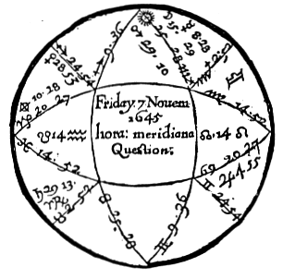

Compliments of http://mithras93.tripod.com

The Resolution of

slow in motion, or in any of the Dignities of the Lord of the 3rd, or placed in the 3rd, or in Sextile or Trine or Conjunction either with the Lord of the 3rd, or with a Benevolent Planet posited in the 3rd, or if the Moon Apply to the Lord of the 3rd, or to any Planet posited in the 3rd, or be in the 3rd, or cast her Sextile aspect to the Signe ascending, or her Square in Signes of short ascensions, in any house whatsoever, or if she be swift in motion, all, or any of these are arguments, that the party shall goe his short Journey, and with good successe; and if you would know to what part of Heaven the place lyeth whether he goe, consider the Signe of the 3rd house, the Signe wherein the Lord of the 3rd is, and wherein the Moon is, and judge by which of them is strongest in essentiall Dignities where he is; if the principall Significator be in a Northerne Signe, then his Journey is intended North, and so of the rest, with their due limitations.

196

Compliments of http://mithras93.tripod.com all manner of QUESTIONS.

In November 1645, a citizen of London being gone into the West of England, and no newes for many weeks had where he was, his owne Brother with great importunity moved me to give my judgment concerning these Particulars.

1. If living or dead? if dead, whether killed by souldiers? for at this time our miserable Kingdome was full of Souldiery.

2.

If living, when he should heare of him? and where he was?

3.

When he would come home?

CHAP. XXX

Judgment upon the preceding Figure.

The Ascendant doth represent the shape and forme of him that asked the Question, with consideration had to Saturn Lord of the Signe; and as both the Signe ascending and Lord thereof are of a dry quality and nature, so was the Querent, leane, spare of body, and a reall Saturnine man, &c.

Taurus is the Ascendant of the 3rd House, and Venus being Lady of the Signe, did represent the absent Brother, or party inquired after: the Moon in regard she neither applyed to one significator or other, had not much to doe in this Question, I mean in description of the parties..

For as much as Venus significatrix of the Quesited is no manner of way afflicted either by Mercury who is Lord of the eight in the figure, or by Mars who is Lord of the eight as to the Ascendant of the quesited, and that the seperation of the Moon was good, viz. from a Dexter of Jupiter, and her next application to a Conjunction of Sun, upon the Cuspe of Medium Coeli, I judged the absent Brother was alive and had no manner of casualty happened unto him, but was in good health. Having judged the man to be alive, there needs no proceeding to judgment of the rest of the first Quere.

197

Compliments of http://mithras93.tripod.com The Resolution of

When Heare of him.

You see Venus is Lady of the 3rd, and Saturn is Lord of the Ascendant; if you consider the Signes they are in, and the severall degrees of each Planet in the Signe; you shall observe, that as well the Significator of the absent Brother, who is Venus, as Saturn Lord of the Ascendant doe apply to each other by a friendly Trine; for Saturn though a ponderous Planet, yet being Retrograde and in more degrees of the Signe then Venus, does by Retrogradation apply to meet her: a very good argument that the Querent should heare newes of his Brother very suddenly; and if you looke into the Ephemeris of Eickstadius 1645, Nov.7, you shall finde the true time of the Trine aspect betwixt Saturn and Venus to be at five of the clocke the same day the Question was asked in the afternoon; but with reduction to our London Meridian a little after foure: I therefore advised the Querent to goe to the Carriers of those Countries where he knew his Brother had been, and aske of them when they saw the quesited; for I told him, it was probable he should heare of him that very day; upon the reason onely because the Significators of both parties met by a friendly Trine, He has since confidently affirmed, that about the very moment of time, viz.

about four, a Carrier came casually where he was, and informed him his Brother was in health and living.

Where He Was.

His Journey was into the West; at time of the question I find Venus the quesited his Significatrix, leaving Sagittarius a Northeast Signe, and entring Capricorn a South Signe: whereupon I judged he was in the South-east part of the Country unto which he went; and because Venus was not farre removed from the Ascendant, but was in the Oriental quarter of Heaven, I judged he was not above one or two dayes journey from London; and because Venus was departing the Signe Sagittarius, and entring the Signe Capricorn, wherein she has essentiall Dignities by Triplicity and Terme, I judged the man was leaving the country and place where he last was, and wherein he had no Possessions or Habitation, and was coming to his own house in London, wherein he 198

Compliments of http://mithras93.tripod.com all manner of QUESTIONS.

had good propriety; in regard that Venus wanted one degree of getting out of Sagittarius, I judged he would be at home in lesse then one week; for Sagittarius is a Bicorporeal, Common Signe, and one degree in that Signe, and in the nature of this question, might well denote a week.

But he came home the Tuesday following, when the Moon came to the body of Venus, she being then got into Capricorn to her owne Termes, and into her Diurnall Triplicity.

There being an amicable aspect betwixt the two Brothers Significators, viz. Saturn and Venus, these two Brothers alwayes did, and doe agree lovingly: This which has been said is enough concerning the judgment of this question; vary your judgment according to the position of your Significators and matter propounded, and by this method you may judge of anything propounded belonging to this 3rd house.

CHAPTER XXXI.

If a Report or common Rumour were

True or False.

In the yeer 1643, His Majesties Army being then Rampant, severall Reports were given out, that his Majesty had taken Cambridge, &c. a wel-affected person enquires of me, if the newes were true or false? Whereupon I erected the Figure ensuing, and gave Judgment, All that we

heard was untruth, and that the Towne neither was, or should be taken by Him or his Forces.

199

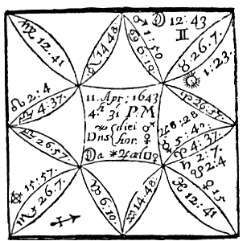

Compliments of http://mithras93.tripod.com

A Report that C A M B R I D G E was Taken by the King’s Forces; if true?

First, I considered that the Angles were all moveable, and that Mars did vitiate the cusp of the 10th, and Saturn the cusp of the 7th, one argument the Report was false.

Secondly, I found the Moon cadent, and in Gemini, a Signe wherein she nothing delights; a second strong evidence of a false rumor.

Thirdly, I found North Node on the cusp of the Ascendant, a Signe of good to the Parliment, for the 1st house signified that honorable Society: I found Venus Lady of the Ascendant, and our Significatrix, in her Exaltation; but Mars, Lord of our Enemies Ascendant, viz. the 7th, entering his Fall, viz. Cancer, and afflicted by Square of Saturn; I saw the Moon seperating from Jupiter, placed in the 7th and transferring his light and virtue to Venus, which gave me reason to expect, that there would come

200

Compliments of http://mithras93.tripod.com all manner of QUESTIONS.

good to us or our side from this report or Rumour, and no benefit to our Enemies: I saw Mars and Saturn in a Square, which assured me our Enemies were so full of division and treason, and thwarting one anothers Designes, that no good should come unto them upon this Report; and so in short, I judged Cambridge was not taken, and what we heard of its taking were lyes.

Had this question been propounded, Whether the Querent should have Brothers or Sisters? Then you would have converted the Judgment thus:

Scorpio –The Signe of the 3rd is a fruitfull Signe.

Cancer –Wherein the Lord of the 3rd is posited, is a fruitfull Signe.

Moon applies to Venus who is placed in a fruitfull Signe, as you may see page 89, where all these Signes are noted Prolifical, or Signes arguing fruitfulnesse; from hence you might have assured the Querent, he might have expected both Brothers and Sisters, or a plentifull numerous kindred; but more Sisters than Brothers, because all the Signes are Feminine, as you may see page 88, and Mars, Lord of the 3rd, is in a Feminine Signe; yet in regard the Moon who is Dispositor of Mars, is in Gemini, a Masculine Signe, and in Sextile platick with Jupiter, a Masculine Planet, Angular, and in a Masculine Signe and House, it’s an argument of the Demandant’s having a Brother or Brethern..

It was too nice a poynt in Art, to predict of the certain number, if we onely intend to satisfie our selfe in generall, leaving the disposing and determination of their certaine number to divine Providence.

The 3rd house is no wayes afflicted, or any ill aspects betwixt Venus, Significatrix of the Querent, and Mars Lord of the 3rd, both being in Signes of the same nature, and Moon Applying by a Square Dexeter in Signes of short ascensions, to Venus; Moon haveing been lately, and yet being within Orbs of the Sextile of Jupiter; there argue an agreement, concord and unity betwixt this Querent Kindred and him, and betwixt him and such Brothers or Sisters as he should in future have.

201

Compliments of http://mithras93.tripod.com The Resolution of

CHAPTER XXXII.

Of the FOURTH House, and the Judgment

depending thereupon.

This is the House of Parents, of Lands, Tenements, Hereditaments, Cities, Towns, Villiages, Farmes, Manours, Castles, Treasure-trove, or of any thing hid in the ground, &c.

To Find A Thing hid or mislaid.

Becareful to take your Ascendant exactly, and consider the nature of the Question, viz. whose Goods, or to whom the thing missing, or lost, or enquired after did appertaine; if the Goods be the Querents own Commodity, then see to the Lord of the 2nd; if it belong to the Brother or Sister, then have regard to the Lord of the 4th; if to the Father, the Lord of the 5th; if to the Mother, the Lord of the 11th, &c. and so in order, according to the nature of the Party who proposeth the Question.

If you find the Lord of the 2nd in any Angle, you may judge the thing lost, hid or missing, is within the house of him that demands the Question; and if the Lord of the 2nd be in the Ascendant, or in the Sign wherin the Lord of the Ascendant is, or in one of his houses, you may judge the things is in that part of the house which he himselfe most frequents, or wherein he doth most abide, or is conversant, or where he layeth his owne Commodities, or such things as he most delights in; but if the Lord of the 2nd be in the 10th house, it’s then in his Shop, if he be a Mechanick; if a Gentleman, in his Hall or Dining-room; if a Husband-man, in the ordinary common room of his house, or first room after entrance into his house: If the Lord of the 2nd be in the 7th, it’s in that part of the house where his Wife, or his Maid-servants have most to do in: If the Lord of the 2nd be

202

Compliments of http://mithras93.tripod.com all manner of QUESTIONS.

in the 4th, it’s where the most aged of the house doth lodge, or formerly did most frequent, or in the middle of the house, or in the most ancient part of the house, where either his Father or some ancient man lodged: The nature and quality of the place is knowne by the Signes the Significators are in;for if the Signe of the 2nd be alery, or the greater number of the Significators and Signe wherein Part of Fortune is, doth concurre, the thing is his in the Eaves or top, or upper part of that house or roome where it is, or on high from the ground: and if the thing hid be in the Field, or in a Garden or Orchard, it’s higher then the ordinary ground, or upon the highest hill or part of that ground, or hangs upon some stalk of a Plant or Tree.

If the former Significators be strong, and in watry Signes, it’s in the Buttery, Dairy or Wash house, or neer Water.

If in fiery Signes, it’s neer the Chimney, or where Iron is, or in, or neer the Wals of the house.

If in earthly Signe, the thing hid is on the ground or earth, under or neer some Pavement or Floor, and if you find the thing to be mislaid out of the house in any ground, it notes neer the Bridge or Stile where people come into the ground..

If your Significator be going out of one Signe and entering another, the thing is behind something or other, or is carelesly fallen downe betwixt two rooms, or neer the Threshold, or joyning together of two rooms, and is higher or lower in the place, according to the nature of the Signe, &c.

[What Part of the House or Ground.]

The Ancients have delivered many rules, and doe say, that to judge in what part of the house or ground the thing is in, you must see to the Lord of the hour, and if he be in the 10th house or 11th, you may say the thing is in the South part of the house, towards the East; and if he between the 4th house and Ascendant, then North-east: if he be between the 4th house and 7th, then North-west; If between the 10th house and the 7th, then Southwest This is and was the opinion of the former Astrologians, however, I have not found this judgment very exact, therefore I laboured to find a more certaine manner, and a more exact way for the 203

Compliments of http://mithras93.tripod.com The Resolution of

ready discovery or finding out anything mislaid or missing in the house, and not stolen: and it was thus:

First, I considered the Signe ascending, it’s nature, the quarter of Heaven it signified.

Secondly, what Signe the Lord of the Ascendant was in. The Signe of the 4th house.

The Signe the Lord of the 4th was in.. What Signe the Moon was in..

The Signe of the 2nd house.

The Signe the Lord of the 2nd was in.. The Signe Part of Fortune was in.

I considered the quality of the Signe, as to shew what part of the house it was in; I mean, what quarter, whether East, West, North or South, according to the greater number of testimonies: and you must know, for things lost, mislaid, or fugitives, there are the true quarters of Heaven the Signes signifie.

Ari. - East,

Leo - East by North,

Sag.- East by South

Lib. - West,

Gem.- West by East,

Aqu.- West by North

Can..- North,

Sco. - North by East,

Pis.- North by West

Cap.- South,

Tau.- South by East,

Vir.-South

by

West

Having found the quarter of Heaven, the nature of the Signes showed me also the quality of the place in the house, viz.. aiery Signes, above ground; fiery Signes, neer a Wall or Partition; earthly Signes, on the Floor; watry Signes, neere a moyst place in the roome, &c. A few experiments I know may better this Judgment: I have sometimes in merriment set a present Figure, and by that discovered in what part of the house the Glove, Book or any thing else was hid, and found the rule very true.

CHAP.

XXXIII.

Of Buying and Selling Lands, Houses, Farmes, &c.

Give the Ascendant and Lord thereof, and Planet from whom the Moon is separated to the Querent or Buyer.

Give the 7th house the Lord thereof, and the planet to whom the Moon applyes to the Seller.

204

Compliments of http://mithras93.tripod.com all manner of QUESTIONS.

Give the 4th house, the Planet therein placed, and the Moon and the Lord of the 4th house to the House, Ground or Mannour to be bought or purchased..

Let the 10th house, a Planet or Planets posited therein, and Lord of that house signifie the Price, that is, Whether it will be sold cheap or deer.

[If Agree.]

If you find the Lord of the Ascendant and Lord of the 7th in any amicable aspect, the Lord of the 7th applying to the Lord of the Ascendant, you may judge the Seller hath good will to Sell and to deale with the Querent or Buyer: and if the Significators be in any essentiall Dignities upon this their application or translation of light; or their application be by Conjunction, it’s then probable they will agree and conclude upon the Purchase with little labour: if the application or translation of light be by Square or Opposition, the two Parties will at last bargaine, but with many words and probabilities of breaking off, and after much expense of time.

Consider also, if the Lord of the Ascendant or the Moon apply to the Lord of the 4th, or the Lord of the 4th or the Moon to the Lord of the Ascendant, and whether only the Lord of the 4th apply to the Lord of the Ascendant, and he receive him in any of his Dignities, or if the Lord of the Ascendant be in the 4th, or the Moon, or the Lord of the 4th in the Ascendant, then shall the Party enquiring buy the House or Inheritance at that time in question, But if this dwelling in houses be not, yet if the Moon transferre the virtue or light of the Lord of the 4th to the Lord of the Ascendant, the Bargaine will be concluded, but rather by Messengers or Brokers, than by the personall treaty of the two principall Agents.

If there be no application or translation, or transferring the light of one Planet or another, it’s not like there will be any Bargaine concluded..

Of the goodnesse or badnesse of the Land or House..

[House or Land, good or ill.]

If you find in the 4th house the 2 Infortunes, very potent or peregrine, or if the Lord of the 4th be Retrograde or

205

Compliments of http://mithras93.tripod.com The Resolution of

unfortunate, or in Fall or Detriment, ‘twill never continue long with your Posterity..

But if either Jupiter, Venus or North Node be in the 4th, or the Lord of the 4th in his owne house, viz. in the 4th, the Purchaser may expect good successe in the Land or House now in buying, and that it may continue a long time with his Posterity, and it’s an argument he shall have good encrease for his Money by that Bargaine.

[Quality of the ground.]

If it be arrable land, and you would know the nature of it, make the ascendant the Significaton of the Tenants, Husband-men and Farmers occupying it.

The 4th house shall signifie the condition and nature of the soyl, its form and condition; or of a House or Houses, when the Question is for them.

The Angle of the West shall signifie the Herbage thereof, and the quality and quantity, but the Medium Coeli is Signifier of the Wood, Trees and Plants growing thereupon..

[Tenants, good or ill.]

It an Infortune possesse the Ascendant, the Tenants or Occupants are ill, deceitfull and unwilling the goodnesse of the ground should be discovered: if a Fortune be in the Ascendant judge the contrary, viz. the Tenants are honest men, and doe give, and will give the Land lord content, and will love him besides, and are content to hold what they have already, and to occupy the Land still; but if an infortunate Planet be in the ascendant and direct, the Tenants will purloyne the Woods, or weare out the virtue of the land; but if he be Retrograde, the Tenants wil put the land upon the Landlord, or will run away or throw up their Leases.

[Wood on the ground.]

If a Fortunate Planet be in the Mid-fleaven and Direct, say there is good Timber upon the ground, and good store; if the Fortune be Retrograde, judge there are many Trees, but little Timber, and those lopt, or that of late the Seller hath sold many, or made much spoyle thereof, or that the Trees are much decayed, &c.. if an Infortune be in the Medium Coeli, direct, there’s then but few Trees; if he be Retrograde, say, the Country people have stolne, or made great wast thereof,

But if no planet be in the Mid-heaven, see to the Lord of that house, if he behold it with a good aspect, and be in any of his

206

Compliments of http://mithras93.tripod.com all manner of QUESTIONS.

owne Dignities, say there is some Wood on the ground; if he does not behold the Mid-heaven, either there is little or no Wood, or it is North nothing; if the Lord of the 10th be Orientall, and behold his owne house, the Trees are young ones, or the Wood of small growth, or there are Copses: but if the Lord of the 10th be Occidentall, and in the condition beforesaid, the Trees are of more growth, and the Wood is ancient; and if the Lord of the 10th be then direct, the Trees are found, and will continue so a long time; but if Retrograde, there’s many Trunks and hollow Trees among them..

Having considered what precedes, consider the Angle of the West, or the 7th house, which will declare unto thee the state and quality of the Herbage, or smaller Plants of the ground, for if you find either Jupiter or Venus, or the Lord of the 7th in the 7th, it’s an argument the Land yeelds plenty of Grasse, Come, or what is reasonably required from it, if an Infortune be there, judge the contrary, &c.

[Quality of the ground.]

In consideration of the property of the earth, have respect to the 4th house and Signe of the 4th, for if Aries, Leo or Sagittarius be on the cusp of the house, it’s hilly, mountainous, dry and hard piece of ground, or a great part of it is so; if either Taurus, Virgo or Capricorn be on the cusp of the 4th, the ground is plaine, champion, and excellent Pastorage, or good for Grazing or Tillage.

If Gemini, Libra or Aquarius, it’s neither very hilly or very plaine (flat), but there is grounds of both types, and in nature part of it is good, and part not so: if Cancer, Scorpio or Pisces, then there is no doubt but there is some pretty River, Rivolet, or good store of Water.

You must for the perfect knowledge of the quality and nature of the soyle, observe this generall rule, That if an Infortune be in the Signe of the 4th, Retrograde, or in his Fall or Detriment, the land shall partake highly in the infelicity that Planet signifies; as if Scorpio be the cusp of the 4th, and Saturn is place therein, and is either Retrograde or afflicted by some other Misfortune, you may confidently averre, the ground is troubled with too much Water, or it’s Boggy and unwholesome, full of long rushy Grasse, &c.

And if the Land lye neer the Sea, you may feare the excursion of the Sea, or a decay in the Sea-banks, or it is subject to be overflowne with the River or Water, &c. if Saturn afflict a fiery 207

Compliments of http://mithras93.tripod.com The Resolution of

Signe in the 4th, the Land is barren, stony nungry, mountainous, yeelds no profit without infinite labour, wants water, for it’s naturally barren, produces little Grasse: If Saturn afflict the sign of Gemini, by his presence there, or any of the humane Signes, viz. Libra or Aquarius, by his retrogradation, that Signe being the cusp of the 4th, there’s yet defect in the goodnesse of the Land, and ill Husbands have formerly managed it unthriftily: If he be unfortunate in an earthly Signe, upon the Signe of the 4th, the Land is good, but the present Occupiers give it not its due Tillage, or are not in the right way in their managing it, they are idle, lazy, slothfull, penurious, and unwilling to bestow cost upon it; besides, it’s an heavy clay ground, and the Farmers understand not the nature of the Soyl, &c.

[Cheap or Dear.]

This is knowne by the Lord of the 10th, for if he be Angular, Direct, and strong in essentiall Dignities, the price will be high, and the Seller will put it off at deare rates; but if the Lord of the 10th be cadent, retrograde, slow of motion, afflicted, then the price will not rise high.

If it be good to hire or take the Farme, House or Land Desired.

Give the Ascendant and his Lord to the person of him that would hire a House, or take Lands.

Let the 7th house and his Lord signifie him or her that hath the letting or selling of this House or Farme.

Let the 10th house and the Lord thereof signifie the Profit which may arise by that undertaking.

The 4th house, and Planets therein placed shall shew the end which shall ensue upon taking, or not taking the House, Land or Farme, &c. be it what it will be.

If the Lord of the Ascendant shall be in the Ascendant or Signe ascending, or shall have a Sextile or Trifle aspect unto the Signe ascending, but more properly to the degree ascending, within the moyity of his owne Orbs, or if in the Ascendant there be a Fortune, whether essentially dignified or not, or if Part Of Fortune be therein placed, and not impedited, it’s an argument or 208

Compliments of http://mithras93.tripod.com all manner or QUESTIONS

testimony the Farmer shall take the House, Land or Farme, and is full of hope to doe good thereby, or that it will be a good Bargaine, and he obtain much profit thereby, and that he hath much liking to the thing, and is well pleased therewith.

But if an Infortune be in the Ascendant (it’s no matter which of them) if the man have taken the thing ere he come unto you, it now repents him; if he have not taken it already, he has no will thereunto; or if he does take it, he will presently post it off to some other party, for he nothing at all earns for the Bargaine.

Having considered what belongs to the party intending to buy or take a Lease, have now recourse to the 7th house, and Lord thereof, for him that shall let it: If you find the Lord of the 7th in the 7th, or casting a benevolent aspect to the cusp of the house, or find a fortunate Planet therein, the man will keep his word with you, you shall have what you bargaine with him for, but he will profit by the bargaine.

If an Infortune be in the 7th, and not Lord of the 7th, have great care of the Covenants and Conditions to be drawne betwixt you, the Landlord will be too hard for you, he minds nothing but his owne ends in dealing with you.

Consider the 10th house afterwards, and if a fortunate Planet be therein, or behold the 10th house, the parties notwithstanding some rubs, will proceed in their Bargaine, and the House, Farme or Lands will be let to the Querent.

But if you find an Unfortunate Planet in the 10th, or behold that house with an Opposition or Square aspect, there will be no house or Lands taken; and if it be Land that is in agitation to be let, it’s probable they differ about the Wood or Timber on the ground, or upon the new erecting of some houses or building upon the ground; or if it be a house, they differ upon the repaires thereof.

As to the end of the businesse, see to the 4th house, and let that signifie the end thereof; if there be a Fortune therein, or if the Lord of the 4th be there, or behold the house with Sextile or Trine, there will come a good end of the matter in hand, both parties will be pleased: but if an Infortune be there, in conclusion, the Matter, bargain or thing demised wil neither please the one party or other.

209

Compliments of http://mithras93.tripod.com The Resolution of

CHAP. XXXIV.

If the Querent shall enjoy the Estate of his Father.

You must in this Question give the Ascendant and Lord thereof to the Querent; the 4th house, Lord thereof and Planet posited in the 4th for the Significator of the Father; the personall Estate or Goods moveable of the Father are signified by the 5th house, his Lord, and any Planet accidentally placed in the 5th; if in this Question you find the Lord of the 2nd and Lord of the 5th in reception, the Lord of the 5th being in the 2nd, and the Lord of the 2nd in the 5th, there’s no doubt to be made but the Querent shall have a competent fortune out of the Estate of his Father; but if it happen that the Lord of the 5th house be Retrograde, or in some bad aspect of any malevolent Planet, then some part of that Estate the Father intends for the Querent, will be wasted or otherwayes disposed of by the Father; and if you enquire wherefore or upon what grounds, or who shall be the occasion of it? then see what Planet it is that impedites the Lord of the 5th, either by Square or Opposition, or if it be the Sun by Combustion, what house he is Lord of; if it be the Lord of the 6th, it’s probable it is one of the Fathers Brothers or Sisters, or some of his Tenants or Neighbours that will perswade the Father to alter his intention, and to diminish part of what he did formerly intend to doe: If it be the Lord of the 7th, it is some Woman or Sweethart, or one the Querent hath been sometimes at variance with, that will withdraw the Parents intention: If it be the Lord of the 12th, it’s some sneaking Parson or Parish Priest, or some or other of the Mothers Kindred; now if upon the description of the Party, the Querent is well informed of him or her who it is, and he is desirous to obtain this parties favour or good will, that so he may be lesse malicious unto him, let him then observe, when the Planet who impedites, and the Lord of the Ascendant, are approaching to a Sextile or Trine or Conjunction, and that day that in the Ephemeris he shall find the Moon seperating from the one, and applying to the other, let him, I say, about or at that time endeavour a reconcilement, and it’s 210

Compliments of http://mithras93.tripod.com all manner of QUESTIONS.

not to be doubted that he may obtaine his desires, as I have found many times by good experience.

If the Lord of the 5th dispose of Part of Fortune, and be in the Ascendant or 2nd, the Querent shall obtain his desires which he expects from his Father.

If Jupiter or Venus out of the 5th house cast their benevolent aspects to any Planet in the Querents 2nd, it argues the same.

If the Moon separate from the Lord of the 5th, and either have presently after a Sextile or Trifle to the Lord of the 2nd, or of the Ascendant, it shows strong and assured hopes of aquiring the thing demanded of the Father.

If you find an Infortune in the 4th, not having Dignities there, then you may say the Father hath little left to part with his Money, nor will it be good to move him much, untill that unfortunate Planet be transited out of that Signe; but if you cannot stay so long, observe when that unfortunate Planet is Direct, Swift in Motion, Orientall, and in Sextile or Trine with Jupiter or Venus, or with the Lord of the Ascendant, and then let the Father be moved in the businesse: This I write, where the Querent would have present meanes, and cannot conveniently stay the Fathers leizure: nor do I write, that the observation of those times doe themselves enforce the mind or will of the Father, but that then at those times there’s more benevolent inclinations.

If you find the Lord of the 2nd and the 5th, applying by Retrogradation to any good aspect, the Querent will receive some Estate from his Father suddenly, ere he be aware, or when he least thinks of it: now to know, whether the Father love the Querent better than any of his Brothers or Sisters, you must observe, whether the Lord of the 3rd, or any Planet in the 3rd be neerer to, or in better aspect with the Lord of the 4th, then the Lord of the Ascendant is, or if there be any reception betwixt them, viz. the Significators of Brothers and Sisters, or translation of light, and none betwixt the Lord of the Ascendant and the Lord of the 4th, You may then be assured, the Fathers affection stands more to another then to the Querent; the Planet neerest in aspect to the Lord of the 4th, shews the party or person beloved, so do the most powerfull reception of Significators.

211

Compliments of http://mithras93.tripod.com The Resolution of

CHAP. XXXV.

If Good to remove from one house or place to another, or to stay or abide in any place or not?

See to the Lords of the Ascendant, the 4th house and 7th house, for if the Lord of the 4th be in the 7th, and be a good Planet, and the Lord of the 1st and 7th be good Planets, or strong in that part of Heaven where they are, or in the whole Figure, if they be Direct, and of swift motion, and in good aspect with good Planets, it is good then to abide still and not remove from the place where the Querent is; but if the Lord of the 7th be with a good Planet, and the Lord of the 4th with an evill one, it is then not good to stay, for if he doe, he shall receive much damage there: That which I have observed in this manner of Judgment was this; That if the Lord of the Ascendant did lately separate from the Square or Opposition of the Lord of the 6th, 8th or 12th, and the Moon also did concure in judgment, viz. if she separate from any evill aspect of the Infortunes, they being Lords of either the 7th or 4th &c. and not Friends or Significators in the person of the Querent; or if I found an Infortune in the Ascendant, Peregrine or Retrograde, or if a Peregrine or unfortunate Planet was in the 4th, or if the Lord of the 2nd was weak or ill posited, I advised the Querent to remove his habitation, and gave him reason why he should; for if I found the Lord of the 6th house in the Ascendant, or afflicting the Lord of the Ascendant, I judged he had his health very bad there, was sickly, or tormented with ill servants, by whose meanes he did not thrive in his Vocation.

If the Lord of the 12th afflicted the Lord of the Ascendant or the Moon, I said he had backbiting, evill or slanderous Neighbours, or people that lived not very farre from him did scandalize him: If the Lord of the 2nd was unfortunate, or in Square or Opposition to the Lord of the Ascendant, or if Part of Fortune was in the 12th, 8th or 6th, I judged he went back in the world, and his Estate consumed.

If his Significator, viz. if the Lord of the Ascendant was 212

Compliments of http://mithras93.tripod.com afflicted by the Lord of the 10th, I acquainted him, his Reputation was lost, his Trade decayed, or had no Trading; and if the Lord of the 4th was unfortunate, or the 4th house itself, I judged the house was unlucky, and few that had lived therein did thrive, or that the Repaires of the house had much weakened him, r the house stood not conveniently for his Trade]. If the Lord of the 7th afflicted the Lord of the Ascendant or 2nd, his overthwart Neighbours had all the Trade, were better furnished with Commodities, &c. Now in giving direction which way to steer his course, in hopes of better Trading, I observed what Planet in the Scheame was most fortunate and strongest, and had the most friendly aspect to either the Lord of the Ascendant or Lord of the 2nd, look what quarter of Heaven the Signe that Planet was in did signifie, to that part did I ever advise the Querent to remove; and I remember not, that any ever repented their following my advice; many have afterwards returned to me thanks and rewards.

And whereas I mention these words (perhaps the house was unluckie) some may cavill at the words, and say,God’s blessing is alike in all places, and it’s superstitious to judge, a house that is not a living thing, can be made unsuccessfull or unfortunate, &c.: Let them enjoy their opinion still; there’s not a man in this world lesse superstitious than my selfe, yet what I have found by experience, I freely communicate, and doe remaine of this opinion; That in what house any execrable facts are committed, the ministring of Angels of God feeling the villany done in that house, and the dishonor done to God therein, doe accurse that place or house; which continues so long, as there is not a full expiation made by some godly person, for the sinnes committed in that house; or untill the time limited by the angry Angel be expired, the house shall remaine a most unfortunate house for any to live in: And this which I write, and is inflicted upon houses which are insensible, I assuredly know is preformed to the full upon the great and smaller Families of this world, &c. How in a naturall way to discharge these curses, Sunt Sigilla & Lamina quae nec Scripta Sunt,& ego novi.

But some for resolution of this Question, say, if the Moon separate at time of the Question from Jupiter or Venus, then

213

Compliments of http://mithras93.tripod.com The Resolution of

stay; if she separate trom an Intortune, remove; or a Fortune in the Ascendant bids you stay; an Infortune remove: This heedfully considered with the preceeding Judgment, will instruct any indifferent Astrologer to reslove the preceding Question concerning removing from one place to another.

CHAP.

XXXVI.

Of turning the course of Rivers, or bringing Water into ones Ground or House, either by Conduit or Pipes.

In this manner of judgment, you must principally consider the position and strength of Saturn and the Moon, and in what aspect they or either of them are in, either with Jupiter or Venus; for if you find Saturn Direct, Swift in Motion, Orientall, and the Moon in the 3rd, 11th or 5th house, without any aspect either good or evill to Mars, it’s an argument, the Work that is to be undertaken will have good successe, be brought to a good conclusion, and that the Querent will have prosperity and credit by it, and the matter easily performed; and this the rather, if the Moon apply to that Planet who is Lord of the Signe wherein she is, and he receive her in any of his Dignities; and if that Planet who is receiver of the Moon be a Fortune, and is ascending in his latitude, and in a fixed Signe, the Querent shall not need to feare, but that there will be water enough, and that it will run plentifully, and the Water-course will long continue: if there be in the 10th house either Jupiter or Venus, but especially Jupiter, it’s a sure argument the River, Channel, Conduit, Pipe or Water-work shall remaine many a yeer.

In further consideration of this judgment, if you find Saturn in the 11th, very strong and potent, and the Moon in Sextile or Trine unto him, and the Dispositor of the Moon in a fixed Signe, or a common one, or the Moon her self e in one of those Signes producing Raine, which are Cancer, Leo, Aquarius, Pisces.

All these arguments, that in the work you are in hand with, you shall have a good Current, and plenty of Water; but if you find an infortunate Planet in the 10th, it’s probable your Pipes will 214

Compliments of http://mithras93.tripod.com break, your Water-course be subject to ruptures or breaking downe of the Banks, the Water will not run constantly, that the Plot is ill laid, nor is there any successe promised to the undertaker or undertakers, by that present imployment.

CHAP. XXXVI I.

Of Treasure lying hid in the Ground, or to be digged out of the Earth.

The resolution of this Question is various, according to the nature of its propasall, or according to the nature and quality of the thing enquired after, viz. whether Money, Plate or Jewels, or things easily movable, or for Treasure long since obscured or hid, the Querent not knowing what it is: or if it be, whether there be any Mine of Gold, Silver or Iron, or any other minerals in the Ground, Mannor or Lordship now questioned; then it is requisite to know whether the Querent did hide or obscure this Treasure now enquired after, or whose it was, or what relation the party that did so had unto him, or whether that he aske in a generall way of Treasure hid, not being able to discover either when, where, or whose, or what it is?

If the Querent did hide his own Plate, Money or Jewels in any part of his Ground, or in his house, and hath forgotten whereabouts, you must herein observe the Signe of the 2nd house, the Lord thereof, what Signe and quarter of Heaven he is in, as also, the Signe of the 4th and his Lord, and what quarter of Heaven they signifie: the Lord of the 2nd and of the 4th in Angles, the Plate is still in the house, or in the ground, and not removed; but if these Planets be not in Angles, but an Infortune, without dignities, be either in the 4th or 7th, there’s then either part of it, or all removed and made away; and if your Figure promise, that your Goods are not removed, to find in what part they are, have recourse to the first Chapter of this house concerning things hid, &c.

If the question be concerning Treasure absolutely, without knowledge whose or what it was, viz.

whether there be any in the

215

Compliments of http://mithras93.tripod.com The Resolution of

place or ground suspected, yea or no; observe in the Figure whether Jupiter or Venus or North Node be in the 4th house, there’s then probability of Treasure being there; if they be there and in their owne houses, the matter is without dispute, and you may be sure there is Treasure, or something of value in the house or ground suspected; or if you find either Saturn or Mars in any of their owne houses, Direct, and without Impediment, and in the 4th, there is also Treasure, or if you find Venus in Taurus in the 4th, not labouring with any misfortune, it’s probable there is Treasure there, for you must know there is no Planet unfortunate, when he is in his owne house, or essentially dignified, and a Significator.

If you are ignorant of the nature and quality of the Treasure, or thing obscurred, then see to the Planet who signifieth the Treasure, and consider if he be Lord of the 7th house and examine his nature and property, if he be so; if he be not Lord of the 7th, joyne the Lord of the 7th in judgment with him, so frame a mixture for the quality of the thing.

But if that Planet who is Significator of the Treasure be not Lord of the 7th or have affinity with him, then absolutely take the Lord of the 7th to signifie the nature and Species of the Treasure; who if he be the Sun, and he in his house or exaltation, there is Gold there, or precious Stones or Jewels of that colour, or neer to the colour of the Sun.

And if the Question were, Whether there were a good Mine yea or no? the place considered, it’s like there is; if the Sun be not so well dignified, and yet signifie the Treasure, it’s then somewhat very precious, and neere to Gold in goodnesse.

If the Moon be in her owne house or exaltation, and be Lady of the 7th, the Treasure is Silver, Plate, Crystal or Jewels &c. of the colour she is of, &c.

If Mars be the Lord of the 7th, and so dignified, he shewes, the thing sought after may be Brasse or Glasse, or some Curiosities or Engine of Iron &c. but if he be weak, perhaps you may find some old rusty Iron, Candlesticks, Kettles &c. If the Question were about the Iron-stone, it’s probable it will prove good Iron-216

Compliments of http://mithras93.tripod.com all manner of QUESTIONS..

stone, and make good Iron. If Saturn be Lord of the 7th, and fortified as before specified, there’s some Antiquities of great account, or ancient Monuments of men long since deceased, some Urne, &c. or there are some things wrapt up in old blacke Cloaths, or woodden Boxes: and if the Question were concerning any Mine or quarry of Stone, then it’s very probable there is a rich Mine of Coles, if the Question were concerning Coles, or of good Stone, if the Question were of it: but if Saturn be weak, and ill dignified, then neither is the Mine a rich one, or can it be wrought without much expense of Treasure; whether it be full of water, or what may be the impediment, you must require from the Signe he is in, well considering what was formerly said in this Chapter.

If Jupiter be Lord of the 7th and essentially fortified, there is Silver or very rich Cloth, and great store of it, or Tyn, &c.

If Venus be Lady of the 7th, she intimates curious Householdstuffe, costly Jewels, or that fine Linnen is there hid..

If Mercury be Significator, he prenotes some Pictures, Medals, Writings, Books, some pretty Toyes are obscured, or are the Treasure looked after..

If the Querent shall obtaine the Treasure hid.

If the Planet who Signifies the Treasure or thing hid, doth apply to the Lord of the Ascendant, or if there be mutuall reception or translation, or collation of light and nature between them, it’s probable the Querent shall obtaine the matter sought after; if the aspect be by Square or Opposition, then not without difficulty and much labour; and the more assuredly, if they be in a fixed Signe, and posited in the Querents 2nd house, or in the Ascendant, either of the Luminaries placed in the Ascendant and not unfortunated, gives great faculty in the Work; but if neither of them be in the Ascendant, or behold it, but be both in cadent houses, there remaines little hopes in the matter: When Part of Fortune is in the Ascendant, and also his Lord or Dispositor, it promises acquisition of the Treasure: but if the Lord of Part of Fortune be cadent, and both the Lights, especially the Moon, and have no aspect to the Part of Fortune, 217

Compliments of http://mithras93.tripod.com The Resolution of

or the Lord of the Ascendant behold not the Ascendant I can give the Querent then no hope of obtaining the Treasure or thing hid: Alkindus giveth this generall rule concerning Treasure, or anything obscured in the ground; Erect your Figure aright, consider the severall aspects of the Planets, if there be in the Ascendant, or in any Angle a Fortune, say, there is Treasure in the ground, and that the thing hid is still in the ground, the quality, price, esteem thereof, shall be according to the potency, vertue or debility of the Fortune.

If you find the thing hid to be unremoved, then he proceeds and saith, behold the Lord of the Ascendant and the Moon, if there be any good aspects betwixt them, and that Fortune which signified the Treasure to be there, viz. a good aspect and reception, he that demands the question shall then have the thing enquired after, &c. He further says, that fixed Signes shew the thing is hid in the Earth, common Signes in or neer a Wall, moveable Signes on high, or in the covering of houses: whether it lye deep in the earth or not, consider if the Planet Significator, be in the beginning, middle or neer the end of the Signe; if he be newly entered the Signe, the Commodity is not deep, but shallow, neer the upper part of the earth; the further the Planet is in the Signe, the deeper, when you would dig, let not the Infortunes be angular, but if possible, the Significators applying by Sextile or Trine to the Lord of the 2nd house, and the Moon seperating from the Significator of the Treasure, and applying to the Lord of your Ascendant 218

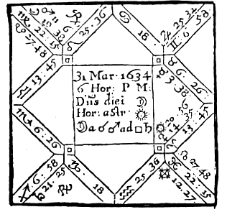

Compliments of http://mithras93.tripod.com

all manner of QUESTIONS.

CHAP.

XXXVIII.

If I should purchase Master B. his houses.

The Inheritance of the house wherein at this present 1647, I live, and some others being proffered me to buy 1634. I had a desire to know if I should deal with the Seller and procure Moneys in convenient time to pay for the Purchase, (my owne Money being in such hands as I could not call it in under six moneths warning) being desirous, I say, to purchase the said houses, and fully resolved upon it, I took my own Question my selfe, at what time I found my mind was most perplexed and solicitous about it; the time of my Quere to my selfe fell out according to the position of Heaven aforesaid.

219

Compliments of http://mithras93.tripod.com The Resolution of

The Signe Ascending is Libra, the degree of the Signe is the same wherein Jupiter was in my Radix; I looked upon that as a good Omen in the first place..

Venus is for my selfe, the Sun locally placed in the 7th is for the Seller; the Sun receives Venus in his Exaltation; besides, Venus is neer the cusp of the 7th, and no other Planet in the 7th Sun excepted, which signified, there was at present no other purchaser about it but my selfe: the Sun so exalted and angular prenoted the Seller to be high in his Demands, (and so he was) nor was he necessitated to depart with it: finding, I say, my Significator received of Sun, and so neer to the cusp of the Angle of the West, it was an argument I should proceed further in the matter, notwithstanding Venus her many Debilities; for as I found Sun Lord of the 7th, so also was he Lord of the 11th, signifying my hopes should not be frustrated: besides, Venus was Applying to a Trifle of Saturn, Lord of the 4th, viz. the houses enquired after, and had no abscission or frustration ere the perfect aspect; a main strong argument I should buy the houses: and indeed both Significators strongly applyed to a Trine aspect viz. Saturn and Venus, for Saturn is Retrograde: I also considered the Sun was in perfect Trine with Saturn, the Sun being, as I said, Lord of my 11th, and he of the 4th; Saturn has also signification of me, as Querent, because he beholds the Ascendant, and therein has exaltation: now whether you consider him, as having Dignities in the Ascendant, or as Lord of the 4th, the Lord of the 11th and he Applying unto each other by a Trine, argued, assuredly I should proceed further in the matter, and in the end conclude for them: The Moon in the next place translating the influence of Mars, who hath Dignities in the 7th, to Saturn, having vertue in the Ascendant, though by a Square aspect (yet out of Signes of long ascensions) did much facilitate the matter, and argued my going on, and probability of contracting, but with some leisure, and slowly, because of the Square aspect; for as the Moon is afflicted, and Venus unfortunate, so had I much to doe, and many meetings about it; the Seller not abating one penny of the five hundred and sixty pounds, being the first penny he demanded: As the Sun is neer to a Sextile aspect of Jupiter, so did a joviall man endeavour to procure the purchase unto himselfe (this was after I had begun and before I had concluded); but Jupiter is cadent, and in detriment, shewing he should not prevaile, Venus angular and in 220

Compliments of http://mithras93.tripod.com all manner of QUESTIONS.

aspect with Saturn Lord of the thing sought after; and as Sun is Lord of the 11th, which is the 5th from the 7th, so a Daughter of the Sellers was my very good friend in this businesse, and suffered no interloper to intervene, though some offered fair (to hinder me); for Mars in my 2nd house Retrograde, argues I should get none of my owne Monies to supply my occasions; nor did I: Jupiter Lord of the Part of Fortune in Sextile with Sun no wayes impedited, but by being in detriment, in Sextile Platick with Venus Lady of my Ascendant, shortly entering his exaltation, gave me such hopes as I doubted not of procuring Monies when he entered Cancer, and Mars became direct, which he did 12 days after, at what time a friend lent me 500 L. The quality of the houses are signified by Capricorn the Signe of the 4th, and Saturn Lord of the 4th, who having no materiall debilities, except Retrogradation and Cadency, also being in Trine with Sun; the houses were really old, but strong and able to stand many yeers. When Venus and Sun came to Conjunction in Taurus, that day I bargained, viz. die Venus 25 Aprill following: the 17 of May Venus and Moon in Conjunction; I paid 530 ₤, and my conveyance was Sealed. So that as Venus wanted 6 degrees of the body of the Sun, so was it 6 weeks and some dayes from the time of the question ere I perfected what the Figure promised; as to the Moles and Scars of my body it does exactly agree: for as Venus is in Aries, which represents the face, so have I a Mole on my Cheek about the middle or it; and as Libra Ascends, I have one on the reines of my backe, the Moon in Virgo Afflicted by Mars, I have a red Mole below my Navell, Jupiter Lord of the 6th in Gemini a Masculine Signe, I have a Mole neer my right hand visible on the outside; so have I on the left foot, as Pisces the Signe of the 6th does represent. Many things might be considered herein, besides what is written; but I feare this book will increase beyond my first intention: Ergo. The truth of the matter is, I had a hard bargaine, as the Figure every way considered doth manifest, and shall never live to see many of the leases yet in being, expired: and as Venus is in Aries, viz.

opposite to her owne House, so did I do my self e injury by the Bargaine, I mean in matter of Money; but the love I bore to the House I now live in, wherein I lived happily with a good Master

221

Compliments of http://mithras93.tripod.com The Resolution of

full seven yeers, therein obtained my first Wife, and was bountifully blessed by God with the Goods of this World therein, made me neglect a small hinderance, nor now, I thanke God, doe I repent it; finding Gods blessing in a plentifull measure upon my Labours: yet was I no Taylor or Scriverner, as Wharton affirmes, or indeed any profession at all; nor was my Master a Taylor, or my Wife a Scriveners Widdow.

Of the FIFTH HOUSE, and its

Questions

CHAP. XXXIX.

If one shall have Children, yea or no?

When this question is demanded by a man or woman, long before marriage, or by some ancient Batchelour or Maid, Whether they shall have any Child or Children, yea or not? herein generally you are to consider, whether the Signe upon the 5th, or Ascending, be of those we call Fruitfull, yea or no, (viz.. Cancer, Scorpio, Pisces) and whether the Lord of the Ascendant (be the Signe what it will) or the Moon be in aspect with the Lord of the 5th house, and that aspect be either Conjunction, Sextile, Trine or Square (though Conjunction is not properly an aspect) which if it be so, and the Planet to whom the Lord of the 5th doth Apply, or is in aspect with, be free from Combustion, and other Accidentall or Essentiall misfortunes, it’s an argument the good old Batchelour or stale Maid, or whoever propounds the Question, shall have Children or Issue ere they dye; In like case judge, if the Lord of the 5th be in the Ascendant, or else the Moon, or the Lord of the Ascendant or the Moon apply to the Lord of the 5th, yet if there be rendering of vertue or light one unto another, or translation of collection by or from the principall Significators, you may still continue your judgment, 222

Compliments of http://mithras93.tripod.com all manner of QUESTIONS.

that the Querent shall have issue, but not so scone, as if it had been forseen by the first manner of judgment. After all this, have respect to the Planet who is receiver of the Disposition of the Significators; who if he be clear from misfortune or affliction, viz. from Retrogradation, Combustion, or Cadency in House, it gives great hopes of issue.. See also if that Planet from whom the Moon is separated the Lord of the 5th Signe from the Signe wherein the Planet is to whom the Moon applies, and both these Planets have any aspects to each other; that also doth testify the party shall have Children or a Childe. If no aspect happen betwixt them, it’s not then likely he will have any; and yet some say, that is the above named Planets or Significators be not in any Aspect, yet if the Planet to whom the Moon Applies be in an Angle, the Querent may have Issue.

If a Woman aske, whether she may conceive?

Many times a Woman married, having been long without Children, may inquire, whether she is like to Conceive, yea or no? In this Question you are to consider: If the Lord of the Ascendant be in the 7th, or the Lord of the 5th in the 1st, or the Lord of the 1st in the 5th, or if the Lord of the 5th be in the 7th, or the Lord of the 7th in the 5th, or the Moon with him, or good Planets in the Ascendant, or with the Lord of the 5th, or in any of the Angles; she may then conceive:

but if none of these testimonies concurre, and you find barren Signes and ill Planets to be in the former places, she neither is at present conceived, or will thereafter conceive. If good and bad Planets be mixed together, she may perhaps conceive or have Children, but they will not live: If Cancer, Scorpio or Pisces be in the Ascendant or 5th, she may have Children; but if Leo or Virgo be there, she neither is at present, or hardly after will be with Child. When women have been long without Children, and propound such a Question, see if their Nativity did not originally deny Children..

At what time, or how long it may be before she have a Childe?

If you finde that according to naturall causes she may have a Childe or Children; and the Querent is desirious to know neer

223

Compliments of http://mithras93.tripod.com The Resolution of

what time: See then where you find the Lord of the 5th house, viz. if in the ascendant or 1st house; then judge the 1st yeere; if in the 2nd house, the 2nd yeere; if in the 10th house, the 3rd yeere; if in the 7th house, the 4th yeere; if in the 4th house, the 5th yeere. And herein you must be carefull in considering what Signe the Lord of the 5th house is in; for the Swiftnesse of a Planet in a moveable Signe doth somewhat hasten the time; a double bodied Signe doth not manifest so soon; fixed Signes prolong the matter; however, this is worthy of your consideration, that let the Significator be in what Signe he will be, yet if he be swift in motion and direct, he doth make the more haste in performance of the businesse he is a Significator in, and causeth the matter sooner to be accomplished..

Whether the Querent shall have Children,

be he Man or Woman that asketh?

Behold the Ascendant, and if fortunate Planets behold the same, and the Lord thereof be in the Ascendant, or in the 10th, 11th or 5th house, and you finde Jupiter also well placed together with that Planet who is Lord of the Triplicity ascending, and he be not Combust or Retrograde; judge then, if the Man aske the Question, he may have Children, or is capable of getting them. If a woman inquires, say, she may Conceive, and is not naturally barren. If the Lord of the Ascendant be in the 4th or 7th, and Jupiter in a good house of Heaven, do you say, the party shall have a Childe a long time after the asking of the Question..

But if you finde the Ascendant afflicted, or infortunated by the Malevolent Planets, and the Lord of the Ascendant in an evill place or House of heaven, and Jupiter Cadent, or in the 8th or Combust, or not fully elongated from the Sunne-Beames; then you shall judge he will have few Children, and they sickly, hardly able to live.. It’s also a great Signe of non-conception, or no capacity to conceive, when the Moon is unfortunate.. If you find a Fortunate Planet in the 5th house, or having a benigne aspect to the Cuspe thereof; it gives hope and strong testimony of 224

Compliments of http://mithras93.tripod.com all manner of QUESTIONS

having a Childe in a little compasse of time; but if an infortune be in the 5th ill dignified, Combust, Retrograde, slow of motion, &c. the Querent will have no Children; but if the infortune be direct and swift, Orientall, and in any of his essentiall dignities, he shall signifie Children; the more Children if Jupiter, Venus or Sun be in Sextile or Trine with him out of good houses: you must ever remember, that the neerer a Fortune is to the Ascendant, the sooner the Querent may expect Children, the more remote the longer time must be allowed. Others observe this rule following, That if Jupiter be in the Ascendant or 5th, and in a Signe which is not barren, it’s an argument the Querent may have a Childe; there is also much strength in the Lord of the house; for if he be angular with reception of the Lord of that Angle where he is, or in the 11th or 5th with the like reception, it is a sure testimony of having Children. In all Questions concerning Children, be carefull of the age of the Querent, and some other natural or hereditary infirmity incident to the Querent, and seldome conclude without two testimonies.

If a Man shall have Children by his Wife yea or not, or of any other Woman whom he nominates.

When it is demanded of you by any Man, Whether he shall have any Children by the Wife he hath, or the Woman he mentions; or if a Woman aske if she shall have Issue or Children by such a Man. Behold the Ascendant, his Lord and the Moon, and if the Lord of the Ascendant or the Moon be joyned to the Lord of the 5th, you may judge he or she shall have Issue by the party inquired of; if this be not, then see if any translation be from the Lord of the 5th to the Lord of the Ascendant; that’s an argument of having Children after some space of time: If the Lord of the Ascendant or the Moon be in the 5th house, he or she may have Children, or the Lord of the 5th in the Ascendant: if none of these be, consider if the Lord of the Ascendant, the Moon, and the Lord of the 5th be not joyned to a Planet more ponderous then themselves; for he collecting both their lights, shall be the receiver of their disposition, and shall signifie whether the 225

Compliments of http://mithras93.tripod.com The Resolution of

Childe or Children (if any be) shall live or not; if he be not impedited the Children then shall live, but if he be Retrograde, Combust, Peregrine, or otherwise unfortunate, neither will the Children live long, or will the Parents take comfort of these Children. After this, consider Jupiter, who naturally signifieth Children, if he be in the Ascendant, 3rd, 5th, 9th or 11th house, free from all manner of misfortune; you may affirme the Woman shall shortly conceive, perhaps upon the first congresse or coition after the asking of the Question, or a little after, and the matter seems as good as done.

If Venus be in the 5th no way impedited, and some other Fortune be there besides, it hastens the time, and she will conceive very suddenly. But if Jupiter be in the aforesaid places impedited, say, that either she is not conceived, or if she be, it will not come to perfection, for the Woman shall suffer abortion. In like manner if Venus be unfortunate by Saturn or Mars, or be under the Sun-Beames, or Combust, the Woman is not conceived, unlesse a Fortune be in the 5th house, and then she is more assuredly with Childe, or shall be shortly; yet you may justly feare she will suffer mischance ere the birth.

If either Saturn or Mars, or especially South Node be in the 5th, or the two former malevolents cast their Opposition to the 5th, it seems the woman is not with childe; and verily the Square of the Infortunes to the 5th house seems to hinder conception.

Whether She is With Child or Not.

A woman mistrusting her selfe to be with Child, and desirous to know the truth; if she aske the Question of thee, then give Answer, having well considered your Figure, erected according to the time of her demand, viz. as these following rules direct you.

[She is. ]

The Lord of the Ascendant or Moon behold the Lord of the 5th with any aspect or translation.

If the Lord of the Ascendant and the Moon be in the 5th house, free from the malevolent aspect of the Infortunes and direct; and herein you must not wholly rely upon Saturn and Mars or the South Node to be the onely Unfortunate Planets, (I meane Saturn and Mars for Planets, Not Nodes) you must consider the position of

226

Compliments of http://mithras93.tripod.com all manner of QUESTIONS.

Heaven at the time of erecting your Scheame, and take any evill aspects of the Lord of the 6th, 8th or 12th, be he what Planet he will, to be an affliction, if he have Square or Opposition to the Lord of the 5th, or Lord of the Ascendant, or the Moon.

Jupiter generally in the 1st, 5th, 11th or 7th, not in aspect to Saturn or Mars, they being slow in motion or Retrograde.

The Lord of the Ascendant or Lord of the 5th house aspecting a Planet in an Angle with reception, and rendring up his venture unto him; if the Moon be in reception with any Planet in an Angle, that is, essentially Fortified, else not; for accidentall dignities in this manner of judgment, giveth hopes, but not reall assurance.

If the Lord of the Ascendant behold the Ascendant with an amicable aspect, out of any good House; or if the Moon be in the 7th, and behold the Lord of the 7th in the 11th, or if the Moon be in the 11th, and behold the Lord of the 7th in the 7th.

The Lord of the Ascendant received in either House, Triplicity or Exaltation, and the receiver of the Lord of the Ascendant having alike dignity in the House, Triplicity, Exaltation, or Term of the received, viz.. Lord of the Ascendant.

The Moon giving vertue, or rendring her light to a Planet in the 5th house, or having essentiall dignities in the 5th.

The Moon applying to the Lord of the Ascendant or Lord of the 5th in the 1st or 10th house, and he not Cadent from his owne House or exaltation;(a Planet Cadent from his owne House) where you must understand this generall rule concerning a Planet his being Cadent from his owne House, is this, viz. if Mars be in Aries, it being his own House, let him then be in any of the 12

Houses, he shall be said to be Angular as to his being in Aries: if Mars be in Taurus he is Succeeding or in Succeedant House in that way: if Mars be in Gemini he is then Cadent as from his owne House; and so forth in the rest: for ever a Planet is Angular in any of his owne Houses.

[These added to other testimonies.]

The Dispositor of the Moon and the Lord of the houre in Angles; Mars in the Signe of the 7th House, she is newly conceived (this is to be understood if he be well Fortified:) Saturn in the 7th, the party is quicke, or her Infant moveth: Jupiter in the 7th, she is impregnated of a male childe Sagittarius or Pisces in

227

Compliments of http://mithras93.tripod.com The Resolution of

the 7th, she is with childe of a Girle; this must be understood when all the rest of the Significators are equall, and ballance not the judgment, then if you finde Sagittarius or Pisces in the 7th, you may judge the party shall have a Girle. Besides, the Moon in the 5th applying to Jupiter or Venus argue the same. You may ever predict true Conception, if the Signe ascending be fixed, and a Fortune therein placed, or the Lord of the 5th strong in the Ascendant or 10th House.

If the Man aske unknowne to the Woman.

[She is.] If the Lord of the 5th behold a Planet in an Angle with reception, or if the Lord of the Houre, Lord of the 5th, Jupiter, Venus, Sun, Moon, Mercury or North Node be in the 5th Fortunate; or if the Lord of the 5th be in the 7th, or Lord of the 7th in the 5th.

[She is NOT.] If Jupiter or Venus be impedited, if Venus be joyned to Saturn or Mars, and they either Combust, Retrograde or slow in motion, or in Leo, Virgo or Capricorn, Saturn or Mars in the 5th, in Square or Opposition to the Lord of the 5th, denotes no conception, or danger of abortion, if other Significators be more prevalent then they, and give testimony or conception.

The Lord of the Ascendant joyned to a Retrograde Planet; or one in a Cadent House, or received by a Retrograde or Combust Planet, no aspect or translation of light between the Lord of the 5th and Lord of the Ascendant; judge by the major testimonies.

[Male or Female.] The Lord of the Ascendant, Lord of the 5th, Lord of the Houre Masculine, and the Moon in a Masculine Signe, degrees, or Quarter, doe note a Male, the contrary a Female.

[Whether it shall live?] The Lord of the 5th Retrograde, Combust, or Cadent from his House of Exaltation, is a presage of Death, &c. e contra.

The Lord of the Ascendant, Lord of the Houre, Lord of the 5th, all or most of them unfortunate, is an argument of death; Saturn, Mars or South Node in the 1st or 5th house, and Retrograde, denote the same.

228

Compliments of http://mithras93.tripod.com all manner of QUESTIONS.

Twinnes. Where suspition is had of Twins: if upon that Question you find the Signe ascending Common, and a Fortune in it, or the 5th or 1st house, and Sun and Moon in common Signes, or the Signe of the 5th one, and Lord of the 5th in a common Signe, you may judge Twins.

Other Judgements concerning Womens being

with childe or not.

CHAP. XL.

Whether a Woman be with Child or not.

When a woman asks this Question, have respect to the Lord of the Ascendant and the Moon who shall signifie the person of the Querent, the 5th house and Lord thereof shall show the Conception, if any be: If the Lord of the Ascendant be in the 5th, or Lord of the 5th in the Ascendant, free from all manner of impediments, it argues the Woman is conceived with child; so also if the Lord of the Ascendant his vertue or disposition be translated to any Planet in an Angle, the more certaine you may judge; if he to whom the Lord of the Ascendant commits his Disposition, be received of the Lord of the Ascendant by him; but if the Planet to whom the Lord of the Ascendant hath committed his Disposition, be in a cadent house, it notes the Woman hath taken griefe; and whereas she thinks she may be conceived of a Child, it’s more like to be a Sicknesse; and if the Conception should hold, t’will come to no good end, especially if the Ascendant be Aries or Cancer, Libra or Capricorn, or if any of the malevolent Planets be in an Angle, or else South Node, for usually South Node in the 5th, shewes abortion, in the Ascendant extreame feare and mistrust of it; but if the ponderous Planet to whom the Lord of the Ascendant commits his Disposition be in good house, viz. in the 2nd, 11th or 9th, not in Conjunction with the Infortunes, and the Moon be free, it notes the Conception shall come to a good end, and the Woman safely delivered: so as also if the Lord of the 5th, who 229

Compliments of http://mithras93.tripod.com The Resolution of

is naturall Signiticator of Children, be in the Ascendant free from misfortune, viz. Retrogradation or Combustion, or not with South Node,

If a Woman doe Conceive with Childe of more

than one?

To resolve this Question, see if either Gemini, Virgo, Sagittarius or Pisces be ascending, then see if both Jupiter and Venus be in the Signe ascending, or in the Signe of the 5th, or be in any of the 12 Signes (except Leo) it’s probable she goeth with 2 Children; and if the North Node be with Jupiter and Venus in the Ascendant or 5th, it’s possible she may have 3; but if none of these be in the Ascendant or 5th, behold if these Planets cast their Sextile or Trine to the degree ascending, or to the cusp of the 5th house; it’s also probable she may conceive, or is with Child with more then one: but if a fixed Signe possesse the Ascendant or 5th house, or any moveable Signes, and the Sun and Moon be therein, viz. either in fixed or moveable Signes, and in the 5th or 1st house, it’s a certain argument the Woman is with child but with one: The Astrologer must not rashly adventure his Judgment without well considering his rules, or without knowledge had, whether it be not naturall or usuall for some of her family to bring at one Birth more than one.

If Male or Female.

See to the Ascendant, the Lord that Signe, the Signe of the 5th and Lord of the 5th, and whether the Signes be Aries, Gemini, Leo, Libra, Sagittarius or Aquarius; these Signes import a Male, the other 6 Signes a Female: If the Lord of the Ascendant be in a Masculine Signe, and the Lord of the 5th in a Feminine, then have recourse to the Moon, and see what Signe she is in, and if she apply to the Planet in a Masculine Signe, then she gives her testimony to that Significator who is in a Masculine Signe, and you may judge the party is with Child of a Boy or Man-Child.

Masculine Planets.

Masculine Planets are always Saturn, Jupiter, Mars and Sun; Venus and the Moon are Feminine, and Mercury as he is in aspect or Conjunction with a Masculine or Feminine Planet, so is he of 230

Compliments of http://mithras93.tripod.com all manner of QUESTIONS.

either sex accordingly; but when he is Orientall of the Sun, he is reputed Masculine; when Occidentall, then Feminine.

How long the Woman hath been Conceived?

In this case have regard to the Moon and the Lord of the 5th and the Lord of the hour, and see which of all these is neerest from the separation of any Planet, and well consider him, and from what manner of aspect this separation is; if he be separated by a Trine aspect, say, she is in the 5th moneth of her Conception, or the 3rd, if the aspect was a Sextile, say, she is in the 2nd or 6th month; if the separation was by a Square aspect, she is in the 4th of her Conception; if is was by an Opposition, she has been Conceived seven moneths; if it were by a Conjunction, then she hath beene Conceived one moneth.

Of the time when the Birth will be?

In judging about what time the Querent may be delivered, you are to consider, When Mars and Sun are in Conjunction with the Lord of the 5th, and with the Moon and Lord of the houre, or the more part of them, and that time of their Conjunction shall shew the hour of Birth; help your selfe herein by that Fortune which in the Question shall behold the “Part of Children”,viz. when he shall Apply to that Quarter of Heaven where the “Part of Children” is, and direct that ‘Part of Children’, by the Ascensions to the degree of the 5th house, and to the degree of Jupiter, and to his aspects, especially if Jupiter is between the Part of Children and the 5th house, because when that Part doth apply it self to the degrees of ascensions, and when it is within the Orbes of those degrees, is the time of delivery, giving to every degree one day.

Behold also the Disposition or application of that Planet to whom the Part of Children is directed, before the Conjunction of the Lord of the 5th with the Lord of the ascendant, in the ascendant or in the 5th house, because about that time will be the time of birth. See also when the Significator of the Question doth

231

Compliments of http://mithras93.tripod.com The Resolution of

change his form, viz. when he removes out of one Signe into another, then is also like to be the time of the birth: or behold the Lord of the 5th, how far he is removed from the cusp of the 5th, and give to every Signe 1 month, and help yourself with your other testimonies, and judge according to the major part of those Significators that do most nearly concur.

The Part of Children is taken day and night from Mars to Jupiter and projected from the Ascendant

Whether the Birth Shall be by Day or by Night?

In this manner of judgment, behold the Ascendant and his Lord, the Moon, Planet in the Ascendant, Lord of the 5th, Signe of the 5th; if the major part of the Significators be in Diurnal Signes, the birth will be by day; if the contrary happen, then in the night. If the Significators disagree amongst themselves, take him that is Essentially most strong, and judge by him; or else consider the number of degrees that the Planet you judge by is distant from the cusp of the 5th house, so many degrees as is their distance each from other, do you project from the degree ascending, and see where your number determines; and if it end in Diurnal Signe, she will be brought to bed by day; if contrary then in the night: by this means also you may judge of the quality of the sex, by considering the Lord of the 5th, the Moon, the Lord of the Hour, and the Part of Children before mentioned, and his Dispositor; if the major part hereof be in Masculine Signes, it’s a Male the woman goes with, and the birth will be by day; but if the testimonies be equal, the birth will be by twilight.

Some say if the Question be, Whether a woman be with Child or not; consider the Lord of the Asc, Lord of the 5th, and Dispositor of the Moon, and the Moon herself; if any application be between these Planets, and the Moon be in a Common Signe, and the Ascendant one, and the Significators in Angles, or if in the Ascendant or 2nd there be a Fortunate Planet, she is with Child, otherwise not.

Or if by chance a Planet Direct be in Conjunction with the Moon, it shews the same; Jupiter and Venus in the 5th, or Moon in the

all manner of QUESTIONS.

5th, applying to Jupiter or Venus, or a Planet in Cazimi of the Sun, the Planet being a Fortune, is a strong argument of being with Child; but if instead of Fortunes you find the Infortunes so placed as abovesaid, it’s no signe of Conception; or if there be assurance of Conception before the Question be asked, it’s a pregnant proofe of abortion, and if you find Mars to be the 232

Compliments of http://mithras93.tripod.com Infortunate Planet afflicting, she will miscarry by a Flux of blood; if Saturn afflict, then by Sicknesse, Feare, Frights, or by too much aboundance of wind and water.

If you are demanded of the state of the Mother, and how, or in what case she shall be in after the Birth? behold the Moon, and observe to what Planet she applies, and according to the last application she hath before she goe out of the Signe she is in, it shall be with the Mother; so observe that Planet she last applies unto, his Nature, place in the Heaven and Fortitude, so shall it be with the Mother after Birth: I have in my practice observed this concerning the safety of the Mother, and her condition at the Birth, if it were evident she were with Child; and I found the Ascendant free, and the Lord of the Ascendant neither separated from a bad aspect of the Lord of the 8th or 4th, or applying to any aspect of the Lords of those two houses, or if I found the Moon Fortunately Applying to either of the Fortunes, or to the Sun, or indeed to any good aspect of the Infortunes, I never doubted the life of the Mother, and I remember not that I ever failed.

If the Lord of the 5th were in the 8th, and had no essential dignities in the Sign, and had any aspects good or ill to the Lord of the 8th or 4th, I usually judged the Infant would not live long after the Birth, and I ever found the prediction true; and you shall very seldome observe any Infant borne upon the very change of the Moon, but he dyes shortly, seldom outlives the next full Moon; or if he or she be borne at the moment of the Full Moon it’s very probable the Infant dyes upon the next New Moon; for as there is no light in earth but what these two Planets give, so neither doe I beleeve any life can be permanent, when both these at the time of birth are either of themselves, or by Infortunes afflicted, &c.

233

Compliments of http://mithras93.tripod.com The Resolution of

Whether Unity is like to be betwixt the Infant and the Parent, or betwixt the Parent and any

of his Children of elder Yeers.

This were better resolved from the Nativity, but because few among us are capable of judging one, I adventure somewhatby an Horary Question: The Question being then demanded as aforesaid, behold the Lord of the Ascendant, the Moon, the Lord of the 5th; if you find reception and application betwixt the Lord of the 5th, and Lord of the Ascendant, and this in the 10th, 11th, 5th, 3rd, 9th, 1st or 2nd houses, there will be Love and Unity betwixt them; or if Jupiter or Venus doe behold the cusps of both houses, there will be Unity and Concord betwixt them.

I doe in these manner of demands observe onely thus much; I presently consider if either Saturn, Mars or South Node be in the 5th, for if those two Planets, or any Planet who is posited in the house be Peregrine; I say, that the Childe will be untoward, very averse, and not easily regulated by his Parents directions, and that the fault is wholly in the Child, or young Man or Maid, according to the Question propounded. If I find Saturn, Mars or South Node in the Ascendant, I tell the parents that enquires, the fault is their owne, that the Child is not more observant unto them; and if Mars be there, I say, they are too much lordly over him or her, or their Children, and over-awe them, and keep them in too much subjection; if Saturn be the Planet impediting, I say, they are too austere, dogged, and too much close-fitted, and expect more service, duty, obedience or attendance from them then is fitting in a Christian liberty, that they give their Children no encouragement, or shew them any countenance, &c. If South Node be there in the Ascendant, I blame the Parent enquiring, and tell him, he is too jealous, and too mistrustfull of the actions of his or their Children, that he believes lyes and calumnies against his or their Children, that simple people foole him in his humour, and besot him with vaine reports, &c.

You may apply the last part of Judgment to any other Question as well as this, with very good successe, as I have done many times, and thereby have reconciled the father or mother and their Child.

But by all means I desire all Astrologers to deal fairly and honestly, let the fault be where it will be, &c.

234

Compliments of http://mithras93.tripod.com all manner of QUESTIONS.

CHAP. XLI.

Of Embassadours or Messengers.

The Lord of the 5th shall represent the person of the Embassadour, the Moon shall herein be admitted to have signification, that Planet to whom either the Lord of the 5th house or the Moon doe apply unto, shall shew the cause of his Embassage, or you may take judgment from both those Planets to whom they apply.

If you find the application is from a Fortune by a Square or Opposition or Conjunction, and if there be reception betwixt them, or collection or translation of light by any Planet, and that Planet be either Lord of the 10th, or in the 10th, you may say, the cause of his Embassage is unto the King upon a meer point of honour, or upon some high and great Businesse, or concerning a very great and urgent occasion: If the Planet who is received, or who collects or translates the vertue of one to another, be Lord of the 11th, he comes to renew the League of Friendship betwixt the two Nations: If the Lord of the 5th be Unfortunate in the 7th, and the Lord of the Ascendant and he be in Square or Opposition, and Mars have any malicious aspects to them both, or to either of them, there is then no likelihood of Unity, or to be any content in the Embassage to be delivered, or both parties will find triviall meanes to discontent one another, so that no solid peace may be expected from any act performed or to be performed by this Treaty or Embassage, rather probability of falling at varience; whether the Embassador will deal fairly or prove false, or shuffle in his Undertakings, you must know that Judgment from the well or ill affection of the Lord of the 5th house, and from that aspect he shall cast to the Ascendant or Lord thereof, or to the Lord of the 11th; observe also in what 235

Compliments of http://mithras93.tripod.com The Resolution of

house the Lord of the 5th is in, for if he be in the 10th, and there dignified essentially, the Embassador will stand too much upon the Honour of his owne Prince, and hath an overweening conceit of his owne abilities: If Mercury and the Lord of the 5th be in Square or Opposition, the Embassador hath not a Commission large enough, or shall be countermanded or contradicted either by some Missive from his Prince, or the Secretary playes the knave with him, &c. or his Message will be ill taken.

Observe this generally, if the Significator of the Embassadour have any Sextile or Trine aspect (or be he well dignified or not) either to the Lord of the Ascendant, or Lord of that Signe under which the Kingdome you are in is subject, the Embassadour himself wishes well to the Kingdome, and will performe his trust with much sincerity.

Of A Messenger Sent For or Upon Any Errand For Money.

Herein give the Ascendant and his Lord to him that sends, the 7th house and his Lord unto him to whom the Messenger is sent, the Message to the Moon, the Lord of the 5th to the Messenger and managing of the Business: If you find the Lord of the 5th separated from the Lord of the 7th, and applying to the Lord of the Ascendant, you may judge the Messenger has effected the thing he went about, is departed from him, and returning home againe: If the Lord of the 5th be separated from the Lord of the 2nd house, he brings Money with him, whether a Fortune or Infortune be Lord of that house; and you must understand, that the answer which the Messenger brings is of the nature of that house, whose Lord is the Planet from whom the Lord of the 5th is separated, and of the Planet himselfe; so that if you find his separation from a good Planet, it gives hopes of a good Answer, the contrary when separation is from the Infortunes: If the Significator of the Messenger doe apply by Square or Opposition to an Infortune, before he is separated from the Lord of the 7th, you may then acquaint the Querent, the his Messenger has had some impediment in effecting his Businesse by the party to whom he was sent, and that he also sustained some hinderance in his Journey, ere he 236

Compliments of http://mithras93.tripod.com all manner of QUESTIONS.

came to the place to which he was sent: but if this application to an Infortune happen after that the Lord of the 5th was separated from the Lord of the 7th, the Messenger will have delayes or misfortune in his returning home againe; if you find an Infortune in the 9th, he will hardly travell safe for Theeves; if a Fortune be in the 9th, judge his going and returning will be safe.

Concerning the sending of Foot-Posts, Lackeys, &c. about any Message or Errand, whether they shall come to their Journeys end, or safe to the place unto which they are sent, behold the Lord of the Ascendant and the Moon, and if either one or the other be in the seventh, or one or both apply to the Lord of the 7th, he then went safe to his journeys end; ever judge in this manner of question according to the nature of the Fortune or Infortune, and how he is dignified in the Heavens, what is his Vertue, what his Debility, and accordingly frame your judgment according to Fortunes, or they dwelling or being in Significant Houses, portend good, the Infortunes the contrary.

If there be reception betwixt the Lord of the 5th and 7th, and any amicable aspects, your Messenger was well received and entertained by him to whom he went, though the application be by Square or Opposition, yet he was well received; but the party sought after, framed some excuse, or framed some matter in his owne defence, concerning the thing sent unto him for. For your Messengers returne when it shall be; behold if the Lord of the 5th be receded from the Lord of the 7th, or applying to the Planet who is his Dispositor, say, he commeth; the time when, is found out thus; according to the number of degrees of the application, give Days, Weeks or Monthes, according to the nature and length of the Journey, and according to the nature of the Signes, viz., either Fixed, Common, or Moveable; if the Significator be Retrograde, the Messenger will returne when he comes to be Direct, or according to the number of degrees he wants ere he becomes Direct. I doe usually observe this generall rule, when the Lord of the 5th comes to a Sextile or Trine of the Lord of the Ascendant, that day, or neer it, the Messenger is heard of; or when the Moon separates from the Lord of the 5th to 237

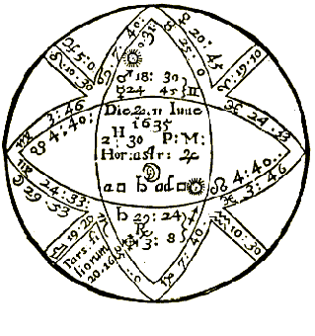

Compliments of http://mithras93.tripod.com

The Resolution of

the Lord of the Ascendant, the Querent shall have intelligence of his Messenger: You must know, the application of the Significator to a ponderous Planet, shews more certainly the day; use descretion in knowing the length or brevity of the Journey, and by what precedes you may be satisfied,

If The Querent Should Ever Have Children?

CHAP. XLII.

Judgment upon the preceding Figure.

The Ascendant is here Virgo a barren Signe, as you may see page 89 and 96, the Signe of the 5th is Capricorn, a Signe of indifferency in this nature of judgment; the Moon is in a barren

238

Compliments of http://mithras93.tripod.com all manner of QUESTIONS.

Signe; Saturn Lord of the 5th house is Retrograde, and in Sagittarius; Mercury Lord of the Ascendant in Gemini; both Saturn and Mercury being in Signes rather barren then fruitfull: the Moon in the Termes of Mars, in Square of Saturn Lord of the 5th, Mercury Lord of the Ascendant in the Termes of Saturn, afflicted by the presence of Mars, and going to Opposition of Saturn, who is Lord of the 6th, as well as of the 5th; South Node also possesseth the Ascendant; a strong argument of barrennesse: for these reasons in Astrologie above recited, I delivered this Judgment, viz. That the Querent neither had been ever yet conceived, or for any reason in Art that I could find, ever would conceive, and that she was naturally barren; for finding the 5th, 10th and 4th houses, being the principall Angles of the Figure, Afflicted, I was certaine, the evil impediting her Conception had been long upon her, and would also continue.

Had I found Jupiter either fortunating the cusp of the 5th house, or in any aspect to the Lord of the Ascendant, or unto Saturn, or if any reception had been betwixt Saturn and Jupiter or Jupiter and Mercury, or any collection of light from Mercury to Saturn, and that Planet so collecting had received Saturn or Mercury, I would not have been so peremptory; but when I found no one promising testimony, I gave my judgment in the negitive, viz. she should not conceive or ever have any children; for whoever considers the positure of Heaven exactly, shall find it is a most unfortunate Figure for having children: as the Moon was in Square of Saturn, Lord of the 6th, and Mercury Lord of the Ascendant, applying to his Opposition, so was the Querent very sickly, and extremely afflicted with the Wind and Chollick in her Belly and small Guts; the South Node in the Ascendant shewed very great paine in the Head, so did Mercury in Gemini, being afflicted by both the Malevolents, represent extreame grief in the Head, for Mercury in Gemini signifies the Head. (see page 119)

Shee affirmed, that the Moles of her Body did correspond exactly to the Figure of Heaven, viz.

one Mole close by the Navill, one upon the right Ancle, signified by Aquarius on the cusp of the 6th; one towards the right Knee on the inner side of the Thigh, represented by Saturn, Lord of the 6th in Sagittarius, one in or neer the member signified by the Moon in Virgo; and as Mercury Lord of the Ascendant is in Gemini, so had the Querent a Scarre or Mole on her right Arme, on the outside thereof, &c.

239

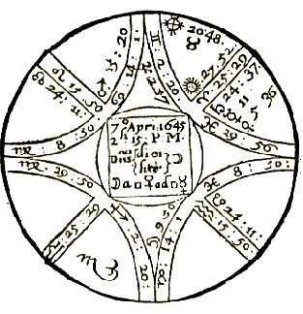

Compliments of http://mithras93.tripod.com

The Resolution of

When you find a Question that is so peremptory in the negative, you shall deale discreetly to enquire the time of Birth, and set the Figure thereof, and see what corresponding there is betwixt the Radix and the Question propounded, and help your selfe in your judgment by discretion; for if the Radix affirrme Barrennesse, it’s impossible any promising Horary Question can contradict its signification: and usually I have found, that whoever propounds a Question to the Astrologer, I meane in their first Question, they have a Signe of the same Triplicity Ascending in their Question, agreeable to the nature of the Ascendant in their Nativity, and many times the very self same Signe and degree is ascending upon an Horary Question which was ascending in the Nativity, as I have many times found by experience; for if Gemini ascend in the Nativity, it’s probable upon an Horary Question, either Libra or Aquarius may ascend, which are Signes of the same Triplicity.

If one were with Child of a Male or Female, and about what time she should be delivered.

240

Compliments of http://mithras93.tripod.com CHAP . XLIII.

Judgment upon the Figure beforegoing.

You may see in the judgments appertaining to this house how to judge of this question; however, I did follow the Method succeeding, and considered onely the plurality of testimonies, Masculine or Feminine, of the proper Significators, and thereby gave resolution.

Arguments of a Girl

Virgo

Signe of Ascending

Feminine

Capricorn

Signe of 5th Feminine

Moon

in a Signe

Feminine

Mercury

Lord of Ascendant

Feminine

W/Venus, a Planet

Significations of a Male Child

Mercury

Lord

of

Ascendant

Masculine

in a Signe

Saturn

Lord of 5th, Planet

Masculine

Saturn

Lord of 5th, Signe

Masculine

Moon

in a house

Masculine

Saturn

in a house

Masculine

Jupiter

Lord of the House

Masculine

Jupiter

in a Signe

Masculine

Mercury Applying

to

Mars

Masculine

His Square, and Mars

A

Planet

You see here are 8 testimonies of a Male Conception, or of Being with child of a Sonne, and but four of a Female; I therefore affirmed, that the Lady was impregnated of a Man child, (and so it proved.)

241

Compliments of http://mithras93.tripod.com The Resolution of

How long ere she should be Delivered.

The Signe of the 5th, viz. Capricorn, is moveable, so is Aries, wherein both the Lord of the Ascendant and 5th are posited; these argued but a short time: but because Saturn Lord of the 5th is a ponderous Planet, and of slow motion, I much valued him in this Judgment, so did I the Moon, because she was posited in the Signe of the 5th; I took their proper difference in degrees and minutes each from other:

Locus

Saturn

in

24:37 Aries

Both Cardinal Signs

Locus

Moon

in

9:50 Capricorn

The distance of the Moon from the Square aspect of Saturn is, as you may find by subtraction of the Moon, from Saturn 14. degrees, 47. minutes.

I then subtracted Mercury his distance from the body of Saturn, because he was Lord of the Ascendant, and Saturn Lord of the 5th.

Saturn

24:37 Aries

Mercury

11:00 Aries

Distance 13. degr. 37.min. so that finding no greater difference betwixt the distance of the Moon to the Square of Saturn, and the Conjunction of Mercury with Saturn, then 1 degree and 10

minutes; I gave for every degree one week, and so judged, that about fourteen weeks from the time of the Question, she should be delivered.

The truth is, she delivered the 11th of July following, at what time Mars transited the degree ascending, and Mercury Lord of the Ascendant, the Opposite place of the Moon, viz. the 9th of Cancer: You may further observe that the Sun the same day is in 27.48 Cancer, viz. in perfect Square to his place in our Figure, and the Moon in Cancer in Conjunction with Mercury.

242

Compliments of http://mithras93.tripod.com all manner of QUESTIONS.

Of The SIXT House, and It’s

QUESTIONS.

Viz. Sicknesse, Servants, Small Cattle.

CHAP. XLIV.

Judgment of Sicknesse by Astrology

That which I hold convenient to write of Sicknesses, is thus much: That in the first place, we aught to carefully take the exact time of the parties first falling sick, viz. the house as neer as can be had, not that moment when first the patient felt a smatch of it, but that very time when first he was so ill, or so extremely oppressed, that he was enforced to take his Bed, or to repose.

Secondly, if that cannot be had, then accept of that time when the sick parties Urine was first carried to somebody, to enquire of the Disease, whether the party enquired of was a Physitian or not.

Thirdly, if no such thing can be had, let the Physitian take the time of his own first speaking with, or accesse to the Patient, or when first the Urine was brought unto him, let a Figure be erected accordingly, and the place of the Moon exactly rectified to the very houre; and then to know where the Disease is, let him carefully observe: First, the Ascendant, what Planet or Planets are therein placed. Secondly, the 6th house, and what Planet or Planets are therein posited. Thirdly, the Signe and house wherein the Moon is.

Fourthly, how she is afflicted or affected, by what Planet, in what house that Planet is, what house of the Figure that Planet is Lord of.

What part of the Body is afflicted;

wherein you consider?

If the 1st house be afflicted by the presence of an evill Planet 243

Compliments of http://mithras93.tripod.com The Resolution of

and he Retrograde, Combust, Peregrine, slow in motion, or in Square or Opposition to any Planet who is Lord of the 4th, 6th, 8th or 12th, the Disease is then in the Head, or in that or those parts of the Body which the Planet or Planets signifie in that Signe then ascending, which you may see by the Table beforegoing page 119, as if the Signe ascending be Cancer, and Saturn therein, you may judge, the sick party is afflicted in the Head, or such Diseases as are incident to the Head, because that 1st house signifies in mans Body the Head, and is now afflicted by the position of Saturn in that house: but you shall also judge the sick party is Diseased with a Loosenesse or Flux in the Belly, or an imperfection in the Reynes or Secrets, or troubled with cold, raw Matter in his Stomack, because Saturn in Cancer doth signifie those members, or else with some rotten Cough; and your judgment herein shall be more certaine, and I dare say infallible, if either the Lord of the Ascendant, the Moon, or Lord of the 6th be in a Signe, and therein signifie that very member which Saturn doth, or if the Signe of the 6th represent that member..

The same course and manner which I have directed in the ascendant, I would have observed in the 6th house, viz. the Signe of the 6th, the Planet or Planets therein placed, what member of mans Body they represent in the Signe wherein they are posited, from whom the Lord of the 6th last separated, to whom he next applies: Together with these, observe carefully the Signe and house wherein the Moon is, the separation and application, and you may then descend to give judgment in what part of the Body the sick party is grieved, and of what nature and quality the Sicknesse is of, or what humour is most predominant and peccant.

From what cause the Sicknesse is. Generally observe: The Significators in Signes fiery, and the Signes ascending in the 1st, and decending in the 6th of the same nature, shew Hectick Feavers, and that Choller is predominant in this Sicknesse.

The Significators in earthly Signes, argue long and tedious Agues, or Feavers of great continuance, of such Diseases as may occasionally proceed from Melancholly, Consumptions,

&c.

244

Compliments of http://mithras93.tripod.com all manner of QUESTIONS.

The Significators in ayery Signes, shew the Blood purified or corrupted, Gouty Diseases, Leprosies, the Hand and Foot Gout.

The Significators in moyst Signes, declare the Disease to proceed from some cold and moyst cause or causes, and shewes Coughs, rottennesse in the Stomack, and that those parts are disaffected, &c

Diseases signified by the Houses.

House

1st

Head, Eyes, Face, Eares, stinking Breath, sore Mouth, and Noli me tangere.

2nd

Throat, Neck, Kings—Evill

3rd Shoulders,

Armes,

Hands.

4th

Stomack, Brest, Lungs.

5th

Back, hind part of Shoulders, Stomack, Liver, Heart, Sides.

6th

Lower part of the Belly, Guts, Liver, Reynes

7th

Hammes, Flank, small Guts, Bladder, Matrix, members of Generation.

8th Back-bone,

Arse,

Groine.

9th

Huckle-Bone, or, the Hips.

10th

Knees, Hamme of ones Leg behind the Knee.

11th

Shank, Legge from the Knee to the Ancle Shin-Bone.

12th

Feet, and all Diseases incident to them.

Diseases signified by the Signes.

Aries

All Diseases incident to the Head (as in the 1st house is signified) and such as proceed or have originall from Choller, small Pocks, Pushes, Pimples.

Taurus

Diseases in the Neck and Throat, having their beginning from Melancholly, as in 2nd house.

Gemini

Shoulders, Armes, Hands, proceeding from Blood distempered.

Cancer

Scabbiness, Cancers in the Brest, Hurts in the Brest, ill Digestion in the Stomack, Spleen, Lungs, Upper part of the Belly, Cold and Moisture being the cause, Surfets, &c.

245

Compliments of http://mithras93.tripod.com The Resolution of

Leo

Back-bone, Sides, Ribs, Heart, Lower part of the Brest, such infirmities as proceed from Choller and excesse of Blood.

Virgo

Shows Melancholly Diseases in the Intestines, and Bellyakes Fluxes, &c.

impediments in the Miseraicks, Wind-chollick.

Libra

Great Heats in the Back, or the Stone in the Reines or Kidneys, Surfets by drinking or eating, or from too much Venery, Diseases in the Buttocks, Joints, Hammes and Haunches.

Scorpio

The Groin and parts about the privy Members, the Arse, Bladder, Pyles, Stones in the Bladder, Strangury

Sagittarius

The Hippes, Hammes, Buttocks, Fistula’s, Itches, Sciatica’s.

Capricorn

The Knees, back part of the Hammes, Scurfs and Itches in and about the Knees, proceeding of Melancholly.

Aquarius

The Legs, Shin-Bone and Calves of the Legs, with the Ancles.

Pisces

The Ancle-bone and Feet, Gouts, Swellings in those parts.

Diseases Of The Planets.

Saturn

Is Significator of these Diseases; of noyse or rumbling in the right Eare arid Head, Deafnesse, Tooth-ach, paine in the Bones, in the Bladder, all cold Diseases proceeding from a deflux of the Humours, the Gout, Scab, Melanchollick, infirmities, Leprosie, Palsie, Consumption, black-Jaundies, quartan Agues, the Iliack-passion, Dropsie, Chin-coughs, Catarres of Rheums falling upon the Lungs and Pectorals.

3upiter

The Lungs, Ribs, Grissels, Liver, the Pulse, the Seed, Arteries, Apoplexies, Pluresies, wringings at the Heart, Convulsions, Inflamations of the Liver, Diseases in the Head, prickings and shootings neer or upon the Ridgebone, all windinesse in the Veines and body, or any Diseases arising from putrification in the Blood, &c.

Mars

The left Eare, Gall, Reines, Privities and Stones, the Plague, wounds in the Face, Imposthumations, burning-Feavers, yellow-jaundice, Carbuncles, Fistula’s, Epilepsies, bloody-Flux, Calentures, St. Anthonies Fire.

246

Compliments of http://mithras93.tripod.com all manner of QUESTIONS.

Sun

The Braine, Heart, Eye-sight, right Eye of a man, left eye of a woman, Cramps, Swoonings or sudden tremblings at the Heart, the Cardiack Passion, Fluxes in the Eyes, Catarres, red Choller.

Venus

The Matrix, Genitals, Paps, Throat, Liver, Sperme, or Seed in man or woman, Suffocations or Defections in the Matrix, Pissing Disease, Gonorrhea, Debility in the Act of Generation, Strangury, weakness of Stomack and Liver, French or Spanish Pocks, imbecility or desire to vomit, or that Disease when presently after eating, all comes up againe.

Mercury

The Braine, Spirit, Fancy, Imagination, Speech, Tongue, Fingers, Hands, privation of Sense, Madnesse, Lethargy, Stammering, Hoarsenesse, Coughs, falling Evill, aboundance of Spettle, &c.

Moon

Left Eye of Man, right Eye of woman, the Braine, the Small Guts, the Bladder, Taste, falling Sicknesse, Palsie, Collick, Menstrues in women, Apostems, Fluxes of the Belly, viz. Loosness, and all coagulated, crude Humours in any part of the Body

From what proceeds, it’s easy to discover both the member afflicted, quality of the Disease, it’s cause and original rise; which being well considered, it’s requisite you be able to aquaint the sick party of the length or shortness of his Disease, and its time of accesse or recesse, the better to comfort him if life be ordained, or to make him more penitent and prepared for Heaven, if you see apparent testimonies of death.

Whether the Disease will be long or short.

Herein you must have respect to the time of the yeer in the first place, and to consider, that Sicknesses happening in the Winter are usually more long, and of long continuance; in the Summer more short; in the Spring they are reputed healthfull; in the Autumn, for the most part Diseases mortall and pernicious are stirred up.

Also cold and dry Diseases which proceed from Saturn, or which he 247

Compliments of http://mithras93.tripod.com The Resolution of

stirs up, or is the Author of, are more permanent and long, and generally are regulated by the Sun: hot and dry Diseases, which are procreated from the influence of Mars and the Sun are but short, and are determined by the motion of the Moon: Saturn produceth chronick Infirmities; Jupiter and Sun short; Mars more short, violent and quick; Venus a meane betwixt both; Mercury divers and unconstant; the Moon such as do againe revert, as the Falling-Sicknessee, Giddinesse, Swimming of the Head, Gout, &c.

Signs of a long or short Sicknesse.

If the Signe of the 6th be fixed, expect a long Disease; a moveable Signe, short continuance, a common Signe, a mediocrity, neither too long or too short, but for the most part, an alteration of the Disease, and returne of it againe.

The last degrees of any Signe being upon the cusp of the 6th house, the Disease is almost at an end, or is either altering for better or worse: fixed Signes do argue the humour not to be expulsed without much time and difficulty.

When the Lord of the 6th is of evill influence, and placed in the 6th, it's an ill Omen, or an unlucky Signe of a durable and great Sicknessee: but if in the like nature a Fortune be there, the Disease will soon be cured, nor is it mortall: When the Lord of the 6th is stronger than the Lord of the Ascendant, the Disease is like to encrease, advise the Patient to take fit remedies, for nature is weaker then the Disease; but is the Lord of the 6th house be more weak then the Lord of the Ascendant, then be assured nature will be able to overcome the malignity of the Disease, without much assistance of the Physician: When Saturn is Lord of the 6th house, and fixed in the Signe he is in,, he extremely prolongs the Disease; if he be Retrograde or slow in motion, he performs the same; but if he be in a moveable Signe and in any of his Termes, or Swift in motion, he is not then much unfortunate, or will he greatly prolong the Disease: a moveable Signe in the 6th, and the Moon likewise, and no impediment otherwise appearing, the Disease continues but a while; common Signes do continue longer any infirmity, except Pisces, for that being upon the cusp of the 6th, I ever found it equivalent to a 248

Compliments of http://mithras93.tripod.com all manner of QUESTIONS.

moveable Signe: If the Moon apply by ill aspect to the Lord of the Ascendant, the Disease encreases; if the Moon be in the 6th in ill aspect with Venus, the sick may thank himselfe for his Disease, he is a disorderly fellow, and of ill Dyet; and if Venus be in Scorpio, &c, he has got a clap of some uncleane woman; if a woman asks, she has too great Flux of Whites or Reds, or the Disease is occasioned by her owne Folly, &c, If the Lord of the 6th apply to the Lord of the Ascendant by Square or Opposition, the Disease is encreasing, and is not yet at his height or full growth; so also the Lord of the 6th in the 8th or 12th, is an ill argument and great presumption, that the party sick must be more afflicted before his Disease leave him:

If an Infortunate Planet be in the 6th, and is removing out of one Signe into another, the Disease will speedily alter: if it’s desired When, or how long it may be before it does so? then see how many degrees the malevolent Planet wants ere he can get out of the Signe, and thereby judge so many Monthes, Weeks or Dayes according to the nature and quality of the Signe: if the Lord of the 6th be Retrograde, Combust in the 8th or 12th, and in Square, Opposition or Conjunction with Saturn, Mars, or Lord of the 8th or 4th of the Figure, he prenotes much infirmity, a long continued and sudden alteration of the Disease from better to worse, if not Death it selfe; the Lord of the 6th in the 8th, and the Lord of the 8th in the 6th, there being also a Sextile or Trine aspect betwixt both Significators, you shall not doubt of the death of the Patient at that time, for the Heavens do declare that Nature is not yet overcome, or so weak, but that the sick shall overcome it: if there happen any Trine, Sextile or Conjunctions betwixt the Lord of the 6th and Jupiter, and he in the 9th, and the Moon separate from the Lord of the 6th to Jupiter, so in the 9th house posited, it’s an assured argument, that the Medicines which the Physitian precribes, or which the Patient has already taken, have caused the party to be very sick at time of their taking, and whilest they operated, and that the Medicines wrought effectually in the outward parts of the body, but afterwards the sick felt great comfort, and has found great emendation in the parts of the Body, afflicted at time of his first being ill; either Saturn or Mars, or any unfortunate Planet in the 6th, threatens great danger in the Sicknesse, yet 249

Compliments of http://mithras93.tripod.com The Resolution of

if he be Nell affected or essentially fortified, he hurts little; and you may rather judge, the Disease is happened casually and suddenly, then upon any prepared matter in the Body beforehand, therefore let the sick be of good comfort: so likewise when you find a Benevolent Planet well fortified in the 6th, and he not author of the Disease, you may safely judge, the Disease is not, or will not be permanent.

Many times it happens that in some Country-townes, people are afraid of Witches; If the Lord of the 12th be in the 6th when mistrust is had by any such Querent, it’s a strong argument the supposition is true, that the party is vexed by an evill Spirit, or by Fascination; when you find in the Question of a sick party, the Lord of the 6th in the Ascendant, and the Lord of the Ascendant in the 6th, you may give judgment the Disease has been of long continuance, and will continue untill one of the Significators get out of the Signe wherein he is; and if it happen, at the time of the Planets transit out of the Signe into another, he meet with the Square or Opposition of the Lord of the 4th or 8th, or with the oppressing or malicious aspect of Saturn or Mars, and they slow in motion, in Signes odiously beholding or aspecting another, it’s a very great Signe the sick will then depart this Life; when you find the Lord of the 6th afflicted by the Square or Opposition of the Lord of the Ascendant in Azimen degrees, a sig. for the Physitian, the Disease is uncurable, and the sick party continually pained: When the Lord of the 6th is in the Ascendant, the Disease will continue, but the paine doth slacken and seems quite removed at same times, or the Patient sometimes is not sensible of the paine: but if he be in a Cadent house, the Disease is neither very grievous, or will it endure any long space of time; so also good Planets in the 6th do promise a good end of the Disease; evill the contrary: Usually a malignant Planet in the 6th, shew his Disease unsettled, so doth also the Lord of the 6th if he be in the 6th, 8th or 12th, denotes a Disease not easily curable; if the Lord of the Ascendant and Moon be ‘free from the Square, Opposition, or Conjunction of Saturn or Mars, or any other infortunate Planet, and be Direct, free from Combustion, swift in motion, not Peregrine, or in his Fall or Detriment, or in the 8th or 6th, or in any aspect with the Lord of the 12th house, 6th or 8th, it’s 250

Compliments of http://mithras93.tripod.com All manner of QUESTIONS

faire signification of health and recovery; when the Lord of the Ascendant is in the 4th or 8th and is not afflicted, he shall not signifie death, but recovery; but if he be unfortunate in the 4th, it notes great difficulty ere the party be cured; but if the Lord of the Ascendant be himselfe unfortunate, either in his house, or by Retrogradation, Peregrine, Combustion, or be in his Fall or Detriment, it’s possible be may be cured, but within a short time after he will relapse, dye or fall into some desperate infirmity; when also the Lord of the Ascendant is infortunated by the Lord of the 6th or 12th, and in bad aspect of the Moon, there’s danger in the Disease threatened; above all, have a care if Saturn be Lord of the Ascendant, and in his Dignities, slow, diminished in light, Retrograde, for then the Patient or Querent will be long sick; judge contrary of the signification of Saturn when otherwayes qualified..

The Lord of the Ascendant in an Angle, having no configuration to any malevolent Planet, but being in benevolent house of Heaven, and under the Sun Beames, or Retrograde, you may judge the Querent is in no danger at this time: When the Lord of the Ascendant be swift in motion, and entering into another Signe, or going out of his owne house into another, so it be not into the Signe of the 6th or 12th, the Disease will quickly determine: If the Lord of the Ascendant be not afflicted in himselfe, or by any ill aspect of the malevolent Planet or Planets of a contrary nature unto himselfe, but is swift in motion, and in some goad aspect with the Fortunate Planets, it’s a strong argument that the nature of the Diseases or Querent is nothing diminished, but is able to overcome the malignity of the Disease, and that in a very short time; but if the Significator of the sick be afflicted powerfully, it’s a Signe of a strong fit of Sicknesse; the greater it will be, when the Significator of life is more weak then the Planet afflicting: if all the Significators of the Diseases be in fixed Signes, it prenotes a great space of time before the Patient can be cured, nor will the cure be easily perfected; when the Lard of the Ascendant is applied unto by a malevolent Planet, it retards the cure, prolongs the infirmity, though at present great hopes appeare; so doth also the Moon when

251

Compliments of http://mithras93.tripod.com The Resolution of

she is slow in motion, and goeth in 24 hours lesse than her meane motion, and be in any aspect or Conjunct with the Lord of the Ascendant; but if she be swift the sure is performed presently, or effected in a little time; for the most part when the Moon decreases in light and motion, and comes to the Conjunction, Square or Opposition of Saturn, unless the Disease be in its decrease and leaving the Patient or Querent, it’s I say, very mortal and dangerous: When the Moon is in Conjunction with a Planet that is Orientall, Direct and Swift, expect a short Sicknesse; joyned to a Retrograde or Planet Occidentall, look for’ the contrary.

When you find Scorpio Ascending, you may for the most part judge, the party was cause of his owne infirmnesse, either by peevishness, folly, choller or the like; and your judgment will be more firme, if Mars be then placed in Scorpio: If both the Luminaries be in Cadent houses, and the Planet or Planets that are their Dispositors be unfortunate, the Querent may expect a terrible Sicknesse; if the Fortunes assist in judgment, yet will the Sicknesse be of long continuance, and of a sharp Disease, prove chronick, yet beyond all expectation, the sick party will recover; and the more confident in your judgment, by how much more strong the Fortunes are Dignified above the Infortunes; when you find Mars Lord of the Ascendant and posited in the 6th house in Sextile or Trine with Venus, Nay, but if he be in Square or Opposition of Venus, there’s no great danger.

If the Lord of the 6th be Combust or Retrograde, in his Fall or Detriment, and in the 8th, in Conjunction, Square or Opposition of Saturn or Mars, you may doubt, and not unjustly, that the Disease will never leave the sick party till death; and if the Moon have equall testimony to the former Significators, viz. if she also apply to the Square, Opposition or Conjunction of the Lord of the 8th, your former judgment will be very certaine; if either the Moon or Lord of the Ascendant be in Square, Conjunction or Opposition to a benevolent Planet, Retrograde, the sick will recover, but not in haste, for it’s an argument for the prolongation of the Disease, and relapsing out of one Disease into another: When you find the Moon receded from Opposition of the Sun, to be swift in motion, and hastens to the Square or Opposition of Mars it will come to passe, that the Disease which the Querent now undergoes, will be grievous and mortall; but if she Salute at the same time the Sextile or Trine of Jupiter or 252

Compliments of http://mithras93.tripod.com All manner of QUESTIONS

Venus, the sick shall recover. There’s usually no danger if the Moon at time of the Question be strong, and the Lord of the Ascendant free from misfortune, and in no aspect to the Lord of the 6th, yet when the Moon at time of the Question applies to Saturn, or is impedited, it’s an ill Omen and Signe of a Sicknesse at hand, and that the Querent mistrusts his owne health is sick, but knowes not where to complain, or in what part of the Body the infirmity is placed.

At the time of ones first lying down, if the Moon be placed in the Ascendant, in Conjunction, Square or Opposition of Saturn or Mars, or any of the unfortunate Planet, it’s a Signe of ill, and shews ill, unless the Moon be in reception with the Planet or Planets so afflicting: It’s very considerable to observe at the time of the question, what Signe the Moon is in: if in a Fixed, expect a long fit of sicknesse; in a moveable Signe, quick dispatch; in a Common or Double-bodied Signe, the Disease will not be very difficult to cure, but somewhat long in curing: and thus much more you must consider, that if there be translation of light (from that Planet who is Dispositor of the Moon, and he unfortunate) to the Lord of the Ascendant, or Signe Ascending, it gives great suspicion that the Querent will have a sharp sicknesse, according to the nature of the Signes and Planets signifying the infirmity.

Testimonies that the Querent shall live and not dye of the infirmity now afflicting.

When it is demanded seriously, if you conceive the Querent shall escape Sicknesse he now languishes under, or shall live, you must carefully have recourse to your Figure erected, and therein observe these rules following: That if the Moon be separated from a malevolent, weak Planet (that is ill dignified) and is applying to a Fortune powerfully strong, the sick party will be restored to former health; where Saturn is Orientall of the Sun, and Significator of the Disease, it proceeding from Cold (which is the true nature of Saturn without mixture) the Patient will recover; if you find in like case, that Saturn is Occidentall, and the generall Significators do incline or manifest, that the Disease is more of Heat than Cold, the sick will also be 253

Compliments of http://mithras93.tripod.com The Resolution of

recovered; yet you must ever understand, that Saturn is unlucky when he is Occidentall &c. For the Disposition of Mars, you shall find, that after his Opposition with the Sun, that is, when he is Occidentall, he is not so much to be feared (viz. his evill influence) as when he is Orientall; for the Conjunction of the Moon with Mars is dangerous, and an argument of a strong sicknesse at hand, his Opposition or Square aspects do less mischiefe; the Moon doth more hurt in her encrease then in her decrease, so doth Mars being Orientall, more then when Occidentall.

When you find there is any reception betwixt the Lord of the Ascendant and the Lord of the 8th, and neither of then infortunated by the malignant Planets, after desperation, there will be recovery: The Lord of the Ascendant in reception of the Lord of the 8th by House or Triplicity, the Fortunes afflicting either with their Trine or Sextile the degree Ascending or the 6th house, or the Moon her selfe, there’s no danger of death, but the sick will perfectly recover; so also, when the Lord of the ascendant shall happen to be a benevolent Planet, and posited in the 1st, 10th, 11th, 5th or 3rd house, being no wayes endangered by the Square or Opposition configuration of the Malevolents, it prenotes sanity: so doth also the position of the Fortunes in the Mid—Heaven or 1st house, at what time the sicknesse first assaulted the sicke person, nothing is a more sure argument of health, or that the party sick shall live, then when you find the Sun, Jupiter, Venus or the Moon in the ascendant of the question, not any wayes damnified led by the hatefull aspect of the Lord of the 8th or 6th; and this argument is more certaine, if the aforesaid Significators be in good Signes, that is, in either of Jupiter his houses, or in Cancer or Leo, Libra or Taurus: When the Moone is in her owne house, or in the house of Jupiter or Venus, and there in either of their aspect, free from any ill aspect of Saturn or Mars, she signifies health and life.

It’s a good argument of recovery, when in your Question you find the Moon in Conjunction with Jupiter, let Jupiter be in what Signe he will it denotes good, but less in Capricorn then in any other Signe, for neither the Moon or Jupiter have any delight therein, that Signe being the Fall of Jupiter and Detriment of the Moon; in very deed, no Planet delights to be in the Signe wherein he Fals, or is he able therein to express the strength of 254

Compliments of http://mithras93.tripod.com all manner of QUESTIONS.

his influence. When the Moon is applying to the Lord of the ascendant by a Trine or Sextile aspect, and she be cleer of all misfortune, or not impedited by the Lord of the 8th, or 6th especially, health and life are promised: Safety is also to be expected, when the Moon shall be well affected and posited in a Succeding house, provided, she be encreasing in light and motion, and not neer the bodies of Saturn or Mars, or infected with their Rayes: The Moon either in the 1st, 10th, 11th, 9th, 2nd, 3rd or 5th, in Trine or Sextile with the Lord of the ascendant, or with his Antiscion, Yea; if he be a malevolent Planet, so that neither the Lord of the ascendant. or the Moon have any other impediment, it doth argue life.

When at the first falling sick of the infirme Body, the Moon is voyd of course, and at her next Crisis meets with a Sextile or Trine of Jupiter or Venus, in that very degree which makes a perfect crisis, the sick shall recover, but he never so much pained or grieved at the time of demanding the Question or accesse of the urine: when in the first beginning or approach of a Disease, the Sunne, Moon and the Lord of the Ascendant are free from ill aspects of the Infortunes or Lord of the 8th, there needs no feare or suspicion to be made of the death of the then sick person, or when the Benevolent Planets are more potent then the Malevolent, they give assured hopes of life, and invite the infirme person to confide of his escape.

Arguments Of Death.

When the ascendant at time of first falling sick, shall be the 7th house at the Birth, you may feare death, unlesse the Profection of that yeer be the same Signe: What Profection is, you shall know in my Treatise of Nativities; those Signes which are adverse in a Nativity are the Signes of the 6th, 7th, 8th and 12th.

When the 5 Hylegicall places at the hour of Birth, at time of Decumbiture of the sick, as also the Lord of the Ascendant, are oppressed, judge death immediately to follow, unlesse reception intervene betwixt the Infortunes, and the Fortunes interject 255

Compliments of http://mithras93.tripod.com The Resolution of

their comfortable aspects; for then, by a divine miracle as it were the sick party may escape.

He will be infinitely oppressed who in the houre of Mars shall first get an hot Disease, and in the house of Saturn a cold one.

The Lord of the Ascendant and of the Figure Combust, doe undoubtedly declare death, unlesse there is some reception between the Sun and them, such a chance happening, and the Moon proving Fortunate, after all hopes of escape, a little hopes remaines.

The Lord of the Ascendant and the Moon in Conjunction with the Lord of the 8th, without the interposing aspects of the Fortunes, threatens death.

The Lord of the 8th in an Angle, the Lord of the ascendant in a Cadent, is alwayes mortall; the rather if he be an Infortune.

The Application of the Moon to a Planet in the 8th, is alwayes dangerous: The Application of the Lord of the Ascendant unto the Lord of the 8th or unto Malevolent Planets therein, the Moone being any manner of way corrupt, denotes death.

The Moon transferring the light and influence of the Lord of the ascendant to the Lord of the 8th, brings usually death: So also when the Lord of the 8th is in the ascendant, the Lord of the Ascendant and the Moon being both afflicted: It also proves fatall when the Lord of the ascendant is infortunate in the 8th, the Moon being then corrupted or very weak, and in no essentiall Dignity: The Lord of the ascendant being Subterranean, and in any aspect to the Lord of the 8th in the 8th, or if he be in the 4th, and the Lord of the 8th in the 4th, and they both in Conjunction, argue death: It’s a very ill Signe of life when the Lord of the ascendant is corporally joyned with the Lord of the 4th, 6th, 7th or 12th, it seldome succeeds well with the sick person then.

Having speciall consideration to the Luminary of the time, for according to the well or ill affection thereof you may improve your Judgment. The Lord of the ascendant afflicted of an evill Planet in the 8th, without the benevolent aspect of the Fortunes, the Moon also then vitiated, shews great perill of death, and

256

Compliments of http://mithras93.tripod.com all manner of QUESTIONS.

usually by reason of ill government of the sick party, or some error in his ordering and course in Physick: It’s a powerful argument that the sick person will dye, when at time of his first Question to his Physitian, you find the Lord of the ascendant Combust in the ascendant The Lord of the Ascendant and of the 8th unfortunate, prenote death.

The Lord of the 8th in the 10th house, and Lord of the ascendant in the 4th, 6th or 7th, afflicted of the malevolent Planets, argue death.

A Planet very strong, and placed in the ascendant, if he be Lord of the houre and of the 8th, portends death: If the Lord of the 8th be Retrograde, and in Conjunction, Square or Opposition of the Moon, it shewes death: The Lord of the 8th in the 7th, the Moon and Lord of the ascendant in cadent Houses, infested with ill aspects of Infortunes; and more certaine, if one of the malevolents be Lord of the 8th, or posited in the 8th; some say, if the Moan be in Conjunction with Saturn or Jupiter, the sicknesse will have little good thereby, nor will he escape, unlesse Saturn be Retrograde and Jupiter Direct.

When the Lord of the Ascendant is in Conjunction with the Lord of the 8th, or in Square or Conjunction of a Planet posited in that house, or in the Antiscion of the Lord of the 8th, without the benevolent Sextile or Trine of Jupiter, and at the same time the Moon be anyway afflicted, it’s probable the sick will dye; but if the Lord of the Ascendant be in reception with the Planet in the 8th, it’s possible he may avoyd death; however, let him be assured a very long and grievous Disease he cannot: If the Moon be with Saturn or Mars, without the assistance of some good aspect from Jupiter and Venus; and if Saturn be slow in motion, or is going Retrograde, it’s so much the worse, and it’s one argument the sick will dye at that time; if other testimonies concurre, it’s more certaine. The Lord of the Ascendant in the 7th, in his Fall, or under the earth in the 4th or 6th, or in other Cadent houses, afflicted by the malevolents, and the Lord of the 8th in the 7th, these are testimonies of death. malevolent Planet neer to the degree ascending, or a violent fixed Starre, viz. Antares in 4 degrees of Sagittarius, Lans Australis about the 9th degree of Scorpio, Palilicium in 4 degrees of Gemini, Caput Medusae in 20 degrees of Taurus, these 257

Compliments of http://mithras93.tripod.com The Resolution of

prenote death. The Lord of the Ascendant in Leo or Aquarius, in any bad configuration of the Lord of the 6th or 12th, shewes little hope of recovery.. Both the Lights afflicted of Saturn in Angles, give testimony of a tedious long sicknesse; so doth both the Lights, being ill dignified and under the earth, signifie the same. When as also the Sun from the beginning of the Disease shall be corporally afflicted, or by the Square or Opposition of Saturn or Mars impedited, or be in the perfect Antiscion of a malignant Planet, or shall apply and not separate, either death, or an extraordinary long sicknesse succeeds. The Moon after the beginning of the Disease comming to Opposition of the Lord of the Ascendant, and he Retrograde or Combust, argues death, or a sharp disease, not easily curable.. Saturn in Opposition with the Lord of the 8th, the Moon in the 4th with Mars, or Moon in the Ascendant, and neer the degree ascending, are arguments of death.

The Moon besieged by the Infortunes, or between Sun and Mars, or between Sun and Saturn, are ill Omens of health. He who fals sick whilest the Moon is under the Sun-Beames, viz. departing from Combustion, his Disease shall encrease till she hath passed the Sun his Opposition; but then if she prove ill affected, and come to an ill aspect of the Lord of the 8th, it threatens death, otherwise he or she will escape..

Any malevolent in the 6th, or any Planet peregrine and unfortunate in that house, shew great danger in the Disease; the Combustion of the Moon in the 8th house, and in Leo, or in Libra, in Square or Opposition to Saturn or Mercury, or in Conjunction with the Pleiades in 24 degrees of Taurus, or other violent fixed Starres, argues death.. The Moon being Lady of the 6th, or of the Ascendant in Combustion, and the Lord of the 8th at the same time afflicted by Conjunction, or ill aspect of Saturn or Mars, shew death.

DARIOT Abridged.

In regard I have ever affected Dariot his Method of judgment in sicknesses, I have with some abbreviation annexed it, in a farre more short way and method heretofore published.

258

Compliments of http://mithras93.tripod.com All manner of QUESTIONS.

If the Party be sicke of whom the

Question is Demanded.

[DARIOT]

The Significator of the Querent in the Signe contrary to his owne nature, as Mars being Lord of the Ascendant, and naturally hot and dry, if he be in Cancer, which is cold and moyst; or if the Lord of the Ascendant be in a Cadent house, chiefly in the 6th, he is sick..

A diurnall Planet being Significator, and he under the earth ill affected, Combust, Retrograde, in his Fall or Detriment, weak, or in Termes of malevolents, or with violent fixed Stars, or besieged by the two Infortunes, these things happening, the party is sick.. What was spoken of a diurnall Planet, must be understood of a nocturnall one. (consideratic, consideratis)

[LILLY]

When a Question was asked of me upon any Urine, or without it, having erected my Figure, I observed this method, to know whether

If the Ascendant were not afflicted, or the Lord thereof out of his essentiall Dignities, or in any evill aspect of Saturn or Mars, or Lord of the 6th.

Or if no Planets afflicted the 6th house by presence, or that the Moon were not afflicted in the 8th or 12th; or if I found Jupiter or Venus or North Node in the Ascendant, or the Sun in the 6th, or the Moon and the Lord of the Ascendant in any good aspect, or Jupiter or Venus casting a Trine or Sextile to the cusp of the Ascendant or the 6th house, I would directly aquaint the party they were not sick, or that no sicknesse would succeed upon the Quere, but that their mistrust of a sicknesse was grounded upon some sudden distemper of Body, which would presently be rectified.

Cause Of The Disease Inward or Outward.

DARIOT

The inward cause and condition of the Disease we require from the ill disposition of the Significator, in Signe, House and place in Heaven, his good or ill configuration with the malevolent Planets: where generally observe, any Planets may in this case be malignant, if he be the Lord of the 8th, 12th or 6th, &c.

259

Compliments of http://mithras93.tripod.com The Resolution of

The Outward cause is required from those Infortunes that doe afflict the Lord of the Ascendant, or from the principall Significators in the Figure, or the Moon; for if you find the Lord of the Ascendant sufficiently strong in essentiall Dignities, swift in motion, in a good house of Heaven, you may then judge the Querent is not naturally ill, but accidentally and outwardly afflicted, and if you find notwithstanding the strength of the Lord of the Ascendant, that either Saturn or Mars have some Square or Opposition aspect unto him, and neither of them be Lords of the 6th, or Dispositors of the Moon, you may judge some outward cause hath happened to the party, whereby it comes to passe he is not well, yet not perfectly sick; doe you then observe in what house that Planet is, or of what house he is Lord, and from the judgments belonging to that house, require satisfaction in Art; as for example:

[LILLY]

If you find the Lord of the Ascendant casually afflicted by Saturn or Mars, &c. and either of them are Lords of the 2nd house, and there appears no inward cause of a Disease, then doe you judge the Querent is in some want of money, (if the Significators apply) or hath had lately damage, the Significators are separated; the greatnesse or smallnesse of his losse judge according to the strength of the Planet afflicting, and quality of the aspect; where note, Oppositions herein are worse then Square aspects or Conjunctions. If it be the Lord of the 5th, be the Planet good or ill, that afflicts, or hath evill aspect to the Lord of the Ascendant, either by evill Dyet, Surfet, &c.

or by losse at Dice, Tables or Sports (if Querent is capable) or that the Father comes not off freely with his Pension; (this is when young people demand a Question, or are distempered) if it be the Lord of the 7th that oppresses the Lord of the Ascendant, the party has had lately some difference with his Wife (and so a Woman, on the contrary, with her Husband) or some Law-suit, or willful Neighbour-contention, or Partner is the outward cause of his evill indisposition. In Youth, if the like configuration be upon the Question from the Lord of the 7th to the Lord of the Ascendant, it’s alone melancholly, his Friend, or 260

Compliments of http://mithras93.tripod.com all manner of Questions

the Maid he affects, or the man she longs after is unkind, and discontent for that occasion is the outward cause of this ill affectedness in the Body, yet will no sicknesse follow it.. This is the Method which I ever observed, which I freely comunicate to the world, and which, if well understood, will give knowledge sufficient to this way of judicature.

Of the qualitie and nature of the Disease.

Although formerly I have briefly given directions herein, yet now I hold it fit to be more copious, and desire the Learner that he will contract what I write into such a Method as may best please his owne Phansie; and be inabled to make the best use of it for his owne advantage. When therefore you have erected your Figure, consider what Planet is significator of the Disease; and if you so find Saturn to be significator, he produces continued and tedious Sicknesses, quarten Agues, Coughs, comsumptions, &c. If he be in Leo or in Scorpio with South Node or North Node, or Combust, or if Saturn be with violent fixed Starres, he afflicts the sicke party with pestilent and dangerous Feavers, and it may be doubted (where suspicion of Poyson is) that the Sicke has been indeavoured to be Poysoned, or hath taken some potion equivolent to Poyson.

When Saturn is in the Signe of the fiery Triplicity, as Aries, Leo, Sagittarius, he usually signifies Hectick-Feavers. If he be in Cancer, Scorpio or Pisces, the cause and matter of the Disease growes from some cold and moyst cause or matter, or distemper; and this more assuredly if Venus or Moon, who are moyst Planets, have together with him and signification in the Disease, the matter then afflicting or cause of the disease is more grosse and vicious with long Paroxismes, with ebbing and flowing of the Disease. The sicke party is almost overwhelmed with horror, dread and fearful imaginations, with extreme chillinesse or coldnesse.

When Saturn is in fixed Signes, as in Taurus, Leo or Aquarius, he afflicts the Patient with durable and long continued Agues and Feavers, pectorall rotennesses, or dry coughs, the joynt Gout, Leprosie, or generall Scabbinesse all over the Body, all manner of Gouts.

261

Compliments of http://mithras93.tripod.com The Resolution of

Saturn being in moveable Signes, as Aries, Libra, Cancer, Capricorn, prenotes a generall Flux of humours all-over the Body, principally the Dropsie or Tympanicall humours. Being in common Signes, the Disease proceeds not from the disaffection of one humour alone, but has many changings, receding and reverting, and yet the Disease continues a long time..

Jupiter When he is author of the Sicknesse, he demonstrates ill affection of the Liver, and a corruption of the blood either by inflamation, or other causes of nature agreeable to the Signe wherein he is posited, as if in Cancer, or in a moyst Signe the blood is waterish, or too thin, &c.

If in Aries, Leo or Sagittarius, it’s overheated by some extravagant excesse of heat or choller, if in Aquarius, Libra or Gemini the blood over flows, there’s too much, breathing of a Veine is necessary or sweating. If in Taurus, Capricorn or Virgo, the blood is infected with Melancholly, too grosse, and not fluent.. Jupiter in fiery Signes causes Feavers proceeding from blood, yet without rottennesse or store of putrification..

When Mars is joyned with the Sun, it prenotes a distempered Feaver procreated, by putrification of the blood.

If Mars be significator of the Disease and in any Signes afflicting the Luminaries or the Ascendant or Lord of the Ascendant, he procreates hot burning Feavours, some mixture of Melancholy. If Saturne be mixed in the Judgment of the disease, that is, if he have anything to do in the Signification of the Disease, or Mars in any of his dignities.

When Mars is in common Signes, the disease will not easily be discovered, it will come and goe, and be at no certainty, yet at what time it seems to leave. If Saturne have any signification and be in aspect with good Planets, the disease will quite goe away, but if then Saturne be with the Lord of the 8th or 6th, the Sicke may expect death. Usually when Mars is in common Signes the Patient is vexed with many infirmities and they acute, returning when expectation is of amendment. The symptoms hereof are sudden motions, and more quicke and speedy Criticall dayes, either to good or ill, according to the nature of the Significator. Mars under the beames of the Sun in the 6th or in the 12th, in fiery Signes, brings scorching or burning inflaming Feavers, that is, Feavers exceeding, especially in heat, and as it were boiling the blood.

262

Compliments of http://mithras93.tripod.com All manner of QUESTIONS

Mars being the cause of a Feaver and in Leo, shews ebolition or a boyling of the humours, continuall burning Feavers, whose originall cause springs from the great Veines neer the heart: When the Sun at first lying downe of the Sicke party, is in Conjunction, Square or Opposition of Saturne, or in Saturne his Antiscion, the Disease then afflicting is meerly Melancholly; If the Sun be afflicted of or by Mars with the aforesaid aspects, the Disease is from Choller: Venus being Significatrix of the Disease, shewes it proceeds of intemperancy, too much Gluttony of some Surfeit, the disaffection in the Belly, or in or neer the privy parts, or by some Womanish trick,

&c. Venus in Fiery Signes, shewes a Feaver but of one dayes continuance, but if Mars joins in signification, it notes rotten Feavers arising from Fleagme.

When Mercury is unfortunate and is author of the Disease, the sick party hath his Braine disaffected, is disturbed with an unquiet Fancy or Minde, with a Frenzie, Fallingp-sicknesse, Cough, Ptissick, or the like. When the Lord of the 9th is in the 6th, the Disease is from some Poyson, Witchery or Fascination, Charme, or by or from some occult cause; this is, when mistrust is of such like chances.

Whether the Disease be in the right or left side or part of the Body of him that demands the Question

or is Sick.

When you finde the Lord of the 6th unfortunate or afflicted above the earth (that is in the 12,11,10,9,8,7 houses) the Disease is in the right side of the Body, and in the upper part thereof.

If the Lord of the 6th be under earth, viz.. in the 1,2,3,4,5,6 houses, or vitiated in a diurnal Signe, the Disease is in the superior or fore-part of the body, as in the fore—head, stomacke, &c. If in a nocturnall Signe, the infirmity is in the back part of the Body.

If the Significator of the Disease be in a Feminine Signe, and in Aspect to a Feminine Planet in a Feminine Signe or House, the Disease is in the left side of the Body. I ever finde this generall rule to hold true, viz. if the Lord of the 6th be a Masculine Planet and above earth, the right side of the Sicke is pained. If the Significator be in few degrees of the Signe, the 263

Compliments of http://mithras93.tripod.com The Resolution of

upper part of that Member is pained or grieved; If the Significator be in the middle of the Signe, the middle part of the Member is distressed, and so the lower part of the Member, when the Significator possesseth the lower degrees of the Signe.

Whether the Disease be in the Body, Minde or both.

You must understand in the first place, that the Signe ascending the Moon and the Lord of the house wherein the Sun is, doe shew the Spirit of Man, and that the Lord of the Ascendant, the Planet who is Dispositor of the Moon, doth denote both the externall and internall Members.

Wherefore in giving judgment herein, you may consider if the Ascendant Sun and Moon be all vitiated or afflicted, the Disease is then through the whole Body, or no place is free. If those Planets who dispose of the Sun and Moon, or he that is Lord of the Ascendant, or two of them at least be afflicted, the Disease is in the Spirits together with some indisposition of minde. The reason hereof is, because the Lord of the Ascendant and Dispositor of the Moon are properly the Significators of the Animal faculties and infirmities in Man, or which may chance unto him. As deprivation of Sense, Maddnesse, Frenzie, Melancholly, &c.

If the Ascendant, the Moon and Lord of the House of the Sun are all or but 2 of them impedited, the infirmity rests in the Mind but not in the Body.

If the Ascendant and the Moon be both unfortunate, and the Lord of the Ascendant and Dispositor of the Moon free, the indisposition is in the Minde and not in the Body. This generall rule many Astrologians observe, viz. that Saturn naturally forshews or causeth Melancholy, all manner of distempers from Melancholly, and by consequence the disturbed Minde; wherefore wheresoever you finde Saturn Lord of the Ascendant or of the Houre, or 12th House, or 6th, or if the Moon separate from him, or if Saturn be in the 6th house, or in the Ascendant, or in Conjunction, Square or Opposition of the Lord of the Ascendant, the sick-party labours with some affliction of Minde, or with some vexatious care where—with his minde is more troubled; now the contrary hereof Jupiter effects, for he never oppresseth the 264

Compliments of http://mithras93.tripod.com all manner of QUESTION

Minde but the Body. If the Lord of the House of the Moon and of the Ascendant are unfortunate by the Sun, or Combust, or under his beames, the infirmity is Bodily.

If that Planet who rules the Signe wherein the Lord of the Ascendant is in, and he who is Dispositor of the Moone be infortunate in their fall, detriment or otherwayes very much afflicted, the Disease raignes more in the Minde then in the Body.

If a Planet in the Ascendant, or the Ascendant, or if the Lord of the House of the Moone be oppressed in the 12th, or by a Sextile or Trine or Opposition of Mars, the Disease is both in the Minde and the Body. A Planet being by nature malevolent, beholding the Ascendant and not the Moone, and together with this, if the Lord of the Signe where the Sun is be afflicted, the party is grieved in Minde, but not sick in his Body. Also, if the degree ascending and degree of that Signe wherein the Moon is be more afflicted then the Lords of those Signes, the Disease ranges more in the Minde then the Body, and so the contrary when the Lords are more afflicted then the parts of the Signes before mentioned. If the Lord of the Ascendant and the Sun be in their exaltations, and the dispositor of the Moon in his detriment or fall, the Disease is in the Body, not the Minde. When the Lords of the places of the Moon and of the Sun be in their detriment, fals, or Peregrine, Retrograde, Combust, and the degree ascending in Square of the Moon; and free from ill aspects of Saturn and Mars, then is the Patient vexed with a tormented Soule.

Usually when the Sun, the Lord of the Ascendant, or houre, or of the 12th house are Significators of the party inquiring, these shew a Minde vexed with haughtinesse, vaine-glory, self—

conceitednesse, Pride, &c.

Venus argues luxury, a laviscious desire to Women, wherewith both Body and Minde are disturbed. Mercury shews doating fancies, and fearfull imaginations, wheresoever you finde him a Significator and afflicted: as also, that he is stirred to mistrust upon vaine feares, his owne jealous fancies, or upon some flying reports.. Over and above the many Directions formerly prescribed, you must well consider whether the degrees wherein the Lord of the Ascendant, the Sun or Moon at time of the Birth (if you have the Patients Nativity) doe fall to be the degrees of a Signe

265

Compliments of http://mithras93.tripod.com The Resolution of

when the Moon is 12 degrees from the wherein a present Eclipse is, at time of the sicknesse or neer it, or of some eminent great Conjunction; for I must tell you, these are all unfortunate.

The Signe of the Eclips or of a great Conjunction threatening evil, or the Signe of the 8th House of the yeerly revolution of the World, falling in any of the Angles of the Nativity, especially in the Ascendant, proves very dangerous.

When a Signe ascends upon the first falling sick, or demand of the Patient, wherein the Infortune was in the Nativity, it most fearfully torments the sick party, viz. it shews he shall have a hard fit of Sicknesse. The Conjunction of the Moon with the Sun is a very ill Signe, when there’s not above 6 degrees distance betwixt them, and the Moon not yet passed by the Sun, that is, not having been in Conjunction with him: however, upon the Sun and Moon their being in Conjunction in Aries or Leo, this misfortune is lessened; Sun, she shews little danger..

Of the Crysis, or dayes Criticall.

Sundry Astrologians have handled this part of Medicinall Astrology so learnedly, that I shall onely refere them to their excellent Works, which are publikely to be had; onely thus much I have ever observed, that to find the true Crysis, you must as neer as can be obtained, get the hour wherein the Patient first took to his Bed; which if it cannot be had, then take the hour when first Judgment was required of the Physitian, and rectifie the Moon her motion to that very hour; if the Disease be not chronick, but acute, you shall find great alteration in the Disease and party infirmed, neer upon those times when the Moon comes to be distant from that her first place, 45

degrees; so also when she is 90 degrees from that place; and again when distant 135 degrees, for discovering whether the Crysis will be good or ill, you must note what Planet she is in aspect ithal at those times, whether with a friendly Planet or Infortune. If she be in a good aspect at those times with a benevolent Planet, it doth promise ease, and a better condition in the Disease..

But if she then meets with an ill aspect of the Lord of the 8th or 6th, the Patient will be worse, his paine encrease,

266

Compliments of http://mithras93.tripod.com all manner of QUESTIONS.

and the Medicine will do little good. I usually observe, and I doe not remember that I have failed, viz. that as oft as the Moon came to Square, Conjunction or Opposition of that Planet who did any wayes either afflict the ascendant; the Lord of the ascendant of the Moon, or when she came to the like aspect of the Lord of the 6th or any Planet that was posited in the 6th, I say, then I did ever observe the Patient to be much distempered, the Disease high, and Medicines given about those times to work little or no good effect; when I observed Moon to come to a Trine or Sextile of the Lord of the Ascendant, or Lord of the 11th, or Lord of the 9th or 10th, I use to pronounce to the Infirmed, comfort and some relaxation or an intervall of ease; so also, when the Lord of the Ascendant came to any good aspect of the Sun (if he has not power or domination in the disease, I found the Patient’s mind much enlightened.)

[How long ere the sick recover.]

When I find, that by God’s blessing the sick party shall recover, and it be demanded, When or about what time it is like to be? I usually observe, who is the Lord of the Ascendant, and which of the benevolent Planets he is in aspect with, and how many degrees there are distant betwixt them, in what house they both are in, viz. whether Angles, Succedant, Cadent, what Signe they possesse, whether Moveable, Fixed or Common, and according to discretion and quality of the Disease, so I frame my measure of time; yet ordinarily if the aspect be in moveable Signes, I judge, in so many dayes the party will amend, the more certainly, I determine, if the significators be swift in motion, angular.. If the application be in common Signes, I neither judge moneths, weeks or dayes, but according as I can with discretion frame my judgment, having first observed the nature of the Disease, and possibility of determining in such or such a time, the Ancients did say:

Moveable Signes shew Dayes.

Common Signes, Weeks or Moneths.

Fixed Signes, Moneths or Yeers.

Angles are equivalent to moveable Signes.

Succeedant to common Signes.

Cadent to fixed Signes.

267

Compliments of http://mithras93.tripod.com The Resolution of

Together with the principall Significators, consider the quick or slow motion of the Moon, the Signe she is in, and its quality, mix all together, and your judgments will be more rationall: I many times find, when the Lord of the Ascendant moves out of the Signe he is in at the time of the Question, and has essentiall Dignities in the Signe he is going into, the party recovers then, or sensibly feels an alteration for the good in himselfe; and so if the later degrees of a Signe are on the cusp of the 6th, viz. if I find 28 degrees, and the Signe common, I say, the Disease will vary in lesse time then 2 weeks: I might give infinite rules, but in judgment of a Figure or two subsequent, I shall better be understood in the practicall part of it, and deliver the method I always observed; but because, together with what I write, the Reader might have more variety of judgment; and because nothing in this life is more irksome then Sicknesse, or more delightfull then health, I have endeavoured to English the Iatromathematicks of Hermes, much esteemed in all Ages, and here to insert them, as being necessary to the Judgments of this House.

HERMES TRISMEGISTUS upon the first

Decumbiture of the Sick.

The heavenly Rayes or influence proceeding and emitted from the seven Planets are multiplied and dispersed into the severall members of man, even whilest the conception in the Mothers Wombe, doth first begin to cleave together: neither verily doth it happen otherwayes when the child first sees the light of this world, but even according to the position of the twelve Signes of Heaven, so doe we assigne the Head to the Signe Aries.

268

Compliments of http://mithras93.tripod.com all manner of QUESTIONS

The Sensitive Parts or Instruments of Mans Body are thus attributes to the seven Planets.

The right Eye to the Sun, the left to the Moon.

The sense of Hearing and Eares to Saturn..

The Braine to Jupiter, Blood to Mars.

Smelling and Tasting to Venus.

The Tongue, the Weesell-pipe of a mans Throat or Lung-pipe to Mercury.

That member suffers a defect or imperfection, of which either at conception or birth an afflicted Planet had dominion or did Signifie the same.

There are also in man foure more principall and generall parts; the Head, the Breast, the Hands, and Feet.

If the Planet who governth any of those principal parts be unfortunate and ill affected, either at the time of Conception or Birth, the same Planet afflicteth or disfigureth all those parts so attributed unto himselfe, or some particular or principall part of those members.

As when the Sun or Moon be ill disposed or vitiated, either the one or both, the eyes receive prejudice; if Saturn the eares, teeth or sense of hearing. When Mercury is oppressed, we find a defect in the tongue, or stammering in speech. And in the same manner we may apprehend, whether any part of the Breast, Lungs, Liver, Spleen, Heart, or any of the intestines or inwards of the body be corrupted and infected, radically from the Birth or Conception..

In consideration of the Hands and Feet we shall observe, whether the Fingers, Nailes or any of these are unperfect or vitiated by the affinity of some predominating malignant Planet.

To such defects and imperfections as are within the compasse of cure, convenient Medicines are to be applyed, and we must resist the Disease proceeding from the influence of the Planets, by other Planets of contrary nature and power to the Planet afflicting.

To Saturn are assigned such Medicaments as doe coole or refrigerate, extenuate with drinesse and promotes ficcity.

269

Compliments of http://mithras93.tripod.com The Resolution of

To Mercury such as congeale, are flatuous and windy.

To Mars such as are calefactive, warm and impletive, as unto a Planet being a very sharpe heater and procurator of blood..

To Jupiter and Venus things conglutinating, mollifying and are effective to asswage and cure all Ulcers.

The Moone helps that Planet, or lends assistance to him, be he good or bad, to whom she applies..

To him therefore that would either cure the Sicke or heale the Lame, the position of Heaven ought to be well considered and knowne, set or erected for the houre of his first falling sick, or lying downe; the Planets and their respective disposition and mutuall habit to and among themselves, is carefully to be respected, for without the congresse and influence of these in humane and worldly affaires, nothing is either infirme or sound. No Patient can possibly be cured by the industry of his Physitian, be he never so learned, without the benevolent configuration of the Stars, and happy positure thereof; but he shall either perish, being destitute hereof, or recover and be preserved by their kinde influence..

If the certaine hour of the parties first falling sick cannot exactly be knowne, then carefully take the position of Heaven at that given time when judgment is required of the Physitian: therein observe from whom the Moon is separated, to whom she applies, with what Planets she is in Square or Opposition to, or with whom in Conjunction; if she be in configuration with the malevolents, she intimates the Disease will extend almost to death. But with the Fortunes, the sick will obtaine remedy more speedily: Observe if she be swift in motion, and encreasing in light, or whether both of them happen at once, or neither of them: for if after her Conjunction with the Sun, when she begins to grow great, and as it were, to swell with the encrease of light and motion, she shall then be afflicted by the Square or Opposition of Mars, before she came to Opposition of Sun, and no intervening aspect of a benevolent Planet chance between, she signifies mortall or pernicious Diseases. But if conjoyned, or in good aspect of beneficiall Starres, the infirme Body shall recover, though he were absolutely persuaded he should not live or escape that Disease; but if the Moon be decreasing in light and motion, and afflicted either by the Square or Opposition of

270

Compliments of http://mithras93.tripod.com all manner of QUESTIONS

Saturn (unlesse presently after Opposition with Saturn the vigor of the Disease remit) the Disease is not curable but Mortall. If she apply to benevolent Planets, the Disease will soone be cured.

This is further to be considered, that during the encrease of the Moon in number and light, the Disease encreaseth.. When the Moon growes slow in motion, the sicknesse diminisheth. This ought carefully to be regarded upon the first insult of every Disease..

Those who are at the time of their first lying downe are oppressed by the malignant influence of Saturn or Mercury, they are commonly heavy and drowsie, unwillingly moving their diseased Members, stupified or benummed with immoderate cold, or molested with unnatural defluxions: The Disease by little and little stealeth upon the sick party, nor is he easily awaked though moved thereunto: He is silent in speech, fearfull, desires such Plaisters or formentations as are very hot, and inforce heat; they delight to be without light, as to be in darknesse; he sighes continually, and gently drawes in his breath, or sucks it up, or is short winded; the Pulse is swift and painfull; warme things applyed gives them great comfort; they have feeble Pulses; the outside of their bodies are cold and dry whereby it comes to passe, that in curing such people, that the Physitian ought to apply such Medicines as are naturally hot, doe mollifie and constringe.

Who fall sicke upon any malevolent configuration of the Sun or Mars, become disturbed in their Minds, perplexed in their Fancies, are troublesome and very rugged in their deportment; the superficiall parts of their bodies being inflamed with a fiery heat. They are prone to anger, make much clamor or noyse, look peevishly, lye staring, aiwayes thirsty by reason of the roughnesse of their parched tongues; desirious of Wine, cold Drinke, importuning the use of Bathes: no manner of Meat whets their appetite; they freely squander out their virulent language against every man; they have a short, depressed and inordinate Pulse; red rubicund faces, oppressed with fullnesse of body. For recovery of these Men, it conduces much to let Blood untill the fifth day, or prescribe such Medicines as evacuate and Purge the foulnesse of their bodies, and to administer such other Remedies

271

Compliments of http://mithras93.tripod.com The Resolution of

as the necessity of nature further requires. What Medicines are agreeable to the nature of Mars are repugnant to Saturn as not calesactive, emollient or mollifying and dissolving obstructions.

Medications which naturally are concurring with Saturn, prove contrary to those of the nature of Mars; as those which are refrigerating or cooling, astringent or binding, and repercussing.

All infirmities or passions, or tremblings of the heart, and such as proceed from the mouth of the Stomack, Diseases and paines in the Arteries, Veines and Joynts, have originall from the evill influence of Mars and Sun.

Continues Feavers, Phrensies, Exulceration and inflamation of the Lungs and Lights, and such like Diseases, draw their originall from Saturn and Mercury; Against such Diseases, Medicines that refrigerate are most proper, of which sort are these: Nightshade Stone

Hematites

Allum

Coriander

Purcel/Egg White

Flower of Field-Vine

Endive

Flax-seed

Fruit of Palm Trees

Juyce of Poppy

Reed

The Myrrh-Tree

Root of Alkakenge

Leaves of Mallows

Summach

Knot-graffe Pomegranet Fresh

Roses

Singreen Hypocistis Bull-Rushes

Fleawort Cypress

Tree

Ladanum

Lentiles Blackberry

Tree

Saffron

Vine-leaves Acania

Potomagitum

White Lead

Quinces

Silver-froth Pirapirastra

Such medicines as are naturally calesactive or hot, are assigned to the dominion of Mars and Sunne; whereof some are as followeth:

Oleum Cyprinum

Ongnentum Irinum White Daffodille

Cinamon Fenigreek

Sweet

Marjorum

Spikenard Myrrh

Cassia

Odorata

272

Compliments of http://mithras93.tripod.com all manner of QUESTIONS

Bdellium Frankinsence

Storax

Calamita

Ammoniacum Helleborus

Ocymum

Root Sera

Rue/Hearbgrace

Pyrethrum

Dry Figgs

Mirabolans

Chrysocalla

Cummin Onions

Pix

Salt-Peeter Garlic

Fat

Granum Gnisdium

Leeks

Marrow

Staves-acre Raddish

Roots Galbanum

Stone Asius

Chick Peas

Flower de Luce

Galangal Sea-Salt

all things smelling sweet, and being fragrant.

To expulse and recover those Diseases which have their original rise and cause from Saturn or Mercury (which afterwards you shall have discovered by the course of the Moon) such manner of Medicines as these must be administered, which do naturally heat and mollifie. But in repressing Solar and Martiall Diseases, the learned Physitian must apply such Remedies, as by nature are refrigerative, cooling and repercussive.

Of the Signes and conjectures of the Disease, and of life or death by the good or ill positions of theMoon at time of the Patient first lying downe, or demanding the Question.

Whoever shall first lye downe of their sickness, the Moon decreasing in light and motion, in any of the 12 Signes, and afflicted by Saturn his Square, Opposition or Conjunction, shall in part or in all, be partaker of such Diseases as follows, during the time of the continuance of their Disease..

MOON IN ARIES (CONJUNCT - SQUARE – OPPOSITION) SATURN

Viz.. With Head—ach, or heavinesse of the Head, or Rheume, falling down into the Nostrils, singing in the Eares, stuffing in the Head, wearinesse or dulnesse of the Eyes, distillation of Rheumes and corrupt humours falling from the head into the Throat and Wind-pipe, weak Pulse and inordinate, drowsinesse of mind, loathing of the Stomack, intemperate or unseasonable Sweats, hot within, cold without, more afflicted by night then day; if Moon be not favoured by the aspect of any good Planet , without doubt

273

Compliments of http://mithras93.tripod.com The Resolution of

the sick party will dye, God sending no extraordinary remedy. To loosen the Belly represses the grief, to let blood is ill.

MOON IN TAURUS (CONJUNCT- SQUARE - OPPOSITION) SATURN

Feavers proceeding from obstructions and distemper of the Ppaecordiacks and Arteries, viz. of the inward parts neer the Heart, Liver and Lungs, occasioned by too much Luxury, or from Surfets or inordinate Repletion; their Pulses are lofty and high, but immoderate, an inflation or puffing up of the Body, ulceration of the Lungs; if the Moon be not supported with some gentle aspects of the Fortunes, the party will hardly live fourteen dayes; but if the Moon be, as beforehand, in any good aspect, beyond expectation the sick will recover. Those Medicines which purge or dissolve grosse Humours, and Phlebotomy are good..

MOON IN GEMINI (CONJUNCT – SQUARE – OPPOSITION) SATURN

Who fall sick, the Moon in Gemini, afflicted of Saturn, by Conjunction, Square or Opposition, have the original of their Disease, occasioned by wearinesse of the mind, and over-burdening it with multiplicity of affaires, or some wearinesse in oistu, or over-much exercise of body, feare of a small Feaver, the paine disperses itself all over the body, but principally in the Arteries and Joynts.

I find the Vitals much afflicted when Moon is in Gemini, at the time of any ones Decumbiture, and the sick inclinable to a Consumption; with such the Pulse is rare and little, afflicted with frequent sweatings, Simptomes of the Spleen, and the Disease more troublesome in the night then in the day; if Mars, together with Saturn, at the same time afflict the Moon, most Authors hold, the sick will not live above ten dayes, unlesse the favorable aspects of Jupiter or Venus intervene, and then after a long time, the sick may recover.

MOON IN CANCER (CONJUNCT – SQUARE – OPPOSITION) SATURN

Who fals sick the Moon afflicted of Saturn in Cancer, is much afflicted in the Brest with tough melancholly Matter, or with filmy, thick Flegme, is vexed with Coughs, or abundance of Spittle and oisture, Catarres, Hoarcenesse, distillation of Rheumes, or descending of Humours into the Brest, their Pipes are narrow and obstructed, small Feavers, and many times feare of the 274

Compliments of http://mithras93.tripod.com all manner of QUESTIONS

Quotidian Ague; but usually a Quartan Ague followes, holding a long time, Belly ake, or some infirmnesse in the Reynes or Secrets. If the Moon be decreasing and neer the Body of Saturn, The sicknesse will continue a great space of time; and if together with her affliction, the Lord of the Ascendant be impedited by the Lord of the 8th, there’s small hopes of recovery.

MOON IN LEO (CONJUNCT - SQUARE - OPPOSITION) SATURN

Those who lye down or first complaine, the Moon being impedited of Saturn in Leo, the sicknesse shall proceed of ill melancholy Blood, the sick will be oppressed with unkindly heat in the Brest, intension of the Heart-strings, with violent Feavers, the Pulse are troubled, externall and internall Heats doe much annoy the sick, sometimes they are taken with a fit of the Stone, or faintnesse of Heart, or Swooning, and if the Disease does continue long, the sick is in danger of the Black-jaundices.

Such things as gently moisten and heat, are good for the Diseased; when the Moon comes to the Opposition of Saturn, if the Sextile, Trine or Conjunction of Jupiter or Venus afflict not, many times the sick dyeth.

MOON IN VIRGO (CONJUNCT - SQUARE - OPPOSTION) SATURN

The Moon in Virgo afflicted by Saturn, the Sicknesse proceeds from Crudities and evill digestion in the Stomack, and from too much viscious Flegme obstructing the Bowels and Intrailes, pricking or shooting under the Ribs, inordinate Feavers, many times I find the sick afflicted when the Moon is in Virgo in aspect of Saturn with the Wind-chollick, with extreme Melancholly, with the Gout or aches in the Thighes and Feet, &c., things which mollifie heat and dissolve, are most proper for the sick; when the cause of the Disease originally rises from this configuration of the Moon in Virgo, unfortunated by Saturn, I seldom find by experience but that the Diseased continues sick a great while; for Virgo is an Earth Signe and Saturn is Slow.

MOON IN LIBRA (CONJUNCT - SQUARE - OPPOSITION) SATURN

The Moon in Libra afflicted by Saturn, the Disease has its originall form some Surfet of Wine, Gluttony, or Meat not fully digested, or too many Venery, the Brest is disaffected, so also the Head, no appetite to eat, a loathing in the Stomack, the 275

Compliments of http://mithras93.tripod.com The Resolution of

Cough, Hoarcenesse, distillation of Rheums afflict him: I have found the sick party, upon this aspect of the Moon to Saturn, to have been troubled with great panes in the Joynts, Knees and Thighes, and an itching in those parts, they fearing a Sciatica..

MOON IN SCORPIO (CONJUNCT - SQUARE - OPPOSITION) SATURN

Saturn afflicting the Moon in Scorpio, the Disease is in Ano or Anglice [Arse-hole] usually an Ulcer there, or the Hemorroids or Piles, or some Exulceration or Bubo, [Anglice] a botch in the Privy-members.

I find by experience, if a man or woman enquire upon the Moon her affliction by Saturn in Scorpio, there’s no retention of Urine, the party is vexed with the Stone in the Bladder, or with a swelling dropsical Humour, offending and swelling about their Knees and Legs. As also sometimes they have a Flux, if a man then the Gonorrea; if a woman, too much aboundance of Menstrua’s.

MOON IN SAGITTARIUS (CONJUNCT – SQUARE – OPPOSITION) SATURN

Saturn afflicting the Moon, the diseased party is sensibly oppressed with Deflux of subtill, thin sharp Humours, griefes in the Arteries or Joynts, feare of a Feaver, extremeties of heat and cold, many times a double accesse of a Feaver. What mitigates heat gently, and moystens, is good for such people as fall sick under this aspect.

I find by experience, that the Moon in Sagittarius, afflicted by a Conjunction of Saturn, doth cause the Disease to proceed from Blood infected with choller and melancholly, and many times by too great paines-taking, or violent exercise, and cold thereupon taken. Upon the Opposition of the Moon and Saturn, for the most part the sick has a spice of the Gout, or some Tumour or Swelling in the Hands, or Thighes, or Feet &c. If Mars have any ill aspect to the Moon as well as Saturn at time of first falling sick, it proves a violent burning Feaver.

MOON IN CAPRICORN (CONJUNCT – SQUARE – OPPOSITION) SATURN

The Disease proceeds from Cold and Melancholly, with subtill, thin Distillations, heavinesse of the Brest and Stomack, difficulty of breathing, dry Coughs, the Lungs oppressed, intended Feavers, more pained in the night then in the day-time. Medicines that heat and moysten moderately doe availe in this Disease.

The party will still complain of the Head-ach, or paine in the left Eare, or of a Rumbling or Noyse in his Head.

276

Image 11

Compliments of http://mithras93.tripod.com

all manner of QUESTIONS

MOON IN AQUARIUS (CONJUNCT - SQUARE - OPPOSITION) SATURN

The Sicknesse hath beginning, or is occasioned from too much labour, wearisomenesse or toyling the Body and Minde, want of sleepe and due refreshment of nature: The Malady ceaseth on him unequally, with remission and intension, untill the Moon have past the opposition of her owne place, then if your Fortunes have any good Aspect to the Moone, the sicke is recoverable.

I finde the sicke complaining or lying downe under the preceding malevolent Aspect, to be grieved with winde or noyse in the head, with faint fits or passions of the heart; or many times they have either a sore throat, or are troubled with a rising there, and in danger of suffocation.

MOON IN PISCES (CONJUNCT - SQUARE - OPPOSITION) SATURN

The Malady its cause, is from cold distillations; the party is afflicted with continual Feavers, oft and continuall sighings, pricking or shooting under the Paps, extensions of the precordiacks and hart-strings.

I find the Sicke have surfeited by some extremity of cold, that their throat is oppressed with thicke fleagme, and their brest is troubled with a rotten cough and aboundance of watery matter lodging there..

Those Medicines that heat and gently califie are good in these cases.

As we have treated of such Diseases as may afflict any one upon their first falling Sicke or Decumbiture, the Moon being in any of the 12 Signes and oppressed by Saturn, or indeed by Mercury.. So now we will endeavour to chew the quality of the Disease from the Moon her affliction from Mars or the Sun through the 12 Signes of the Zodiacke.

MOON IN ARIES (CONJUNCT - SQUARE - OPPOSITION) MARS

Who fall sick the Moon in Conjunction, Square or Opposition of Mars in Aries, their disease shall proceed from a distempered affection of the Membranes or Pellices of the braine, continual Feavers, no rest or quietnesse. An hot thirsty mouth, extreme thirst, drynesse of the tongue, hot Liver or inflamation thereof, much heat in the Brest, high and sublated Pulses, keeping no order, a Phrensie may be feared, or deprivation of Senses: letting of Blood and such things as do coole and nourish are very helpfull.

277

Compliments of http://mithras93.tripod.com The Resolution of

If the Moon next after her separation from the Malevolent beames or aspect of Mars doe apply to Conjunct or Opposition of Saturn, and she decreasing in light and slow in motion, there’s small hopes of life; let the sicke prepare for God. I finde, usually the Moon being in Aries afflicted of Mars, the party is almost ready to run mad, or hath some extreme paine or griefe in his Belly or smal guts occassioned by chollericke obstructions..

MOON IN TAURUS (CONJUNCT - SQUARE - OPPOSITION) MARS

The party falling sicke, has too much abundance of ill Blood, continuall Feavers, the whole frame of the body obstructed, inflamation of the throat, neck and hinder—part thereof, ach of the bones, ungentle slumbers, but no sleepe, a foolish longing after Wine and cold water. Blood letting and such things as moderately coole or allay heat are necessary.

I finde Moon in Taurus afflicted by Mars, the Patient is afflicted with the stranguary, or stone, or gravell in the Reines and Kidneys, with pestilent soare throats, or hoarsenesse, or some malignity there in that member.

MOON IN GEMINI (CONJUNCT - SQUARE – OPPOSITION) MARS

Who takes his or her Bed the Moon in Gemini afflicted by Mars, usually shews he or she shall undergo a violent and dangerous Feaver, obstructions; high and inordinate Pulses attend such; the blood is too hot, and a necessity there is of emission of blood. The whole body being neer corruption, by reason of the ranknesse of blood..

I finde those falling sicke the Moone in Gemini afflicted by Mars, to be pained all over the body, the Disease in no place ettled, their Blood extremely windy, corrupted, and what not, some lameness or grief in their Arms or Joynts, and afflicted with the stone or heat in the reines, and sometimes spitting of blood.

MOON IN CANCER (CONJUNCT – SQUARE – OPPOSITION) MARS

The Moone afflicted by Mars in Cancer, the Sicke is sensible of great abundance of sweet fleagme in his stomacke, hath too much ingurgitated, or taken some surfeit, oft vomits or desires so to do, with eversion or turning of the ventricle.

278

Compliments of http://mithras93.tripod.com all manner of QUESTIONS

I finde, usually it is a meer surfeit gotten by riot and excesse, and most that I have seen thus afflicted have been cured by Vomit; many times it turns to a loosenesse, or a rotten filthy cough, sometimes spitting of blood.

MOON IN LEO (CONJUNCT - SQUARE - OPPOSITION)

MARS

In this case too much blood abounds and thereby strong Feavers, very weake Pulses, raving and strong raging fits, a disturbed Braine, depravation of appetite, heavinesse and drowsinesse all over the body, many distempers of the heart; the body in danger of a Consumption; usually they dye about the ninth day after the first falling sicke, if other configurations of heavens accord. I finde the Blood over—heated, the party almost starke raging mad, choller in excesse abounding, the body over—dryed, a probability of the Plurisie; faintnesse and swooning, or the heart very much afflicted; I evermore feare this dangerous Conjunction or Opposition of Mars and the Moone in this Signe, more then in any other of the Zodiacke.

MOON IN VIRGO (CONJUNCT - SQUARE - OPPOSITION)

MARS

Usually in alteration or flux in the Belly, or miseraicks followes this unluckie position, small Feavers, the originall choller and melancholly, the Pulse remisse, eversion of the ventricle loathing of food; death within 30 days, if the Fortunes assist not.

I have by experience found, the afflicted upon this aspect or aspects, to be tormented with the winde, chollicke, many times weaknesse in the legges or neere the ancles. Yet I did never finde any Disease easily removeable, if the Moone at time of the decumbiture, or first falling ill, was afflicted by Mars in Virgo.

MOON IN LIBRA (CONJUNCT - SQUARE - OPPOSITION)

MARS

The Patient is grieved with plenitude of Blood, and from that cause hath intended Feavers, high Pulses, abstains from sleepe, has no naturall rest, an inflamation all over the body. I observe in this kinde, sick people upon this kinde are oppressed with Blood over-heated, have taken some surfeit by disorder in dyet; many times have the stone or gravell in their kidneys, or great heat therein.

279

Compliments of http://mithras93.tripod.com The Resolution of

Glister, and such things are gently coole, are best in this nature; many times the Disease is all over the Body, in every part; and most violent burning Feavers follow. Blood letting is good.

MOON IN SCORPIO (CONJUNCT - SQUARE - OPPOSITION) MARS

Its neither better or worse with the party inquiring, but that he or she hath some grievous infirmnesse in his or her privie parts. There’s usually some exulceration, the Pox small or French (or Mesels, if children) the Hemerods or Pyles.

I observe the Sicke offended with snafling in the Head, or some grievous colds or rheumes in that member; if the party looke like a wanton, the French Pox or Gonorrea or burnt Prick, without more words I doe judge: many times I find the party scabby and oppressed with breakings out, &c.

This is corruption of Blood, &c. such things as heat and comfort, are now necessary; the Disease usually is a scandalous one. Let a modest party propound the Question; there’s cause to distrust foule play, &c. if a Man propound, the Wife may be faulty, &c. in Contrarlo.

MOON IN SAGITTARIUS (CONJUNCT - SQUARE - OPPOSITION) MARS

Such an affliction of the Moone in Sagittarius intimates, the sick party is grieved with a very desperate Disease, occasioned from surfetting or gluttony, or too much repletion; he is tormented with high Feavers, with chollerick passions, with the Flux or Laske: the Pulses are few and faint, or beat slowly and weakly. If the sicke escape the 7th day, or know properly that day when the Moone comes to a true Square of the place she was in at first lying downe, there’s then hope of true recovery.. I daily find by experience, the sick party his Blood is over-heated by some inordinate exercise, that he burnes extreamly, sometimes the malignancy of the pestilent Feaver is such, he is twice or thrice let Blood; they are besides many times offended with the Hand and Foot-gout, or Itches and breakings out, and sometimes with sore Throats, &c. at other times sharp Rheume offend their Eyes..

MOON IN CAPRICORN (CONJUNCT - SQUARE - OPPOSITION) MARS

Here appears no perfect concoction, Choller abounds, the sick desires to vomit, there’s inappetency of the Ventricle, a

280

Compliments of http://mithras93.tripod.com all manner of QUESTIONS.

swelling of puffing up in the Sinews, a Flux of the Belly followes immediatly, continual or oft returning Feavers, inflamation of the Brest, some Exulceration offends the party, or a cholerick humour his Hands or Joynts of his Fingers. Obstructive and contingent Medicines are usefull, their Pulses are remisse and slow.

I find the sick inclinable to the Yellow-jaundies, their Countenance meagre, and their Persons exceeding leane, and that the Blood all over the body is disaffected, and the Disease is very hard to be cured by the most Learned; such usually have very little Blood, or their Blood is corrupted to purpose, or in the highest measure.

MOON IN AQUARIUS (CONJUNCT - SQUARE - OPPOSITION) MARS

If the Moon be slow in motion, and decreasing in light, when a Disease first takes the party, and is afflicted of Mars, the Infirmity proceeds from most sharp and violent affections, or vehement passions; any favorable Planet casting his good aspect unto the Moon, either at her first Square to her owne place, or when she comes to Opposition of that degree of the zodiack she was in at the first lying downe, gives present remedy after twenty dayes.

Experience hath informed me that upon the preceding aspects, especially upon the Opposition, the sick has been pained at the Heart, troubled with swooning fits, had a most desperate Feaver, the Blood swelling in all the Veines, high Pulses; sometimes they complaine of great paine in their Brest, and draw their Wind with great difficulty.

MOON IN PISCES (CONJUNCT - SQUARE - OPPOSITION) MARS

When the Moon is afflicted of Mars in this Signe Pisces, and is encreasing in light, and swift in motion, the Body is full of grosse Humours, the Disease proceeds from too much ingurgitation, swelling and drinking, the Disease is most prevalent in the night-time; the party is vexed with a phrenetick Out-rage or Delirium, hath sharp burning Feavers, vehement thirst and desirous of Wine.

Usually I find, the party sick or enquiring, when the Moon is of Mars in Pisces so afflicted, oppressed with violent Loosenesse, and grievously complaining of paine in their Bellies, or an extraordinary rotten Cough, and continuall defluxion of Rheume 281

Compliments of http://mithras93.tripod.com The Resolution of

from the Head into the Throat, the party almost suffocated therewith, their Bellies swollen, and they in danger of a Dropsie.

Astrologicall Aphorismes beneficial

For Physicians.

1.

In questions concerning sick People, give the Ascendant and his Lord and the Lord of the Figure for Significators of the sick party.

2.

From the Signe of the 6th, the Lord of that House, Planets therein placed, and place of Heaven and Signe wherein the Moon is, require the Disease or part afflicted, with relation to the Ascendant

3.

The 7th house represents the Physician, the 10th his Medicine; if the Lord of the 7th be unfortunate, the Physician shall not cure; if the 10th house or Lord thereof, his Physick is improper.

4.

The 4th house signifies the end of the sicknesse, and whether It will terminate quickly, or endure long: fixed Signes prolong, common Signes vary the Disease, moveable ones shew an end one way or another quickly.

5..

That Physician that first visits his Patient in the houre of Saturn, his Patient shall either be long sick, or long in curing, and suffers much torment in his cure; nor shall be cured, untill almost both Physician and Patient despaired.

6.

He that first enters upon a cure in the hour of Mars, shall find his Patient disaffected to him, and partly disdaine or reject his Medicines, his pains ill rewarded, and his person slighted.

7.

He that first visits his Patient in the hour of Jupiter or Venus, shall have good words of the sick, be well esteemed and paid for his paines. Though he faile of the cure, yet shall he receive no prejudice thereby; I meane, in point of estimation..

8.

When a Urine is brought, let the Ascendant represent the sick Party, whether the Querent come with consent or no, for the Urine was sometimes of the essence of the sick.

9.

If no Urine or consent of the sick party come to the 282

Compliments of http://mithras93.tripod.com all manner of QUESTIONS.

Physician, then the Ascendant presents the Querent; but the person and sicknesse must be required according to the relation the Querent has to the sick party: A man for his servant, the 6th shall shew his person, not his Disease, that must be from the 6th to the 6th, which is the 11th, &c., sic. in allis where no consent is.

10.

But in every Disease have care to the place of the Moon, for she is a general Significatrix in all things.

11.

The sick party is in great danger of death, when at the time of the Question asked, or when the sicknesse first invaded the sick party, both the Sun and Moon are under the Earth.

12.

As no light is in this World without the presence of the Sun or Moon, so no safety, or hopes of recovery in the sick, when they are obscured or subterranean at first lying downe of the sicke, and it’s greater argument of death, if either of them be then afflicted.

13.

The Square or Opposition of the Fortunes, as it destroyeth not, so neither doth the benevolent aspect of the Infortunes profit, unlesse that aspect be with Reception.

14.

If the Sun and Moon, or Lord of the Figure, or Lord of the Ascendant, be free from affliction, and have no affinity with the Lord of the 8th, without doubt the sick party will recover; if two of these Significators be so affected, it will goe well with him, otherwise he dyes.

15.

The Lord of the Ascendant in his Fall, unfortunate or Combust, or else the Lord of the Figure, it’s doubtfull the sick party will dye of that Infirmity.

16.

When the Significator of the sick is feeble, and the Lord of the 8th strong and afflicting him, it’s much feared the sick party will dye of his then infirmnesse, nature being weak, and the Disease prevalent.

17.

If the Lord of the Ascendant be placed in the 8th, and received of the Lord of the 8th by some essentiall Dignity, though the Lord of the Ascendant receive not him againe, the sick party recovers beyond expectation.

18..

The Physitian may justly feare his Patient, when the Lord of the Ascendant and the Moon do both apply by ill aspect to a Planet under the Earth; the contrary is to be expected, if they apply to a Planet above the Earth. The 12th, 11th, 9th, 8th, 7th houses are above the Earth, the rest under.

19.

The Lord of the 8th being on the cusp of the 10th, and the Lord of the Ascendant under the Earth, there’s great fear of recovery.

283

Compliments of http://mithras93.tripod.com The Resolution of

20.

If the Moon be swift in course, and encreasing in light, and by a Sextile or Trine apply to the Lord of the Ascendant, though under the Earth, it hastens the cure, the more easily if any Reception be; the cure must needs be sooner if the application be above the Earth to the Lord of the Ascendant.

21.

If the Lord of the Ascendant be in the 6th, or the Lord of the 6th in the Ascendant, it protracts the Disease, and is an argument of much affliction therein; so also doth the Square or Opposition of the Lord of the 6th to the Lord of the Ascendant.

22.

If the two benevolent Planets Jupiter and Venus be most powerfull in the Figure, judge well to the sick, or hope well; if the Infortunes be most strong, judge the contrary.

23.

The application of the Lord of the 4th, to the Conjunction of the Lord of the 8th, prolongs the Infirmity, and also signifieth Death, if the Lord of the 4th be an Infortune; of a benevolent expect the contrary.

24.

A Retrograde Planet Significator of the Disease, shews the continuance of it, and argues the Bodies Consumption, Backsliding and Relapse.

25.

The Significator being stationary, shews aptnesse and desire to vomit, and the oft change and variation of the Disease; but if he be Combust of the Sun, for the most part the sick dyes: and the reason is, a Planet stationary hath time to work mischiefe, because he moves not.

26.

A Significator in his Fall or Detriment, shewes ill and much danger, and argues much distrust and fear in the sick party..

27.

The Ascendant and the Moon being afflicted, and the Lord of the one and Dispositor of the other not so, the Disease is in the Body, not in the Spirits: 28.

But the Ascendant and Moon free from misfortune, and their Lords unfortunate, the griefe lyes in the Spirits, not in the Body; but if both be afflicted, both Body and mind are tormented: so also, is a malevolent Planet behold the Ascendant and not the Moon, the Disease is in the Animals, not the Body, and so on the contrary..

29.

The Lord of the 6th in the Ascendant, 9th, 11th or 10th house, the Disease is manifest; in the 7th or 4th, it lyes occult and not knowne, and so in the 12th or 8th.

30.

Moveable Signes easily cause the Disease to vary; fixed Signes make it long and permenent, and not without much difficulty; removeable, common Signes shew recidivation, or that it’s now here, now there, or that the sick party is much better at one time then at another.

284

Compliments of http://mithras93.tripod.com all manner of QUESTIONS

31.

In the beginning of Diseases, ever feare the ill positure and affliction of the Moon, mix the signification with the well or ill being of the Lord of the Ascendant, and so judge of the good or ill attending the sick.

32.

If the Nativity of the sick may be obtained, observe if the Moon at the time of the first Decumbiture or Question asked, be then in a place where an Infortune was in the Radix, or in Square or Opposition thereof, the cure will goe on the more hardly, and be more difficult to overcome.

33.

If in the beginning of a sicknesse the Moon be in the 6th of the Nativity, 4th, 7th, 8th, 12th, and both times there happens to be an Infortune, it doth manifest death, unlesse a Fortune at one of those times cast forth his benevolent Beames.

34.

When the Ascendant of the sicknesse is opposite to that of the Nativity, and is either the 4th, 6th, 8th, 12th, or 7th, the Ascendant of the Revolution being not the same, it shews hardly any recovery.

35.

When the Lord of the 2nd doth Infortunate the Lord of the Ascendant the sick shall not be cured without too much expense of his money; or if he dye, he spends most part or much upon his cure to no purpose.

36.

The Sun in the Ascendant brings usually health immediately; if in the 6th, the sicknesse presently changes; if the Lord of the 8th be Combust, the sick shall recover and not dye at this time.

37.

The Sun is the candle or light of Heaven, and that Spirit which clarifies and beautifies those Signes he is in, destroying natures enemies.

38.

Fear not the death of thy Patient if Jupiter be in good aspect to the Sun, although the Lord of the Ascendant apply to the Lord of the 8th..

39.

When a sicknesse takes one first, at what time the Moon separates from combustion, the sicknesse will encrease untill the Moon doth come into Opposition of the Sun.

40.

The Lord of the Ascendant being unfortunate in the 8th, the Patient will much encrease the Disease and retard the cure by his ill government and carelessnesse.

41.

The Significator of the sick, Occidentall, denotes chronick Diseases; but Orientall, new sicknesse: consider the separation of the Moon, and as she separates or applyes, so will the Disease decrease or increase, &c.

42.

If Saturn be author of the Disease, it proceeds of Cold; if 285

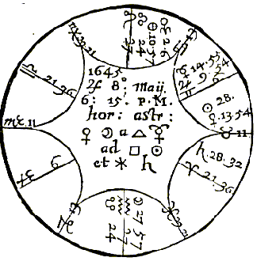

Compliments of http://mithras93.tripod.com

The Resolution of

Mars or the Sun, it proceeds of Heat and Drinesse; and so doe in the signification of the rest of the Planets.

43.

The Moon is more afflicted of Mars when she is encreased in light, and more oppressed by Saturn in her wane: beware in the beginning of a sicknesse when the Moon is thus unfortunated, and understand Mars doth more mischiefe when he is in masculine Signes, Oriental and above the Earth: doe the contrary in the judgment of Saturn.

CHAP. XLV.

A sick Doctor, what was his Disease?

If curable?

What part of the Body was afflicted.

The Signe ascending in the Question is Scorpio, the Chelae notable fixed Stars neer the Ascendant, yet it is not afflicted by the

286

Compliments of http://mithras93.tripod.com All manner of QUESTIONS

evill position or presence of any evill Planet; therefore I must next look to the 6th house, and see if it be afflicted, wherein I find Saturn in his Fall, who thereby afflicts that house, which naturally signifies Diseases by his unlucky presence; from whence I concluded, that from thence and from that house I must require the part or member of the Body afflicted or most grieved, as you may read page 244.

Aries represents the Head, as you may see page 245.

Saturn in Aries signifies the Brest, as page 112.

Mars Lord of the Ascendant in Leo doth signifie the Heart.

The Lord of the Ascendant is Mars, and him you find but lately separated from a Square Dexter of Saturn, both of them in Cardinall Signes, Mars at time of the Square in Cancer, which presents the Brest and Stomack: from hence I positively concluded, as to the parts of Body grieved, they were the Head, Brest, Heart and Stomack, and that there lodged in the Brest or Stomack some melanchollick Obstruction, the cause of all his disease and Misery.

From what Cause the Sicknesse was.

Saturn being principall Significator of the Infirmity, in his owne Termes, and the Moon in his house applying unto him, did prenote Melancholly, and such dry Diseases as are occasioned from melancholly distempers, and might abide in the Head and Brest: what Infirmities Saturn naturally signifieth, see page 244. how to make a right mixture, your Physicians best know, and what Diseases man may be subject unto in those parts, and may proceed from such causes as abovesaid.

Mars Lord of the Ascendant was also in the Termes of Saturn, and the Moon out of his Termes, applyed to a Square of Sun, and he in Mars his Termes; so that Choller was a secondary cause of this Doctor’s sicknesse; and indeed when I came to speak with him, he was afflicted with great paine and rumbling in his head, very silent, dull and melancholy, slept very little, had a very dry Cough, and complained of great weaknesse and paine in his Brest, and at the Heart; his Complexion was betwixt black and yellow, as if there was inclination to the Jaundies; he had besides

287

Compliments of http://mithras93.tripod.com The Resolution of

these, a lingering Consumption and great wearinesse all over him, and in every joynt, for the Moon is in an ayery Signe; and as Scorpio doth ascend, which signifies the Secrets, Stone in the Bladder; so doth also the Moon in Aquarius signifie the Secrets and Diseases therein, &c. so had he difficulty in making Urine, voyded red gravell, and was greatly pained in those parts, &c.

Having my selfe little judgment in Physick, I advised him to perscribe for himselfe such Physicall Medicines as were gently hot, moyst and cordiall, whereby he might for a while prolong his life; for the Moon in the 4th in Sextile with Saturn, argues sicknesse until death: He dyed the fourteenth of August following..

Whether the Disease would be long or short?

Saturn being author of the Disease, shewed it would be permanent, or of some continuance, as page 248. for he is a ponderous, slow Planet: besides, the Angles of the Figure are all fixed, the Moon and Sun both in fixed Signes, and in Square, out of Angles, both in the Termes of an Infortunate; Mars Lord of the Ascendant and 6th in a Fixed Signe; all these portend the longitude of the Disease: Besides, the Antiscion of Mars falls neer the Sun, and thereby afflicteth him, being the Luminary of the time.

288

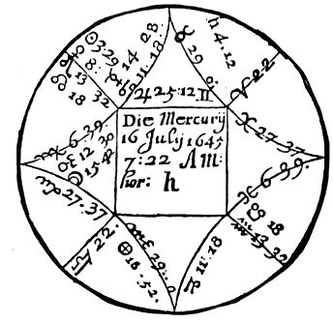

Compliments of http://mithras93.tripod.com

all manner of QUESTIONS.

CHAP.

XLVI.

Whether the Sick would live or dye,

and what his Disease was?

Judgment of the Figure aforesaid.

The Signe Ascending, viz. Virgo, is in the Figure most afflicted by the corporall presence of Mars, who is partly Lord of the 8th house, therefore from that house and Signe must we require the Disease, cause, and member grieved: Aquarius being the Signe of the 6th, is fixed, afflicted by South Node, and Saturn who is Lord of the 6th house is in Taurus, a fixed Signe, earthly and melancholy, of the same nature and Triplicity that Virgo, the Signe ascending is of; the Moon a generall Significatrix in all Diseases, being afflicted by her proximity to Mars and posited in 289

Compliments of http://mithras93.tripod.com The Resolution of

the Ascendant, in an earthly, melancholy Signe, together with the other Significators, did portend the Patient to be wonderfully afflicted with the Spleen, with the Wind—chollick, and melancholly obstructions in the Bowels or small Guts, small Feavers, a remisse Pulse; and as the Signe Virgo is the Signe ascending, and Moon and Mars therein, it argued, the sick was perplexed with distempers in his Head, slept unquietly, &c. (all which was true) I perswaded the man to make his peace with God, and to settle his house in order, for I did not perceive by naturall causes, that he could live above ten or twelve dayes..

And my reasons were, because all the Significators did promise no lesse then death: for first, Sun who was the temporall light at time of the Quere, and is (sons vitalis potentia) was in perfect Square of Saturn Lord of the 6th in Signes fixed.

Secondly, the Ascendant was extreamly afflicted by the presence of Mars, he being naturally ill, and accidentally almost Lord of the whole 8th house.

Thirdly, the Moon was neer Cauda Leonis, and afflicted by the crosse influence of Mars, in that house which signifies life, viz. the Ascendant

Fourthly, the Moon did separate from the Sextile of Mercury, Lord of the Ascendant, in Signes of long ascensions (which is more properly a Square aspect) and did transfer his vertue to Jupiter Lord of the 8th.

The sick dyed the 28th of July following, Mercury comming to the degree of the Sun in the Question, and therein to the Square of Saturn Lord of the 6th, the day preceeding; and the Moon to an Opposition of the Sun, the Moon that day transiting the degree of the 6th house at the time of the Question, viz. 14. of Aquarius, and Sun the cusp of the 12th.

CHAP. XLVII.

Of The Crysis in Diseases.

Crisis is no other thing then a duel or contention betwixt nature and the infirmity; if nature at time of the Crysis

290

Compliments of http://mithras93.tripod.com all manner of QUESTIONS

overcome the malignity of the Disease, it’s a good Crysis; if the sicknesse prevaile, it’s a pernicious and ill Crysis. Or

C R Y S I S is no more then this, viz. A sudden alteration of man’s body when he is sick, tending either to health or further sicknesse; for when this Crysis is, there’s a sharp fight, as it were, betwixt nature and the Disease, whether of them shall overcome.

Dayes Criticall, Decretory and Chrysmall are all one, and intend no more then a certaine and more sure judgment of the infirmity afflicting, either more powerfully, or in a lesse measure at those times when the true Crysis is.

The true Crysis is best of all taken from the moment of time when first the sicknesse invaded the Infirme; which if it cannot be had, then it may be taken (but not so certainly) from the very hour when first the Water is brought to the Doctor to advise for recovery: but if no Urine come, then when the Doctor first speaks with the sick party, and is demanded by the Infirmed what he thinks of his sicknesse, and what course he would advise for cure thereof.

Every sudden and vehement motion of the Disease may be called a Crysis as Galen saith; or it is, not a locall motion altogether, but an alteration of the Disease.

Or Crysis imports judgment in the Disease afflicting, and which way it will terminate, viz. for good or evil..

Hypocrates will have Crysis to be an acute or swift reportation in Diseases, either to recovery or death: But, say some, in regard there are more Diseases to terminate in health then in death (except pestilentiall Diseases) where the matter and cause is so malignant and poysonous, that nature many times doth not attend a fight or combat with the Disease, whereby it cannot properly be called a Crysis; the definition of the Hypocrates will not well hold, unlesse it be in such Diseases as doe determine in a recovery of the sick party: So some say.

Avicenna, in Canticis, agrees with Galen, and saith, Crysis (est velox motus morbi ad salutem vel ad mortem..)

There are some that have contended, That although in diseases there is a Crysis, yet is it not caused by influence of the Celestiall bodies, but from inferior causes.

291

Compliments of http://mithras93.tripod.com The Resolution of

Now if this were granted that Decretory or Criticall-dayes did proceed from inferior causes, then according to divers sicknesses and variety of humours, the severall Criticall—dayes were to be assumed, after a different way in tertians, quartans and continued Feavers: But this, as many learned say, cannot be, therefore it is more generailly received and concluded, that in regard of the great dominion and influence the Moon hath upon inferior Bodies, whereby she doth excite and stir up the humours, that she by her motion doth declare the true Crysis of the disease, and that it is required from the time of the sick parties first falling sick, and her recesse and accesse forward and backward to and from that place or degree of the Zodiack, wherein she was at the exact time of falling sick; or if that time cannot be procured, then as beforesaid, take her true place exactly rectified to the hour of the Patients first asking for advice.. I have hereunto inserted a Table, wherewith if you enter with the place of the Moon in Signe and degree, you shall easily discover when she comes to an Indicative day, when to a Semi— quadrate or halfe Crysis( when to a true Square, when to an Opposition ) which is called a full Crysis, and so for all the Indicative and Criticall dayes during the sicknesse, &c.. As for example; let the place of the Moon in the later Figure of the 16th of July 1645. be supposed the true period of beginning of a Disease, the place of the Moon is 15.42. Virgo; because 42 minutes doe almost make one degree, I enter with 16..degr.. under the Signe of Virgo in the 8th column, so that 16.degr. of Virgo is my Radix, or true place of the Moon; over against 16.degr. to the right hand, I find 8.30 over the head thereof Libra, so that when the Moon comes to 8.degr. and 31.min. of Libra, it was the first Indicative day, wherein the Physician might expect how the Disease then would shew it selfe; upon every Crysis or Indicative day, have consideration with what Planet the Moon is in configuration; if with a benevolent, expect some remisnesse in the Disease; if with a malevolent, a bad indication, &c.

Next on the right hand to 8.30, Libra, you find 1 M, viz. when the Moon came to the first of Scorpio, she was then in Semiquadrate to her first place, and this is, as it were, halfe a Crysis, at what time the Disease might more or lesse manifest it selfe according to that aspect the Moon found at her being in

292

Compliments of http://mithras93.tripod.com all manner of QUESTIONS.

that first degree of Scorpio. In the next column on the right hand, you see 23.30. over it Scorpio, it tels you, when the Moon came to the 23. and 30.min. of Scorpio, it was a second Indicative day, whereby the Physician might further judge of the encrease or decrease of the Disease: In the next column you find 16. over it Sagittarius, when the Moon came to the 16th of Sagittarius there was then a true Crysis, at what time the Disease assuredly might be more fully discerned in one kind or other, and then, according to the aspects the Moon in that degree had to the Planets, good or ill, so might the Patient or Physician expect a better or worse Crysis: and so in the same continued line or column, you run round the Heavens, ever observing the Moon her comming to those places of the Zodiack, wherein she makes the Indicative or Criticall day, and what Planets she is then in aspect with, and whether in the Figure they promise good or ill: Besides this, you shall observe what dayes she transits the cusps of the 6th, 7th and 8th houses, and how then she is aspected of the benevolent or ill Planets.

293

Compliments of http://mithras93.tripod.com The Resolution of

The Table Followeth.

B C D D E F G G H I J J K L

15 30

8 0 30

23 15 30

8 0 30

23 15 30

8 0 30

23 15 30

8

16 30

9 1 30

24 16 30

9 1 30

24 16 30

9 1 30

24 16 30

9

17 30

10 2 30

25 17 30 10 2 30

25 17 30

10 2 30

25 17 30

10

18 30

11 3 30

26 18 30 11 3 30

26 18 30

11 3 30

26 18 30

11

19 30

12 4 30

27 19 30 12 4 30

27 19 30

12 4 30

27 19 30

12

20 30

13 5 30

28 20 30 13 5 30

28 20 30

13 5 30

28 20 30

13

21 30

14 6 30

29 21 30 14 6 30

29 21 30

14 6 30

29 21 30

14

22 30

15 7 30

30 22 30 15 7 30

30 22 30

15 7 30

30 22 30

15

23 30

16 8 30 1 E 23 30 16 8 30 1 H 23 30

16 8 30 1 K 23 30

16

24 30

17 9 30

2 24 30 17 9 30

2 24 30

17 9 30

2 24 30

17

25 30

18 10 30

3 25 30 18 10 30

3 25 30

18 10 30

3 25 30

18

26 30

19 11 30

4 26 30 19 11 30

4 26 30

19 11 30

4 26 30

19

27 30

20 12 30

5 27 30 20 12 30

5 27 30

20 12 30

5 27 30

20

28 30

21 13 30

6 28 30 21 13 30

6 28 30

21 13 30

6 28 30

21

29 30

22 14 30

7 29 30 22 14 30

7 29 30

22 14 30

7 29 30

22

1 C 30

23 15 30

8 1F 30 23 15 30

8 1 I 30

23 15 30

8 1 L 30

23

2 30

24 16 30

9 2 30

24 16 30

9 2 30

24 16 30

9 2 30

24

3 30

25 17 30 10 3 30

25 17 30

10 3 30

25 17 30 10 3 30

25

4 30

26 18 30 11 4 30

26 18 30

11 4 30

26 18 30 11 4 30

26

5 30

27 19 30 12 5 30

27 19 30

12 5 30

27 19 30 12 5 30

27

6 30

28 20 30 13 6 30

28 20 30

13 6 30

28 20 30 13 6 30

28

7 30

29 21 30 14 7 30

29 21 30

14 7 30

29 21 30 14 7 30

29

8 30

30 22 30 15 8 30

30 22 30

15 8 30

30 22 30 15 8 30

30

9 30 1 D 23 30 16 9 30 1 G 23 30

16 9 30

1 J 23 30 16 9 30 1 A

10 30

2 24 30 17 10 30

2 24 30

17 10 30

2 24 30 17 10 30

2

11 30

3 25 30 18 11 30

3 25 30

18 11 30

3 25 30 18 11 30

3

12 30

4 26 30 19 12 30

4 26 30

19 12 30

4 26 30 19 12 30

4

13 30

5 27 30 20 13 30

5 27 30

20 13 30

5 27 30 20 13 30

5

14 30

6 28 30 21 14 30

6 28 30

21 14 30

6 28 30 21 14 30

6

15 30

7 29 30 22 15 30

7 29 30

22 15 30

7 29 30 22 15 30

7

294

Compliments of http://mithras93.tripod.com all manner of QUESTIONS.

You must observe, that upon the Criticall day (but especially upon the first Quartill) when Moon meets with the body or aspect of a fortunate Planet, it’s very probable (if the party be ordained for life) that nature will be fortified above the disease; and this her good aspect or application is a good indication of health, and that the Physician now imployed shall restore the sick party to former health by most easie Medicines; but if she meet at that time with the unlucky aspect of an Infortune, it gives the Physician little hopes at present; the Crysis is then ill, and the Physician must more warily proceed, &c. formerly men did repute the 7th, 14th and 21st dayes for Criticall dayes; but in regard that the Moon her motion is sometimes more slow, at other times more quick, the precise day cannot be had without compute or calculation of her true motion; which how to doe, I have given sufficient direction in my Introduction.

In giving Medicines, observe the motion of the Moon, for she Ari,Leo,Sag, the Attractive vertue is strengthened in the Plhegmatick.

Being In:

Tau,Vir,Cap, the Retentive is fortified in Sanguine people.

Gem,Lib,Aqu,

the

Digestive in the Melanchollick.

Can,Sco,Pis, the Expulsive in the Cholerick.

Moon in Cancer,Scorpio,Pisces, in Sextile or Trine to: Jupiter

Purge

Melancholly.

Venus

Purge

Choller.

Mars Sun

Purge Plegme.

The vertue retentive is stirred up from Saturn, by reason of his frigidity.

Vegetative & Digestive

by

Jupiter

Attractive & Irasicible

by

Mars

Vital & Natural Potency

by

Sun

Appetitive & Concupiscible

by

Venus

Cogitative & Imaginative

by

Mercury

Expulsive by

Moon

Fiery Signes stir up red choller, viz.

Ari,Leo,Sag.

Earthly Signes, Black melancholly

Tau,Vir,Cap.

Ayery Signes, Blood

Gem,Lib,Aqu.

Watry Signs, Spittle & Phlegme

Can,Sco,Pis.

295

Compliments of http://mithras93.tripod.com The Resolution of

I once intended a more large Discourse of Sicknesse, but Master Booker having promised to undertake that labour, I forebeare.

CHAP. XLVIII.

If a Servant shall get free from his Master?

The first house, the Lord thereof, and the Moon, shall signifie the Servant; the 10th house and the Lord of the Signe shall denote his Master, let this condition be what it will be in this judgment; consider if the Lord of the Ascendant be joyned to the Lord of the 10th house, and whether it be a perfect Conjunction, whether by body or aspect, whether with reception or not: if it be a Conjunction by degree and minute, the Servant shall be freed easily, and in a short time; but if the Lord of the Ascendant be separated from the Lord of the 10th some few minutes, it’s an argument he is as good as freed already from his Master: if no such Conjunction or aspect be betwixt the Lord of the Ascendant and the Lord of the 10th, then have recourse to the Moon, and judge the same of her, as if she had been Lord of the Ascendant, &c. I mean if she be so aspected as abovesaid.

But if neither the Moon or Lord of the Ascendant be separated from the Lord of the 10th, consider if either of them be separated from the Sun, or joyned with him, judge in the like nature of them as you would have done with the Lord of the Ascendant and the Lord of the 10th, the same aspects considered: but if the Question be determinate and not absolute, viz., if he demand, Shall I be freed from the service or slavery of this man my Master, in which I now live, or shall I ever be freed from his power? then see if the Lord of the Ascendant be cadent from an Angle, and have no aspect to the Ascendant, or is in aspect with any Planet in an Angle, or with a Planet that doth behold the Ascendant, or if he be in the 3rd or 9th, or joyned to a Planet in them; then say, he shall be freed from his service, and shall depart from his Master: say the same if you find the like aspects or have the same occasion, from the aspects of the Moon.

But if the Moon or Lord of the Ascendant be in the Ascendant, 296

Compliments of http://mithras93.tripod.com all manner of QUESTIONS.

10th, 7th, or 4th house, or if either of them be joyned to a Planet being in those angles, and that Planet be Direct, he shall not be delivered from his Master; but if the aforesaid Planets be Retrograde, it argues freedome, but with slownesse and difficulty: If the Lord of the Ascendant be impedited in the Ascendant, 10th, 7th or 4th, by corporall Conjunction of any ill Planet, or by his Square or Opposition, or if he be entring combustion, he shall not be freed from his service,

&c.

FINIS SEXE DOMUS

(finish sixth house.)

*****************************************************

The Significations of the SEVENTH

HOUSE

It signifies Marriage, open Enemies, Law-Suits, Controversies, Contracts, Warres, Bargaines, Fugitives, Thefts, &c.

Because the Demands which doe naturally appertain to the 7th house, require more consideration, and are more difficult to judge then any other house, I have been enforced to be more large in delivering the opinions of the Ancients, as of some moderne Practisers; and have also published 43 significant Aphorismes; which, if well understood, will give great light, not only for better understanding what concernes this house, but the whole body of Astrology.

297

Compliments of http://mithras93.tripod.com The Resolution of

APHORISMES and Considerations for

better judging any HORARY

QUESTION.

1.

See the Question be radicall, or fit to be judged; which is, when the Lord of the Ascendant and hour be of one nature or Triplicity.

2.

Be not confident of the Judgment if either the 1st degrees or later of any Signe be ascending; if few degrees ascend, the matter is not yet ripe for judgment; if the later degrees arise, the matter of the Question is elapsed, and it’s probable the Querent hath been tampering with others, or despaires of any successe; however, the Heavens advise you not to meddle with it at that time.

3.

The position of Saturn or Mars in the 10th, and they peregrine or unfortunate, or the South Node in that house,. the Artist hardly gets credit by that Question.

4.

Judge not upon every slight motion, or without premeditation of the Querent, nor upon sight and triviall Questions, or when the Querent hath not wit to know what he would demand.

5.

Have speciall regard to the strength and debility of the Moon, and it’s farre better the Lord of the Ascendant be unfortunate then she, for she brings unto us the strength and vertue of all the other Planets, and of one Planet to another.

6.

Behold the condition of Saturn in every Question, he is naturally ill by his excesse of cold; Mars is of ill influence, because of his too much heat: in very truth, neither of them is cold or dry, but signifie so much in their vertue and operation, and therefore in all Questions they shew tardity and detriment in the Question, unlesse the Moon and they receive each other in the Signification.

7.

See the condition of Jupiter and Venus be observed, who naturally are Fortunes and temperate, and never import any malice, unlesse by accident: where they are Significators without reception, they put forward the matter, but they best preforme the matter in question when they apply by Trine or Sextile, and to purpose when in Essentiall Dignities.

8.

In every Question where Fortunes are Significators, hope well; but in Infortunes, then fear the worst, and accordingly order your businesse.

298

Compliments of http://mithras93.tripod.com all manner of QUESTIONS.

9.

Generally consider the state of the Moon, for if she be void of course there’s no great hopes of the Question propounded, that it shall be effected; yet if she be in Cancer, Taurus, Sagittarius or Pisces, your fear may be lesse, for then she is not much impedited by being voyd of course.

10.

See from what Planet the Moon is separated, that Planet shewes what has already been done: if from a Fortune good; if from a malevolent, ill; according to the nature of the house, &c.

11.

The Application of the Moon shewes the present condition of the thing demanded, viz.

her applying by a good aspect, and in a good house, to a good Planet, intimates the strong hopes of the thing intended.

12.

The Application of the Moon to a Planet in his Fall, signifies anguish, trouble and delayes in the thing demanded.

13.

A Retrograde Planet, or one in his first station, Significator in Question, denotes ill in the Question, discord and much contradiction.

14.

We ought warily to consider if evill Planets be Significators in any thing, for if they predict evill in the thing quesited, the vengence is more heavy; if they foretell of any good, it’s lesse then what it expected, it’s imperfect, and nothing therein comes, without infinite solicitation and affliction, &c.

15.

A Planet that is slow in motion, prolongs the thing quesited after, so that it’s hardly performed; the nature of the Signe wherein the Planet is, doth herein much advantage the judgment.

16.

When Infortunes are Significators of any evill, doe you well consider if the Fortunes, viz.

Jupiter or Venus, cast not any aspect unto them, then the evill intended formerly is lessened; doe so when the Fortunes are Significators.

17.

If the Fortunes signifie any thing, and are cadent, or ill placed in Dignities, or behold not the Ascendant, or are Retrograde, then are they impedited, and shall performe little, if not received.

18.

Notwithstanding Reception, if he be an Infortune, he performes but little; but if the same happen when the Fortunes are Significators, the thing is perfected.

19.

A Planet Peregrine, viz. having no essentiall Dignities where he is, he is malicious beyond expression; if he be in essentiall Dignities, the lesse; for then he is like a noble soule that hath his enemy in his clutches, but scornes to hurt him.

299

Compliments of http://mithras93.tripod.com The Resolution of

20.

And yet generalily, if Saturn or Mars be in House, Exaltation, Triplicity and Angles, and then have Signification in a Question, they performe the thing desired.

21.

Confide not too much in the assistance a Fortune lends, unlesse he be in essentiall Dignities; for then he performes matters wholly, else but by halves.

22.

When in a Question wherein both the Fortunes and Infortunes are either weak or equally ill placed, promise no successe upon that demand; deferre the Judgment untill the Heavens have a better Position.

23.

Beware in all Judgments, when the Significator of the question is either Combust, or in Opposition to the Sun, he will then signifie nothing of the matter, no good, nor is be able to bring anything to perfection.

24.

One Infortune joyned to another, if good be signified by their aspect, yet will it have no effect, or come to any thing: If they signifie evill, it’s probable that it may fall out with more malice then expected.

25.

The Lord of the Ascendant out of his essentiall Dignities, Cadent, &c., shewes the Querent is out of all hopes in his businesse.

26.

A Planet within 12 degrees of the Sun, is said to be under his Beames, and then hath no fortitude, let it be in what Signe it will; when a Planet is within 16 minutes of the Sun, he is said to be in Cazimi, or heat of the Sun, and then it’s an addition of fortune, and he is wonderous strong.

27.

See to what Planet the Significator commits his disposition, and if Orientall or Occidentall; if it be to Saturn, Jupiter or Mars, and they Orientall, the matter is sooner performed; later, if Occidentall, doe the contrary in Venus and Mercury.

28.

Observe if the Planet that is Significator of the thing desired, be in a fixed Signe, moveable or common: fixed Signes shew stability, and that the thing shall continue, whether it be begun, or is to be begun: common Signes shew the oft probability of perfecting the thing, and yet not its conclusion: moveable Signes shew a sudden resolution or conclusion of the matter one way or other. From hence we begin Foundations of Houses and Townes when Significators are fixed; short Journeys when they are in moveable: but in things wherein we define a mediocrity, we elect common Signes.

300

Compliments of http://mithras93.tripod.com all manner of QUESTIONS.

29.

The Lord of the Ascendant or the Moon with the Head or Taile of the Dragon, brings damage to the Question propounded; see in what house they are in, and receive signification from thence.

30.

Look whether the degree of the Ascendant, or place of the Signe the Significator is in, be the then place of any Eclipse at hand; though the matter propounded be in a faire way to be concluded, yet shall it insensibly receive prejudice when least is expected, and hardly be concluded.

31.

If you find the Moon impedited in any Question, be it what it will, there will be the like stay, demur or hinderance in the thing quesited; and indeed there’s seldom good end comes of a Question where the Moon is impedited; if it be in going to Warre, you may feare the life of the Querent; if in a Journey, ill successe; if Marriage, an ill end of Wooing, &c.

32.

If the Lord of the question or the Moon be in a Signe opposite to his owne house, as Mercury in Sagittarius or Pisces, &c., the Querent hath no good hopes of his demands, he despairs, nor doth he delight in it, nor doth he care whether it can be performed or not.

33.

Consider diligently the Planet impediting the Signifier of the thing demanded, and what house he is either Lord of, or is posited in; from the nature or person of that house require the cause obstructing.

34.

The neerer your Significator is to an Angle, the more good you may expect; lesse, if placed in a Succeedant house; little, if in a Cadent.

35.

In all Questions, know there’s not so great an affliction to the Moon, as when she is in Conjunction with the SUN; the ill aspects of the infortunes doth much afflict her, but none so powerfull as her Combustion.

36.

In any Question, see if an Infortune aspect your Significator, and whether they be both Peregrine, Retrograde, Cadent, or in Signes contrary to their owne nature, it may then be doubted they inferre such a mischiefe in the question, as is inevitable, according to naturall causes.

37.

Planets that are Significators in any thing, if they are in Conjunction, and in a Signe agreeing to their owne nature, then the thing quesited after is brought to perfection with much ease and facility, else not.

38.

Have special regard to the Significators, and whether any frustration or prohibition be before the perfect aspect:

the Planet frustrating describes the party or cause hindering the matter demanded.

39.

Ever consider the Part of Fortune, which if well dignified in any house, the Querent gets by men, or things denoted by that house; and so, if ill dignified, damage from thence.

301

Compliments of http://mithras93.tripod.com The Resolution of

40.

In questions of Marriage, and unfortunate Planet in the 7th threatens ill agreement in Marriage, unlesse the same Planet be a Significator at the Birth.

41.

If the Lord of the 8th be impedited or unfortunate in the 8th, the Querent shall receive prejudice by the death of some woman, or concerning some debts due unto him from men deceased.

42.

In what house you find Jupiter and Venus well dignified, you may expect benefit from such men and things as are Signified by that house; as if in the 3rd, from Kindred; in the 4th, from Father, or by Lands, &c. in the 5th by Play, &c. and so in other houses.

43.

Beware of men and things appertaining to that house wherein South Node is in; it seldome failes, but the Querent shall receive damage, scandall or slander from men and matter signified by the house he is in.

C H A P.

X L I X.

Of Marriage.

If a Question be asked of Marriage, behold the Ascendant and the Lord thereof, and the Moon, and the Planet from whom the Moon is separated, and give those for the Significators of the Querent; and the 7th house, and the Lord thereof, and the Planets to whom the Moon applieth, for the Signifiers of him or her concerning whom the Question is asked. If it be a man that asketh the Question, joyne the Sun and Moon with his Significators, and make him partner in the Signification; and if it be a woman, joyne Venus and Moon, and make them partners: afterwards, behold what application the Lord of the Ascendant or Moon hath with the Lord of the 7th, and what application that Planet hath from whom the Moon is separated, with the Planets to whom she doth apply, or Sun with Venus; for if the Lord of the Ascendant or the Moon apply to the Lord of the 7th house, it doth signifie the Querent shall have his or her desire, yet with many petitions, solicitations and prayers: and if the application be by Square or Opposition, and with reception, it signifieth that it shall be brought to passe with a kind of slownesse, labour and travell: but if the Lord of the 7th apply to the Lord of the Ascendant, or 302

Compliments of http://mithras93.tripod.com all manner of QUESTIONS.

the Planet to whom the Moon doth apply, unto the Planet from whom she is separate; or if the Lord of the 7th be in the Ascendant, the matter shall be brought easily to passe, with great good will of the man or woman quesited after; chiefly if there be an application by Trifle or Sextile aspect.

Aphorismes of A L K I N D U S Touching

M A R R I A G E.

When the Lord of the ascendant doth apply to the Lord of the 7th, or if the Lord of the 7th apply to the Lord of the Ascendant, it’s an argument the Marriage shall be preformed and done. Also, if the Moon doth apply to Venus, and she strong, increasing in her motion, and in some of her owne Dignities, and the Moon likewise, the Marriage shall be concluded: if Venus doth behold the Sun, and the Sun have any dignity in the Ascendant, and behold the Lord of his house, viz.

of the Signe wherein he is, it doth signifie likewise the Marriage shall be concluded; but if the Planet applying, and he to whom he doth apply, be cadent from the angles, and especially if their Lords doe not behold them, it doth signifie there shall be good hopes at the first, but by dallying and tracting the time, there shall be trouble, and no Marriage at all performed: Also if Moon, Sun, Venus and Lord of the 7th, and Lord of the Ascendant be in angles, and they beholding one another, or if their Lords behold them, though with Square or Opposition, yet it signifieth the matter shall be first in despaire or suspended, but afterwards it shall by the will of God, be brought to passe, and finished by the consent of all parties.

Of Marriage, whether it shall take effect or no?

Give unto the Querent the Lord of the Ascendant, the Moon and the Planet from whom the Moon is separated; and to the party enquired, the Lord of the 7th, and the Planet to whom the Moon doth apply; and if the Querent a Man, then adde the Sun, but if a Woman then adde Venus. Then behold what application there is between the Lord of the Ascendant and the Lord of the 7th, for if

303

Compliments of http://mithras93.tripod.com The Resolution of

the Lord of the 7th be in the Ascendant, or apply to the Lord thereof, it will willingly be consented to by the party desired; If the Lord of the Ascendant or the Moon apply to the Lord of the 7th, or be in the 7th, the Querent shall obtaine his purpose by his owne labour; but if none of these happen, yet if there be translation of light between them, then it shall be effected by the meanes of Friends or Acquaintance; also the Moon in the 10th signifieth the same, also, the application of the Moon with Venus effecteth the matter, but by mediation of friends: also the application of the Sun and Venus, especially when Sun hath dignity in the 7th, idem: if the Lord of the 7th be in the Ascendant, or with the Lord of the Ascendant, or behold him with a good aspect, it doth give great encouragement for effecting the matter.

Of Marriage.

If a man aske, his Significators are; First, the Lord of the Ascendant: Secondly, the Moon; Thirdly, the Planet the Moon is separated from; Fourthly, Sun, the naturall significator of men.

The Significators of the Woman are; the Lord of the 7th, the Planet the Moon applieth to, the Planet in the 7th, Venus the naturall significatrix of women: the like judge for the woman if she aske the Question, (mutatis mutandis) that is, the Ascendant and other significators, and Venus; the question asked by the woman, the 7th and his Lord, the Planet the Moon applies unto; these are for the man, the Ascendant and his Lord, the Planet the Moon is separate from, the Moon and Venus, so the Querent hath three Significators, the party desired hath also three: It shall be, if the Lord of the Ascendant or Moon be in the 7th; secondly, if the Planet the Moon separates from, applies to the Planet the Moon applies to, thirdly, or the Sun and Venus apply to each other; fourthly, the Lord of the 1st in the 7th, or 7th in the first; fiftly, any translation of light from the Significators, or Reception of the Significators, or any collection by a more weighty Planet, it shall be, viz. one in Termes, the other in the Triplicity of the Significator, or the like. The signifiers in interchangeable Dignities, the Moon in 304

Compliments of http://mithras93.tripod.com all manner of QUESTIONS.

the 7th giving vertue to the Lord of the Ascendant, or Lord of the 7th.

Which love most, or desire it most.

The Lord of the 7th in the Ascendant, the party desired loveth best: The Lord of the Ascendant in the 7th, the Querent loveth best; and so with the other significators, for those that apply argue most love, &c. The Lord of the 7th in the 7th, especially in one of his owne houses, the party desired is free from love, hath little mind to Marriage, and her Portion is knowne, or the mans.

The significators of the party desired, not beholding the Significators of the Querent, noteth the love of some other more then the Querent, or an aversnesse to the party now enquiring.

The application of the Significators frustrated, notes the Marriage to be broken off, by such person or thing as that Signifier noteth, which you may know by the house he is in & Lord of, viz. if by the Lord of the 2nd house, want of Riches; if Lord of the 3rd, by the Brother, &c.

contrariwise, the Marriage being presaged by translation of light, or collection, it shall be furthered by such a one (as above mentioned) viz. if by the Lord of the 2nd, by some friend promising Dowry; 3rd, a Brother; 10th, a Mother; 5th or 11th, a Friend; 6th, an Unckle, Aunt, or a

Servant: Where note, that Marriages promised by Conjunction Square or Opposition, note performance with much adoe; Trine or Sextile, easie; with Reception, best of all.

What shall be the occasion of hindring the Marriage.

Having carefully observed, that although there seem great probability of effecting the Marriage enquired of, yet you find just cause to judge, it shall not either really be acted, or much obstruction will be before it can be done; and you are desirious to know from where the impediment shall come, the better to prevent it; consider what evill Planet it is who doth hinder the Reception of the disposition of the Significators, viz. of the man and woman, or who frustrates their aspect, or prohibits them, or interjects his Rayes betwixt the Significators; if he be the Lord of the 2nd, they break off on the Querent’s behalf, Money or 305

Compliments of http://mithras93.tripod.com The Resolution of

Fortune being wanting on that side, or poverty objected: if it be the Lord of the 3rd, the Querent’s Kindred, Brethern or Sisters, or some untoward Neighbor, or some Journey &c. if the Lord of the 4th, the Parent will not agree, he will part with no Lands, no House, Houses or Tenements, will settle no Estate: if the Lord of the 5th, Children may be the occasion (if either party have any;) or if a Batchelour propounds, perhaps it’s objected, he either is not capable of getting a Child, or that he hath had a Bastard, or is scandalized about such a thing, or that it’s feared the party will be wanton, or given to luxury, too much to his pleasure and pastime, &c.

vary your rule, and it serves if a woman propounded, &c. If it be the Lord of the 6th, either some of his Fathers Kindred, viz. some Unckle or a Servant, or the like, or some infirmity or sicknesse in the Querent may be the cause impediting.

If it be a Planet in the 7th, some other he or she Friend will impedite, or a publick Enemy, or one he or she have formerly had variance with, or a Law-suit, &c.

If it be the Lord of the 8th, it may be feared Death will bereave the Querent of Life ere the Marriage, or the quesited hath not a sufficient Portion, their Estate is disliked, it gives no content, it will not be accepted.

If the Lord of the 9th, one or other of the quesited’s Kindred or difference in Religion, or some busie-headed Priest, or by reason of some Journey to be undertaken by the querent, &c.

If the Lord of the 10th the Father of the Quesited, or Mother of the Querent, or some principall man, Officer or Magistrate.

If the Lord of the 11th, the Friends of both parties dislike the Match, or such as at first brought on the matter, will now endeavour to dissolve the match.

If the Lord of the 12th, then there is some under-hand dealing and much juggling in the businesse, the matter shall be much retarded, and the Quererit shall never know by whom; the Querent is much slandered, or some scandall privately insinuated doth much wrong, and will quite break the matter.

As you have notions whereby you may understand what may be the 306

Compliments of http://mithras93.tripod.com all manner of QUESTIONS.

obstacle in any Marriage, so by the same rules, rightly varied, you shall find who will afflict or befriend the Querent in his suit, or will endeavour to do him good therein; I have herein dealt very candidly, and expressed the whole truth.

Whether a man shall Marry.

If the Moon behold the Sun or Venus by a good aspect, or the Lord of the Ascendant be in the 7th, or the Lord of the 7th in the Ascendant, or either of them behold other with a good aspect, it signifieth Marriage to the Querent.

I observe, if the Significators be in Prolificall Signes, or Dignities of Venus, the party enquiring doth marry.

The time of Marriage.

The degree of the application of Moon to Sun or Venus, or Lord of the Ascendant to the Lord of the 7th, or Lord of the 7th to the Lord of the Ascendant; if it be in moveable Signes, Dayes; in common Signes, Moneths; in fixed Signes, Yeers; according to that time the Marriage shall be performed.

This must be understood when you find strong testimonies of Marriage, and that the Significators are swift.

How many Husbands a woman shall have.

Behold from the degree of the 10th house to the degree of Mars, and so many Planets as you shall find between them, so many Husbands shall she have; but if Mars be in the 11th house, then look from Mars to Jupiter, and judge accordingly: some judge from Mars to the Lord of the 10th; these rules are Arabicall: plurality of Husbands is best adjudged from the Lord of the 7th and Sun, Mars being in common Signes, or many Planets in the 7th, or Sun in Sextile or Trine to many Planets in the 7th, argues plurality, or more than one.

307

Compliments of http://mithras93.tripod.com The Resolution of

From what part one shall Marry.

If the Lord of the 7th be in the 9th, he shall marry a Stranger, &c. if the Lord of the 7th and of the Ascendant be in one quarter of Heaven, or in one house or Signe, usually the party marries one neer to the place of his own abode: consider the Signe of the 7th, the Signe and quarter of Heaven the Lord of the 7th is in, and judge by the major testimonies, from what part of Heaven the party shall live whom the Querent shall marry; as if most concurre in South testimonies, the South; mix the quarter of Heaven and Signe, preferring the Signe before the quarter: but this will be best explained upon an example.

What manner of person he or she is.

For the man, note the Planet the Moon is with; as if with Venus, say she is faire, slender and pleasant; and for the woman, judge by the Planet the Sun beholdeth; Sun in Trine or Sextile of Saturn, wife and painfull; Sun aspecting Jupiter, honest; and so of the rest; the Sun and Moon in Square or Opposition, note contention, separation and discords.

Whether man or woman be more noble.

If the Lord of the 7th be in an angle, and the Lord of the Ascendant in a succeedant house, the woman is best descended; and so if the Lord of the Ascendant be in an angle, judge accordingly; in like manner one may judge of two Companions, or any one else: A most assured way is, by observing which of the Significators is most superiour, and most potential in essentiall Dignities; if no such thing be, who is best placed in an angle, is most noble; and this will not faile.

Who shall be Master of the two.

Behold the Lord of the Ascendant and the Moon; if the Moon or the Lord of the Ascendant be received in an angle, and he that is the

308

Compliments of http://mithras93.tripod.com all manner of QUESTIONS.

receiver be an heavy or ponderous Planet, the Querent shall be Master; and whether Significators shall be found weak, ill dignified, or in cadent houses, that party shall be subject.

Whether she be rich or not.

If a man ask, see the Lord of the 8th, or Planet in the 8th, for if they are strong, or Moon applying to the Lord of the 8th by a good aspect, then she is wealthy (&c., e contra, poor;) if the woman ask of the man, and of his estate, judge after the same manner. (eadem est ratio.) Whether the MARRIAGE be Legitimate.

If the Significators of them, either of the man or woman be vitiated or joyned to Saturn or Mars, and they not Significators in the Question, or if they be with South Node, it sheweth unlawfull Marriage, viz. there hath been some wrangling or claime laid to the party by some former man or woman.

How they shall agree after Marriage.

If the Figure performe Marriage, note if the Lord of the Ascendant and Lord of the 7th aspect each other with Trine or Sextile, they agree well: Moon beholding her Dispositor, or Lord of the Exaltation of the house wherein she is, with good aspect, idem: The Lord of the 7th more weighty, and in an angle, she will be Master, or strive for it: if neither the Lord of the Ascendant, or of the 7th be in angles, then note the weightier, for that party signified by him, shall be Master; Sun impedited, worst for the man; if Venus be impedited, worst for the woman; if the Moon be impedited or unfortunate, is ill for them both.

Disagree.

The Lord of the Ascendant and Lord of the 7th in Square or Opposition, Lord of the Moon impedited beholding the Ascendant,

309

Compliments of http://mithras93.tripod.com The Resolution of

or Saturn, Mars or a Retrograde or Combust Planet in the Ascendant, doth note contention ever by the Querent, &c. e contra, judge the like if the Lord of the 7th suffer the same afflictions, that then the Quesited shall be the occasion of strife: the Moon in her fall, or at Square or Opposition with Saturn or Mars, or any Retrograde Planet, if the Moon then behold the Ascendant, noteth brawling ever moved by the woman; Saturn, Mars, South Node in the Ascendant, idem., if the question be asked by the man.

Who shall be the cause of their Strife,

or the author of their Good.

If the Lord of the 3rd be that Planet who doth afflict or impedite, and he in the Ascendant or 7th house, it shall be by Brethern or Kindred; an Infortune in the 10th, notes brawling, and continuall chiding and wrangling: In the 4th, either a Divorcement or a willingnesse to it, or hinderance in Dowry; the Moon infortunate beholding the Ascendant, note brawling, separation and dishonest living: ill Planets in the 10th and 4th, ill persons make contention, or their Parents; no application between the Planet the Moon separates from, and the Planet unto whom she doth apply, notes contention alwayes: if the Moon doth aspect, or be in conjunction with Saturn or Mars, one of them shall dye quickly, or have some misfortune; if this conjunction be in the 10th or 4th, in a masculine Signe, the man shall suffer; if in a feminine Signe, the woman: The Moon in Trine or Sextile good Planets, declares gifts from Friends; Moon in Square of good Planets, by dead men; Moon in conjunction of good Planets, promises good by their owne industry and labour; if the Moon aspect Saturn or Mars, or be in the 12th or 8th, or voyd of course, they shall have both troubles, griefes and sicknesse; in angles, notes a probability of separation or long disagreements.

That the Marriage shall be broken,

and the cause thereof.

Behold the Planet who receiveth the light of the Significators, if he be a heavy Planet, and be hindered by Square or Opposition

310

Compliments of http://mithras93.tripod.com all manner of QUESTIONS.

of an ill Planet, or be Cadent, the intended Marriage shall be broken off againe, though at present it is very feasible. Behold whether parties Significator is strongest, that party shall first marry after this dissolution.

If the ill Planet that hindereth the Marriage be Lord of the 2nd or 8th house, it is for matter of Dowrey; if Lord of the 3rd, Brother; if Lord of the 4th or 10th, it is the Father or the Mother, or such like; and so judge for the rest.

If there be an ill Planet that carries the light between the Significators, it shall be by meanes of a Messenger; describe that Planet, and you may notifie the party.

That woman who doth depart from her Husband or become a Widdow, the Moon being between the 17th degree of Sagittarius, and the 1st minute of Capricorn, shall never returne or marry. (An Arabic Aphorism, not overmuch to be credited without consent of other Significators.) Whoso is Espoused to a Wife the Moon being in the first 12 degrees of Capricorn, shall lose her before marriage, or dye within 6 moneths, or live in discord with her.

Whether a Man or his Wife shall dye first,

and the time when.

Behold the Lord of the Ascendant and the Lord of the 7th, and see which of them goes first to Combustion, and if the Lord of the Ascendant, the Querent shall dye first; if the Lord of the 7th, the Quesited: The Lord of the Ascendant Retrograde or Combust, or in his Fall, or neer the Lord of the 8th, the Man; the Lord of the 7th in the, like case, the Woman: Sun unfortunate, the Man; Venus unfortunate, the Woman.

Usually I observe, whose Significator is first Combust, and in what Signe; if he be Combust in Tropick Signes, as Aries, Cancer, Libra, Capricorn, it portends death in a short time; If in common Signes, viz. Gemini, Virgo, Sagittarius, Pisces, the time is longer: in Signes fixed, viz.

Taurus, Leo, Scorpio, Aquarius, it will be a longer time ere the party dye, &c.

Which of the two shall live longest?

Behold the Lord of the Ascendant, and of the 7th, which of these 311

Compliments of http://mithras93.tripod.com The Resolution of

two are in the best place of heaven, best dignified, and in good aspect with Fortunes, and more remote from the presence or ill aspect of the Lord of the 8th house. That person shall live longest: Where you must observe, as to the Lord of the 7th, the Lord of the 2nd in the Figure is his 8th house, and so Lord of, or Significator of death.

Whether she be a Maid, or Chaste,

of whom the quere is.

Look if the Lord of the Ascendant Venus and the Moon be found in fixed Signes, good Planets beholding them, then say,, she is a Maid, and chaste: But if in place of the Fortunes there be Infortunes, say she is neither a Virgin, nor chaste: especially if Mars be there, and he in the house of Venus without Reception: Also, if Moon and Sun behold themselves and Mars, she is no Maid; but if the Significators be in moveable Signes, Infortunes beholding them, say then she desireth a man very much, and that she refraines and restraines her concupiscence very much, and casts off her Suitors; yet, it is not to trust alwayes to this judgment, because the nature of women is changeable.

The Significatrix of the woman in her owne essentiall Dignities, or in Trifle to the Sun or Jupiter with any Reception, or the Moon and the Significatrix in Trine or Sextile, in Reception, out of any mutuall Dignities, or Venus in Leo not afflicted, or the Moon in Aquarius, free from Square, Conjunct, or Opposition of Mars, I judged honesty, and I found it ever true.

Whether A Damosell be a Maid or not.

Behold the Ascendant and his Lord, and the Moon, and if thou findeth them fixed and well disposed, it signifieth she is a Virgin; but if they be in common or moveable Signes, or evill Planets be in fixed Signes beholding them, or aspect them any way, it is a doubt of Legerdemain; also Scorpio Ascending, argueth she is, or would be too familiar.

In many things I dissent from the Ancients, and so in this; for if Mars be in Leo, and Scorpio ascend, the Querent is suspected and tempted, but yet is honest.

312

Compliments of http://mithras93.tripod.com all manner of QUESTIONS.

Whether a Woman be honest to her Husband.

The Lord of the Ascendant, the Moon or Venus in fixed Signes, in aspect of the Fortunes, she is chaste; these being in aspect of the Infortunes, not chaste, chiefly with Mars; Sun or Moon beholding Mars, she is meretrix; Sun and Moon in no aspect, nor Mars with them, she is suspected a privy Harlot, rather privately wanton.

I must change all sonnes of Art to be sparing in delivering judgment upon these queries, rather to be silent; for as men we may erre, and so by delivering an unlucky judgment, be authors of much mischiefe.

Of a woman whether she be corrupt, or has a

Lover besides her Husband or sweetheart.

Behold the Ascendant and his Lord, and the Moon, and see if they be both in angles or fixed Signes, then say the Maid is a Virgin, and they lye of her, or what is reported is false: if the Lord of the Ascendant, and the Moon be in fixed Signes, and the angles be moveable Signes, she was tempted, but gave no credit or admittance to the Temptor. If the Moon be joyned to Saturn, Jupiter, Mars, Sun corporally by aspect, so that there is between them but 5 degrees or lesse, she is tempted of someone who has the effigies of that Planet to whom she is joyned; but if

the

Moon be joyned to Venus or Mercury, she is tempted by some woman for a man, but she makes not reckoning of the old or young Bawds words, but she laughs her to scorne: If the angles be fixed Signes, and the Lord of the Ascendant or Moon in moveable or common Signes (for in this judgment the common are of lesse importance) she hath been attempted, and is still tempted, but she is honest; and hath been formerly deluded, if she be with the North Node: but if then the Moon be with South Node, she has formerly offended, and is still guilty, nor will she amend hereafter; the same may be said of Mars, if he be in place of the South Node; yet Mars imposes not so much malice on the woman as South Node: generally the Moon in any Question with South Node, imports mis—reports of the woman, you may call them slanders.

313

Compliments of http://mithras93.tripod.com The Resolution of

Whether a woman is honest.

*This where suspition of the quesited’s honesty will hold true.

The Moon in the last face of Gemini, the woman seems to be corrupt, if the Ascendant be a moveable Signe, or common, or if the Lord of the Ascendant or Moon be in moveable or common Signes she is no Virgin; The Lord of the Ascendant combust in a moveable Signe, the woman has been tempted and made a harlot by violence, or she was unwillingly drawn to lewdnesse; the Lord of the Ascendant in a fixed Signe, and the Ascendant fixed, though the Moon be in a moveable Signe, she is still a Virgin and honest; the Moon in the Ascendant with Saturn, the woman was abused by force, and not by her concent: If the Ascendant be a fixed Signe, and the Lord of the Ascendant in the 5th, or the Moon in the 5th, or the Lord of the 5th in the Ascendant, or both of them corporally joyned in one Signe, it seems the woman hath newly conceived, or was lately tempted; but if they be separated asunder by 3 degrees, it seems the woman is delivered, or free from the party she was lately in fear of.

Whether A Woman Trades With Any But Her Husband.

*These judgments must be carefully observed and well considered before judgment be propounded in the negative, viz. that she is not honest.

Behold the Ascendant, his Lord, the Moon, and Planet from whom the Moon is separated, these are Signifiers of the Querent; the 7th house and his Lord, the Planet to whom the Moon is joyned, are the Signifiers of the woman: see to whom the Moon and Lord of the 7th is joyned, which if they be both joyned to the Lord of the Ascendant, whether with Reception or Conjunction, say, the woman is not faulty, but honest: but if the Lord of the 7th, or the Moon or either of them is joyned to the Lord of the Triplicity of the Ascendant, viz. to him that is Lord of the Diurnall or Nocturnall Triplicity then ascending, or if any of them is joyned to the Lord of the 7th, and Moon is separated from the Lord of the Ascendant, it then seems she hath a Friend that she loves besides her Husband: the Lord of the 7th voyd of course, the woman hath no Friend.

The Lord of the 7th, the Moon, or both, separate from any other Planet but the Lord of the Ascendant, and he not separated above

314

Compliments of http://mithras93.tripod.com all manner of QUESTIONS.

3 degrees, the woman did love another, but she hath now left him: the Lord of the 7th with the North Node, the Woman is blamelesse, without he be in Conjunction with some other Planet, then she is worthy to be blamed not, was also in times past, and in times to come will be; for if she be not faulty in act, she is in her desires and affections.

The Lord of the 7th or Moon joyned with Mars, if the North Node be there, it seems the woman hath a Sweetheart whom she loveth, and that useth her company: If Mars be with South Node, and the Lord of the 7th be joyned as beforesaid, it minisheth the malice, and though the woman love some martial man, yet he cannot bring her under his Yoak, yet is the hard put to it, and much perswaded

If Mars be with the Lord of the 7th, or with Moon, or in one Signe in Conjunction, or with South Node, the woman hath a Sweetheart in contract, not farre from her house; and if they be in 1

degree, then he is in the house, and one of the familiars of the man that asks the Question, or of her owne Husband.

If the Moon or Lord of the 7th separate from Mars, or Mars from him, or that they be separated, perchance the woman had a Lover before she knew her Husband, but now they have one forsaken the other, or they have forgot each other.

Mars Lord of the 7th, or Moon Lady of the 7th, in Aries or Scorpio, and Mars beholding any of them, viz. either of the Signes, or Moon, or in Reception with one or other, viz. Moon and Mars, for if Mars did receive the Moon, she did a long time love one, but she hath little to do with him now: Moon Lady of the 7th, in Conjunction with Mars or Jupiter in any Signe whatsoever, the woman hath loved a certaine man, a Nobleman or a Bishop, viz. a man of better quality than her selfe, but if there be a mutuall Reception between them, they still love one another, or still some acts of kindnesse passe between them, and there wants nought but opportunity.

The Lord of the 7th or Moon joyned to Mercury, the woman seems to love a young Clerk, or a Merchant, or witty, nimble Fellow.

The Lord of the 7th joyned with Venus with Reception, with or without any aspect, or else by a Trine or Sextile, or Square

315

Compliments of http://mithras93.tripod.com The Resolution of

without Reception, the Woman cares not for men, but hath a friendship with women, or speaks wantonly, but is not naturally lewd or vitious.

The Lord of the 7th or Moon in Conjunction with Saturn, the woman loveth an Old Man, or a Religious man, or a Country-man or a man of plaine sober carriage.

The Lord of the 7th joyned to the Sun, she loveth at present, and did love a certain great person, according to the quality of the Demandant; if it be with Reception, he hath or may have, if he please, to doe with her; but if it be without Reception, he cares not for her, but hath quite forsaken her: But if more Planets doe behold the Sun as well as the Lord of the 7th, especially Saturn or Mercury, more men hath had to doe with her, nor is she yet amended, but somewhat tardy, &c.

If ones Lover or Wife hath a Sweetheart besides himself.

See if Mars be in the 7th house, so that he be not in his owne house, then she hath none; if Saturn be there, she loveth one but lyeth not with him; if Jupiter be there, she hath much adoe to be honest; if Venus, she is a merry wag, and is thought to be wanton, but is not: if Mercury, she had a Friend but hath not now; if Moon be in the 7th, she as yet hath none, but she will have, and will be common: if Sun or North Node be there, she is chaste and hath no Friend: After the same manner you may judge of Friends, or of the man, when the woman propounds the Question.

Hath she a Lover?

Any Planet in the 7th, (so he be not the Lord of the 7th) she hath one of his complexion, (if none be in the 7th, none;) thus doe for the man, but have relation to the 11th house: The Lord of the 7th voyd of course, she hath none; or with the North Node, idem: the Lord of the 7th or Moon joyned to Mars, she hath a Sweetheart, or one whom she is familiar withall, that she doth much respect, but I say not in any dishonest way.

316

Compliments of http://mithras93.tripod.com all manner of QUESTIONS.

If a Marriage shall be perfected or no.

Consider the Lord of the Ascendant and the Moon, these are properly Significators of the Querent; the 7th house and his Lord are for the Quesited.

If the Lord of the Ascendant or Moon be joyned to the Lord of the 7th, in any of the dignities of the Lord of the 7th, and in the Ascendant, 11th or 10th, hardly in the 7th, the querent shall obtaine the party desired.

If both Significators behold each other with Sextile or Trine, out of the Ascendant and 11th, or 9th and 7th, or 7th and 5th houses, with or without Reception, no prohibition, frustration or abscission, or Retrogradation of the principall Significators intervening, the Match will be concluded if the querent please, (for we doe suppose a freedome of will in this , nature) if a Square or Opposition be between the Significators (and no Reception) the matter will come to nothing.

A Square aspect with Reception of Significators, perfects the matter, but with a little difficulty; if no Reception be, there’s onely hopes, no grounds whereby to judge the thing shall be effected really.

Contrary to all the rules of the Ancients, I have ever found, that when the Lord of the 7th hath been in the Ascendant, the Querent hath loved most, and when the Lord of the Ascendant was in the 7th, the Quesited loved best.

If the Significators aspect not one another, but some Planet transferres their influence one to another, and this with a benevolent aspect, then shall the matter be brought to passe by one signified by that Planet, whose description you may frame according to the Signe wherein he is, and his quality from the house he is Lord of. A masculine and diurnall Planet denotes a man; a feminine, nocturnall Planet, or a man of a feminine construction, &c. sic e contrario.

If a Planet transfers the Significators disposition, observe who that Planet is, and to whom he commits his disposition, and whether he be not Retrograde, Combust or unfortunate or Cadent 317

Compliments of http://mithras93.tripod.com The Resolution of

from his owne house, or in the figure, or in Opposition or Square aspect to an Infortune, without Reception; for then if no such thing be, the matter will be effected and continue, especially if he be a Fortune, and the Matrimony will take well, and the people love together.

Whether the Child conceived is the Sonne of him who is reputed his Father.

Behold the Lord of the Ascendant and the Moon, who signifie the Interrogant; then observe the Signe of the 11th and his Lord, these signifie the issue in Conception; if these Significators behold one another by Trifle or Sextile, with Reception or not, the Conception is legitimate; if they behold one another with Square or Opposition, with mutual Reception, and perfect aspect, or the Lord of the Ascendant or the Moon in the 5th, or if the Lord of the 5th be in the Ascendant, without evill aspect of the Infortunes, or if the Fortunes one or both doe behold the 5th house or his Lord, the Child conceived is legitimate and true begotten, &c. but if none of these things be, but that Saturn, Mars or Mercury behold the 5th house, or Lord thereof, there may be just suspicion the Child is conceived in adultery, and the Mother was stuprated.

Of a woman living from her Husband, whether she shall ever live with him againe or not,

or be received into favour.

This Question will as well resolve the doubt concerning a Mistris, &c. or Sweetheart.

If the woman her selfe propound the Question, who is absent from her Husband or Friend, &c.

Whether she shall be received into favor or not againe?

Consider herein the Lord of the 7th, which is the Ascendant of the woman in this case, for the 7th is ever given to the banished or expulsed party; see if the Lord of the 7th behold the Ascendant so partilly, or with so true and good an aspect as himself doth, then without doubt she shall again return and come into favour; if the Lord of the 7th behold not the Ascendant, but another Planet who is not impedited, yet beholds the 318

Compliments of http://mithras93.tripod.com all manner of QUESTIONS.

Ascendant, the woman shall be received againe by the mediation of some person who shall interpose his friendship with the Husband or Friend, and reconcile them; if none of these things be, then have recourse to the Sun, the natural Significator of man, or the Husband, and of Venus, the naturals Significatrix of the woman; and if the Sun be above the Earth, and Venus behold the Ascendant with a pleasant Sextile or Trine the woman shall return to her house or Sweetheart with ease or without any great noyse.

If the Sun be under the earth, and Venus above, and behold the Ascendant with Sextile or Trine; the woman or wife shall be received, but with some importunity and delayes, with much adoe, and a great deale of labour, and all her Neighbours shall take notice of it.

If the Moon be encreasing in light, and in any good aspect to the Ascendant, she shall returne, but with much solicitation.

If the Moon be Decreasing in light, and in her 2nd or last quarter, and not neer the Sun beames, but beholding the Ascendant, she will returne with much ease and quickly.

Behold if Venus be Occidentall, Retrograde and hastening to Combustion, then of her owne accord the woman will returne to her Husband, fearing by her absence she shall offend him, and she is sorry she ever departed from him; but if she be lately separated from the Sun beames, then it repents the man that he gave occasion to his Wife to absent her selfe, or that he abused her; but the woman will be angry and malapert, and seems sorry that she shall returne, nor will she much respect her Husband after that time.

CHAP. L.

Of Servants fled, Beasts strayed, and things lost.

The Signifier of the thing lost is the Moon, wherefore if you find the Moon applying to the Lord of the Ascendant, or to the Lord of the 12th from the Ascendant, or to the Lord of the house 319

Compliments of http://mithras93.tripod.com The Resolution of

of the Moon, the thing missing shall be found againe; [this principally concerns Cattle strayed]

but if the Moon apply to none of these, nor abide in the ascendant nor in the 2nd house, the thing lost or miscarried shall not be found: if the Lord of the house of the Moon be in the 3rd, or in a Sextile to the Ascendant, there is some hope of finding the thing againe, during that aspect with the degree ascending: And againe, if he separate himselfe from the Lord of the 12th, 8th, or 6th house, and apply unto the degree of the house of Substance, (what aspect soever it be) there is hope to find it again; or if the Lord of the house of the Moon do behold Moon; but if you finde these Constellations contrary, judge the contrary; if the Moon be fortunate by any of the two Fortunes, the thing that is lost chanced into the hands of some trusty body, which keepeth the same, and would fame restore it againe; or if that Fortune apply to the ascendant, or behold the same, or the Moon behold the ascendant, that faithfull person will restore the same again to the owner.

The place where the thing is that is lost.

The Signifier of the place where the thing is at time of the Question, is the place of the Moon according to the nature of the Signe she is in, for if the Signe be Orientall, it is in the east part; if it be Occidentall, it is west, &c. Behold also the place of the Moon in the Figure, for if she be in the Ascendant, it is in the east, &c. if the Lord of the house of the Moon be in humane Signes, it is in a place where men use to be; if in Signes of small Beasts, as Aries and Capricorn it is where such kind of Beasts be: Also, look to the Moon, and see if she be in a fiery Signe, it is where fire is; if in a watry Signe, where water is &c. if the Moon be with the Lord of the ascendant in one quarter, and there be not between them more then one Signe, the thing lost is in the house of him that lost it, or about it; but if there be between more then thirty degrees, and lesse then seventy degrees, the thing is in the Towne where the owner is, but if they be not in one quarter, it is then farre from the owner.

320

Compliments of http://mithras93.tripod.com all manner of QUESTIONS.

How the things or Goods was lost.

If you will know how in what manner they were lost, behold from whom the Lord of the Ascendant did last separate, and if he did separate from Saturn, the cause of the lost thing was through forgetfulnesse of the owner, who knowes not where he laid it, or it is forgotten by reason of some cold or sicknesse which afflicted the loser, especially if Saturn be Retrograde, if he be separated from Jupiter, or in the house of Jupiter, then through fast or abstinency, or ordering of Lawes, or by his excesse of care of governing of things, or managing the affaires of the house, or else by some trust put upon him that carried it away or mislaid it. [This was Frierly Astrology and supposes somewhat lost in an Abbey or Nunnery.]

If he be separated from Mars, or in the house of Mars, it was lost through fear, or by some hidden passion, provoking the loser to anger, fury, fire, or for emnity, or upon a quarrell. If from the Sun or his house, then by the meanes of the King, study of hunting or pastime, or by meanes of the master of the Family, or a Gentleman. If from Venus or in her house, then by drinking, Cards or Dice, or making merry in an Alehouse or Taverne, or by pastime, or singing and dallying with women, &c. If from Mercury by reason of writing, or sending, or dictating of Letters, or going on a Message: If from the Moon, or in the house of the Moon, it was lost by too frequent use, and shewing the Commodity of thing lost, or the party made it too common, or some Messenger, Widdow or Servant lost the same. If the thing lost or missing be a Beast, and not a thing moveable, the signification in knowing the place, and the state thereof, is as the said significations of things not having life, but that it is needful to seek whether it fled away of it selfe, or some other drove him away, whether it liveth or no? and to find the cause of the death of it, if it be dead.

Whether it be stolen or no.

[This concerns Cattle.]

If you would know if the Beast fled away by it selfe, or some body took it, behold if you find the Lord of the house of the

321

Compliments of http://mithras93.tripod.com The Resolution of

Moon seperating himselfe from any Planet, say then, that he fled away of his owne accord; but if the lord of the house of the Moon be not separated from any Planet, but that another Planet is seperating himselfe from him, say that some one or other took it and fled away; but if the lord of the house of the Moon be not in any of these two we speak of, behold what you see by the positure of the Lord of the 2nd house , and judge by him as you judge by the Lord of the house of the Moon, and her separation; and if you find of these two no separation, say that the Beast is still in his place, or neer it, and that he fled not away.

Whether it be alive.

If you will know whether it be alive or not, behold the Moon and if you find her in application to the Lord of the 8th house from her, say it is dead; and if you find no such thing, behold her Lord, and if you find him applying to the Lord of the 8th house from the Moon, say likewise that it is dead, or it shall dye very shortly; but if in none of these you find application, take the signification from the Lord of the 8th house after the same manner.

Whether the thing missing be stolne, or fled of it selfe.

[Stolen.] If the Significator of the Theef be in the ascendant, or giveth his vertue to the Moon, or the Moon to him, it is stolen, or the Lord of the ascendant to the Significator of the Thiefe, or the Signifies of the Theef apply to the Lord of the Ascendant by Square or Opposition, or the Moon by Conjunction, Square or Opposition, or the Lord of the house of the Moon, or her Terme, or the Lord of the 2nd house, or Part of Fortune or his Lord, or if any Planet be in the Ascendant, and give his power to the Signifier of the Theef, or the Signifier to him by Square or Opposition, if some of these constellations be not, it is not stolen, except there be an Infortune in the Ascendant or 2nd, or the Lord of the house of the Moon, or her Terme be infortunate, or the Part of Fortune or his Lord, or the Lord of the Ascendant, or the Lord of the 2nd house be infortunate, these signifie losing.

[Not Stolen.] Or of you find the Lord of the house of the Moon 322

Compliments of http://mithras93.tripod.com all manner of QUESTIONS.

seperating from any Planet, it is fled of its owne accord; if he separate not, but some other from him, it is driven away; the like in either by the Lord of the second, if he be in no such state or position, the thing abideth still, and it is not stolen.

For Beasts strayed, or Fugitives, or any thing lost.

[If found.] The Significator is Moon, wherefore the Moon applying to the Lord of the ascendant, or 2nd house, or the Dispositor, it shall be found, otherwise not; Moon in the Ascendant, or her Dispositor in a Trifle or Sextile, gives hopes to find it; the Dispositor of the Moon seperating from the Lord of the 6th, 8th or 12th, and applying to the Lord of the Ascendant, or to the degree of the 2nd house, good hopes also; Moon in aspect to her Dispositor, good; Moon infortunate of the Lord of the 6th, 8th, or 12th house, it is in the hands of an ill person that will not depart from it, chiefly if the Infortune behold the Ascendant or his Lord.

[Restored.] Moon beholding Jupiter or Venus, it is in the hands of an honest man that will restore it againe; if Jupiter or Venus have any aspect to the ascendant, or Moon apply to the ascendant; Moon in the ascendant, it is restored with trouble or paine; or the Lord of the 12th in the 12th house, the Lord of the 7th in the 12th, the Fugitive is imprisoned. [Fugitive in restraint.]

[The Place.] The place: Moon in the 10th, it is south; in the 7th, west; in the 4th, north; in the ascendant, east, &c. the Dispositor of the Moon in a humane Signe, it is in a place where men use; in Cancer, Scorpio or Pisces, a place of Water or Wels; Moon in the last face of Capricorn, it is amongst Ships; this must be when things are lost neer a Harbour.

Moon In Aries, Leo, Sagittarius, in a place of fire; Moon or her Dispositor being in movable Signes, it is in a place newly broken up.

[Strayed.] Moon within 30 degrees of the Lord of the Ascendant the thing is with the Loser, or neer him; Moon more then 30 degrees from the Lord of the Ascendant, it is farre off; the Dispositor of the Moon seperating from another Planet, it is strayed; another Planet seperating from the Dispositor of the Moon, it is stolen.

323

Compliments of http://mithras93.tripod.com The Resolution of

Moon Or her Dispositor applying to the Lord of the 8th, or 8th house from the Moon, it is dead or will dye shortly.

Moon In the ascendant, or Trine to the Lord of the Ascendant; Moon in Trine to Sun, found.

The Lord of the 2nd in the 10th or 9th, it is in the house of the Querent, or in the power of a familiar friend; Sun in the Ascendant (unlesse in Libra or Aquarius) found; the Lord of the 2nd in the 11th or 12th, farre off.

Of Beasts or Strayes.

If the Lord of the 6th be in the 6th, the Beasts be small: if the Lord of the 12th be in the 12th, the Beasts be great: if the Lord of the 6th be in the 6th or 12th, they be in a Pound; if the Lord of the 6th be in fiery Signes, they shal be under fetters and locks; if the Lord of the Ascendant and Lord of the hour be one Planet, then it is true they are in Pound; if the Moon be in common Signes, they are in rushy grounds; if in an angle, they be in Closes or Grounds, if in a succedant, they be within Closes, or about them, on the right hand of the owner; if the Moon be in a cadent house, they are in common Fields; if in Cancer, where Dennes and water-beasts be, or some little Rivolet, if Aquarius or Pisces in watry or fishing places, or neer Fish-ponds, in the last moity of Capricorn, in a place of Ships, or some Wood or Wood-yard.

[This concerns Goods immovable.]

Behold the Signe where the Moon is, if in fiery Signes, in a place where fire is, or about a fire, or where fire hath formerly been made; the Moon in watry Signes, where water is, or about waters; the Moon in ayery Signes, in a place of many windowes, or open places, as Garrets, and such like; (this has relation to Beasts strayed.) the Moon in earthly Signes, in an earthly place, where houses are made of earth, or neer mud wals or clay; the Moon, or the Lord of the house where she is, be in a movable Signe, in a place new peopled, or a house new built, or where are hils, and in other places levell grounds; the Moon in a fixed Signe, in a plaine Country or champion; the Moon in a common Signe in a place of much water, according to the nature of the place where the thing was lost or missing.

all manner of QUESTIONS.

Another Judgment

324

Compliments of http://mithras93.tripod.com Common Signs, as Gemini, Virgo, Sagittarius or Pisces, do signifie within the house, if it be dead things, as rings &c. but if it be quick or living things, or Cattle, it signifieth watry grounds, Ditiches, Pits, Rushes, a Market-place; fixed Signes, the Goods are hid, or laid low by the earth, or neer it, in wals, or in hollow Trees; movable Signs, high places, Roofs, or Seeling of houses; watry Signes, in water, or under the earth, a Pavement, Foundation of houses, &c.

That the Beasts are lost.

The Lord of the 6th unfortunate by Saturn or Mars, the Beasts be lost, chiefly if the Lord of the 6th be cadent, or that the Cattle are drived away or stolen; if any Planet doe separate from the Lord of the house of the Moon, it is driven away or sold; if the Planet separate from the Lord of the 2nd, idem; if you find none of these, the Beasts are not far off.

Dead or alive.

If the Moon apply to the Lord of the 8th, it is dead, or to the 8th house; if the Lord of the house of the Moon apply to 8th,idem; or if the Significator of the Beast be in the 8th, in Square to any infortunate in the 4th.

In Pound or not.

If the Lord of the 6th or 12th be in the 9th or 10th, then are the Beasts with some Justice or Officer, as Baily or Constable, or under Lock, or are commanded to be safe kept; for the most part Lord of the 12th or 6th in the 12th or 6th, they are kept close.

That the Cattle shall be found againe.

If the Lord of the 6th be fortunate by Jupiter or Venus, and if they be found in the 2nd, 5th or 11th houses, the Beasts will be had again; if the Lord of the Terme of the Moon, or the Lord of the Cusp of the 4th house be with the Lord of the Ascendant, idem; or if the Lord of the 6th or 12th be in Trine of Sun out of angles.

325

Compliments of http://mithras93.tripod.com The Resolution of

How farre off a thing lost is from the owner.

The Moon in the same quarter with the Lord of the Ascendant if there be but one Signe between them, the lost thing is in the house, or about his house that lost it; if there be more then 30

degrees unto 70, the thing lost is in the Town, and in the same limits and bounds where the owner is; and if it be not within 90 degrees, the thing list is farre distant from the owner; for usually when the Significator of the thing lost is in the same Quadrant, or the Moon, the goods are in the same Town or Hundred where the Querent liveth.

Beasts stolen or strayed.

If the Lord of the house of the Moon, or Lord of the 2nd doe separate from their owne houses (if the goods be fixed) it is stolen; if moveable, fled of his owne accord.

In what place they are.

If the Lord of the 6th be in an angle, the Beasts be of small growth and in Pounds, Closes or houses; in cadent, in a Common, and are going way-ward; in succedant, in some Pasture neer hand.

Which way.

If the Lord of the 6th be in fiery Signes, east-ward in Woods or where Bushes, Brambles or Ferne have been burned; but in angles in fiery Signes, in Closes or Pound, or under Lock.

The Lord of the 6th in earthly Signes, South on dry lands, or grounds, but if in an angle, in a Pound, or close Pound with a thing that earth is about it, viz. a mud wall; if succedant, it is about Closes on the right hand of the Querent.

The Lord of the 6th in an ayery Signe, they are most in plaine ground, if he be in an angle, they be in Pound or housed west from the place where they were lost; In succedant, on the right hand westward; on cadent, on the left and going away-ward, viz. Straying further from their right Owner.

326

Compliments of http://mithras93.tripod.com all manner of QUESTIONS.

If the Lord of the 6th be in watry Signes, North, in a low place; if in an angle, in Close-ground, northward; in cadent, in the Common on the left hand, where water is, or Medowes, going away-ward, or where people water their Cattle.

In what grounds they be.

If the Lord of the 6th be in movable Signes, they are in hilly ground.

If the Lord of the 6th be in fixed Signes, in plaine ground where is new building, or some grounds new plowed or turned up. Common Signes, where water is, rushy grounds, ditches.

If the Lord of the Terme of the Moon be in a fixed Signe they are in a plain ground newly taken in, or nigh a new building.

In movable, in new land, or ground full of hils.

In common Signes, in a watry place, rushy or a marshy ground, nigh ditches and pits.

The Cattle shall to Pound.

If the Moon be in the 12th, they shall be had to Pound or be pounded, what signification soever, if the Moon be unfortunate, they shall to Pound; if the Lord of the 12th and principall Significator be unfortunate, they shall to pound, or be kept obscurely in some private or close place.

Long in Pound.

If Saturn be in the 12th, or in the 1st (when the Querent comes to know of you what is become of the Cattle) or the Moon in the 12th, any of them unfortunate, than shall they be long in pound; if Mars aspect Saturn or the Moon in the 12th, with Conjunction, Square or Opposition, they will be killed in Pound, or dye there, or be very neer starving.

From hence the movable, fixed or common Signes may easily be knowne, when Sheep be stolen, whether and where they are killed

327

Compliments of http://mithras93.tripod.com The Resolution of

or not? if Saturn be in the ascendant, 4th, 8th or 12th, long in pound.

Escape the Pound.

If the Lord of the ascendant be in a movable Signe, in the 3rd, 9th or 10th, they shall escape Pound; if the Lord of the ascendant be in the 12th, though good, yet sick and ill in Pound. If the Lord of the ascendant be in the 8th, it’s probable they dye in pound.

If the principall Significator of the ascendant be Retrograde they dye in Pound.

If the Lord of the 6th behold the Lord of the ascendant with Sextile or Trine, they will be had againe; if he behold him with Square or Opposition, then they will be stopped: if he behold the Moon or the Lord of the house of the Moon, with Sextile or Trine, had againe; with Square or Opposition, stopt or staid in some Village or Towne.

Whether the Fugitive shall be taken.

Give the ascendant and his Lord and the Sun unto the Querent, and the 7th and his Lord unto the Fugitive or thing asked for, and behold what aspect is between them, and so judge; for if the Lord of the ascendant apply unto the Lord of the 7th with Conjunction, Sextile or Trine, or that the Lord of the Ascendant be in the 7th, it betokeneth the Querent shall recover the things lost or Fugitive, gone away. Also, if the Lord of the 7th be in the Ascendant, or apply to the Lord thereof, or there be any translation of light betwixt them, it sheweth the same with more facility.

Of the Moon.

For Fugitives, have respect to the Moon, being naturall Significatrix of them, by reason of her quick motion, for if she be in the Ascendant, or apply to the Lord thereof with a good aspect, or that the lord of the 7th or the Moon separate from the Fortunes, and be immediately conjoyned to the Infortunes, all

328

Compliments of http://mithras93.tripod.com The Resolution of

these shew, that the Fugitive shall returne and be recovered, or shall be so hindered, that he shall come againe.

The Moon encreasing in light and number, he shall be long in search; decreasing, soon found, and with lesse labour: also, the Moon seperating from the Lord of the 7th, and joyned with the Lord of the ascendant, the Fugitive is sorry he went, and will send some to entreat for him; the Lord of the 7th Combust, signifies the Fugitive will be taken, will he, nill he; behold in what quarter the Moon is, that way the Fugitive draweth, or intendeth to goe.

Whether he shall be taken.

The Lord of the 7th joyned to an Infortune in an angle, upon good search, the Fugitive will be taken; but if both be not in an angle, he shall be detained or staid by the way, but not imprisoned; if the Lord of the ascendant behold that Infortune who afflicts the Fugitive, the Querent shall find the Fugitive detained by some one, to whom he ought to give money, or who wil demand mony before he so restore the Fugitive unto him: if the Infortune be in the 9th, he shall be staid in his journey and taken; the Lord of the 7th with a Planet stationary, in his 1st or 2nd station, in an angle or succedant, he knoweth not which way to fly but shall be taken.

If a Fugitive shall be found, or come againe.

If the Lord of the 7th be in the ascendant, the Fugitive will returne of his owne accord; Moon seperating from the Lord of the ascendant, and joyned immediately to the Lord of the 7th house, or to the 7th house, one will shortly bring newes of him; the Lord of the 7th combust, or entring combustion, the Fugitive shall be found (volens, nolens;) the Moon seperating from the Lord of the 7th, and joyned immediately to the ascendant, or Lord thereof, the Fugitive repenteth his departure, and will send some to entreat for him; Moon joyned to Infortunes, viz. Saturn, Mars or South Node, or to a Planet Retrograde, he shall be found or come againe, and hath endured much misery since his departure; the Lord of the 7th beholding and Infortune from the 7th, the 329

Compliments of http://mithras93.tripod.com The Resolution of

Querent shall find him that is fled with some to whom he must give money before he can have him; Moon seperating from Jupiter or Venus, he shall quickly come back againe, or, a thing lost shall suddenly be found; Moon aspecting her owne house with Sextile or Trine, the Fugitive returneth within three dayes; for according to probability, the Querent shall hear where he is within three dayes, if the distance be not too great.

Distance.

Behold the Lord of the 7th, and the Lord of the hour, and look how many degrees are between them, so many miles he is off from the place he went from.

The former rule I doe conceive not so perfect as this which followes; see what distance there is betwixt the Moon and significator, viz. their aspect and what Signes they are in; give for every degree in a movable Signe 17 houses or furlongs, at discretion; in common Signes, give for every degree 5 Furlongs or distance of five houses; in fixed Signes, for every degree give one Furlong, or one house, &c. having relation to the thing lost, and whether it be in a Town, or in the Fields.

Of a Woman flying from her Husband.

The Sun under the earth, Venus Occidentall and Retrograde, she will returne of her owne will; Venus Orientall, she cometh, but not willingly; Lord of the ascendant, the Moon, and Lord of the 7th in Trine, she returneth, with a Square or Opposition without Reception, never; Mars in an angle, and giving the Moon strength, and the ascendant movable, they shall be contented to be separated for ever.

Of a Thief and Theft.

Haly saith, you must know that the ascendant is the Significator of the Querent, the Lord of the 2nd is Significator of the thing that is stolen or taken away, and the 7th house is the Significator of the Thiefe, if there be no Peregrine Planet in an angle or 2nd house; the 10th house is the Signifier of the King,

330

Compliments of http://mithras93.tripod.com all manner of QUESTIONS.

and the Signe of the 4th the Signifier of the place where the thing is, that is, or was taken away; whose proper significations you must know from the Lords of those houses, whereby you may know the condition and state of what is missing, and if you find in the ascendant a Planet peregrine, put him as the Significator of the Thiefe, and especially if he be Lord of the 7th house; but if no Planet be in the Ascendant, look if there be any in the other angles, and give him to be Signifies of the Thief. [This shall be more copiously handled in some Chapter following. A most certaine rule.]

Of the S I G N I F I C A T O R of the Thiefe.

[A Planet is then peregrine when he is neither in his House, Triplicity, Terme, Exaltation or Face.

I rather and more assuredly prefer the Lord of the 7th, as more rational and consentanious to reason.]

The Lord of the 7th commonly signifies the Thief, but especially if he be peregrine in the ascendant, or in any other angle; but if he be not so, then behold if any other Planet be peregrine in any of the angles, call him the Thief; if none be peregrine in any of the angles, take the Lord of the Hour, and call him the Thief, and if it happen that the Lord of the Hour be Lord of the 7th, then it is more radicall; if the Lord of the 7th be in the ascendant, the Querent is Thief; this will hold where just suspition is made of the Querent’s fidelity, or most cause above all others, whose complexion and condition is according to the Planet, Lord of the 7th, and Signe thereof.

The S I G N I F I C A T O R of the thing stolen.

[This rule is vulgar, and not of any credit.]

The Significator of the thing stolen is the Lord of the Term the Moon is in; when thou hast found the Significator of the Thief, and understandest the nature of his disposition by the significant Planet and his aspects, know that the ascendant is Signifier of the Question, or Demandant, and if thou see the Lord of the ascendant draw towards the Lord of the 7th, or to the Lord of the houre, or be in the 7th, it signifieth that the Thief shall be taken anon after, or it gives hopes of discovery of the thing lost.

Of T H E F T S.

The 1st house, which is the ascendant, is for the Querent, and 331

Compliments of http://mithras93.tripod.com The Resolution of

his Lord for him that hath lost the Goods, and signifieth the place from whence the Goods was taken; the 7th house and his Lord, and the peregrine Planet in an angle, and the Lord of the hour, signifieth the Thief, or party that took away the Goods. [This is a very good judgment, and may well be trusted.]

The 2nd house and the Lord of the 2nd house and the Moon, shall signifie the Goods or thing that is lost, stolen or mist; the 4th house and his Lord shall signifie the place where it is laid, put or done, or conveyed unto, and is in at that instant of time.

The aspects of the Sun and Moon, of the Lord of the ascendant, of the Lord of the 2nd house, and of the Lord of the house of the Moon, to the Lord of the ascendant, and their application and aspects one to another, shall tell and shew whether the Goods shall be found and had againe or not: If the Lord of the 2nd and the Moon be in the 7th, in the Signe if the 7th, and the Lord of the 7th house behold them both by Trine or Sextile aspect (though long out, viz. if the aspect be by many degrees distance) then is the Goods taken away by some body. viz. they are not simply lost: if the Moon be Lady of the 2nd and in the house of the Lord of the hour, going to Conjunction of the Lord of the 7th house, then hath the party lost the thing or Goods in some place where he was, and hath forgot it, and it is neither lost or stolen, but carelesly mislaid.

If the Moon be Lady of the ascendant, and in the 4th, and the Lord of the 2nd in the 7th, or in the sign of the 8th house, in Opposition to the 2nd house, at a Sextile or Trine to the Moon, the thing is not stolen, but taken away in jest. If the Moon be Lady of the ascendant, and in the ascendant, not farre remote, and the Sun Lord of the 2nd in the 10th with the Lord of the 7th house, and the Lord of the 7th oppresse the Moon with a Square, then is the Goods stolen and taken away; if the Moon be in the 3rd, opprest with the Lord of the 7th house by his Square aspect, and Lord of the 2nd also being Lord of the ascendant, and in the 7th, in the Signe of the 7th, then it is stolen, but first it was taken in jest, and it will be hard to get it againe, except the Sun and Moon behold the ascendant.

332

Compliments of http://mithras93.tripod.com all manner of QUESTIONS.

If Moon be in the 7th in the Signe of the Lord of the hour, the Lord of the hour being Lord of the 7th, then is the Goods not stolen or taken away, but overlooked and mistaken. If Moon be in the 5th house and in Capricorn, and be Lady of the hour, and Venus Lady of the 2nd in the 10th, in the Signe of the 10th, and Moon in Opposition to the Lord of the 7th, then hath the party lost the Goods as he went by the way, or was in some place where he left them: If the Moon be Lady of the hour, in Cancer, in the 8th, and Lord of the 2nd in the 5th, and neither of them behold the Lord of the 7th, but the Lord of the 7th be in the 7th, then is the Goods taken away in jest by the Master of the house, and he will deny it: If the Moon be Lady of the hour in the 4th, in Opposition to the Lord of the 7th, and the Lord of the 2nd in the 12th, in a Sextile to the Lord of the 7th, then hath somebody taken the things away in jest: If Moon be in the Signe of the Lord of the 7th, and not beholding the Lord of the 7th, but Moon in the 12th, and Lord of the 2nd in the 6th, then is the Goods taken away in jest, if the Lord of the 2nd did last separate from the Lord of the house of the Moon, then the Goods is stolen in jest, but will scant be had again. If the Moon doe separate from the Lord of the 2nd by Square, the Goods is taken where she is, then it is stolen: If the Lord of the ascendant doe separate from Jupiter, or from the Lord of the 2nd house, then did the Querent lay it downe and forget it, and so it was lost: but when the Lord of the Ascendant and Lord of the 2nd doe separate from Jupiter, it is the surer: and sometimes it fals out, that the Moon is Lady of the ascendant, and separates from Jupiter, and doth apply unto the Lord of the 2nd house, which did also last separate from Jupiter, and sometimes the Lord of the Ascendant, as Sun is also Lord of the 2nd, and doth separate from Jupiter, yet if it be so, it giveth all one judgment as aforesaid: If the Lord of the 2nd or Jupiter doe separate from the Lord of the ascendant, then did the party lose the Goods by the way as he went, or in some secret place where he was, or else it tumbled out of his pocket privily into some secret place where it is not stolen or found: But if there be none of these separations 333

Compliments of http://mithras93.tripod.com The Resolution of

aforesaid, then see if the peregrine Planet or Lord of the 7th or Mercury, who is also for the Thief, doe apply to Jupiter, or the Lord of the 2nd; if they doe, then is the Goods absolutely stolen, and the Thief came with intent for to steale: If the Lord of the 2nd or Jupiter doe apply unto the peregrine Planet, or to the Lord of the 7th, or to Mercury, who is for the Thief, then the Goods or the thing lost did offer it selfe to the Thiefe, or he came easily by them without trouble; for he that stole them, came not with intent for to have stolen it, but seeing the thing did lye so open, and so carelesly, he took it and carried it away. If the Moon be Lady of the ascendant, and also lady of the 2nd, and be in Taurus, and apply by Conjunction to the Sun, within one degree, and Sun be the Lord of the 3rd house, and Mars be the peregrine Planet, and in the 10th, and Mercury apply to Mars, none of the abovesaid separations or applications impediting, or the Lord of the 7th in the 3rd, then the Querent did lose the thing by the way as he went, and it is not stolen from him.

Whether it be stolen or no.

For this, behold if the Signifier of the Thiefe be in the ascendant, or give his vertue to the Moon or the Moon to him, it is stolen; if the Lord of the ascendant give his vertue to the Signifier of the Thiefe, it is stolen; if the Signifier behold the Lord of the ascendant by Square or Opposition, or the Moon by Conjunction, Square or Opposition, or the Lord of the house of the Moon, or the Lord of the Terme of the Moon, or the Lord of the 2nd house, or the Part of Fortune or his Lord, the thing is stolen.

And if any Planet be in the ascendant, and give his power to the Signifier of the Thiefe, or the Significator to him by Square or Opposition, it is stolen, except there be an Infortune in the ascendant or 2nd house, or the Lord of the house of the Moon, or of the Terme of the Moon is unfortunate, or the Part of Fortune or his Lord be unfortunate, or the Lord of the ascendant, or the Lord of the 2nd house be infortunate, all these signifie losse of losing.

334

Compliments of http://mithras93.tripod.com all manner of QUESTIONS.

That the Goods are stolen.

If any Planet be in the ascendant peregrine, it is stolen; or the peregrine Planet give vertue to the Moon, or the Moon to him, it is stolen; the Lord of the ascendant peregrine, it is stolen; if the Thiefe be peregrine, that is, if he have no dignities where he is, it is stolen; if the Significator be with the Lord of the ascendant or in Square or Opposition to the Lord of the ascendant, it is stolen.

If any Planet doe separate from the Lord of the house of the Moon, it is stolen; if any Planet have respect to the Lord of the Terme of the Moon, with Conjunction, Square or Opposition, it is stolen: if any Planet be separate from the Lord of the house of Substance, it is taken away: if the Thiefe have respect unto the Lord of the house of the Moon, with Conjunction, Square or Opposition, it is taken away.

Not stolen.

If neither the Lord of the house of the Moon or Lord of the 2nd separate not themselves from one another, or any other Planet from them, then what you look for is in his owne place; if the Moon give vertue to Saturn or Mars, or to any Planet in cadent houses, or to the Lord of the 8th, not stole, but missing, or else negligently throwne aside.

It will be (or is intended to be stolen.)

If the Moon be Lady of the 7th, and give her vertue to a Planet in the 2nd, or in the 11th or 5th, having her selfe neither Sextile or Trine to the Cusps of the houses, or if any Planet in the 7th give vertue to a Planet in the 2nd, 5th or 11th, and have no Sextile or Trifle to the Planet in the 7th, it will be, or if the Lord of the 10th be in Conjunction, Square or Opposition with the Thiefe, it will be stolen.

It is Lost of Stolen.

If a Planet doe separate himselfe from the lord of the house of 335

Compliments of http://mithras93.tripod.com The Resolution of

the Moon, or from the Lord of the 2nd, then it is taken away with hands and stolen: If the Moon be Lady of the 7th, and give vertue to the Lord of the ascendant, it is stolen: if the Lord of the ascendant give vertue to the Moon in the 7th, it is stolen.

If any Planet in the ascendant give vertue to the Signifier of the Thiefe, it is stolen, or the Thief to the Lord of the ascendant, its stolen, but the Thief gives so much of the Goods to the owner againe, according to the vertue or light that the Thief giveth to the Lord of the ascendant; if any Planet in the ascendant be peregrine, it is stolen, and the Thief shall escape.

If the peregrine Planet give vertue to the Moon, or the Moon to him, if the Thief aspect the Moon with Conjunction, Square or Opposition, or aspect the Lord of the Terme of the Moon, it is stolen.

If the Moon give vertue to Saturn or Mars, or if she give vertue to any Planet in a cadent house, or if the Moon give vertue to the Lord of the 8th, and he in a movable Signe, the things are stolen, but in fixed Signes, taken away.

[not stolen] If the Lord of the house of the Moon separate from any Planet, or the Lord of the 2nd doe separate from any Planet, stolen.

If the Lord of the house of the Moon or 2nd be in his owne house, and have vertue of Saturn or Mars, gone away by it selfe, and not stolen.

Of the age of the Thief.

The age is taken from the Planet that is Significator of the Thiefe, if he be Orientall, he is young; in the midst of his Orientality, then of middle age; if he be in the end of his Orientallity, he is old, saith Haly.

To judge by the distance of the Planets from the Sun, for by the Sun the Planets are Orientall and Occidentall, by which the signification of age is taken, after Haly, and other Writers.

If together with this, you consider in what degrees of the Signe the Significator is in, you shall doe better, for a Planet Orientall and in a few degrees, denotes youth, or younger; in more degrees, more age; frame the age according to an exact mixture.

336

Compliments of http://mithras93.tripod.com all manner of QUESTIONS.

If Saturn, Jupiter or Mars be significators, then behold the distance of them from the Sun; from their Conjunction with the Sun to the Square aspect, signifieth the age of 18 yeers, and the neerer the Sun the lesser in age, and from the Square to the Opposition signifieth the age of 36. from the Opposition to the next Square signifies the age of 45. from that last Square to the Conjunction signifieth the age of 72. and so to the end of life.

Guido Bonatus saith, the Sun being significator, and being between the ascendant and Midheaven or 10th house (which is all one) signifieth the thiefe to be young, and so increasing till he come to the angle of the earth.

And if Venus or Mercury be significators, the age is taken by their distance or elongation from the Sun, from their Conjunction with the Sun, being direct to the mid-way of their Conjunction in their Retrogradation, signifies the age of the thiefe to be about 18. and the neerer the Sun the younger, and from the mid-way to their Conjunction in their Retrogradation, signifieth the age of 36. or neer that age, the neerer to the Conjunction the elder, and from the Conjunction in the Retrogradation, to the mid-way of their Conjunction in direction, signifieth the age of 72. and so to the end of life; and if the Moon be signifier judge as by Saturn, Jupiter and Mars, as before is said.

The same Guido saith, Venus signifieth the thiefe to be young, a woman or a Maid, Mercury of lesse age then Venus, Mars signifieth full age, or in prime of his youth, Jupiter more of yeers then Mars, and Saturn signifieth old age or decrepit, or well in yeers, the Sun signifieth as before said; the Moon being significatrix in the beginning of the Moneth to the first quarter, signifieth to be young; and if she be neer to the full Moon, it signifieth the middle age or perfect man; and if she be in the end of the Moneth, it signifieth the Thiefe to be aged, or of greater yeers.

The age of the Thiefe.

If the Moon increases, he is young; if decrease he is old; if the significator be in the house of Saturn, or aspected by him, or in the last degree of a Signe, it signifies old age; Saturn the same; Mars, Sun, Venus, Mercury from the Ascendant unto the 10th, signifie young yeers, especially if they be in the beginning of

337

Compliments of http://mithras93.tripod.com The Resolution of

Signes: from the 10th to the 7th, middle yeers; if the Significator be a superiour Planet and direct, then he is of good yeers, if Retrograde elder or very old, and so judge of inferior Planets; for if they be Retrograde or joyned to Planets Retrograde, it augmenteth the age: thus is you mingle your signification, you may judge better. The Sun between the Ascendant and mid heaven argueth a childe, between the Meridian and Occident, accuseth a young Man, between the Occident and Septentrionall angle, a Man growne; and from the Septentrionall to Orientall, accuseth a very old Man; Lord of the ascendant in the East quarter, or Moon in the Ascendant, a young Man; Mercury alwayes signifies a Childe or a young Man, especially being in the Ascendant and Orientall: any Planet, except Saturn, Signifieth young Man; or if the signifier be joyned to Venus, Moon increasing in light, or in the first ten degrees or middle of the Signe, or the significator in the beginning of the Orientall quarter, signifies a Childe, or a young Man, or a Woman, &c.

Whether the Thiefe be a Man or Woman.

[behold the signe of the 7th and the Lord of the 7th]

Behold the Signe ascending and the Lord of the houre; if both be Masculine, the Thiefe is Masculine; and if the Lord of the houre and Ascendant be both Feminine, the Thiefe is Feminine; if the Signe Ascending be Masculine , and the Lord of the houre Feminine, it is both Masculine and Feminine, viz. there were two Theeves, both a Man and a Woman.

Also the Significator Masculine and Moon in a Masculine Sign, signifieth a Man-kinde, & e contra. If the Lord of the Ascendant and the Lord of the houre be both in the Ascendant in Masculine Signes, it is a Man; in Feminine Signes, a Woman.

If the Lord of the Ascendant and the Lord of the houre be the one in a Masculine, and the other in a Feminine Sign, both a Man and a Woman had a hand in the Theft.

The Angles of the Figure Masculine, a Man; Feminine a Woman.

Venus Significatrix aspecting Mars with Square, notes impediment in hearing, principally in the left eare.

338

Compliments of http://mithras93.tripod.com all manner of QUESTIONS.

Venus, Mercury, Moon noteth Woman, Saturn, Jupiter, Mars and Sun Men; respecting the Signe and quarter wherein they be.

If one Thiefe or more.

Behold the Significator of the Thiefe; if he be in a fixed Signe, and of direct Ascensions, or a Signe of few Children, or of few shapes and likenesse; it signifies to be one and no more. If the Signe be of two bodies, viz. a common or bycorporeall Signe, it signifies more then one, and more likely if there be in the Signe many Planets peregrine: also when the Sun and Moon behold themselves by a Square in the Angles, it signifies more then one: Signes that signifie many Children are Cancer, Scorpio and Pisces; few Children are Aries, Taurus, Libra, Sagittarius, Capricorn and Aquarius. Divers shapes or formes, Gemini, Cancer, Sagittarius, Aquarius: barren Signes are Gemini, Leo and Virgo; Signes of direct Ascensions Cancer, Leo, Virgo, Libra, Scorpio and Sagittarius; Signes of oblique Ascensions are Capricorn, Aquarius, Pisces, Aries, Taurus, Gemini. If the Moon in the houre of the Question be in the Angle of the Earth, in a common Sign, there is more then one; if she be in any of the other Angles, in a fixed Sign, there is but one Thiefe. Looke how many Planets are with the Thieves significator, so many Theeves; the Moon in a common Signe more then one. Lord of the Ascendant in a Male Signe, and Lord of the houre in a Female, Man and Woman (as aforesaid;) looke to which the Moon doth agree, viz. to whom she applies, that person is the principall actor; the Angles moveable especially the 1st and 7th, or the Significator being in Cancer, Scorpio or Pisces, more then one. The Sign wherein the Significator of the Thiefe is in, if it be immoveable, or a double bodied Sign, more then one. Both the Luminaries beholding one another from Angles, more then one; Moon in the Ascendant, and it a double bodied Signe, doth demonstrate there were more Thieves then one.

Of the Cloathes of the Thiefe.

You must know the colour of the Cloathing by the Planets, Signs and Degrees, and the House the Significator is in; and after the mixture the one with the other, accordingly judge the colour of 339

Compliments of http://mithras93.tripod.com The Resolution of

their Cloathes. If there be signification of many Theeves, judge them by the Lord of the triplicity the significators are in. The Significators of the Colours of the Planets after Alcabitius are these, Saturn Blacke, Jupiter Green, Spotted, or Ashy, or such like; Mars Red; Sun Tawny or Saffron, I rather conceive an high Sandy colour. The Colours by mixing the Planets one with another are these; Saturn and Jupiter, a darke Greene, or deepe spotted with Blacke; Saturn and Mars a darke Tawney, Saturn and Sun a Blacke—yellow and shining, Saturn and Venus a White gray, Saturn and Mercury a Black Black or Blewish, Saturn and Moon a deepe Tawney, or deep Gray or Russet. Jupiter and Mars a Tawney, somewhat light spotted, Jupiter and Sun much after the mixture of the Sunne and Mars but more shining, Jupiter and Venus a Greenish-gray, Jupiter and Mercury a Spotted Green, Jupiter and Moon a somewhat high Greene. Mars and Sun a deepe Red shining, Mars and Venus a light Red or Crimson, Mars and Mercury a Red or a red Tawney, Mars and the Moon a Tawney or light Red.

[They who are conversant in judging many Theft might much perfect this judgment; I have known it hold true very many times; my greater imployments keeps me from further observations.]

You must mix the colour of the Signifier with the colour of the House he is in, and thereafter judge the colour of their Cloathes; or judge the Colour by the Signes and the Degrees the Signifier is in; as if he be in the Signe, or House, or Terme of Saturn, judge after Saturn as before; and if he be in the House of Saturn and Terme of Jupiter, judge after the mixture of Saturn and Jupiter, and so of all other as before.

For Names.

Jupiter, Sun and Mars in Angles signifie short Names and of few Sylables, and being neer the Mid-heaven doe begin with A or E: Saturn or Venus Significator, the Name is of more Syllables, as Richard or William, for the most part if the Querents Names be short, so is also the Quesited.

Names of Theeves or Men, as Astrologers write.

To know the Names by the Lord of the 7th house; or the Planet in the 7th House, or the Planet joyned with them, as followeth:

340

Compliments of http://mithras93.tripod.com all manner of QUESTIONS.

MENS NAMES

Principall Planet Cojoyned

Mens

Signifier Joyned

Names

Mercury Mars

Matthew

Moon Mercury

Simon

Sun Jupiter

Laurence

Mercury Sun

Clement

Mercury Saturn

Edmund

Jupiter Sun

John

Saturn Venus

William

Mars Sun

Robert

Mars Sun

Peter

Mars

Anthony

Sun Mercury

Benjamin

Jupiter Saturn

Thomas

Sun

Roger

Sun

Phillip

Saturn Sun

George

Sun Saturn

Andrew

Moon Sun

Henry

Moon Saturn

Nicholas

Jupiter Sun

Richard

Sun

James

Sun

Stephen

WOMENS NAMES

Mars Mercury

Katherine

Mercury Mars

Sun

Christian

Saturn Moon

Venus

Joane

Venus Saturn

Isabel

Saturn Sun

Elizabeth

Saturn Sun

Julian

Moon Mars

Sun Mary

Moon Venus

Ellin

Venus Mercury

Agnes

Sun Mercury Margaret

Sun Venus

Alice

Sun Mercury Edith

Sun Venus

Maud

Sun Jupiter

Lucy

Sun

Anne

Jupiter

Rachel

Moon

Nell,

Ellenor

341

Compliments of http://mithras93.tripod.com all manner of QUESTIONS.

Some moderne Professors, have endeavoured to give aprobable conjecture what Christian name the Thiefe is of, or party enquired after, whether man or woman. First, they consider if the Planet who is principall Significator of the party enquired of, whether he be angular or no, and then whether he be in aspect (it matters not what aspect, good or ill) with any Planet or Planets: if he be in no aspect, then in whose Dignities he is, and from hence they make their mixture; for example; let us admit Mercury to be Lord of the 7th, and Significator of a Maids Lover.

342

Compliments of http://mithras93.tripod.com The Resolution of

and he in aspect, or in the dignities of Mars, I shall then have recourse on the Table before, and there I find in the first line over against Mercury and Mars Matthew, I shall then say the man’s name is Matthew, or of a name equivalent in length, or same number of letters: for my part I never use this way, nor yet have much credited it; yet I beleeve, were it well practiced we might find out very pretty conclusions, and goe neer to find the very name, or somewhat neer it.

Whether the Thief be out of the house or not.

If both the Lights behold the ascendant, or he be in their owne houses, the Thief is one of the Family, the Lord of the 7th in the ascendant, idem; the Lord of the 6th in the 2nd, it is a Servant; if either of the Luminaries behold the ascendant, it is no stranger; Sun opposite to the ascendant, it is an overthwart Neighbour; the Lord of the 7th beholding the ascendant with a friendly aspect, idem.

A Stranger or Familiar.

Sun and Moon beholding the ascendant or the Lord of the ascendant in the 1st, or joyned to the Lord of the 7th, it is one of the house, or one that frequents the house; the Luminaries in their proper houses, or in the house of the Lord of the ascendant, the same; in the Triplicity of the Lord of the ascendant, a Neighbor; in the Terms of him, a familiar; Moon in the 9th in Conjunction, Square or Opposition to Saturn or Mars, brings back the Thief; without fail if they be Retrograde.

Another.

If the Sun and Moon aspect the Lord of the ascendant, and not the ascendant, the Thief is knowne to the owner; the Significator of the Thiefe strong in the ascendant, noteth a Brother or Kinsman; Zael, Lord of the 7th in the 9th from his owne house, it is a Stranger; Sun and Moon beholding each other, a Kinsman; the Lord of the ascendant in the 3rd or 4th, accuseth thine owne household-Servant; this I have oft proved true by experience.

343

Compliments of http://mithras93.tripod.com all manner of QUESTIONS.

Ruled by the Lord of the Seventh house.

The Lord of the 7th in the ascendant or 4th, noteth one of the house, or of the household, or frequenting the house, and is in the City or Towne, and is one whom the Querent least mistrusteth, and one which will hardly confesse the fact.

The Lord of the 7th in the 2nd, noteth one of the household, or an acquaintance (if is be in a Masculine Signe,) but if it be in a Feminine Signe, it is his Wife, perhaps a Sweetheart or Mayd of the house, and is within the power of the Loser, or some of his house, and may be recovered by money.

The Lord of the 7th in the 3rd, one of the Kindred, Brother, Sisters, Cozens, or his onely Fellow by way of service, or some Neighbour often in his sight, or his Disciple, Messenger or Servant,

&c.

The Lord of the 7th in the 4th, it is his Father, or some old Body, or of his Fathers Kin, or one dwelling in the Heritage or house of his Father, and the Thiefe hath given it to his Wife, or the Woman to her Husband, or it is the good man or good Wife of the house, or else he is a Tiller or Labourer of the Land for the Querent,

The Lord of the 7th in the 5th, the Sonne or Daughter of him, or the Sonne or Daughter of his Cozen or Nephew, (if the Sign be a masculine) or of the household of his Father, or else his very Friend.

The Lord of the 7th in the 6th, A Servant, a Disciple or Labourer to the Querent, or one conversant with some Churchman, a Brother or Sister of the Father, a sick body or unsteadfast, or grieved person.

The Lord of the 7th in the 7th, his Wife or Lady, or an Harlot, or a woman that useth to be suspected for such matters, or a Buyer or Seller in Markets; if it be a feminine Signe, the Taker is an utter enemy to the Loser, by some cause formerly happened between them, and dwels somewhat far from him, and the things are in his custody still, and hard to be recovered. [This must be warily understood.]

The Lord of the 7th in the 8th, a Stranger, yet seemeth to be one 344

Compliments of http://mithras93.tripod.com The Resolution of

of the household, or one of his open enemies, or of his neer Kinswoman, for some cause of offence done, or some evill disposed person (and of the Livery of the Man) and he useth to come to his House, and either is kept by him, or else doth some servile acts, as a Butcher or Labourer doth, otherwhiles to kill Cattell, and it seemeth the thing lost will not be had againe but by either faire words, or dread of death, or by reason of some threats, or else the thing is lost by some Man absent, the which is not now had in the minde at this time, but seems to be quite forgotten.

The Lord of the 7th in the 9th, an honest person, a Clarke, or a Church-man, and the Thiefe is out of the way or Country, a Disciple, or Governour to some Master of some priviledged Place, or a poore vagrant person, hard to be recovered but by some religious person as aforesaid.

[I ever finde it to signifie one lodging in the House, when the thing was lost, or using the House.]

The Lord of the 7th in the 10th, a Lord, or Master, or Governour in the Kings House, or of his Household; or some Lady or Gentlewoman, if the Figure be Feminine, & e contra; or some crafts-Master; usually its some person that lives handsomely, and is not necessitated to this course of life.

The Lord of the 7th in the 11th, a Friend or one knowne by some service done; or of the household of some man of the Church, or Neighbour, or Servant in the place where the Querent hath some Lordship, and is put in trust, or is of the Household of the Querent his Mother, and by such a one or his meanes to be recovered againe.

The Lord of the 7th in the 12th, a Stranger, envious a false person, and inthralled, incumbered or oppressed with poverty, and hath no riches; wherefore he hath visited many Regions, as some Enemy or Beggar doth, and he joyneth in it; judge his quality by the Signe and Place, and commix all these with the other testimonies of the Signes and Planets.

Whether the Thiefe be in the Towne or no.

Behold the Significator of the Thiefe, if thou find him in the end of the Signe direct, or seperating from Combustion, or applying to a Planet in the 3rd or 9th House; say, he is gone or 345

Compliments of http://mithras93.tripod.com all manner of QUESTIONS.

going out of the Towne, for the removing of the Significator out of one Signe into another, denoteth change of Lodging or removing; if it be a superiour Planet, the rule is infallible.

If the Lord of the ascendant and the Moon be not in one quarter but above 90 degrees asunder, it noteth departure, or a great distance betwixt the Goods and the Owner; but if they be in angles, and applying to Planets in angles, it noteth no farre distance, especially if the Moon and the Lord of the ascendant be in one quarter.

Distance betwixt the Owner and the Thief.

[These judgments best agree from the Country.]

If the Thief, viz. his Significator, be in a fixed Signe, account for every house betwixt the Lord of the ascendant and him, three miles; in common Signes, every house betwixt the ascendant and Thief, one mile; in movable Signes, for every house betwixt the ascendant and the Thiefe, account that so many houses on the earth are betwixt the Loser and the Thiefe.

If the Signe ascending be a fixed Signe, for every house give three miles; if a common Signe, then for every house give one mile; if a movable Signe, for every house reckon one halfe mile.

If his Significator be in an angle, he is still in the Towne; in a succedant, not far off, in a cadent he is far gone.

Where the Thief is.

[These are still for the Country.]

Moon in an angle, at home; succedant, about home; if in cadent, far from home, The Significator of the Thief in an Angle, in a house; Moon in an angle, in his owne house; in a succedant, he is in Closes; Moon in a succedant, in his owne Closes, The Significator of the Thiefe in a cadent house, he is in a Common; Moon in a cadent, in his owne Common, or that which belongs to the Towne he lives in.

If the Signifier of the Thief be within thirty degrees of the Lord of the ascendant, then is the Thiefe neer him that lost the

346

Compliments of http://mithras93.tripod.com The Resolution of

Goods; if within seventy degrees, within the Towne or Parish of him that lost the Goods, the more degrees betwixt them, the farther off they are from each other.

If the Significator be in a Square aspect to the Lord of the ascendant, he is out of the Towne; if the Lord of the 7th be strong, & in an angle, the Thief is not yet gone out of the Town or Parish where the Theft was acted; if he be found weak in an angle, he is gone, or departing.

Another.

[It sometimes holds true, the Lord of the 7th in the ascendant, the Thiefe brings the Goods home willingly.]

If the Lord of the 7th be in the ascendant, tell the Querent the Thiefe will be at home (before him) or before he get home, probatum est.

If the Lord of the 7th be in the 7th, he is hid at home and dare not be seen.

If the Lord of the 6th be in the 1st, or 2nd with any of their Lords, the Thief is of the house of the Querent.

If the Lord of the ascendant and the Significator of the Thief be together, the Thief is with the Querent, probatum est; the very truth us, he cannot be far from him.

Towards what part the Thief is gone.

[These things shal be more fully explicated in the succeding sheet, If you would know to what part he is fled, after he is gone out of Towne, behold the Planet that signifies his going out of Towne, and in what Sign he is; and if he be in a fiery Sign, say he is in the east part of the Towne or Country; if he be in a watry Signe, he is in the North; if in an Ayery Aign, he is in the west; if in an earthly Signe, he is in the south: Behold also in what quarter of Heaven he is in, and judge accordingly; if the signifier be in the west, he is in the west; the east part os from the Mid-heaven to the ascendant, &c. mix the signification of the Signe with the signification of the quarter, and thereafter judge, preferring the Signe before the quarter, onely making use of the quarter to ballance your judgment when other testimonies are equall.

347

Compliments of http://mithras93.tripod.com all manner of QUESTIONS.

Which way the Thief is gone.

Behold the significant Planet, in what Signe he is, and also the quarter, and accordingly judge; others judge by the place of the Moon; others behold the Lord of the 7th, and the Lord of the hour, what Signe and quarter they are in, and if they agree, then they judge thereafter; others regard the Significator to whom he doth apply, or render his power; others by the Lord of the 4th, I alwayes judge by the strongest, either of the Significator or the Moon.

[The peculiar quarter of heaven every Signe naturally signifies doth follow hereafter.]

If the Significator of the Thief be in a fiery Sign, he went east; earthly, south; ayery, west; watry, north; see what angle Moon is in, there is the Thief; in no angle, look for the Lord of the house of the Moon, to that part he went.

See what Signe the Lord of the 7th is in; if in Aries, eastward; in Taurus, in the South against the east; and so of the rest,

Of the house of the Thiefe, and the mark thereof.

If you will know the quality of the house the thing lost is in, and the Signe and token thereof, and in what place the thing is, behold the Signe the Significator of the Thief is in, and in what part of heaven he is, and say in that part of the Towne the thing is; if it be in the ascendant, it is in the point of the east; in the 7th, just in the west; in the 4th, just in the north; in the 10th, it is south; and if it be between these angles, judge accordingly; as south-west or north-west; give the place of the Sun to be the house the Thief is in, and the place of the Moon to be the door of the house; if the Sun be in an Orientall Signe, the house is in the east part from the Master, or from him that lost the Goods.

The Door of the house.

To know in what part of the house the Door is, behold the place the Moon is in, whether in the angles, succedants or cadents, and judge as it is said in the parts of the house, the which part is 348

Compliments of http://mithras93.tripod.com The Resolution of

taken of or from the Signe the Moon is in one way; if the Moon be in a fixed Signe, say the house hath but one door; in a movable Signe, say the door is high above the earth, and it may be there is one other little one; and if Saturn have any aspect to that Signe, the door hath been broken and after mended againe, or else it is black or very old.

[Or is well bard with Iron.]

If Mars have any aspect thereunto, the gate or door shall have some token of burning or fire; and if Saturn and Mars have a friendly aspect to the same Signe, the gate is Iron, or most part of it, or a good strong one; and if the Moon have small light, the house hath no door opening to the high-way, but opens on the back part of the house.

Tokens of the Thiefe house.

If the Moon be in Square, Conjunction, or Opposition to Mars, the door is burned with iron, fire or candle, or hath been cut with some iron instrument; if the Moon be in Trine or Sextile to Mars, say the door of the Thiefs house is mended with iron; if the Moon be but newly encreased in light, his gate or door is part under the earth, or under a Bank-side, or they goe downe by a step, Moon in a fixed or movable Signe, he hath but one door outwardly, in common Signs more then one.

[Or men goe down by steps,]

Moon in a fixed Signe, the gate is under the earth, viz. if in Taurus, or the house standeth on the Bank-side, if in Aquarius; Moon in movable Signs, the gate or door is above the earth, and a step to go up in to it (probatumn est.) or one ascends somewhat in going into the house.

Moon Infortunate, the gate is broken, and note what part of heaven Moon is in, that part of the house the door standeth in; if Saturn aspect the Moon with Conjunction, Square or Opposition, the door or gate is broken downe, old or black; if with Sextile or Trine, the door is mended againe.

Of the house where the Thiefe remaineth or dwelleth.

Behold the Signe wherein the Signifier is in, and in what part of 349

Compliments of http://mithras93.tripod.com The Resolution of

Behold the Lord of the terme wherein the Significator of the Thiefe is, and by him judge the estate of the Thiefe; if an infortunate Planet be in a fortunate terme, he was of a wilde stocke, and now is in good state: If a fortune be in the terme of an infortune, say the contrary.

If he carried all with him,

Behold the Lord of the 7th and 8th, if the Lord of the 7th be in an Angle, he was willing to have carried all away, but could not; if in a succedent, and the Lord of the 8th with him strong, he had all; if both the Lord of the 7th and 8th be in cadent Houses, he neither carried it away or had it, The distance of the thing from the Owner.

[These rules are much followed by those that practice in the Country.]

Behold how many Degrees are between the Significator and the Moon; and whether the Signes be fixed, movable or common; in fixed Signes account for every Degree a Mile; in common Signes so many tenths of Miles; in Movable Signes so many Rods. How many Degrees betwixt the Lord of the 7th and the Lord of the houre, so many thousand Paces betwixt the Querent and the Fugitive.

Looke what distance is betwixt the Ascendant and his Lord, such is the distance betwixt the place where the thing was lost and the thing it selfe.

Looke how many Degrees the Signifier is in his Signe, and so many Miles are the Cattle from the place where they went, and in that quarter or coast where the Lord of the 4th is.

How farre the thing is from the Querent.

Behold the Lord of the Ascendant and the Ascendant, and see how many Signes and Degrees are betwixt the Lord of the Ascendant and the Ascendant; and if the Lord of the Ascendant be in a fixed Signe, then give for every Signe (betwixt him and the Ascendant) foure Miles; and if he be in a common Signe, give for every Signe a Mile and a halfe; and if he be in a moveable Signe, give for

350

Compliments of http://mithras93.tripod.com all manner of QUESTIONS.

every Signe (betwixt them) halfe a Mile, and the overplus of the Degrees, according to the Signe the Lord of the Ascendant is in:

As for Example;

A Question was asked, and the 7th Degree of Capricorn ascended, and Saturn in Scorpio foure Degrees; so there is between the Ascendant and Saturn 3 Signes, and Saturn in a fixed Signe; therefore I must give for every Signe 4 Miles, 3 times 4 is 12, and there is 3 Degrees more to the which belong halfe a Mile; so the whole sum is 12 Miles and a halfe.

The Place where the Goods stolne are.

[More certainly by the Lord of the 4th. This is where things are hid in grounds.]

If you will know the place where the thing stolne is in; take Signification of the Place from the Signe the Significator of the Thiefe is in, and from the place of the Lord of the 4th House; if they be both in one Signification it is well; if not, behold then what place is Signified by the Lord of the 4th House, and judge by that Signe the nature of the place where the thing stolne is. If he be in a moveable Signe, it is in a place high from the ground; if in a fixed Signe, it is in the Earth; and if in a common Signe, it is under some Eaves of a House; and helpe your judgment in these by the Terme of the Signes, as if the Significator be in Aries, it is in a place where Beasts doe use that be small, as Sheep, or Hogs &c. if he be in Leo, it is in a place of Beasts which bite as Dogs,

&c. if he be in Sagittarius, it is in a place of great Beasts that are ridden; as in a Stable of Horses, or such like: if in Taurus, Virgo or Capricorn, it signifieth a House or place of great Beasts, as Oxen, Kine or such other Cattle: Virgo and Capricorn Signifieth a place of Camels, Mules, Horses, Asses, and such like: Virgo hath the Signification of a Barn, or of such places as be under the Earth, or neer to the Earth, or Granaries, such as they put Corne in: Capricorn signifieth a place of Goats, Sheepe, Hogs, and such like. If he be in Gemini, Libra, Aquarius, it is in the House; in Gemini it is in the Wall of the House; Libra neer a little House or Closet, Aquarius it is neer a Doore that is above a Doore or Gate, in some place on high. If Cancer, Scorpio or Pisces, the thing is in Water, or neer Water, and these doe Signifie a Pit or Cistern: Scorpio it is neer a place of unclean

351

Compliments of http://mithras93.tripod.com The Resolution of

Water, or where they use to cast out filthy Water, as a Gutter: Pisces sheweth a place alwayes moyst.

The place where the thing lost or stolne is hidden.

Behold the place of the Signifier of the Thiefe, and the Lord of the 4th, if they be both in one Signification and wel agreeing, if not, behold the Lord of the 4th; if he be in a moveable Signe, it is in an high place; if in a fixed Signe, it is on the Earth; if in a common Signe, in a covered place. Herein behold what Signe the Moon is, or whether in the Ascendant or Mid-heaven, or about it, behold the forme or Signe that Ascends with her, and say the thing is in that place which the forme thereof representeth..

Where the Goods are.

Looke to the Lord of the 2nd and his Almuten, (viz. he that hath most dignities there) there are the Goods: if the Lord thereof and the Lord of the 4th be both in one Signe, judge the things to be where they are, and the Thiefe and Theft both together; if they be not together, judge by the 4th,

&c.

If the Lord of the 4th be found in a fixed Sign, the Goods are in the Earth, or in a House having no Chamber.

If the Lord of the 4th be in a moveable Signe, the Goods are in a Chamber above another, or in an upper Loft or Room.

If in a common Signe, in a Chamber within another Chamber. If the Goods be found in a fiery Signe, they are East; in an Earthly South; in an Aery, West; in a Watry, North.

[This is, when Goods are certainly known to be out of the House.] If the Lord of the Terme of the Moon be in an Angle, and in a moveable Signe, the Goods are in Closes where are both Corne and G rasse -

If in a succedent and fixed Signe, in Woods, Parkes, or in closed Grounds that lyeth from the High-way-side: if in a cadent and common Signes, in a Common of divers Mens, or Pasture or Meddow of divers Mens.

Haly saith, it was asked him one time when Leo was Ascending and 352

Compliments of http://mithras93.tripod.com all manner of QUESTIONS.

Venus therein; and he saith, the thing was under a Bed neer a Robe or Covering; because Venus was in the Ascendant, the which is Significatrix of a Bed, and after these considerations judge.

Lost or stolen in what part of the house.

[The true quality of the place every Planet and Signe doth Signifie, I have exactly set forth from Pg. 57 to page 100.]

If the thing is lost or stolen be in the house, & you would know the place where it is, behold the Lord of the 4th. and the Planet which is therein; if it be Saturn, it is hid in a dark place or part of the house, or in a desolate or stinking place and deep, be it a seige-house or Jakes, where people seldome come.

If it be Jupiter, it signifies a place of Wood, Bushes or Bryers. If it be Mars, it is in some Kitchin, or in a place where fire os used, or in a Shop, &c.

If it be Sun, it signifieth the Cloyster or Hall of the House, or the Place or Seat of the Master of the House.

If it be Venus, it signifieth the place of the Seat of a Woman, or Bed or Cloathes, or where women are most conversant.

If it be Mercury, it is in a place of Pictures, Carving or Books, or a place of Come, and chiefly in Virgo.

If it be Moon, it is in a Pit, Cisterne or Lavatory.

The forme or likenesse of the entring of the house.

[This hath relation as well to any other thing as to Thefts, and may be made good use of for severall Discoveries.]

Behold the place of the Sun, from him is knowne the forme and likenesse of the opening of the house; from Moon is knowne the Sellar, and the place that holdeth the water, or a Pit; by Venus, the place of Mirth, Play and women &c. from the place of the North Node is knowne the place of height, or highest Seat, Stool, Stairs or Ladder to climbe by; and from the place of the South Node is knowne the place the Wood is in, or the house the Beasts be in, or a Pillar in the house; and if Mercury be in a common Signe it is in a little Cell within another Chamber; if he be in a movable Signe, it is within a little Cell that hath another Chamber about it; if in a fixed Signe, it is in a house that hath no Sellar nor other Chamber, as many Country-houses have not.

353

Compliments of http://mithras93.tripod.com The Resolution of

And if Jupiter or Venus, or both of them be in the 10th house, the door hath a faire opening; if Jupiter be in the 10th, the opening of the door is neer some Ditch or Pit, or deep place; if Mars be there, neer to the opening of the house is the place of making the fire, or killing os Beasts, or heading; if Mercury be in the 10th, say in the opening of the house, is a place where the Master of the house keeps his things in, viz. his instruments or Tools he uses about his Beasts; and if Sun be in the 10th, in the opening is some Stoole or Seat to sit on, or a bed; if the Moon be in the 10th house, say that in the entring of the house is a door under the ground, or some other necessary thing that a man hath much occasion to use in his house, as a Furnace or Overn, or such like,

What is stolne by the Lord of the 2nd or 10th House.

[More properly by the Lord of the 2nd.]

Saturn—Lead, Iron, Azure, blacke or blew colour, Wooll, blacke Garments, Leather, heavy things, labouring tooles for the Earth: Jupiter—Oyle, Honey, Quinces, Silke, Silver: Venus—

white Cloth, and white Wine, Green-colour.

Mars - Pepper, Armour, Weapons, red Wine, red Cloathes, Brasse, Carbuncles, yellow Cloathes: Moon - ordinary and common Commodities.

The quality of the Goods stolne.

[These Judgments are more proper for the Country than City.]

Behold the Lord of the 2nd; if he be Saturn, it is Lead, Iron, or a Kettle, something with three feet; a Garment or some blacke thing, or a Hide or Beasts skin.

If Jupiter be Lord of the 2nd, some white thing; as Tyn, Silver, or mixed with vaines, as it were with yellow and white, or broad Cloath, &c.

Sun signifies Gold and precious things, or things of good value.

Mars - those which be fiery belong to the fire, Swords, Knives.

Venus - such things as belong to Women, Rings, faire Garments, Smocks, Wastecoats, Peticoats.

Moon - Beasts, as the Horse, Mules, Cowes, or Poultry in the 354

Compliments of http://mithras93.tripod.com all manner of QUESTIONS.

Country of all forts; Mercury - Money, Books, Paper, Pictures, Garments of divers colours.

A signe of recovery.

[These are excellent and approved rules, this must be in signes of short ascentions.]

The Moon in the 7th Aspecting the Lord of the Ascendant with a Trine, Venus or the Lord of the 2nd in the Ascendant, Jupiter in the 2nd direct, Venus Lady of the 2nd in the Ascendant, Moon in the 10th in Trine to a Planet in the 2nd: Moon in the 2nd, with a Trine to the Lord of the 2nd: Moon in the 2nd, to a Square of Sun in the 12th: The Lord of the Ascendant in the 2nd, Sun and Moon aspecting each other with a Trine, Sun and Moon aspecting the cuspe of the 2nd with a Trine: Lord of the 2nd in the 4th, or in the House of the Querent, viz. in the Ascendant.

If it shall be recovered.

To know if it shall be recovered or not: For resolution hereof, behold the Lord of the terme of the Moon, the which is Signifier of the substance stolne to be recovered. If the Lord of the terme of the Moon, and the Lord of the house of the Moon be increasing [To encrease in motion is, whenas lately a Planet had moved slowly, and now encreases his motion, or moves more quick; to encrease in number is, when the day subsequent he is found to have moved more minutes then the day or dayes preceding.] both in motion and number, and free from infortunes; it shews it shall be recovered whole and found, and nothing diminished thereof.

Consider also the Lord of the houre, and take his testimony, as you did from the Lord of the terme of the Moon; behold also the application of the Lord of the Ascendant, unto the Lord of the terme of the Moon, or unto the Lord of the 2nd House; or if that they apply unto him, for when he doth apply unto one of them, or to both, and the Moon apply unto them both or to the Lord of the House, or if the Sun doe apply unto the Lord of his House, and the Moon be diminished in light; I meane if the Lord of the House of the Sun, doe apply to the Sun; for the state of all these doe Signifie that the thing stole shall be found, and especially if the Planet Signifier be in an angle or succedant.

Also if the Lord of the terme of the Moon, or the Lord of the House of the Moon, or the Lord of the 2nd house apply unto the

355

Compliments of http://mithras93.tripod.com The Resolution of

Lord of the Ascendant, the Master of the thing lost shall recover the same. Also if the Moon or Lord of the Ascendant apply unto the Ascendant, or one of them apply unto the Lord of the 2nd House, or unto the Lord of the terme of the Moon, the thing stolne shall be had againe through inquisition and diligent search.

And if the Lord of the House of the Moon, and the Lord of the Terme of the Moon be both diminished in their motion or number, say the more part is lost and shall not be recovered.

If the Lord of the terme of the Moon, and the Lord of the house of the Moon be increasing in number and motion, and safe from ill fortunes, the thing shall be restored whole and nothing diminished; for if those Signifiers be not Cadent from angles, it Signifieth the things shall be soon recovered; but is they be in angles, it Signifieth meanly, viz. neither very soone nor very late, viz. the recovery.

In what time it shall be recovered.

Behold the application of the two Planets that Signifie the recovery, and number the Degrees that are between them, or from the one to the other, and determine dayes, weekes, yeers, or houres, in this manner; Behold the place they are in, or the place of their application; for if they be in moveable Signes, the shorter time is required, or it shal be in weeks, or in months; in fixed Signes it Signifies Moneths or Yeers; in common Signs a meane betwixt both: helpe your selfe from these judgments: or if the Significator be quick in motion, they Signifie it shall be recovered quickly, or lightly: which Significators, if they be falling from angles, signifieth a time short, wherein the Goods shall be recovered: These Judgements are made properly for this Chapter; you must not judge in other things by these, or by this Method.

Aphorismes concerning Recovery.

The Lord of the 8th in the Ascendant, or with the Lord thereof, 356

Compliments of http://mithras93.tripod.com all manner of QUESTIONS.

signifies the recovery of the theft. The Lord of the 2nd in the 8th, denieth recovery.

Saturn also, or Mars, or South Node, signifieth dividing and losse of the thing, and that all shall not be recovered.

The Lord of the 2nd in the Ascendant sheweth recovery, The Lord of the Ascendant in the 2nd, signifieth recovery after long search.

If the 2nd House be hindered or the Lord thereof, it cannot be that all shall be found and recovered.

When the Lord of the Ascendant and the Moon; with the Sun, or the Lord of the 10th, or the Lord of the House of the Moon; or if the Lord of the 7th be with the Lord of the Ascendant, or have good aspect to him; or if the Lord of the 7th be in combustion; or at least the Lord of the 10th, and the Lord of the house of the Moon agree well together, upon such a position it is probable the thing lost shall and may be recovered. When both the Luminaries are under the earth it cannot be recovered,

Whatsoever is lost, the Sun together with the Moon, beholding the Ascendant cannot be lost but will, shortly be discovered.

Behold when the body of the Moon and the body of the Lord of the Ascendant, viz. when one of them applyeth bodily to the Planet that signifieth recovery; the thing stolne shall then be recovered; and if the application of the Significators be by Retrogradation, the recovery shall bee sudden, if the application be by direction, the recovery shall be before it be looked for.

Behold also the Lord of the term of the Moon, if he do apply to the same term, and the Lord of the house of the Moon applies to the same house, or when the Lord of the 2nd applies to his own house: or when any of them apply to the Ascendant; all these do signify the time of recovery.

Look also if the Part of Fortune have any testimony with the Lord of the Ascendant, or with the Moon, because when any of them apply to each other, or the Lord of the house of the Moon to the Moon, there is the time of the recovery in hope; and when the Lord of the Part of Fortune applyes to the Lord of the Ascendant, or to the 2nd house, or unto the place in which the Part of Fortune is, or to the Moon; all these signify recovery: Behold 357

Compliments of http://mithras93.tripod.com The Resolution of

also how many degrees is from the planet which signifieth recovery, unto the angle he goeth first to, and the number of those degrees is the time of recovery.

When both the lights behold themselves in angles, it signifies recovery of the thing at length, but with labour and pain; and it signifies more then one thief; if the aspect be a Trine, it signifyeth the lighter recovery.

The Moon in the Ascendant with any Fortune, it signifies recovery: If the Moon be in Sub Radijs, or combust, it signifieth the thing lost shall not be recovered, if it be, it shall be with much pain and labour; Sun and Moon in the 10th, sudden recovery.

If both Sun and Moon be nearer the Ascendant then any other angle, it signifyes recovery of the thing with much trouble, anxiety, strife, bloodshed, or quarrelling.

When Sun is in the Ascendant, the thing stolen shall be recovered, except the Ascendant be Libra or Aquarius; for therein the Sun is weak. The Moon in the Ascendant and Jupiter with her, it shall be recovered.

Of the discovery of the thief, and recovery of the goods.

If the Moon be in the Ascendant, or in a Trine aspect to the Lord thereof, thou findest the thief.

If there be a Trine aspect between Sun and Moon, it signifies recovery. If Sun and Moon be joyned to the Lord of the 7th, or beholding him by aspect, he cannot hide himself.

If the Lord of the Ascendant apply to the 2nd, or the Lord of the 2nd to the Ascendant; if there be any application or translation of light between the Lord of the 8th, and the Lord of the 2nd; or the Lord of the 8th be in the 2nd, it signifyes recovery. Moon in the 2nd with one of the Fortunes, or applying with a good aspect to her own house, or the Lord of the sign wherein she is, sheweth recovery.

The chiefest signes of no recovery are if Saturn, Mars or South Node, be in the 2nd, or the Lord of the 2nd in the 8th, or combust, or when the Lord of the 2nd applieth to the Lord of the 8th with any aspect, all or any of these are signes of no recovery. If the Lord of the 2nd be in his exaltation, there is

358

Compliments of http://mithras93.tripod.com all manner of QUESTIONS.

a great hope of recovery, especially if there be any other testimony of the recovery.

The Theft.

[Thefts recoverable or no,]

If the Lord of the 7th be in the Ascendant, the theft shall be restored againe; if the Lord of the Ascendant be in the 7th, it will be found after much enquiry; if Moon be in the ascendant, or with the Lord of the ascendant, it will be found or may be found; if the Moon be in the 5th, with the Lord of the ascendant, it may be had; or if Sun and Moon be in the 5th, and the Lord of the 8th be with the Lord of the ascendant in the ascendant, it will be found.

If the Lord of the 2nd be in the 8th, it cannot be had; if Saturn or Mars or South Node be in the 2nd, it will not be had; if the Lord of the 2nd be in the ascendant, it will be had againe, and none shall know how; if the Lord of the ascendant be in the 2nd, with great labour it may be had; if the Lord of the 2nd be cadent, it will not be had; but if he be in his exaltation, it will be quickly restored; the sooner if Moon apply unto him.

Other Judgments of Thefts.

Lord of the ascendant and Lord of the 7th joyned, it shall be got by searching of the Querent.

Lord of the ascendant in the 7th, or the Lord of the ascendant joined to the Lord of the 8th, or Lord of the 7th in the ascendant, the Thief comes of his owne accord before he goes any farther; very many times I have found it so.

If Moon be separated from the Lord of the ascendant, and be joyned to the Lord of the 7th, he shall be found, viz. the Thief.

The Lord of the 7th joyned to an Infortune in an angle, he shall be taken: the Lord of the 7th joyned to a Fortune, he shall not be taken, unlesse that Fortune be under the Sun Beames, or impedited; if he goe to combustion, it signifies his death.

[I have oft found this true.] Moon joyned to an infortunate Planet, he shall be found; the Moon joyned to a retrograde Planet, he returnes of his owne accord, if he went; if the same 359

Compliments of http://mithras93.tripod.com The Resolution of

Planet be stationary, he shall not remove from his owne place untill he be taken.

Whether the Thief shall be knowne or not.

Most Planets in cadents, he shall be knowne: Sun Conjunct, Square or Opposition to the Significator of the Thief, knowne; Sun in Sextile to him, he is suspected, but not openly knowne.

Whether the Thief be suspected of the Owner or not.

If the Thief be in Square or Opposition to the Lord of the ascendant he is suspected, a Trine or Sextile, not; if the Thieve’s Significator be in Conjunction with the Moon, the Owner suspecteth one with him, or using his owne company.

If the Moon be in Square or Opposition to any Planet in the 10th or 7th, say he suspecteth one far from him, except the Almuten of the 10th or 7th house be in Square or Opposition to the Moon.

If Moon have Conjunction or Opposition to a Planet in the 7th, or to the Almuten thereof, the Owner suspecteth him; but if Moon aspecteth another Planet, he suspecteth another, and not the Thief: if the Moon be joyned to, or received of an evill Planet, the suspected is the Thiefe; look to the Lord of the ascendant and the Moon, and take the strongest of them, who if he have received any vertue from evill Planets, viz. separated from them, he hath played the Thiefe; and so much the more being received of the Lord of the 2nd: Lord of the ascendant in an angle, applying or seperating to a Planet in a cadent house, truth is said of him; or Moon conjoyned to a Planet in an angle, especially in the 10th, signifies the same.

Who did the Deed or Theft.

[This where the querent is suspected a Knave.]

Lord of the ascendant in the 2nd, or 7th, it is the Owner himselfe; or Lord of the 2nd in the ascendant, the owner. If Sun and Moon be with the Lord of the 3rd, it’s Owner’s Kinsman; Sun and Moon in the 4th, Father or Mother, or a Friend; Sun or Moon in the 5th, a Sonne or Daughter of the Owner; Sun or Moon in the 6th, a Servant; Sun or Moon in the 7th his Wife or a Woman, Sun

360

Compliments of http://mithras93.tripod.com all manner of QUESTIONS.

and Moon together cojoyned, beholding the ascendant, the Owner’s acquaintance; or if either of them behold the ascendant, idem. Sun or Moon in their proper houses, or in the ascendant, the Owner may be justly suspected.

If Sun or Moon be not together, but one of them behold the ascendant, it was one was borne, or formerly lived in the house where the robbery was done, If Sun or Moon be in their owne Triplicity, the Thief retaines him that lost the Goods; they having but a Face where they are, then he is not one of the house, but Kin unto him. [A Familiar of the house.]

If Sun or Moon behold the ascendant, and not the Thief, the Thief entred not the house before he took it.

If the Thiefe have any great Dignities in the ascendant, the Thiefe is Kin to the Querent, or a very neer acquaintance. Mars being Significator of the Thiefe, and placed in the 10th, the querent is the Thief, or very negligent.

The Lord of the 7th in the ascendant, he is suspected to be the Thief e.

Whether it be the first fact the Thief hath committed.

If Sun and Moon doe behold the Lord of the house where the Moon is from an angle, he hath plaid the Thiefe more then once. If Part of Fortune or Lord of the 7th be free from misfortunes, or Jupiter Significator alone of the Thiefe, it is the first fact he hath committed.

Mars seperating from the Lord of the 7th, or Saturn Orientall, it is not the first; Mars Significator, he breaketh in [viz. by violence.]; Venus, under the cloak of love; Mercury, by subtilty and flattery.

Of Theft by Astrologie, or LILLIES best experienced Rules.

[Number.] Many Thieves, if Peregrine Planets be in angles. The Significator in a Signe of Fruitfulnesse, viz. Cancer, Scorpio, Pisces; or in a Bycoporeall, viz. Gemini, Sagittarius, Virgo, Pisces; or beholding many peregrine Planets.

[One.] The angles fixed, or the Moon or Significator in Signes of direct ascention which are Cancer, Leo, Virgo, Libra, Scorpio, Sagittarius; or in Signes not fruitfull, viz. Aries, Taurus, Gemini, Leo, Libra, Sagittarius, Capricorn.

361

Compliments of http://mithras93.tripod.com The Resolution of

The Sex.

Masculine, if the Lord of the hour, Lord of the 7th and his Dispositor be Masculine, or if the Dispositor of the Moon and the Planet to whom she applies be masculine; or if the Significator be in the part of Heaven, viz. in the 1st, 12th, 11th or 7th, 6th, 5th, and Orientiall. Feminine, if the contrary to this happen.

Age.

Old, or in yeers, the Significator being Saturn.

A man, if Jupiter, Mars or Sun.

Not so old, if Mercury or Venus be Significators.

The Moon for her age, viz. young, she in her first quarter; more man if in her second quarter; and so in her third quarter more aged; in her last quarter of greater yeers.

Where note, the Moon or any Planet Orientall, denotes the Thief more young; Occidontall, more aged. Or thus; observe in what house the Significator is in, give for every house five yeers from the ascendant.

Or observe the degree descending in the 7th house, and give for every degree two yeers.

Or see the age of the Planet to whom the Moon applyes, or the Significator of the Thief, or consider the day of the moneth the Question is asked, give for every day elapsed to the day of the Question two yeers.

The best way, and most sure is, to consider most of these wayes, and pitch upon the greatest number.

Forme and Stature.

Proportion great, if the Significator have much Orientality, and be in Leo, Scorpio or Sagittarius.

Proportion little, if his Occidentality be much, or the Significator in Cancer, Scorpio or Pisces.

The upper part of his body is thick and strong, if the Significator be in Aries, Taurus, Leo; his lower parts if in Sagittarius, Gemini, Scorpio.

362

Compliments of http://mithras93.tripod.com all manner of QUESTIONS.

Fat.

If the Significator have much latitude from the Ecliptick, be Retrograde, or in his first station, or in the first part of Aries, Taurus, Leo, or in the last part of Gemini, Scorpio, Sagittarius.

It’s probable he inclines to talnesse, the Moon in Cancer or Pisces, Libra, Virgo or Aquarius give fleshy bodies, and well proportioned.

Leane

The Significator having small latitude, or direct, or in his second station, or in the beginning of Gemini, Scorpio, Sagitarrius, or in the summity of his Eccentricity.

Sun beholding the Significator, gives a handsome shape and fatnesse; the Moon Beholding, gives temperature and moystnesse.

The Thiefs strength.

Significator in South Latitude, the party is nimble; in North latitude, slow in motion.

A Planet in his first station gives strong bodies; going out of one Signe into another, weak and feeble.

Where the Knave is.

He flyes, or is running out of one place into another, or removing his Lodging, if the Significators be going out of one Signe into another; or if the Significator be leaving combustion, or the Rayes of the Sun; or if the Thief s Dispositor separate from the Lord of the 1st, and apply to a Planet in the 6th, 8th or 12th.

He flies, or is farre distant if the Significator of the Thiefe and thing sought after be not in one quarter of heaven, or apply to the Lord of the 3rd or 9th, or if the Significators be in the 3rd or 9th.

He remaines.

If the Lord of the 1st be joyned to a Planet in a cadent house, and behold the ascendant.

363

Compliments of http://mithras93.tripod.com The Resolution of

A Familiar if Sun and Moon at one time behold the ascendant, or if the Lord of the 1st be joyned to the Lord of the 7th in the ascendant.

Or if Sun and Moon be in Leo or Cancer, or in the ascendant it selfe, or in the house of the Lord of the ascendant, and beholding him, or the Lord of the 7th house in the 12th or 8th, the Sun or Moon in their exaltation, note one well knowne, but not of the Family.

The Luminaries in their Termes or Faces, the party is known to some of the household, but not of the Family; Lord of the 7th in the 7th he is of the Household.

A Stranger.

If the Lord of the 7th be in the 3rd or 9th from his house. Lord of the ascendant and Lord of the 7th not if one Triplicity.

If you see the Thief is domesticall, then

Sun Signifies Father, or Master,

Moon The Mother, or Mistris.

Venus The Wife, or a Woman.

Saturn A Servant, or a Stranger lying there by chance.

Mars A Son, or a Brother, or Kinsman.

Mercury A Youth, Familiar or Friend.

Whither is the Thief gone, or Fugitive.

Where you are principally to observe, that the ascendant or a Significator in the ascendant, signifieth the East; but this Table expresses the quarters of Heaven more fully.

1st house- East.

7th house- West.

2nd house- Northeast by East.

8th house- Southwest by South.

3rd house- North Northeast.

9th house- South Southwest.

4th house- North.

10th house- South.

5th house- Northwest by North.

11th house- Southeast by South

6th house- West, Northwest.

12th house- East, South-east.

364

Compliments of http://mithras93.tripod.com all manner of QUESTIONS.

The Signes.

Aries- East.

Aries- East..

Taurus- South and by East..

Leo- Northeast by East.

Gemini- West and by South.

Sagittarius- East Southeast.

Cancer- is full North.

Libra- West.

Leo- East and by North.

Gemini- Southwest by West.

Virgo- South and by West.

Aquarius- West, Northwest.

Libra- full West.

Cancer- North,

Scorpio- North and by East.

Scorpio- North, Northeast.

Sagittarius- East by South.

Pisces- Northwest by North.

Capricornus- Full South.

Capricornius- South.

Aquarius- West by North.

Taurus- Southeast by South.

Pisces- North by West.

Virgo- South, Southeast.

[This small difference breeds no error, let every one use what he finds most true.]

The flight of the Thiefe.

It’s swift, if his Significator be swift in motion, or joyned to Planets swift in motion, or being himselfe in Signes movable or of short ascentions.

His flight is uncertaine.

If his or their Significators are in their 2nd station, or joyned to stationary Planets in angles or succedants.

He makes slow haste.

If his Significator is slow in motion, or joyned to Planets of slow motion, or in Signes fixed or of long ascentions.

He shall be taken.

If the Lord of the ascendant be in the 7th, or in Conjunction to the Lord of the 7th; or the Lord of the 7th in the 1st, or joyned to the Lord of the 1st, or a Retrograde Planet; or if the Moon separate from the Lord of the 7th, to the Conjunction of the Lord of the 1st; or from the Conjunction of the Lord of the 1st to the Lord of the 7th; or if Sun and Moon be in Conjunction with the Lord of the 7th, some day, if they behold him; or if the Lord of the 7th be going to Conjunction, viz.

Combustion; or if the Lord of the ascendant be in Conjunction in the ascendant, 10th or 7th, or an infortunate Planet in the 7th.

365

Compliments of http://mithras93.tripod.com The Resolution of

If the Lord of the 7th be in aspect with a Fortune, if in aspect to Jupiter or Venus in the 11th, he escapes by friends; if in the 3rd, by strangers.

The Goods restored.

If the Lord of the 1st and 2nd are in Conjunction with the Lord of the 8th, or in any strong Reception:

Or if the Lord of the 2nd depart from Combustion; or Sol or Moon in the ascendant or 10th house, it notes recuperation; the most part, if they are strong; lesse, if they be weak.

There’s hope of retribution when the Lights behold themselves with any aspect, chiefly in angles; or the Lord of the 7th or 8th.

No Restitution.

If the Lord of the 2nd be Combust or the Lord of the 7th in Conjunction with the Lord of the 8th; or if the Lord of the 2nd behold not the 1st house, or his Lord; or the Sunne and Moon not aspecting themselves, or the Part of Fortune, or when both are under the earth.

Other Rules that the Thiefe shall be taken.

Moon in the 7th, applying to the Lord of the 8th.

Lord of the 1st in the ascendant.

Moon in the 7th applying to a Square of Mars.

Moon seperating from a Square of Saturn or Mercury, applying to a Square of Sol.

Moon in the 6th, 8th or 12th.

Moon Seperating from a Conjunction of Saturn, applying to a Square of Mercury.

Moon in the 8th, in Opposition to Mars in the 2nd.

CHAP. LI.

Of Battles, Warre, and other Contentions.

If one demand, whether he shall overcome his Adversary or not; give to the Querent the Lord of the ascendant the Moon, and the Planet from whom she is separated; and unto the Defendant the 7th

366

Compliments of http://mithras93.tripod.com all manner of QUESTIONS.

and his Lord, and the Planet to whom the Moon applyeth; and behold whose Significator is in Angles and gest and with better Planets, and so judge.

If evill Planets be in the Ascendant, and Fortunes in the 7th, the Adversary shall overcome, & e contra.. The Lord of the 7th in the Ascendant, betokens victory to the Querent, & e contra.

Whether one shall return: safe from Warre, or any dangerous Voyage.

Behold if the Lord of the Ascendant be strong, and with a good Planet, and well disposed; it is a great testimony of security, & e contra. Behold also the 7th and the Lord thereof, and if they be Fortunate (although the 1st be not so) yet shall the Party returne, though not without great crosses and lets, & e contra. Behold also the Moon how she is disposed; for her application with the good is Fortunate, & e contra. Evill Planets also in the 8th, are no small Signification of feare, and terrour, or death. Saturn signifies ruines or bruses, Mars or the South Node wounds by Weapons..

If one shall returne safe from Warre.

If the Lord of the Ascendant be with good or good himselfe or a good Planet in the Ascendant, he shall returne safe. If the Sun be with the Lord of the Ascendant in any part of the Question, he may not goe; because the Sun burnes him. If the Lord of the 7th be with a good Planet, and the Lord of the Ascendant with an evill, he shall have some impediment in his way, yet shall not dye.

If an evill Planet be with the Lord of the 1st, and a good one in the 1st; if he then goe, he shall suffer great losse, but not death; but questionlesse he will be sorely wounded.

If Saturn be in the 1st, or with the Lord of the 1st, let him not goe; because losse will happen unto him by one whom he meeteth: If an ill Planet be with the Lord of the 1st, and Saturn in the Ascendant, or with his Lord, he shall be wounded with Wood or 367

Compliments of http://mithras93.tripod.com The Resolution of

Stone. If Mars or the South Node be in the Ascendant, or with the Lord thereof, or evill Planets in the 1st, or with the Lord thereof, he shall receive a wound, and go neer to dye thereof.. Also if an evill Planet be in the 8th, it is to be feared, death will ensue; if the Sun be with the Lord of the 7th, or in the 8th, it is ill to goe; and so of the 10th and 7th.

What will ensue of the Warre.

Behold the Lord of the 7th and 1st, and their Lords: the 1st house signifieth the Querent, the 7th his Adversary; if good Planets be in the 1st, and malevolent in the 7th, and the Lord of the Ascendant good, and the Lord of the 7th ill; the Querent overcomes: but if an Infortune be with the Lord of the Ascendant, and an evill Planet in the Ascendant; and the Lord of the 7th good, and a good Planet there, the Querent shall be overcome, and shall be taken or slaine.

If both the Lord of the Ascendant and 7th be in the Ascendant, and on the behalfe of the Lord of the Ascendant, there be good Planets casting their benevolent aspects to the cuspe of the 2nd; then the Querent will doe well in the Warre and obtaine money thereby; he shall have victory of his Adversary, or they will endeavour to be reconciled..

[Any Planet in the 10th, 11th, 12th, 1st, 2nd, 3rd, is conceived a friend to the Querent. So all Planets in the 9th, 8th, 7th, 6th, 5th, 4th, are reputed for the Quesited.]

If both Lords, viz. of the 1st and 7th, be in the Ascendant, and good Planets be on the part of the Ascendant, and evill on the part of the 7th; both Parties shall suffer losse; but the Querent shall have the better in the end. If the Lord of the 7th be in the Ascendant, of his Question, it shewes the Fortitude of the Actors; the contrary noteth the contrary.

If the Lord of the Ascendant be in the 8th, or with the Lord of the 8th, or the Lord of the 8th in the Ascendant; it notes the death of the Querent.

If the Lord of the 7th be in the 2nd, or with the Lord thereof; or the Lord of the 2nd in the 7th, or with the Lord of the 7th; it notes the death of the Adversary.

368

Compliments of http://mithras93.tripod.com all manner of QUESTIONS.

CHAP. LII.

Who shall doe best in a suit of Law.

[This shall be more copiously handled, ere I conclude the judgements of this 7th house.]

If the Lord of the Ascendant and 7th be in angles, weither shall overcome: See which is joyned to an evil Planet in a cadent house, that Party shall be overcome: If both be joyned to Infortunes, both Parties will be undone by the Suit, or receive infinite prejudice. If the one be strong and the other weake, and he that is strong be not cadent, nor joyned to an Infortune; and he that is ill dignifyed, or in a weake quarter of Heaven or House, I say, if he be not in his owne House, or Exaltation, or with a good Planet; then the strongest in the Scheame overcomes.

He that is but meanly strong in the Figure, seems very fearfull; sometimes he hopes to win, at othertimes to loose: and observe this in Questions, concerning Warres and Kingdomes, the Fortitude of a Planet is greater in his Exaltation then in his House, in all other Questions quite contrary.

Of Partnership, Society or Fellowship betwixt two, if it shall be, or not.

If good Planets be in the 7th and 1st, the Society shall be, and good will come of it: the continuance of it, whether for yeers, dayes, or moneths, is knowne by the Lord of the 7th. If you will know when it shall be, see if a good Planet be in the 7th, then the Society or Partnership shall be that yeere. If the Lord of the Ascendant and 7th agree in nature and quality, the Parties will agree; if not, they will disagree, and there will be perpetuall (or at least often) jangling.

Of two Partners, which shall game or doe best.

The Lord of the Ascendant and 7th are to be considered, and in what state their Lords be, and so judge; for if the Significators of the Querent be in better dignities then the Quesited, the Querent prospers; & e contra. If evill shall come on the 369

Compliments of http://mithras93.tripod.com The Resolutionn of

businesse, then he whose Significator is in a cadent house, that party doth the worst; if any ones Significator be exalted, he gaineth.

See the 2nd and his Lord, and the 8th and his Lord, and in which of these houses the best Planet, or the Lord thereof in the best place, or joyned to the best Planet, he shall game most. The 2nd house sheweth the Querents substance, the 8th the riches of the Companion or Partner; if both be good, both shall game. If both ill, both shall lose; if one good and the other ill, he that hath the good Planet shall gaine, the other shall lose.

Of familiarity betwixt Neighbour and Neighbour.

Whether Society or Friendship shall endure, behold if a good Planet be in the 7th, then he pretendeth thee or the Querent good fellowship and meanes really, especially if the same Planet or the Lord of the 7th behold the ascendant, or the Lord thereof, with a Trine or Sextile aspect; also it shall endure so many Moneths, Dayes or Yeers, as he hath Degrees to goe in the same House, or Signe, fixed, common, or moveable.

Of removing from place to place.

Behold the 4th and 7th houses, and their Lords, and if they be good and strong, and well affected, and good Planets in the said houses, it is very good, & e contra.

Another.

The Lord of the ascendant stronger then the Lord of the 7th, abide; if not, remove; if both be evill, stay; & e contra. Moon seperating from Infortunes, goe; from Fortunes, abide. Note the ascendant is for the Journier ( or the place he goeth from,) the 7th the Place whither he would goe. Also if the Lord of the ascendant separate from Infortunes and apply to Fortunes, goe; If from Fortunes, and applieth to Infortunes, stay: and if the Lord of the Ascendant and Moon agree, the judgement is more certain.

370

Compliments of http://mithras93.tripod.com all manner of QUESTIONS.

Of removing from one place to another; or of two Businesses, which is best.

Consider the 1st and 2nd houses, and their Lords, and the Lords of the places to which thou wouldest goe, and Lord of the substance thou thinkest for to attaine there, see the 7th and 8th houses and their Lords, which of them is best and strongest, thither goe and remove. Or see the Lord of the ascendant or the Moon, whom if thou findest to be separated from evill Planets, and joyned to Fortunes, it is better to goe then stay, and doe any businesse thou intendest. If the Lord of the ascendant be separated from fortunes, and apply to infortunes, neither move or do the businesse thou intendest; see if the planet to whom the Moon applyes be better then that she separated from, for then thou mayest remove, else not: &c.

If it be best to remove or stay in any place, whether Village, Territory, City or House.

See the Lord of the Ascendant, 4th and 7th house; if the Lord of the 4th be in the 7th, and be a good planet, and if the Lord of the 1st and 7th be good, and with good planets, it is good to abide still: but if the Lord of the 7th be with a good planet, and the Lord of the 4th with an evill one, it is then not good to stay; for if he goe, he shall receive much dammage by abiding there.

CHAP. LIII.

Of Hunting.

[Sith the Ancients have taken notice of such trifles, I must consent.]

You shall know the Lord of hunting by the ascendant, the Moon, and from the Lord of the terme of the degree of the Moon and from the Lord of the hour; for the Lord of the hour is of great force and strength, when he is in the ascendant, and the ascendant a signe of four footed beasts: in case of hunting see if the ascendant be a signe of four footed beasts, or an earthly signe, for these are good for hunting amongst mountaines, and hils; see the Lord of the ascendant, and the Lord of the hour, if they be fortunate or infortunate; and if either do behold other, or separate one from another, and if one be falling from another, 371

Compliments of http://mithras93.tripod.com The Resolution of

note this. Consider after if the 7th be a signe of four footed beasts, and if you do finde in the same the Lord thereof, or the Lord of the hour; or the Lord of the angle fortunate, judge that the beast you seek for shall be found and taken. But if the Lord of the 7th be an Infortune, and the Moon infortunate, the good planets falling after her, after much search something shall be found, and little shall be taken, and that with wearinesse of the body; which shall be the truer, if the Lord of the ascendant be Saturn, and in the 7th or in any of the angles of the Lord of the 7th, and she be fortunate, say that he shall speed in his Hunting.

Of a Law-suit or Controversie betwixt two, who shall speed best, or whether they shall compound, or have the matter taken up or not

before they doe goe to Law.

Behold the ascendant, his Lord and Moon, these signifie the Querent; the 7th house and his Lord are for the Adversary.

If the Lord of the Ascendant or the Moon be joyned to the lord of the 7th, or be in Sextile or Trine aspect with mutuall Reception, the parties will easily of themselves accord, and compose all difficulties without mediation of any, or with a little entreaty.

But if one receive the other, and he that is received, receive not the other Significator, they shall agree without Suit of law, but not without intermission of a third party or more; and those that intercede, for the most part shall be his Friends or Acquaintance that did receive the other Planet.

If they, viz. the lord of the 7th and ascendant are in a Square aspect, or in Opposition, with Mutuall Reception, or in a Sextile or Trine without Reception, they will be reconciled, but first they will have one little combate at law: and you must observe, that unity shall proceed from that party whose Significator is lesse ponderous, and commits his disposition to the other; and this concord shall be the more firme, if both Significators receive one another: If the lighter Planet be joyned to the more weighty, and receive him not, but the superiour Planet receive him, it argues, he that receive would accord whether his Adversary will or not.

372

Compliments of http://mithras93.tripod.com all manner of QUESTIONS..

Having considered the former Significators, now observe the Significator of the Judge, who is ever the lord of the 10th house, and whether he aspect either of the Significators, viz. whether the lord of the ascendant or 7th, or be in Conjunction with either of them; see if the lord of the ascendant hastens to the Conjunction of the lord of the 7th, or the lord of the 7th to him, and that the lord of the 10th house doth frustrate their Conjunction, it’s then an argument they shall not agree before they have been at law, and herein the Judge or Lawyer seems faulty, who will not permit the parties to compose their differences: see if the Moon transferre light between the lord of the ascendant and 7th; if she doe not, see if any other Planet carry their influence or light to each other; for if it be so, it’s like some or other interpose their paines, and reconcile the parties though they be in law.

See after this, whether the lord of the ascendant or 7th be strongest, for he whose Significator is most powerfull, ought to have the victory; he is strongest, who is in an angle, and in some of his essentiall Dignities; the greater his strength is, how much greater the essential Dignity is wherein he is; and if he be also received by any other Planet, it’s an argument that party is able, and that he hath the more Friends to assist him:

if you doe find that they will compound, the first mover thereunto, will be on the part of the lighter Planet, who commits his disposition to the other; for is the lord of the ascendant be more light, and the lord of the 7th more ponderous, the first motion of peace shall come from the Querent, and so E CONTRARIO: A Planet in a cadent house is more weak, if not received or assisted by the aspect of some other; if the lord of the 7th house be in the ascendant, then the Querent without doubt overcomes, and the Adversary will yeeld; the like happens to the Querent, viz. that he shall be overcome: and this happens not onely in law Suits, and for more Moneys, but also in Fights, Duels and Warre: see further if the Lord of the ascendant be retrograde, it argues the weaknesse of the Querent, and that he will not stand to it stoutly, that he will deny the truth to his Adversary nor will he beleeve that he hath any right to the thing 373

Compliments of http://mithras93.tripod.com The Resolution of

in question; if the lord of the 7th be retrograde, it argues the same things on the Quesited’s part.

Behold the Significator of the Judge who is to give sentence in the Cause, which is the lord of the 10th house, whether he be direct, and behold them, for then he will proceed according to order of law in the Cause, and will endeavour to shorten and determine it; but if he be Retrograde, it’s an argument the Judge will not goe on or proceed according to order of law, nor will he care to end it; nay it’s rather probable he will prolong it a longer time then he ought by law: judge the same if the Lord of the ascendant be separated from the Lord of the 7th, or the Lord of the 7th from the Lord of the ascendant.

See if the Lord of the ascendant be in aspect with the Sun or Moon, or either of them joyned to him, so that no other Planet hinder their aspect, beware it be not a corporall Conjunction, for that signifies an impediment, unlesse the Planet were in the heart of the Sun, for then the Planet was fortified thereby; so is he in like nature, if the Planet be in either of the houses of the Luminaries, or if the Sun and Moon be in the ascendant, these argue the potency of the Querent: if the Lord of the 7th be dignified or qualified as before I mentioned of the Lord of the ascendant, you must judge in like nature on the behalfe of the Quesited: If the Lord of the ascendant be joyned to the Lord of the 10th, he that is the Querent will aquaint the Judge himselfs, or make meanes to acquaint him with his Cause, and it may be he will endeavour to bribe the Judge, that so he may judge on his side: if the lord of the 10th receive the lord of the 2nd, the Judge will have Money for his paines; but if the lord of the 10th receive the Lord of the ascendant, the Judge hears the Querent’s importunities, otherwayes not.

If the lord of the 10th be more light then the lord of the ascendant, and joyned unto him, he will doe the Querent’s businesse, though he never speak unto him; if the lord of the 2nd be joyned to the lord of the 10th, then the Adversary makes meanes to the Judge; and if the lord of the 10th receive the lord of the 7th, he will assist him; but if he receive the Lord of the 8th, he will take his Money.

If the lord of the 10th receive both Significators the Judge will 374

Compliments of http://mithras93.tripod.com all manner of QUESTIONS.

compose the matter ere it doe come to a full Tryall.

If the Lord of the 10th be in the 10th, in his owne house, the Judge will then doe justice, and judge the cause of his honour, unlesse that Planet he Saturn: if the Lord of the 10th be onely in his owne Termes or Triplicity, it’s true the Judge will determine the Cause, but makes no matter which way it goes, if a Planet be in the 10th house that hath no dignity, or is not in Reception with the Lord of the 10th, it argues the parties will not be content, or stand to that Sentence, they both feare that Judge, and had rather have another Judge his Sentence, with which they would be content: If Saturn be Judge, he will not judge as he ought; if at that time Jupiter, Venus, Sun, Mercury or Moon be in any aspect to Saturn but Opposition, the Judge will be ill reported of, but in a little time will be cleered, and the aspersion taken off; but if any of those be in Opposition to Saturn, there will goe a hard report on the Judge for that his Sentence, and it will continue long; the Judges defamation will be great if Mars be in Opposition to Saturn, unlesse Mars be with Saturn in Capricorn, then the scandall will be the lesse.

But to be short, in these like Judgments observe this method; the Querent is signified by the Lord of the ascendant, the Adversary by the Lord of the 7th, the Judge by the Lord of the 10th, the end of the matter from the Lord of the 4th; consider well the Lords of the houses, their Fortitudes, and whether they be in Angles, Succedants or Cadents, Fortunate or not Fortunate; for the Planet that is most strong, and best posited, is the best man, and most likely to carry the victory, and hath the best Cause.

If more Planets be in the ascendant and 2nd, the Querent shall have most Friends & sic e contario: if both Significators give their vertue to one Planet, there will be one who will intercede betwixt them: if the Signe ascending and 7th be fixed, both Querent and Quesited are resolutely bent to proceed in the Suit or Controversie; if movable Signes be there, it’s like they have no great stomack to the businesse, but will end it very shortly; if common Signes be there, they will continue the Suit long, and have the Cause out of one Court into another; on whose part you find the Infortunes, that party shall receive most prejudice, sorrow and trouble by the Contention.

375

Compliments of http://mithras93.tripod.com The Resolution of

You are to consider in this manner of Judgment the Moon from whom she is separated, and the Planet to whom she applyes are equally significant, as the ascendant and 7th house, &c.

CHAP. LIV.

Of Buying and Selling Commodities.

The Buyer is signified by the Lord of the Ascendant and the Moon; the Seller by the Lord of the 7th, see if the Moon be joyned with the Lord of the 7th, the Querent may then buy the thing or Commodity he desires, and this quickly; if the Lord of the ascendant be a more light Planet then the Lord of the 7th, the Querent will occasion the sale of it, & e contra, if the Lord of the 7th be the lighter Planet: if the preceeding Significators have no aspect to each other, behold if the Moon or some other Planet transferre not the light of the one to the other, a Friend shall then appeare who will drive on the bargaine for them both, so that the matter will be done: In this manner of Judicature, you must distinguish what you are to buy; as if a Servant or Sheep, Hogges, Coneys, &c. the 6th house and his Lord are then considerable: if it concerne Horses, Asses, Camels, Oxen or Cowes, Judgment must be drawn from the 12th house and the ascendant: if a House, Towne or Castle, then the 4th house and his Lord, and so consider in any Commodity..

If the Lord of the 7th be in the ascendant, the Seller will importune the Querent to buy; the contrary if the Lord of the ascendant be in the 7th, for then the Querent hath most mind to buy: if either Jupiter or Venus be in the ascendant, the Buyer performes his work suddenly without any labour; so if the Sun be in the ascendant, and not corporally joyned to any other Planet; if Mercury or the Moon be in the ascendant, not infected with the evill aspect of an Infortune, they fortunate the Buyer, and he performes what he intended; Saturn, Mars or South Node in the ascendant, argue labour and difficulty, and that the matter will 376

Compliments of http://mithras93.tripod.com all manner of QUESTIONS.

not be had without much labour, & that the Buyer is a cunning companion, and means deceitfully, and will deceive the Seller, if possible: if the Infortunes be in the 7TH, have a care of the Seller, he will find out one trick or other to delude the Buyer; he is a crafty Fellow, &c. If the Moon be voyd of course, unlesse the Significators apply strongly, there’s seldome any Bargaine concluded, or Commodity at that time, and yet both parties wrangle, and have some meetings to no purpose: If the Planet from whom the Moon separates enters Combustion, he that sels his Land or House at that time, shall never recover them againe: but if the Planet from whom the Moon did last separate, be free from misfortune, and beholds the Lord of that Signe from whence the Judgment, or thing in question is required; it’s then possible the Seller may in time re-purchase the Lands or Commodities againe, or others of as good value.

CHAP. LV.

Of Partnership.

The Lord of the ascendant is for the Querent; Lord of the 7th for the Partner intended: but herein be carefull that you observe what Planet is in the 7th, and neer the cusp of the 7th, and whether the party enquired of be more like to the description of the Planet posited in the 7th, or to the Lord of the 7th; take that Planet for his Significator who is neerest to his description, and consider him as you would otherwayes the Lord of the 7th, and as you ought to doe of the Lord of the 7th, no other Planet being in the 7th.

Let the Moon be partner in signification; the 10th house shall shew what credit there may come of the Partnership: but whether the Partnership will extend to good or ill, you must expect that from the 4th house and his Lord, and the Planet therein posited, and the Planet to whom the Moon applyes.

If the Lord of the ascendant and the Moon be in movable Signes without Reception by House or Exaltation, or Triplicity or Terme, then there will happen Contention, and they will disagree, but 377

Compliments of http://mithras93.tripod.com The Resolution of

matters will againe reconciled, and the Partnership will hold, but still they will be mistrustfull of one another, nor will much good come of it: but if the Significators be in fixed Signes, their society will continue long; but if no Reception be, little profit will come from thence accrew to either party if they buy any thing, the Commodities will lye long on their hands; if the Significators be in common Signes, it promises a gainfull Partnership, and that they will be faithfull to each other; If one Significator be in a movable Signe, and the other in a fixed, the disturbance arising will be lesse then at first may be feared: If ill Planets aspect both the Significators, viz.. Lord of the ascendant and Lord of the 7th, the Partnership will be ill for both, neither the one party or other will deal fairly; see where, and in what house or houses the evill Planets are posited, and from thence you may discerne the cause: I have oft acquainted you with the signification of the houses: an evil Planet in the ascendant, the Querent is a false companion; judge the like if an evill Planet be in the 7th.

If the Moon separate from one Fortune and apply to another, they will begin well and end well, though neither of them get any Wealth; but if she be separated from a good Planet, and apply to an ill, they begin well, but end in strife and hatred; and so the contrary: but if the Moon be separated from an ill Planet and apply to another, they will begin Partnership with muttering and repining, continue it with feares and jealousies, end it with Law-suits.

A good Planet in the 10th, shewes they will obtaine reputation, and will rejoyce and delight in their mutuall Society.

A good Planet in the 2nd, best for the Querent; in the 7th for the Partner.

An ill Planet in the 2nd, or South Node, the Querent will get little, but be cheated, or entrust much, and get in few Debts.

If the Lord of the 4th apply to the Lord of the 11th by Sextile or Trine; or if a good Planet be in the 4th, or if the Lord of the 11th and 4th be in Reception, or if good Planets cast their Sextile or Trine to the Lords of the ascendant and 7th, a good end may be expected by the Partnership intended: observe the

378

Compliments of http://mithras93.tripod.com all manner of QUESTIONS.

Part of Fortune, how dignified, how aspected; if the Lord of the 7th or of the 8th cast a Square or Opposition to it, the Querent must expect no great good from his Partner, for it’s like he will embessell the Estate, or their common Stock.

CHAP. LVI.

Whether a City, Towne or Castle, besieged, or to be besieged, shall be taken or not.

The ascendant and his Lord are for the Querent, and those that doe or shall besiege; the 4th house shall signifie the Towne, City or Fort besieged, or to be besieged, the Lord thereof the Governour; the 5th house, Planets therein, and his Lord, the Ammunition, Souldiery and Assistants the Governour and Towne may expect to relive or assist them: [in the Town and are in Garrison.] If you find the Lord of the 1st strong and fortunate, or joyned to the Lord of the 4th in the 1st, or with the Moon or Lord of the 10th, or in any house except the 12th, 8th, and 6th, conditionally, that the Lord of the 1st receive the Lord of the 4th, or the Moon receive the Lord of the 4th, though she be not received againe, it’s an argument, the Towne, Fort or Castle shall be taken: or if the Lord of the 4th be in such houses as behold not the 4th, (except the Lord of the 7th be in the 4th, then it will not be taken;) if the Lord of the 4th be with the ill Fortunes, and impedited, it’s probable the City shall be taken, and the Governour wounded, or if Infortunes be in the 4th without some strong aspect of the Fortunes, It will be taken, or can it hold out long, or there may be treason in Towne: If South Node be in the 4th, it will be taken, and there will be some goe about to betray or deliver it, or some principall Work or Fort therein; the Signe shewes which part of the Towne; nor doth the Governour think himself able to preserve it.

If none of these Accidents or Configurations before rehearsed be, then have regard to the Lord of the 4th; if he be in the 4th strong and fortunate, and not Retrograde or Combust, or besieged of the Infortunes, or if the Lord of the 7th be there, free from all impediments, or if Jupiter or Venus or North Node be therein,

379

Compliments of http://mithras93.tripod.com The Resolution of

and no reception between the Lord of the ascendant and 4th, then the City, Fort or Towne at that time surrounded or besieged, shall not be taken or delivered to the Army now besieging it; nay, if there be both a Fortune and an Infortune in the 4th, the Towne shall not be taken, if the Fortune be neerest to the cusp of the house, or first of the two Planets which shall transit the degree of the 4th; and this you may averre with greater confidence, if the Lord of the ascendant be any thing weak, or a light Planet and unfortunate; but if the Lord of the ascendant be fortunate, and a Fortune therein, and he or the Moon behold the 4th house, it notes surrendring or taking the City, Towne or Castle besieged: but if he be unfortunate and otherwayes impedited, and an Infortune in the 2nd, or the Lord thereof Retrograde, or in Square or Opposition to the Lord of the ascendant, it signifies the Querent’s Souldiers will desert him, and will not continue the Siege, they have no mind to the work, or the Querent wants to fit instruments or materials for a Siege, or his Ammunition will not come opportunely, or the Souldiers will depart discontented for their pay, or their duties are too hard, so that he may expect no honour at this Siege.

CHAP. LVII.

Of COMMANDERS in Armies, their abilities,

fidelity, and whether by them Victory may

be bad yea or not, &c.

A Gain, consider well all the 12 houses and their proper Significators, and make the ascendant Significator of the Querent, and his Lord; let the 7th & his Lord shew the opposite parties or Adversaries who may come to relieve the Besieged; let the 8th be their Seconds or Friends, and the 9th their 3rd house, and so all the other houses in order, An In-fortunate in the ascendant, or beholding the house with Square or Opposition, it notes, the Querent, or that side he takes part with, will not manage their matters well, or prosecute the Warre discreetly: an Infortune in the ascendant, or being Lord of the ascendant, argues no great justice on the Querents

380

Compliments of http://mithras93.tripod.com all manner of QUESTIONS.

part, or that he hath no cause to begin the Warre or quarrell, but if either a good Planet be in the ascendant, or behold the ascendant with Sextile or Trine, it signifies a good ground or cause on the Querent’s behalfe; if an Infortune be in the 2nd, and be not Lord of the 2nd (or have Exaltation in the Signe,) if he, I say, behold the 2nd with a Square or Opposition, it’s like there will be not Warre, but if any be, the Querent shall have the worst; a Fortune in that house, or aspecting it, shewes the contrary, &c. If an In-fortune be in the 3rd, and Mars be that Planets, and be strong, the Querent is like to have good warlike Provisions; say the same if Jupiter be there: but if Mars be therein unfortunate, his Army is like to be composed of Thieves, Highway men, vagrant Fellowes, seditious, and such as will obey no commands, If an Infortune be in the 4th, the place where the Warre is like to be, or where the Armies may engage, is like to be unfit for the Querent’s Army: if it be mountainous, the places are rough, inaccessible not habitable, full of Woods, no passage for Armies; if the place seem to be described moyst, it’s miery, dirty, full of standing waters, Bogs, Rivers and Brooks, not fit to marshall an Army in, or wherein an Army can doe any service: If Mars be in the 5th, well dignified, or the good aspects of the Fortunes irradiate that house, or a Fortune be therein posited, then it’s like the Army or Souldiers on the Querent’s part, will be good Souldiers, apt for fight, and obedient to their Officers; the Infortunes posited therein shew contrary qualities. If either of the Fortunes or North Node be in the 6th, the Carriage-Horse attending the Army, seems serviceable, high prized, and fit for the employment.

If Mars be therein well dignified, the Horse entertained or employed will be fierce, impatient and hard to be governed.

But if Saturn be in the 6th without dignities, the Horse are old, rotten jades, unserviceable, tyred, over-spent, slow, not fit for this service, diseased, &c.

If a Fortune be in the 7th, the instruments of Warre and Fortification, the Canons and great Guns of the Army are faire, sound, well cast, and well performe their work: and this 381

Compliments of http://mithras93.tripod.com The Resolution of

position of a Fortune in the 7th, denotes, the Enemy is no foole; if an Infortune be there, or have the before-named evill aspects to the house, the enemy is weak, the Querent’s instruments are nought, will performe no service, the Enemy will rather fight by policy, craft and treachery, then man-hood.

If Fortune be in the 8th, it’s an argument no mortality or much destruction of men will follow, or will there be many men wounded, or their wounds difficult to cure; no great slaughters, fights, flights, or any set Battles will be betwixt the Armies on either part: but if Saturn be therein Retrograde, many prisioners will be taken, much ruine and destruction, much poverty and plundering will succeed.

If a Fortune be in the 9th, or have aspect to the house, the enemy is in a good posture, hopes to benefit himself e by some false reports, or by some false allarums or sallies, and that he intends to act much by such reports, and by witty inventions, for the Enemy is politick.

If a Fortune be in the 10th. or cast his Sextile or Trine thither, it’s an argument, the Commander in Chiefe is a discreet man, understands what to doe in his place, and that the Officers of the Army are expert men, every one in his place being capable of what he undertakes: but if Saturn or South Node be therein, or Mars, any wayes unfortunate, the Officers and Captaines are very asses and buzzards, have no judgment, simple Fellowes, the whole designe is like to be overthrowne by their knavery, and want or discretion and judgment; I meane, the greater part of the Officers, &c. they are more fit for hanging, then to Command.

If a Fortune be in the 11th, it shewes, the Conductors of the Army are men of good discretion and sound judgment, expert men in the art of Warre, know how to command and order their affaires, are valiant and carefull, and understand in every particular when to charge or retreat; in a word, the Officers seem men of approved intregrity and judgment.

If an Infortune be in the 11th, the Conductor or Conductors may be men of fidelity, and assured Friends and Wel-willers to the cause they undertake, but they are unexpert, and not fit to undertake such a waighty imployment in hand, for they nothing 382

Compliments of http://mithras93.tripod.com all manner of QUESTIONS.

understand the stratagems of Warre, whereby the whole cause is like to suffer.

If a Fortune be in the 12th house, those against whom the Army is to go, are well provided, and resolve to defend themselves; they agree well, feare nothing, will stand it out to the last: but if an Infortune be there, they suspect their owne abilities, are not capable of resisting, disagree amongst themselves, feare surprizall every moment: It is, notwithstanding, ever considerable, that if Mars be in the 12th house, the Querent may justly suspect trechery, and indeed you have just cause to feare the same if South Node be in the 12th. Now as you have considered the whole 12 houses on the behalfe of the Querent, so must you observe the same for the Quesited, and so every house in order: Which judgments rightly understood, will give great light to any manner of question propounded in this nature by any prime Officer or Commander.

If the Armies shall fight.

Behold herein the ascendant and his Lord, the Moon and Lord of the 7th, see if they be corporally joyned in any angle, then it seems the Armies will fight: if there be no Conjunction of the Lord of the ascendant and 7th, see if they behold one another by Square or Opposition, they will also then fight: if this happens not, see if any Planet transferre the light of one to the other by Square or Opposition aspect, with or without Reception; if such an aspect be, there will be a fight betwixt them: but if the more ponderous, of the two receive that Planet who transferres their lght, no fight will be, but all things will be composed lightly.

CHAP. LVIII.

If the Querent have open Enemies, or any Adversaries, or many that doe envy him.

This is a difficult Question, and yet by Astrologie responsible, but you must justly consider whether the Querent doe demand thus

383

Compliments of http://mithras93.tripod.com The Resolution of

much, viz. Have I enemies or not? Or, Whether is such a man my adversary? &c.

[But if the Querent doubt his Brother, Father, or Servant; then take Signification from each particular House signifying them.]

If any be nominated, require judgment from the 7th house and Lord thereof: if the Lord of the 7th aspect the Lord of the ascendant, with Square or Opposition, or be in like aspect with the Moon, it’s then very probable, the party enquired after doth envy the Querent, and wishes him no good: if the aspect be separated, they have lately been in some contest, or some difference hath been betwixt them; but if they are then applying to a Square or Opposition, the enmity, difference or controversie is approaching, is not yet over, will grow to a greater height then now it is, and the party enquired after, doth what in him lyes to thwart and crosse the occasions of the Querent.. In like manner, consider if the Lord of the 7th be in the 12th from the ascendant, or in the 12th from the place wherein the Moon is, or if the Lord of the 7th be in Conjunction with any Planet, or in any aspect with a Planet who is in Opposition or Square to the Lord of the ascendant or the Moon, without Reception, then the Quesited, or man or woman nominated, is adverse, and an enemy to the Querent, but if it be not so, then he or she enquired after is no enemy.

If the Question be absolute, (as thus) Whether have I enemies yea or no? you must require judgment herein from the 12th house, and see if the Lord of that house be in Square or Opposition to the Moon with or without Reception; if so, then he hath enemies that watch for an opportunity against him, but they doe all things clandestinely and cunningly, and desire to play their part when they can doe it without noyse or rumour of evill, that so they may still goe under the notion of Friends, when as in truth they are trecherous, false and deceitfull: Consider also where and in what house the Lord of the 12th is, say confidently such people, men or women of such a quality or condition, are the Querent’s adversaries: Many Planets in the 7th, denotes many enemies [often and ever by me found true.] Many Planets in the 2nd, much want of money, if they are all ill dignified, &c. and so doe in all the rest, observing how many Planets there are in the 7th, and of what houses they are Lords of, or from the houses 384

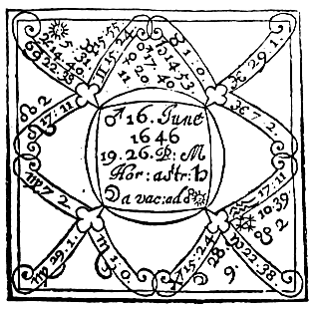

Compliments of http://mithras93.tripod.com

all manner of QUESTIONS..

whereof they are Lords, from thence doe you require the quality of the people who are enemies,

&c. remembering, that the Square aspect shewes envy and malice, yet posible to be reconciled, Opposition aspects with Reception, never, &c.

CHAP. LIX.

A LADY, if marry the GENTLEMAN desired?

Judgment upon the Figure above-said.

The true state of this Ladies cause stood thus: A Gentleman had been a long time an ernest Suitor unto her for Marriage, but she could never master her affection so much as to incline to Marriage—thoughts with him, but slighted him continually; and at last, to the great discontent of the Gentleman, she gave him an absolute deniall: After which deniall so given, she became passionately affectionate of him, and did sorely repent of her 385

Compliments of http://mithras93.tripod.com The Resolution of

folly, and so churlish a carriage, wishing she might againe have former opportunities. This was her condition at what time she propounded the Question unto me.

The ascendant and Sun are for the Querent; Saturn Lord of the 7th, is for the man Quesited after, The Querent was moderately tall, of round visage, sanguine complexion, of a cheerfull, modest countenance, gray eyed, her haire a light browne, occasioned, as I conceive, by Sun Lord of the ascendant, in the Termes of Mars, she was well spoken, and sufficiently comely.

Finding Saturn in an angle of the South, and in Conjunction with Mars, and both in Taurus, a fixed, earthly Signe, I judged the corporature of the Quesited party to be but meane, and not tall, or very handsome, his visage long and incomposed, a wan, pale or meagre complexion, dark haire, or of a sad, chestnut colour, curling and crisp, his eyes fixt, ever downward, musing, stooping forward with his head, some impediment in his going, as treading away, &c. [ this was confessed.] Finding Saturn so, as abovesaid, elevated, and in Conjunction with Mars, I judged the Gentleman to be sad, angry, much discontented, and scorning his former slights, (as ever all Saturine people doe;) I judged him much incensed by a Kinsman or Gentleman of quality, signified by Mars, Lord of the 3rd, in part, from the 7th, and of the 4th, being the 10th from the 7th; and that this Gentleman and he lived either in one house, or neer one another, because both Significators are angular and fixed, [and so it was,] I said the Gentleman had no inclination or disposition unto her, finding the Moon separated from voyd of course, and applying to Opposition of Sun, Lord of the ascendant, it did agrue there was small hopes of effecting her desire, because she her selfe, by her owne perversnesse, had done her selfe so grand a mischiefe, Whereupon she told me the truth of all, and not before, and implored my directions, which way, without scandall to her honour, it might be brought on againe, if possible: and indeed she was lamentably perplexed, and full of heavinesse. Hereupon, with much compassion, I began to consider what hopes we had in the Figure: I found Sun applying to a Sextile of Saturn; this argued the womans desire, and the strength of her affections toward the 386

Compliments of http://mithras93.tripod.com all manner of QUESTIONS.

Quesited, because she is signified by the lighter Planet; but there was no Reception betwixt the Significators, therefore that application gave little hopes: but finding Reception betwixt Jupiter and the Moon, and betwixt Sun and Moon, she in his Triplicty, Sun in her House; observing also that the Moon did dispose of Saturn in her Exaltation, and of Jupiter in her House, and that Jupiter was very neer a Sextile Dexter of Saturn, still applying, and not separated; as also, that Jupiter was in his Exaltation, and a fortunate Planet ever assisting nature and the afflicted, and that he was able by his strength to qualifie and take off the malice of Saturn: besides, the neernesse of Jupiter to the Sextile of Saturn, made me confident that the Quesited was intimately acquainted with a person of quality and worth, such as Jupiter represented, whom I exactly described, and the Lady very well knew: Unto him I directed to addresse her Complaints, and aquaint him fully with her unhappy folly: I positively affirmed, in the Gentleman described she should find all honour and secrecy, and I doubted not but, by God’s blessing, he would againe revive the businesse (now dispaired of) and bring her to her hearts content: But finding that Saturn and Sun came to Sextile aspect the 27th of the same moneth, I advised to hasten all things before the aspect was over; and also gave direction, that the 19th of June neer upon noon, the Gentleman should first move the Quesited in the businesse: and my reason was, because that day Saturn and Jupiter were in perfect Sextile aspect..

My counsell was followed, and the issue was thus: By the Gentlemans meanes and procurment the matter was brought on againe, the Match effected, and all within twenty dayes following, to the content of the sorrowfull (but as to me unthankfull) Lady, &c. In Astrologie, the true reason of this performance is no more then, first, an application of the two Significators to a Sextile, viz the Lord of the 7th and 1st: Next, the application of the Moon to the Lord of the ascendant, though by Opposition, yet with Reception, was another small argument; but the maine occasion, without which in this Figure it could not have been, the application of Jupiter to Sextile of Saturn Lord of the 7th, receiving his vertue which Saturn did render unto him, and again transferred to the Sun Lord of the ascendant, he, viz. Jupiter, meeting with no manner of prohibition, abscission or frustration untill his perfect

387

Compliments of http://mithras93.tripod.com The Resolution of

Conjunction with the Sun, which was the 29th of June, so that no difficulty did afterwards intervene, I did aquaint this Lady, that very lately before the erection of this Figure, her Sweetheart had been offered a Match, and that the Gentlewoman propounded, was such a one as is signified by Venus, one not onely of a good fortune, but excellently well descended: I had her follow my directions, with hope and expectation of a good end, and told her she should not fear his marrying of Venus: Which judgment I gave, by reason Mars was neerer Venus then Saturn, and so interposed his influence, or kept off Saturn. I judged Mars to be some Souldier, or Gentleman that had been in Armes: this I did the more to enlighten her fancy, which I found apprehensive enough. She well knew both the Gentlewoman and man, and confessed such matters were then in action.

Had the Quere been, Who should have lived longest? certainly I should have judged the woman, because Sun is going to Conjunction of Jupiter, and Mars afflicts Saturn by his presence.

Had she demanded, Whether the Quesited had been rich? I must have considered Jupiter Lord of his 2nd house, whom I find in his Exaltation, Direct, Swift, &c. only under the Sun-Beames; I should have adjudged his Estate good.

For Agreement, because Sun and Saturn are applying to Sextile, I should have conceived they would wel accord; yet doubtlesse Saturn wil look for much observancy, for as he is ill by nature, so is he vitiated by Mars, and made thereby chollerick as well as melancholly, so will he be naturally jealous without cause; yet the gentle Sextile of Jupiter to both Mars and Saturn, seems by education, to represse that forwardnesse naturally he may be subject unto.

If it be demanded, Will the Querent be honest? I answer, her Significatrix, viz. Sun, is no way afflicted by Mars: her Signe ascending being Leo, and Reception betwixt Jupiter and Moon, are arguments of a vertuous woman.

In this nature you may examine any Figure for discovery of what is necessary, &c.

388

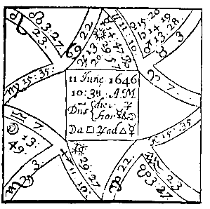

Compliments of http://mithras93.tripod.com

all manner of QUESTIONS.

CHAP. LX.

If she should marry the man desired?

The Judgment.

The Querent was of tall stature, ruddy complexioned, sober, discreet and well spoken, &c. The quesited was very tall, slender, leane, and of a long visage, black haire: His talnesse I attribute to Jupiter, as being in the Termes of Mercury, and the cusp of the 7th being also in his Termes: and indeed the being of a Significator in the Termes of any Planet, doth a little vary the party from his naturall temper and constitution, so that he will retaine a small or great tinture from that Planet according as he is dignified: The sadnesse of his haire, I conceive to be from Jupiter his aspect to Saturn, and the Moon her Square unto him, being her selfe subterranean.

Mercury is here Significatrix of the Querent, Retrograde, under 389

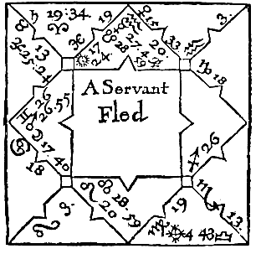

Compliments of http://mithras93.tripod.com

The Resolution of

the Sun-beames, was in some distresse and feare that the Quesited would not have her; and she might and had some reason for it, for Jupiter was in his Exaltation, and neer the Sextile of Venus, an argument the man stood upon high termes, and had been tampering with another; yet were both Significators in a Semisextile, and in good houses, from which I gathered hopes, that there was some sparks of love betwixt them; but when I found the Moon seperating from Square of Jupiter, and carrying his light by a Trine aspect to Mercury the Lord of the ascendant, and he in an angle, receiving willingly, by his Retrograde motion, that her vertue which she brought from Jupiter. I was confident the Match would suddenly be brought to passe by such a one as Moon was, or represented by her, who did much interpose in the businesse, and who at last, with a little difficulty, produced the Marriage to effect, to the content of both parties.

CHAP. LXI.

A Fugitive Servant, which way gone, when returne?

390

Compliments of http://mithras93.tripod.com all manner of QUESTIONS.

Judgment upon the Figure beforegoing,

The ascendant, and Mercury in Aquarius, together with Mars posited in the ascendant, did signifie the Master of the Servant, who was short of stature, corpulent, of a good complexion, and ruddy, fresh countenance; his fatnesse I conceive from the north latitude of Mercury, which was about one degree; as also, that the degrees ascending were in the Termes of Mars, in an ayery Signe, and in the Face or Decanate of Sun, now posited in a watry Signe, and in partill Trine to Moon, both in moyst Signes, which argues a flegmatick, full body, &c.

The Significator of the Servant was Mars peculiarly in this Figure, although many times Mercury shall signifie a Fugitive

Servant: The Servant was a young Fellow of about nineteen, a well set Fellow, short, big joynted, broad and full faced, dark browne haire, his teeth growing ilfavouredly, a Sun-burnt, obscure complexion, yet the skin of his body deer.

I observe that he went away from his Master the Sunday preceding, at what time the Moon was in Gemini, a Westerne Signe, and that now Mars, the Significator of the Fellow was in the same Signe; as also, that Mercury the common Significator of Servants, was in Aquarius, a Westerne Signe, but South quarter of Heaven; it is true that Gemini hath some relation to the South quarter, and Aquarius to the North.

I judged from hence that the Servant went westward at his first departing, and that at the time of the Question, he was West from the Querent’s house; and this I judged because Mars was angular, and every way as strong as the Moon, otherwayes I should have judged by the Moon: Forasmuch as Mars the Significator of the Servant, and Mercury Lord of the ascendant, were suddenly hastening to a Trine out of angles, I judged, that within a day or two he should have his Servant againe: I found the Moon in the 2nd, in her owne house; the Servant being a part of his Master’s Estate, I judged from hence also, that the Master should not lose, but recover forthwith his lost Goods; and the rather, for that the Moon was in the 2nd, and in perfect Trine of the Sun in the 11th, both of them in the Mediety ascending: the 391

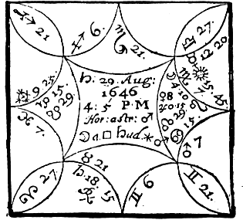

Compliments of http://mithras93.tripod.com

The Resolution of

neernesse of Mars to the degree ascending, made me judge the Servant was not above three or four houses Westward from his Masters house.

The truth is, that upon Friday following betimes in the morning, he came home, and said he had been at Kingston upon Thames:

which if true, then he was full West, or a little to the South, and neer a great Water, viz the Thames, as Moon in Cancer did or might signifie.

CHAP. LXII.

A Dogge missing, where?

Judgment upon this preceding Figure.

Living in London where we have few or no small Cattle, as Sheep, Hogs, or the like, as in the Countrey; I cannot give example of such creatures, onely I once set the Figure preceding concerning

392

Compliments of http://mithras93.tripod.com all manner of QUESTIONS.

a Dogge (who is in the nature of small Beasts) which Dogge was fled or missing. The Quere unto me was, What part of the City they should search, next if he should ever recover him.

The Querent was signified by the Signe ascending and the Lord thereof; and indeed in his person he was Saturnine, and vitiated according to Caudia in the Ascendant, in his stature, mind or understanding; that is, was a little deformed in body, and extream covetous in disposition, &c.

The Signe of the 6th and his Lord signifies the Dogge; so must they have done if it had been a Sheep or Sheep, Hogs, Conies, &c. or any small Cattle.

The Signe of Gemini is West and by South, the quarter of heaven is West; Mercury the Significator of the Dog, is in Libra a Westerne Signe but Southerne quarter of heaven, tending to the West; the Moon is in Virgo, a South-west Signe, and verging to the Westerne angle: the strength of the testimonies examined, I found the plurality to signifie the West, and therefore I judged, that the Dog ought to be Westward from the place where the Owner lived, which was at Temple-barre, wherefore I judged that the Dog was about Long-acre, or upper part of Drury-lane: In regard that Mercury Significator of the Beast, was in a Signe of the same Triplicity that Gemini his ascendant is, which signifies London, and did apply to a Trine of the Cusp of the 6th house, I judged the Dog was not out of the lines of Communication, but in the same quarter; of which I was more confirmed by Sun and Saturn their Trine, The Signe wherein Mercury is in, is Libra, an ayery Signe, I judged the Dog was in some chamber or upper room, kept privately, or in great secrecy: because Moon was under the Beames of the Sun, and Mercury, Moon and Sun were in the 8th house, but because the Sun on Monday following did apply by Trine Dexter to Saturn Lord of the ascendant, and Moon to Sextile of Mars, having exaltation in the ascendant; I intimated, that in my opinion he should have his Dog againe, or newes of his Dog or small Beast upon Monday following, or neer that time; which was true; for a Gentleman of the Querent’s acquaintance, sent home the Dog the very same day about ten in the morning, who by accident comming to see a Friend in Long-acre, found the Dog chained up under a table, and knowing the Dog to be the

393

Compliments of http://mithras93.tripod.com The Resolution of

Querent’s, sent him home, as abovesaid, to my very great credit. Yet notwithstanding this, I cannot endure Questions of Fugitives or Thefts, nor ever would have done any thing, but with intention to benefit Posterity.

Usually I find, that all Fugitives goe by the Moon, and as she varies her Signe, so the Fugitive wavers and shifts in his flight, and declines more or lesse to East, West, North or South: but when the Question is demanded, then without doubt you must consider the strength both of the Significator and the Moon, and judge by the stronger; if both be equivalent in Fortitudes, judge either by the Significator, if he best personate the Fugitive, or by the Moon, if she most resemble him; with relation to either of them that comes neerest in aspect to the cusp of the house, from whence signification is taken.

CHAP.

LXIII.

Of Theft.

It was the received opinion of Master Allen of Oxford, a man excellently versed in Astrologie, that the true Significator of a Thiefe is that Planet who is in an Angle or 2nd house, and beholds the 7th house: if no peregrine Planet be in an angle or the 2nd house, then the Lord of the 7th shall be Significator of the Thiefe, if he behold the 7th house: otherwayes that Planet to whom the Moon applyes, if he behold the 7th house; the rather, if the Moon separate from the Lord of the ascendant, And he saith further, that a peregrine Planet on what angle soever, shall not be Significator of the Thiefe, unlesse he behold the 7th house, or have any dignity in the degree of the 7th; yet if one and the same Planet be Lord of the hour and of the ascendant, he shall signifie the Thiefe, though he behold not the ascendant:

The truth is, I have ever found that if a peregrine Planet were in the ascendant, he was Significator of the Thiefe: next to the ascendant, I preferred the angle of the South, then the West angle, then the 4th house, last of all the 2nd: many peregrine Planets in angles, many are or may be suspected, justly if they

394

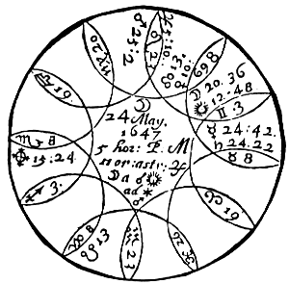

Compliments of http://mithras93.tripod.com

all manner of QUESTIONS.

are in Conjunction, Sextile or Trine; not consenting, if in Square or Opposition: ever prefer that peregrine Planet for your Significator, who is neerest to the cusp of the angle he is in.

Money lost, who stole it? if recoverable?

Judgment upon this Figure.

Scorpio here ascends, and partly represents the Querent’s person, Mars his mind and disposition, who being in Square with Mercury and Saturn gave sufficient intimation unto me of the inclination of the Querent, who was sufficiently ill conditioned, arrogant, proud, wastfull, &c.

Mars is here in the 25 degr. and 2 min. of Leo, is angular, and but two minutes enters his owne Termes, yet being in his Decanate I refused him for Significator of the Thiefe, and that justly, nor indeed was he.

395

Compliments of http://mithras93.tripod.com The Resolution of

In the next place, although Saturn was in the angle of the West, yet did I find him in his own Terms, and Decanate; I also passed by him, In the next place, I found Mercury in 24.42.Taurus, lately separated or rather in Square of Mars, and now almost in partill Conjunction with Saturn; him I found truly peregrine, viz. having no essentiall Dignity where he is, therefore I adjudged Mercury to be Significator of the Thiefe,

But whether Mercury signified Male or Female, was the dispute, as also the corporature, quality,

&c.

The angles are part Masculine, part Feminine, no certaine judgment could therefore arise from thence, the Moon was in a Masculine Sign, applied to a masculine Planet in a masculine Sign,and Mercury usually is convertible in nature, according to the nature of the Planet he is in aspect with: he is now in aspect with Mars, and in Conjunction with Saturn; hence I judged the Sex to be Male.

And said it was a young Youth of some fifteen or sixteen: young, because Mercury ever signifies Youth; but more young, because the Moon was so neer the Sun, and scarce separated from him, I said he was of reasonable stature, thin visaged, hanging Eyebrowes, a long Forehead, some blemish or scarres in the Face, because Mars cast his Square dexter to Mercury; bad Eye-sight because Mercury is with evill fixed Starres, of the nature of Mars and Moon; a sad Haire, because of his neernesse to Saturn; but of a scurvy countenance, one formerly a Thief or suspected for such knaveries: in regard Mercury the Youth his Significator was in Conjunction with Saturn Lord of the 3rd & 4th, I judged he was some Neighbours child; and as the Moon was in Gemini and Mercury in Taurus, I conceived he dwelt either opposite to the Querent or a little Southwest; and because Part of Fortune was in the ascendant, and disposed by Mars Lord of the ascendant in the 10th, and the Moon applyed to his Sextile aspect, and was within four degrees of the aspect: I judged he should not onely heare of, but have his Money within four dayes after the Question. He beleeved not one word I said, but would needs perswade me, that a Woman-servant signified by Mars, was one Theef, and Saturn was another; but I stood firme to the true rules of Art, and would not consent unto it, because both these Planets were essentially dignified.

The event proved directly true as I had manifested, both as to the person described, and to the day of the money returned, which was within three dayes after.

396

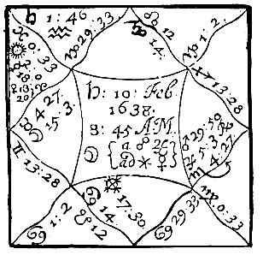

Compliments of http://mithras93.tripod.com

all manner of QUESTIONS.

CHAP. LIV.

Fish Stolen.

Living in the Country 1637. I had bought at London some Fish for my provision in Lent, it came down by the Barge at Walton, on Saturday the 10. of Febr. one of the Watermen, instead of bringing my Fish home, acquainted me, their warehouse was robbed last night, and my Fish stolen: I took the exact time when I ‘first heard the report, and erected the Figure accordingly, endeavouring to give my selfe satisfaction what became of my goods, and, of possible, to recover part of all of them againe.

I first observed, there was no peregrine Planet in angle but Jupiter whom I found upon the cusp of the 7th house, the thing I lost was Fish, therefore any Gentleman would scorne such a course Commodity; I considered the signification of Jupiter in Scorpio, a moyst Signe, and the Significator of my Goods, viz. Mercury that he was in Pisces, a moyst Signe, and that Part of Fortune was in Cancer, a moyst Signe. Discretion, together with Art, assisted me to think he must be a man whose profession or calling was to live upon the Water, that had my Goods, and that they were in some rnoyst place, or in some low rooms, because Part of Fortune was in Cancer, and the Moon in Taurus an earthly Sign.

397

Compliments of http://mithras93.tripod.com The Resolution of

I was confident I should heare of my Goods againe, because Mercury Lord of my house of Substance, was applyed unto by a Sextile of Moon, who was Lady of my Part of Fortune; and yet without hopes of recovering them, but as he was in his own Termes, and had a Trine aspect to Part of Fortune, there was hopes of some of my Goods, There being never a Waterman in that Town of Walton neer unto the description of Jupiter in Scorpio, I examined what Fisherman there was of that complexion; and because Mars Lord of the 7th was departing the Sign Scorpio, viz. his owne, and entring another Signe, I examined if never a Fisherman of Mars and Jupiter his nature had lately sold any Land, or was leaving his proper house, and going to another habitation; such a one I discovered, and that he was much suspected of theevery, who was a good fellow, lived neer the Thames side, and was a meer Fisherman, or man conversant in water; for all Significators in watry Signes, argued, he must needs live neer the water, or a watry place, that stole the Goods, or be much conversant in waters,

The man that was the Thiefe was a Fisherman, of good stature, thick, full bodied, faire of complexion, a red or yellowish haire.

I procured a Warrent from a Justice of Peace, and reserved it privately untill Sunday the 18th of February following, and then with a Constable and the Barge-man, I searched only that one house of this Fisherman suspected; I found part of my Fish in water, part eaten, part not comsumed, all confessed. This jest happened in the search; a part of my Fish being in a bag, it happened the Thiefe stole the bag as well as the Fish; the Barge-man, whose sack it was, being in the same room where the bag was, and oft looking upon it (being clean washed) said to the woman of the house, Woman, so I may have my sack which I lost that night, I care not: the Woman answered; she had never a sack but that which her husband brought home the same night as the Fish. I am perswaded the Barge-man looked upon the sack twenty times before, and knew it not, for the woman had washed it cleane I as heavily complained to the woman for 7 Portugall Onyons which I lost; she not knowing what they were, made pottage with them, as she said, The remainder of my Fish I

398

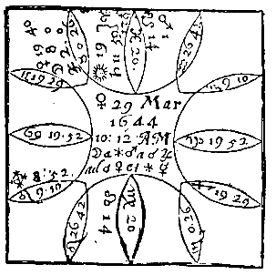

Compliments of http://mithras93.tripod.com

all manner of QUESTIONS.

freely remitted, though the hireling Priest of Walton affirmed I had satisfaction for it, but he never hurt himselfe with a lye.

So that you see the peregrine Planet in an angle describes the Thiefe, and that neither the Sun or Moon in the ascendant, and in essentiall Dignities, gives assured hopes of discovering who it was; the application of Moon to the Lord of the 2nd, argues recovery; a full recovery, if both the Moon and the Lord of the 2nd be essentially dignified; part, if accidentally fortified; a discovery, but no recovery, if they apply and be both peregrine.

CHAP. LXV.

A Figure erected to know whether Sir WILLIAM WALLER or Sir RALPH HOPTON should overcome, they being supposed to be engaged neer Alsford, Venus 29th March, 1644.

The ascendant is for our Army, the Moon, Jupiter and Venus for our General’s, viz. Sir William

& Major Generall Browne, a valiant & prudent citizen of London, who may justly Challenge a large share of honor in that dayes service: Sir Ralph Hopton is signified by Saturn Lord of the 7th, his Army by Capricorn, in the descending part of heaven, which is usually given to the 399

Compliments of http://mithras93.tripod.com The Resolution of

Friends and Assistants of the Enemy; there is onely Mars and South Node in the 9th, so that by this is appeared Sir Ralph had no supplyes ready to attend that dayes successe, &c.

From the existence of the Moon in her exaltation, and in the 11th house with Jupiter, she being Lady of the ascendant, and having principall signification for us and our Army, engaged for the Parliment, I concluded all was, and would be well on our side, and the victory ours: by her separation from Jupiter, I said, I did verily conceive we had gained already from them some ammunition, or performed some service against them, which judgment was more strengthened by Sun, Lord of our assistants and substance, posited in the 10th house, in the very degree of his Exaltation; and though I did imagine, by reason of the proximity of Saturn to Sun, we should not game the whole, or have a perfect victory without diminution of some part of it, yet I was confident we should obtaine a considerable proportion of their Ammunition, and obtaine a compleat victory, the onely thing enquired after; for that the Moon did apply to Venus, and then to a Sextile or Mercury, he angular, I acquainted the Querent that within 11 or 12 hours after the question we should have perfect newes, and it pleasing and good; for considering the fight was within 50 miles of London, I ordered my time according to discretion, not allowing dayes for the time, but hours; for you may see the Moon is distant from Venus 11 degrees, but withall is in her swift motion, and encreasing in light, all which were arguments of our successe, and the Enemies routing; as it did appeare the same Friday by a Letter that came from the Army, certifying, that our Generals took the Thursday before, 120 Commanders and Gentlemen, 560 common Souldiers, much Ammunition. That according to naturall causes in Art, the Enemy should be worsted, I had these reasons; first, because Saturn the Lord Hopton’s Significator is Sub Radiis; next, he is in his Fall; thirdly, in no aspect of any Planet, but wholly peregrine and unfortunate, beholding the cusp of the 7th with a Square dexter, arguing losse to his Army, and dishonour to himselfe by the fight, &c,

400

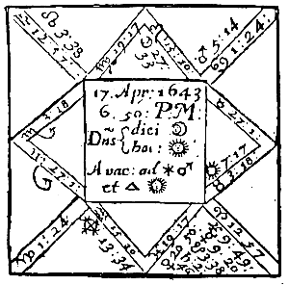

Compliments of http://mithras93.tripod.com

all manner of QUESTIONS.

CHAP. LXVI.

If his Excellency ROBERT Earle of ESSEX should take Reading, having then surrounded it with his

ARMIE.

the most honorable of the English nation, viz. Essex the Kingdomes Generall, is here signified by Mars Lord of Scorpio, the Sign ascending: his Majesty by the Sun Lord of the 10th; the forces that were to relieve Reading, or to oppose and hinder his Excellency, by Venus in Pisces, and Sun in Taurus.

The Towne of Reading by Aquarius the Signe of the 4th, the Governour Sir Arthus Aston, reputed an able Souldier, by Saturn Lord of the 4th, their Ammunition and Provision in the Towne by Jupiter Lord of the 5th, and Venus locally therein.

We have Mars his Excellencies Significator excellently fortified labouring under no one misfortune (except being in his Fall) and of how great concernment it is in Warre, to have Mars the generall Significator of Warre, friendly to the Querent, this Figure well manifests; the Moon separated ( a cacuo) and indeed there was little hope it would have been gained in that time it was; she applyed to a Sextile of Mars, being in Signes of long ascensions, the aspect is equivalent to a Square; which argued, that his Excellency would have much difficulty, and some 401

Compliments of http://mithras93.tripod.com The Resolution of

fighting, ere he could get it: but because Mars and the Moon were in Reception, viz. Mars in her house, the Moon in his Termes and Face, and neer Cor Leo, placed also in the 10th, I judged his Excellency should obtaine and take Reading, and get glory and honour thereby.

Finding the Sun his Majestie’s Significator in the 7th, in a fixed Signe, I aquainted the Querent, his Majesty would oppose what he could, and send Forces to relieve the Towne with all vigour and resolution, but I said he should not prevaile, for Mars is better fortified then Sun.

I considered Aquarius for the Town, and in regard I found not the Signe afflicted, I judged the Towne strong, and capable of holding out; when I considered Venus to be in the 5th, I was confident they wanted not Ammunition. Having thoroughly considered all particulars, and well weighed that Saturn Lord of the 4th, signifying the Governour, was in his Fall with South Node, and that Mercury and Jupiter were not farre from South Node, and that Mars did with his Square aspect behold Saturn, I said and sent somebody word, the most assured way, & which would certainly occasion the surrender of the Towne, was, to set division amongst the principall Officers, and to incense them against their Officer in Chiefe, & that about 8 dayes from the time of the Question, I beleeved his Excellency would be Master of the Towne, yet rather by composition than blood, because Sun and Mars were separated from the Square dexter of Saturn from Cardinal Signes; as also, because the application of the Moon was so directly to the Sextile of the Lord of the Ascendant, without any frustration or prohibition.

The Towne was delivered for the Parliaments use the 27 of April, 1644. three dayes after the time limited by me was expired: But it’s observable, the very Monday before, being 8 dayes after the Figure set, they began to treat.

The truth of this Siege was thus, that his Majesty in person did come, and was worsted and beaten back at Causham-bridge.

That Sir Arthur Aston the Governour, was hurt in the head, as Saturn in Aries with South Node well denotes: nor did they want ammunition, as Venus in the 5th signifies.

It was delivered by Colonel Fielding, a very valiant Gentleman, a 402

Compliments of http://mithras93.tripod.com all manner of QUESTIONS.

good Souldier, and of noble Family, not without jealousie and mistrust of underhand dealing in the said Colonell by the King’s party; for which he was brought to some trouble, but evaded: And I have since heard some of his Majesties Officers say thus, They did beleeve that Fielding acted nothing but what became a man of honour, and that it was the malice of his Enemies that procured him that trouble, &c.

A person of honour demanded this Question, and was well satisfied with what hath been spoken.

Had this very Question been of a Law suit, Who should have overcome? you must have considered the Lord of the ascendant for the Querent or Plaintiff, and the ascendant it selfe, together with the Moon: for the Enemy or Defendant, the 7th and his Lord and Planets therein placed. In our Figure, in regard the Moon applies to a Sextile of Mars, the Querent therefore would have had the victory, by reason of the Verdict given by the Jurors, who ever are signified by the Moon; but because the Sun is locally in the 7th, opposite to the ascendant, and is Lord of the 10th, viz of the Judge, there’s no doubt but the Judge would have been adverse to the Plaintiff, as his Majesty was to his Excellency and to the Parliment.

In this case I should have judged the Defendant a man of good estate, or able to spend well, because Venus Lady of the 8th, viz his 2nd, is in Exaltation; and yet the Sun and Mars in Sextile, might give strong testimonies that the Judge would labour to compound the matter betwixt both parties; the Dispositor of the Part of Fortune in his Fall, viz. Saturn in Aries with the South Node, would have shewn great expence of the Querent’s or Plaintiffs estate and money in this Suit; and that such a man as Saturn would herein be a great enemy unto him, because Saturn and Mars are in Square. As Saturn is Lord of the 3rd, he may shew an ill Neighbour, or a Brother or Kinsman; but as the 3rd house is the 9th from the 7th, it may argue some pragmaticall Priest, or one of the Defendant’s Sisters Husbands; wherefore the Plaintiffe must either take such a one off, or else compound his matter, or must see whether his Enemies Atturney be not Saturnine, then shall he receive prejudice by his extreame rigid following the Cause: If Saturn signifie his Lawyer, the 403

Image 22

Image 23

Image 24

Image 25

Image 26

Image 27

Image 28

Image 29

Image 30

Image 31

Image 32

Image 33

Image 34

Image 35

Image 36

Image 37

Image 38

Image 39

Image 40

Image 41

Image 42

Image 43

Image 44

Image 45

Image 46

Image 47

Image 48

Image 49

Image 50

Image 51

Image 52

Image 53

Image 54

Image 55

Image 56

Image 57

Image 58

Image 59

Image 60

Image 61

Image 62

Image 63

Image 64

Image 65

Image 66

Image 67

Image 68

Image 69

Image 70

Image 71

Image 72

Image 73

Image 74

Image 75

Image 76

Image 77

Image 78

Image 79

Image 80

Image 81

Image 82

Image 83

Image 84

Image 85

Image 86

Image 87

Image 88

Image 89

Image 90

Image 91

Image 92

Image 93

Image 94

Image 95

Image 96

Image 97

Image 98

Image 99

Image 100

Compliments of http://mithras93.tripod.com

The Resolution of

damage is by him, or by some aged man, perhaps the Querent’s Father or Grandfather, or else some sturdy Clowne or ill Tenant, &c. for according to the nature of the Question, you must ever vary the nature of your rules; by exact knowledge whereof, you may attaine the perfection of the whole Art.

The EIGHT HOUSE, and those QUESTIONS

properly belonging unto it.

Of Death, Dowry, Substance of the Wife, &c.

CHAP. LXVII.

If the absent party be alive or dead?

The true resolution of this Question depends much upon a right understanding, what relation the Querent hath to the party enquired of, for you have oft to read in the preceding judgments, that in every Question great care is to be taken, that the intentions of the Demandant and Questied party may be carefully apprehended, that thereby one Significator be not mistaken for another; wherefore for better satisfaction of this part of judgment we now are handling, you must enquire whether he, viz. the Querent, enquire of the death of a Friend, or of his Wife, or a Father, or a Child, or of a Servant, &c. Give the 1st house and his Lord for the Significator of the Querent; but for the party Quesited, give the Signe of that house he is signified by, the Lord thereof and the Moon for his Significators: if you find the Lord of his ascendant in the 4th or 8th, either from his owne ascendant, or of the Figure, that configuration is one argument that man or woman enquired after, is deceased; (this must be

404

Compliments of http://mithras93.tripod.com all manner of QUESTIONS.

judged where the party hath been long absent, and in remote parts, and strong intelligence concurring therewith.)

Together with this, consider if the Lord of his ascendant or the Moon, be in the 12th from his owne house, with any evill Planet, or if he be in the 12th, in aspect of any unfortunate Planet, either by Square or Opposition, or if the Sun be unfortunate or afflicted, or the Moon in like manner, for then the absent is dead: If the Significator of the absent man or woman be in the 6th from his owne house, or 6th of the Question, or in any Square or Opposition or affliction of the Lord of the 6th, without Reception, or the benevolent aspect of a Fortune, the absent is then sick: but if he be going from the Conjunction of evill Planets, wither by body or aspect, so that he be surely separated from them, or is departing from Combustion, it argues the party enquired of hath lately escaped a danger or sicknesse, or perill equivalent; the greatnesse of the disaster or infirmity you shall judge according to the quality if the Signes the Significators are in, and manner of aspect afflicting, having relation to the house from whence the aspects are.

It’s considerable, that you poyse in your judgment, whether the Significator of the absent party be in the 6th, or to any unfortunate Planet afflicting him, or whether he be in any amicable aspect with either of the Fortunes, or if he be strong in the Signe, you must not then judge the man sick, but rather weary or drowsie, or perhaps he hath let blood of late &c. or taken some Physick for prevention of a disease which he feared.

I doe onely observe, of the Significator of the absent be strong, and separated from a Fortune, and in a good house, the absent lives; if he be afflicted, or was lately in Square or Opposition of the Infortunes, he was perplexed, or suffered much misery, according to the nature of the house from whence afflicted; but I judge him not dead, unlesse together with that mischance, the Lord of the 8th doe unfortunate him.

405

Compliments of http://mithras93.tripod.com The Resolution of

Whether one absent will returne or not, and when?

Consider by what house the absent party is signified, and what Planet is his Significator; then see if his Significator be in the 1st house (let his Journey be whither it will,) yet if it be a long Journey, and beyond Seas, then see if he be in the 9th, or if in the 12th, if a very long Journey was undertaken; or if he be in the 5th, if a moderate Journey was intended, or in the 3rd, if a short Journey. If he be in any of these houses, or do commit his disposition to any Planet in any of these houses, it signifies the absent will not dye in that Voyage, but returne: if he be in the 7th, he will returne, but not in hast; nay, he will tarry long; and he is at time of the Question in that country unto which he first went, nor hath he hitherto had any thoughts of returning; however, now he hath: If he be in the 4th, he will stay and abide longer then if he were in the 7th:

if his Significator be in the 3rd or 9th, and in any aspect with any Planet in the ascendant, the absent is preparing to come home, and is fully resolved thereof; or if he be in the 2nd, in aspect with a Planet in the 9th, he is endeavouring to provide moneys for his Voyage homewards, nor will it be long are he be at home; but if he be in a Cadent house, and not behold his owne ascendant, he neither cares for his returne, or hath any thoughts thereof, nor can he come if so be he would: if he be cadent and also afflicted, and behold not the ascendant, but is otherwayes impedited, there’s no hopes of his returne, nor will he ever come; but if either his Significator be Retrograde, or the Moon be joyned to a Retrograde Planet, and behold the ascendant, it imports his sudden returne when not expected: if you find his Significator impedited, see what house he is Lord of that doth unfortunate him; if it be the Lord of the 4th, the man is detained and cannot have liberty; if it be the Lord of the 6th, he is ill; if the Lord of the 8th, he feares he shall dye by the way, or before he gets into his owne Country; if the Lord of the 12th, he is as a prisoner and cannot procure liberty: such configurations as these seem to impede his returne.

Having considered the Significator of the absent, now have 406

Compliments of http://mithras93.tripod.com all manner of QUESTIONS.

recourse to the Moon, the generall Significatrix, for if she be in Conjunction or Good aspect of the absent’s Significator, or commit her disposition unto him, and he posited in the ascendant, it argues his returne; the nearer the aspect is to the degree ascending, the sooner he returnes; the more remote, the longer it will be.

The Significator onely posited in the 8th, without other impediments, prolongs his returne, but at last he will come: but if unfortunated therein, he dyes and never returnes: Moon separating from the Lord of the 4th, 7th, 9th or 3rd, or any Planet under the earth, and then joyned to the Lord of the ascendant, or a Planet above the earth, the absent will returne.

The time when he will returne.

You are herein with descretion to consider, first, the length of the Journey; then the Lord of the ascendant and Significator of the party absent, and to observe, whether they are of the superiour Planets or not, or whether the Journey was long or short, or according unto discretion, in what space of time a man might come and goe, or performe by water or land, such or such a Journey or Voyage; if you find both the Significators applying by Sextile or Trifle aspect, observe in your Ephemeris when the day of the aspect is, and then much about that day or near unto that time, shall you heare some newes of the party, or have a letter from him, or concerning him; this supposes the party so neer, that a possibility thereof may be, for if the distance be very farre, then you may judge within a fortnight or more of the day of the aspect: But if you be asked, When he will come home, or when the Querent shall see him? then it is very probably, when both the Significators come to Conjunction, he will come home and the Querent shall be in his company; if the Significat.or of the absent be in any Signe preceding one of his owne houses, observe how many degr. he wants are he get out of that Signe and enters his owne house, and put them into dayes, weeks, moneths or years, according to discretion, and the nature of the Signe and place of heaven he is in; for movable Signes argue a short stay in the place; common ones, more long; fixed doe prolong and shew long time.

407

Compliments of http://mithras93.tripod.com The Resolution of

Of the death of the Querent, or space of his owne life.

If one is fearful of death, or feels himselfe ill, or would be resolved, Whether, according to naturall causes, he may live a yeer, two, three or more, the better to dispose of some matters concerning his owne private affaires, and shall demand such a Question of you, give the ascendant, his Lord and the Moon for his Significators, and see in what houses they are in, and how dignified essentially, unto whom they apply, or with what Planets associated: if the Lord of the 1st be joyned with any of the Fortunes, and commit his vertue unto him, and that Planet is well dignified and commit his disposition to no Planet, then see if that Fortune be Lord of the 8th; for if he be not, then assuredly the Querent out-lives the year, or two or three, or time by him propounded; but if the Planet to whom the Lord of the ascendant is in Conjunction with, or commits his disposition unto, be Lord of the 8th, then whether he be a good or an ill Planet, he kils (for every Planet must doe his office,) and signifies, that the Querent shall dye within the compasse of time demanded; and this judgment you may averre with more constancy, if the Moon be then impedited, unlesse some other Planet be joyned with the Lord of the ascendant, who receives either him or the Moon, for then he shall not dye in that space of time enquired of by him.

Consider if the Lord of the ascendant be joyned to an Infortune, who receives him not either by House or Exaltation, or by two of his lesser Dignities, and the Moon also at that time unfortunate, it signifies the Querent’s death.

If in like manner you find the Lord of the 1st joyned to the Lord of the 8th, unlesse the Lord of the 8th receive him, and so notwithstanding, as that the Lord of the 1st receive not the Lord of the 8th, though he receive the Lord of the 1st; because if the Lord of the 8th receive the Lord of the 1st, and the Lord of the 1st the Lord of the 8th, whether Fortune or Infortune, you may justly feare the Querent’s death; but if the Lord of the 8th receive the Lord of the ascendant, so there be not mutuall Reception, it hinders not.

408

Compliments of http://mithras93.tripod.com all manner of QUESTIONS.

Having considered judiciously that the Querent shall not dye, behold when or in what time it wil be are the Lord of the ascendant is joyned to that Planet who receiveth him with a compleat Conjunction, untill that time and year or years signified by that Conjunction, the Querent shall be secure, and so may ascertaine himselfe, that at this time he shall not dye.

But if you find just grounds in Art the Querent shal dye, behold when and at what time the Lord of the 1st is joyned to the Lord of the 8th, or to the abovesaid Infortune, who receives him not, but afflicts him, and is the interficient Planet; for when their perfect Conjunction is, whether by body or aspect, at that time he is like to dye.

But if the Lord of the 1st is so disposed, or he is such a condition, as you conceive that by him alone, without other testimonies, you cannot sufficiently judge of his death or life, then doe you consider the Moon, and judge by her position, as you did of the Lord of the 1st: but as I related before, if the Lord of the 8th and the Lord of the 1st be joyned together and each receive other, or at leastwise, the Lord of the 1st receive the Lord of the 8th, it prenotes his death, as aforesaid: when the interficient Planet comes to the degrees wherein the two Significators were in Conjunction, or if they were in Square or Opposition aspect, then when the malevolent Intersector comes to the degree of the Zodiack wherein the Lord of the ascendant was at time of the Question; or when the unfortunate Anareta, transits the degree ascending, and there meets with the malevolent aspect of the Lord of the 6th, or when an Eclipse, or its opposite place fals to be either the degree ascending or the degree of the Signe wherein the Lord of the ascendant was, or of the Moon, if you judged by her, and not by the Lord of the ascendant.

When, or about what time the Querent may dye?

When the Question is absolute, and without limitation, and the Querent shall propound unto you, being an Astrologian, his Question in this manner of way, viz. When shall I dye, or how long may I live? In this demand, you are to behold the Lord of 409

Compliments of http://mithras93.tripod.com The Resolution of

ascendant, the ascendant it selfe, and the Moon, the Lord of the 8th or infortunate Planet in the 8th, and that Planet unto whom either the Lord of the 1st or the Moon is joyned by body or malevolent aspect, and you shall determine the death of the Querent according to the number or distance of degrees which are betwixt the Lord of the 1st and the Lord of the 8th, or of that Planet to whom either the Lord of the ascendant or Moon is joyned, for those number of degrees shall shew either moneths or years: If the Lord of the 1st be in Conjunction with the Lord of the 8th in an angle, it notes so many years; for in these judgments, angles do not accelerate death, but shew that life and nature are strong, and a possibility of overcoming the malignity of the humour afflicting: if the abovesaid Conjunction be in a succedant house, it notes so many moneths; but note, if the Signe be fixed, it gives halfe years, halfe moneths: if in a cadent house, so many weeks: you must understand this Question with mature judgment, and well consider whether the Significators are extremely afflicted, or have sufficiently manifested that according to naturall causes, the Querent cannot live long, or that death is not farre from the Querent.

If the Significators doe not presage death at present, then aquaint him, it’s possible, he may live so many yeers as there are degrees betwixt the Conjunction of the Lord of the ascendant and the Lord of the 8th, or of that Planet at time of the Question afflicting him. The Ancients have ever observed, that the Lord of the ascendant is more in this judgment to be considered then the Moon, and therefore his affliction or Conjunction with the Lord of the 8th, or Combustion with the Sun is especially worth consideration, and most to be feared; for naturally the Lord of the 1st doth signifie the life and body of the Querent, and not by accident.

If the Lord of the ascendant be separated from the Lord of the 8th, or the Lord of the 8th from him, or from that Planet who did afflict him, it’s not then probable the Querent shall dye, in so many years as there are degrees betwixt them, viz. from that their separation: where observe, the Conjunction of the Moon with the Lord of the 8th, doth not much hurt, unlesse the Lord of the 1st be also joyned with him; for let the Moon be afflicted, 410

Compliments of http://mithras93.tripod.com all manner of QUESTIONS.

yet if the Lord of the ascendant be strong, it’s no great matter; but if the Moon be well Fortified, and the Lord of the ascendant be weak and afflicted, the strength of the Moon afflicts nothing for the evasion of the Querent; for although in the Querent’s affaires she hath much to do, yet in this manner of judgment little, where life or death are in question.

Whether the Man or Wife shall dye first?

This doth more neerly depend upon the Nativity of either party, then upon an horary Question, and therefore I would advise in the resolution of this Question, that first the Artist doe demand of the Querent, his or her Age, or if they have it, the time of their Birth, and that he erect the Figure thereof, and see what possibility there was in the Radix, of the length or shortnesse of the Querent’s life if time give you leave, see if the Sun or Moon in the Radix, or the ascendant of the Nativity, doe near the time of the Question, come to any malignant direction, or whether the Querent be not in or neer a Climactericall year or years, which are the 7th, 14th, 21st, 28th, 35th, 42nd, &c. or whether you find not maleficall transits of the infortunate Planets either by their near Conjunction to the degree of the Sun, Moon or ascendant in the Radix, or whether they cast not their Square or Opposition aspects to the degrees of the Sun, Moon or ascendant of the Radix, now at this instant time of the Question; this I would have well considered: and then erect your Figure according to the time of the day given, and behold who asks the question, and let the Lord of the ascendant be for him or her, the Lord of the 7th for the quesited party; see which of them is weakest, or most afflicted in the Figure, and whether the ascendant or 7th house hath any malevolent Planet posited therein, or whether there arise with the ascendant, or descend with the cusp of the 7th, and maleficall fixed Starres; for in this manner judgment they shew much: Behold whether the Lord of the 7th, or of the ascendant goe to combustion first, or to the affliction of any malignant Planet, or to the Lord of the 8th; for it is an assured rule, that if the Lord of the ascendant be

411

Compliments of http://mithras93.tripod.com The Resolution of

most afflicted, or first goe to combustion, and the 1st house it selfe be unfortunated by the presence of an Infortune, that then the Querent dyeth first: and so judge for the Quesited, if the same misfortunes befall to the 7th house, and his Lord, &c.

What manner of death the Querent shall day.

in this manner of judgment observe the Lord of the 8th, if he be therein posited, or what Planet is nearest to the cusp of the house, and hath Dignities therein; for you must take signification of the quality of death from either of these, or from that Planet who afflicts the Lord of the ascendant, and have Dignities in the 8th: If the Planet signifying death is either Venus or Jupiter, you may assure the Querent, he or she shall dye a fair death: and observe what Diseases they or either of them in the Signe they are in doe signifie, and what part of mans body they represent in that Signe, and you may certifie the Querent, that the disease or infirmity he or she dye of, will be of the nature of the Planet, and in that part of the body they signifie in that Signe. Usually, good Planets in the 8th, a fair, gentle death; malevolent ones, either strong Feavers, or long continued Sicknesses, and much afflicting.

CHAP. LXVIII.

Whether the Portion of the Wife will be great, or easily obtained, or whether is the Woman enquired

after rich or not.

Herein vary your ascendant, and then the Question as well resolves the demand concerning the estate of a man as of a woman. The Querent is still signified by the Lord of the ascendant and 1st house, his substance and Estate by the 2nd house, Lord thereof, Planet or Planets posited in the house, and the Lord of Part of Fortune and place of heaven, and sign wherein it is found.

That which is the occasion of this Question is, if a man propounded the Question, Whether the Woman he enquires after be

412

Compliments of http://mithras93.tripod.com all manner of QUESTIONS.

rich, &c. Behold in this judgement the Signe of the 8th house, the Lord thereof, the Planet posited therein.

The Cusp of the 8th in the Termes of Jupiter or Venus give good hopes of Wealth, or Jupiter or Venus posited in that house; plenty of Wealth if they are essentially dignified, direct, and free from Combustion; not so much, if they or either of them be Retrograde, Combust, or slow in motion: for though in essentiall dignities and so qualified, they expresse a sufficient and large proportion, yet with some kinde of trouble it will come to the Querent.

The Lord of the 8th in the 8th no wayes impedited, gives good hopes of some Inheritance or Land to fall to the Wife or woman, or by some Legacy, some Estate; the more certaine if either the Lord of the 4th in the Figure, or the Lord of the 10th and the Lord of the 8th be in any benevolent aspect out of Angles or succedant houses, or out of the 11th and 8th. Part of Fortune in the 8th and in Aquarius or Leo, or any of the houses of Jupiter or Venus, they casting their Trine or Sextile aspect to Part of Fortune: you need not feare but the estate of the quesited party is sufficient, and if the dispositor of Part of Fortune doe but cast his Sextile or Trine to it, or else is in a good aspect of Jupiter of Venus: these argue the Woman inquired after to be a good Fortune, and you are not to make doubt of his or her Estate.

Saturn or Mars Peregrine in the 8th, either poore or little of what is promised will be obtained, or extreame contention about

it.

The Lord of the 8th Combust, slow performance, scarce ability in the Parents to performe what is promised.

South Node in the 8th, no fortunate Planet being there, there’s cheating intended, or more will be promised then performed.

Lord of the 8th in the 2nd, or in Trine or Sextile to the Lord of the 2nd, the Querent shall have what is promised, in Square with difficulty, in Opposition never, without much wrangling; if no reception hardly at all. Its impossible to give such generall Rules as will hold ever certaine, therefore I advise every Practicer to well weigh the Querent his Condition, and the possibility the Figure promises, and so frame his conjecture.

413

Compliments of http://mithras93.tripod.com The Resolution of

CHAP. LXIX.

If one be afraid of a thing, Whether he shall be in danger of the same or not.

Behold the ascendant and his Lord, and the Moon; if you finde the Moon infortunate, or if the Lord of the ascendant be infortunate, and falling from an angle; or especially in the 12th and Moon with him; it signifies the same Fear is true, and certaine that there is cause for it, or that the great labour and griefe shall molest him, and that many things shall be demanded of him, or he charged with many matters not appertaining to him, or of which he is guilty. If the Lord of the ascendant doth ascend from the 12th into the 11th or 10th, or shall be joyned to Fortunes; it signifies the thing feared shall not appertaine to him, or he be molested thereby, or that he need not be afraid, nor shall the matter doe him ill, but he shall escape that feare. When the Lord of the ascendant shall be in one degree with Fortunes, no ill is towards the Querent (if the Fortunes unto which the Lord of the ascendant doth apply, or which apply unto him be in the mid heaven, and the Moon apply unto those Fortunes, and she be in an angle or elevated above him, it signifies he that is afraid shall easily be delivered from feare; nor hath he any grounds for it.

[Substance.]

The signifier of the question applying to infortunes, it is true; to a fortune, and not received of an infortune, it is false. Many have judged, that if the Moon be in the 8th, 6th or 12th, and apply to any Planet in a Cadent house, the Suspition is not true, or the report will hold long, but that it will be smothered and vanish to nothing: the Moon in Trine to Sun discovers all suddenly.

414

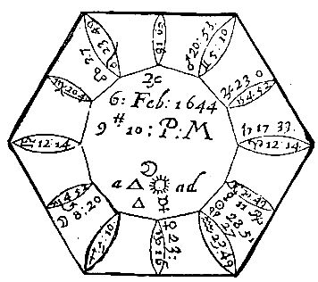

Compliments of http://mithras93.tripod.com

all manner of QUESTIONS.

CHAP.

LXX.

Whether Man or Wife shall dye first?

Judgment upon this Figure.

For many weighty Reasons one desired me to consider whether himselfe or wife should dye first; Whereupon I erected the figure of heaven, as above placed.

Finding the 7th house afflicted, which signifieth the Wife by the position of Saturn in Aries his Fall, and that Mars Lord of the 7th was cadent in Gemini and the 9th house, and disposed by Mercury Lord of the 6th from the 7th, and he Retrograde and in his Fall, and the Moon in Scorpio, but the 8th house from the 7th. These considerations moved me to inquire of the Querent, whether his Wife was not very sicke, and in a Consumption (for so it appeared unto me) and also infirmed (in Secretis.) For if you observe all those Significators which have relation unto her,

415

Compliments of http://mithras93.tripod.com The Resolution of

are wholly unfortunate and out of their essentiall dignities. I inquired her age, her exact Nativity I could not obtaine, onely I understood she was now in her 42. yeer of age, viz. her Climactericall yeer, which is usually dangerous; and the more unto her, she meeting with an untoward Disease neer or in that time.

I considered the 7th house which was her ascendant whereby I judged her Corporature to be small, or her Person incurvating, her visage long and leane, her complexion darke and pale, her conditiond very waspish, or she very forward, &c. which was confessed, and I afterwards found, Because Saturn sheweth long lingering Diseases, and Mercury Lord of the 6th house was Retrograde; I judged she would relaps out of one Disease into another, partly by her owne obstinatenesse, and partly by the errour of the Physician: By her owne wilfulnesse, because that the the Lord of her ascendant was also Lord of the 8th; and partly by neglect of the Physician, who was signified by Venus who was in Square with Saturn in Equinoctiall and Tropicall Signes and in Angles, arguing his or their small care of the miserable Gentlewoman: All things seriously considered, I concluded the Woman would dye first; for the Significator of the Man hath no manner of affliction, viz. Venus she being in her Hayne, and free from the least manner of misfortune, and so was the man from all infirmities. For the time when she should dye, I observed when Saturn and Mars came to an ill aspect; for Saturn did most of all represent her in person and condition; and I found that about the latter end of September following Mars came to an opposition of Saturn, Mars then being neer the place of the Moon at time of the Question, viz.

in 2 degr. of Scorpio, and Saturn in 2 of Taurus, the Moon at that moment in the place of Mars, viz. in 20 degr. of Gemini or thereabouts. From thence I concluded, that it was probable she would dye or be in great danger of death about the latter end of September or beginning of October; and in truth she dyed the 8th of October, upon which day Mars and Mercury were in Conjunction in the 8th degree of Scorpio; the one in the Question being Lord of the ascendant, and the other of the 6th, the degree it selfe the very same of the Moon in the Question, and Moon to the 12. of Libra the opposite degree to her ascendant in the Question.

416

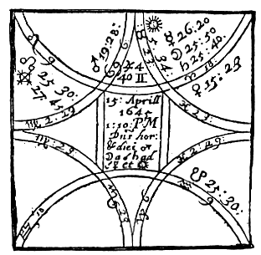

Compliments of http://mithras93.tripod.com

all manner of QUESTIONS.

CHAP. LXXI.

A Woman of her Husband at Sea, if alive, where, when returne?

[This question hath as much relation to the 9th as 8th house.]

Mercury Lord of the ascendant doth personate the Querent, and as Mercury is in Conjunction with Moon and Saturn in Aries which doth signifie the Face, so was she extreamly disfigured therin by the smal-Pocks, had weak Eyes, &c. was full of griefe & sorrow for her Husband occasioned by Saturn his affliction of Mercury; she also had a lisping in her speech, and spake but ill; for usually Saturn afflicting Mercury in mute or bestiall Signes, causeth impediment speech.

[Alive.]

The Quesited was signified by Jupiter Lord of the 7th, who being posited in the 10th house, and lately separated from the Sextile of Venus now in the 9th, she being Lady of the 3rd, argued the man had been lately some voyage South-east; and because both Venus and Moon had been with Sextile of Venus, he being now no way afflicted, but swift in motion, made me judge the man was alive and in health: but as Mercury, who disposeth of Jupiter, is Lord of the 2nd, viz. the 8th from the 7th, and as the Moon is so exceedingly afflicted by Mercury and Saturn, I judged he had been in much danger and perill of his life, by trechery and cunning plots of his adversaries, and had suffered many afflictions in his absence; for Mercury is Lord of the 7th from 417

Compliments of http://mithras93.tripod.com The Resolution of

his ascendant, and Saturn of the 12th from the 7th: besides, Jupiter is accidentally Fortified, but not essentially, and his Detriment, with Oculus Taurus a violent fixed Star, intimating, the man had endured many sudden violent chances.

[Where.]

Finding Jupiter more Fortified then the Moon, she almost entring Taurus a Southerly Signe, and Jupiter in Gemini a Western Signe, and South quarter; I judged the man absent was in the Southwest of England, in some Harbour, because Jupiter was Angular.

[When return or hear of him.]

The Moon separates from Saturn & doth apply unto the Conjunction of Mercury Significatrix of the Querent; an argument after much expectation & longing, the Woman should heare of him in 2 or 3 dayes, because the distance of Moon from the body of Mercury is about 1 degree and no more, and the Sign movable, [so she did.] But as Mercury is in a movable Signe, and Moon is corrupted by him and Saturn, the report she heard of her Husband was false [for she heard he was in Town,] but it was not so. Considering that Mercury and Jupiter did hasten to a Conjunction in Gemini, Mercury being therein very potent, and that this Conjunction was to be the 5th day of May following; I judged from thence that about that time she would have certaine newes of her Husband, if happily he came not then home. The second week in May the Woman did heare certaine newes from her Husband, but he came not home till the second week in July, he had been severall Voyages in the West parts, was taken prisoner by the Kings Forces, and at time of the Question asked, was at Barnstable, &c.

418

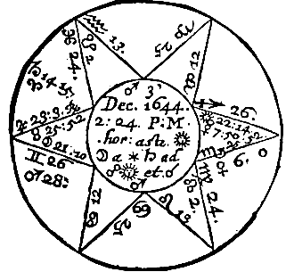

Compliments of http://mithras93.tripod.com

all manner of QUESTIONS.

CHAP.

LXXII.

What manner of Death CANTERBURY should dye?

It may appear to all indifferent minded men, the verity & worth of Astrologie by this Question, for there is not any amongst the wisest of men in this world could better have represented the person and condition of this old man his present state and condition, and the manner of his death, then this present Figure of heaven doth.

Being a man of the Church, his ascendant is Capricorn, the cusp of the 9th house; Saturn is Lord of the Signe, now in Aries his fall; a long time Retrograde, and now posited in the 12th of the Figure, or 4th from his ascendant; so that the heavens represent him in condition of mind, of a violent spirit, turbulent and envious, a man involved in troubles, imprisioned, &c. Jupiter a generall Significator of Church-men, doth somewhat also represent his condition, being if that eminency he was of in our Commonwealth: Jupiter, as you see, is Retrograde, and with many fixed Starres of the nature of Mars and Moon; an argument he was deep laden with misfortunes, and vulgar Clamours at this present..

419

Compliments of http://mithras93.tripod.com The Resolution of

The Moon is Lady of the 4th in the Figure, but of the 8th as to his ascendant; she separates from Saturn, and applies to the Opposition of the Sun neer the cusp of the 8th house; Sun in a fiery Signe, applying to an Opposition of Mars, the Dispositor of the aged Bishop; Mars being in an Ayery Signe and humane, from hence I judged that he should not be hanged, but suffer a more noble kind of death, and that within the space of 6 or 7 weeks, or thereabouts; because the Moon wanted 7 degrees of the body of Mars. He was beheaded about the 10th of January following.

I write not these things as that I rejoyced at his death; no, I doe not; for I ever honoured the man, and naturally loved him, though I never had speech or acquaintance with him: nor doe I write these lines without teares, considering the great incertainty of humane affaires: He was a liberall Moecenas to Oxford, and produced as good Manuscripts as any were in Europe to that University, whereby the Learned must acknowledge his bounty: let his imperfections be buried in silence, Mortuus est, & de mortuus nil nisi bonum. Yet I account him not a Martyr, as one Asse did; For by the Sentence of the greatest Court of England, viz. the Parliament, he was brought to his end.

420

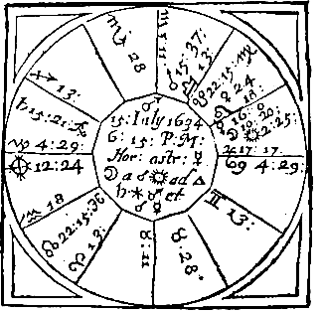

Compliments of http://mithras93.tripod.com

all manner of QUESTIONS.

CHAP.

LXXIII.

If have the Portion promised?

Saturn is here Significator of the Querent, Retrograde, and in the 12th house, as if the Querent had been in some despaire of it, [and so he confessed.]

The Woman is signified by Jupiter and Moon; Jupiter in his Exaltation, and Moon in Leo, a fixed Signe argue the Woman to be well conceited of her self e, confident, yet vertuous and modest: the Moon her Significatrix neer the Sun, she had a scar neer her right eye, for the Moon signifies in Women the right Eye.

That which is pertinent to the resolution of the thing demanded is this; That finding Venus in the 8th house, which is the womans 2nd, and the Sun to be Lord thereof, in his own house, and that Moon did separate from the Conjunction of Sun, and transferred his vertue to Saturn, who is Lord of the ascendant and Dispositor of Part of Fortune, and also Lord of the Querent’s 2nd house, I did from hence cheer up the dull Querent, and assured him he had no cause to feare the non payment of his Wives Portion, but that it would really be performed, whatsoever was or had been promised; and that, to his further comfort, she would 421

Image 105

Image 106

Image 107

Image 108

Image 109

Image 110

Image 111

Image 112

Image 113

Image 114

Image 115

Image 116

Image 117

Image 118

Image 119

Image 120

Image 121

Image 122

Image 123

Image 124

Image 125

Image 126

Image 127

Image 128

Image 129

Image 130

Image 131

Image 132

Image 133

Image 134

Image 135

Image 136

Image 137

Image 138

Image 139

Image 140

Image 141

Image 142

Image 143

Image 144

Image 145

Image 146

Image 147

Image 148

Image 149

Image 150

Image 151

Image 152

Image 153

Image 154

Image 155

Image 156

Image 157

Image 158

Image 159

Image 160

Image 161

Image 162

Image 163

Image 164

Image 165

Image 166

Image 167

Image 168

Image 169

Image 170

Image 171

Image 172

Image 173

Image 174

Image 175

Image 176

Image 177

Image 178

Image 179

Image 180

Image 181

Image 182

Image 183

Compliments of http://mithras93.tripod.com

The Resolution of

prove a chast vertuous woman, but somewhat proud; all this proved true, as I experimentally have it from the Querent’s owne Mouth.

The ninth HOUSE, and those QUESTIONS

properly belonging unto it.

Long Journeys, Religion, Pilgrimage,

Dreams, &c.

CHAP. LXXIV.

Of good or ill in questions concerning this House.

If in this house good Planets have either government, or are in possession thereof, or aspect the same without the testimonies of the Infortunes, it signifieth good, or is an argument thereof in all questions concerning this house.

Of a Voyage by Sea, and Success thereof.

Look to the 9th house, if it be good and strong, and aspected of good Planets, or good Planets in the said house, especially if the Lord of the ascendant and the 10th be well affected, it is very good: but if thou findest Saturn, Mars or the South Node there, then is the way evill, if the Lord of the 9th be with an evill Planet, it is evill, and he shall not speed well in the way, or get any wealth by that Voyage: Mars in the 9th, :intimates danger by Theeves or Pyrates; Saturn threateneth losse of Goods, or sicknesse; the South Node doth import the same that Mars doth, but most part with cozenage and deceit.

The substance of the Journey is from the 10th, because it is the 2nd from the 9th: Fortunes there, expect Wealth; Infortunes,

422

Compliments of http://mithras93.tripod.com all manner of QUESTIONS.

losse: the 9th infortunate, many hardships in the Voyage; Fortunes there, a happy passage.

Together with this, see to the Lord of the 8th, or 8th house; for if he or it be strong there is Wealth to be got; Saturn, Mars or South Node in that house, nothing to be had, or not worth labour.

What wind you shall have.

Behold the Lord of the ascendant, if he be with a good Planet or Planets, and they strong, and in friendly aspect, it signifieth good winds; but if with evill Planets, or they in cadent houses, the contrary; if the Significators be in Opposition out of fixed Signes, and neer violent fixed starres, the Traveller may expect impetuous stormes, sudden blasts, contrary winds often driving the Passenger this way, and sometimes that way; as also, that he shall await many dayes, weeks or moneths for a comfortable wind before he shall gaine it: Gentle gusts of wind are signified when the Significators are in Trine aspect out of Signes ayery, viz. Gemini, Libra or Aquarius.

Of him that taketh a Journey, and the successe thereof.

Behold what Planets are in the angles, if you find in the ascendant a good Fortune, judge then that he shall have good successe, before that he removeth from the place he is in, or in the beginning if his Journey; if that good Fortune be in the Mid-heaven, he shall have much happinesse in his Journey, and after his entring the Ship, or upon the way as he goeth on his Journey: but if the Fortune be in the 7th, he shall have content in the place whereunto he goeth: if that Planet which is the Fortune be in the 4th, it shall be at his returne, or when he shall come to his owne place or home back againe.

If that Fortune be Jupiter, the benefit he expects, or the Means to advance him, shall come from or by meanes of a religious person, or Judge, or Gentleman, in quality and kind according to the power, quality and nature of the Lord of the house of that Fortune, or by a person of that description; as if it be the house of the Sun, it shall be by the King, a Magistrate, or some 423

Compliments of http://mithras93.tripod.com The Resolution of

noble Person, or by a Solar man of noble disposition.. If Saturn be Significator, it shall consist in things and Commodities of his nature, or else in things of antiquity, or Ground, Corne or Tillage; or by meanes of an ancient man: describe Saturn exactly, and let the man apply to such a one in his Affaires. If Venus, it shall be as touching Women, Joy and Sport, or by meanes of Women, Friends, or in Linnen, Silks, Jewels, or pleasant things. If Mercury, it shall be by writing, or by wit and discretion, or merchandize, Accounts or Letters testimoniall, or by the Merchant. If it be the Moon, it shall be by Services or Masteries, much imployment by some Woman or Widdow, or Saylor, or by carrying Newes, or playing at Dice, Sports or Pastimes, Tables, or such like.

Example.

If the Fortune in the 10th house, is Venus, he shall have good, or make great benefit in his Journey, by dealing in such things as bring joy, or cause delight and pastime, by Jewels or Silks which are of the nature of Venus: If the Lord of that house be Saturn, and he be strong, say then of Saturn as in the preceding part, and so of the rest: If a Planet who is an Infortune be Lord of the 12th and he be Saturn, it is to be feared there shall happen unto him some sicknesse comming of a cold and dry cause, or by much trechery, but if Saturn be in a Signe Bestiall, it is to be feared, some ill fortune or mischance shall happen to the Traveller by meanes of some Four-footed Beast; if he be in a humane Sign, it may be by some deceitfull men; if that ill Fortune instead of Saturn be Mars, it is to feared he may incurre some sicknesse that is of a hot nature, or fall into the hands of Theeves, and shall have feare of himselfe touching hurt to his body, &c.

and so of the rest.

Of the short or slow returne of him that taketh a Journey.

Behold the Signifier of the Journey, if that Planet be swift in Course, Occidential, and Moon and he in movable Signes, it signifieth his Journey to be short, and not much tarrying from home, or a quick, speedy passage, yet with trouble and pain; but if he be swift, (viz. the Significator) in motion and Orientall,

424

Compliments of http://mithras93.tripod.com all manner of QUESTIONS.

it shall be quick, short, and without any labour or much trouble: when the Lord of the ascendant doth apply unto the Lord of the house of Journeys, or when the Lord of the Journey applies to the Lord of the ascendant, or any Planet carryeth light of one to the other, or when the Lord of the house of Journeys is in the ascendant, or when the Lord of the 7th is in the ascendant, or the Lord of the ascendant in the 7th; all these doe signifie short returne, or good speed according to the length of the Voyage: But if none of these be, or the greater part of the said Significators be in angles, especially in fixed Signes, it signifieth either destruction of his Journey, or else slow, or to be a great while absent: If a Fortune be in the house of Journeys, it signifieth health of body; a good Fortune in the Mid-heaven signifieth mirth and jollity, or gladnesse in his journey, or that he shall have good company: in the 7th and 4th, it signifieth prosperity, and a good end of the Journey or Voyage.

If the Lord of the house of Journeys be in a fixed Signe, it signifieth continuance and long tarrying: in a common Signe, it signifieth he shall change his mind from his first intended thoughts, or remove from one journey to another.

If the Moon in questions of Journeys, be in the 6th, or in Opposition to the Lord of the 6th, it shewes sicknesse to him that travels, and impediments in his occasions, and that his businesse shall be for the most part feeble, weak and slackly handled, his endeavours and designes shall be much crossed; yet if the Lord of the ascendant be fortunate, or in the house of trust, or not opposite to the same, it signifieth successe and prosperity, and the accomplishing of his businesse, though with many difficulties and obstructions.

When he shall returne that is gone a long Journey..

[You must ever have regard to the proper Significator.]

Behold the Lord of the ascendant, if you find him in the ascendant or mid-heaven, or giving his power to another Planet being in any of those places, it signifieth that he shall returne and is thinking of it; but if the Lord of the 1st be in the 7th, or in an angle of the earth, it signifies, that his returne is

425

Compliments of http://mithras93.tripod.com The Resolution of

prolonged, and that as yet he is not gone far from the place he went unto, nor hath he yet any desire thereunto.

If the Almuten of the 1st be in the 9th or 3rd from the ascendant, applying to a Planet in the ascendant, it signifieth he is in his journey homewards: the same also doth the Lord of the ascendant signifie if he be in the 8th or 2nd, applying to any Planet in the 10th; yet notwithstanding, if the Lord of the ascendant be cadent, and doe not apply to any Planet in an angle, or behold the ascendant, it is a token of tarrying.

But if at any time the Lord of the ascendant or the Moon doe apply unto a Planet Retrograde, or the Lord of the ascendant himselfe be Retrograde, (viz. the Significator of the absent) and doe behold the ascendant, it is a token he is comming: but is the Lord of the ascendant be infortunate, it doth signifie some let or hinderance which makes him to tarry, or that he cannot come: If you find not in the house of the ascendant any of those things which I have said, behold the Moon, and if she doe give her power or light to the Lord of the ascendant, being in the ascendant or neer the ascendant, it signifies that he shall come shortly or intends it: also, if the Moon be in the 7th, 9th or 3rd, applying to the Lord of the ascendant, it signifies that he commeth: If the Moon be separate from a Planet which is in the left side of the ascendant (that is, under the earth) and applyeth to another Planet on the right hand of the ascendant, (that is, above the earth) it doth signifie that he commeth.

If the Moon be on the right hand of the ascendant, and apply to a Planet in the mid-heaven, it signifieth that he commeth, yet with slownesse, for the Moon being in the right hand of the ascendant, doth show so much; which if she had been in the left hand, she had shewed his comming sooner. If the Lord of the house of the Moon be infortunate, it signifies tarrying, and let or hinderance in comming home.

You must ever consider for whom the question is asked, for if he that demands the question ask for a Sonne, then from the 5th house look for the Significator: If for a Brother, then to the 3rd: If for a Father, the 4th, &c. Behold the Fortunes and Infortunes carefully placed in those places, and by them and their position, judge the estate of him that is absent in his 426

Compliments of http://mithras93.tripod.com all manner of QUESTIONS.

journey, both for health and hinderance, for according to the estate or place of the Fortunes or Infortunes in the Figure, and their dignities or imbecillities, so you may judge.

[Still you must keep to the Lord of your proper ascendant.]

When the Lord of the ascendant is in the ascendant, or in the 2nd, entring or arising towards the ascendant, or if he be Retrograde, or the Planet which was the signifier of the Journey be Retrograde, or the Lord of the ascendant apply to the Lord of the 10th, or the Lord of the mid-heaven be in the ascendant, or the Moon received of the Lord of the 10th, or the Lord of the ascendant received of him; all these doe signifie that he is absent is coming, and that he retumneth speedily and shortly.

The Planet from whom the Lord of the ascendant of the question is separated, is the Signifier of the state and condition in which he lately was, and of those actions which are past; and the Planet unto whom the Lord of the ascendant doth apply, is the Signifier of the state he is now in; and the Planet to whom he applyes after him, is the Signifier of the state of him unto whom he shall come, or intends to come.

If a question be asked for one that is in a journey, and you find his Significator going out of one Signe and entring into another, judge that he went out of the place he was in, and is entred another, or taken another journey in hand; and behold in which of those Signes he was stronger, more fortunate, or better received and so judge his successe the better, and corresponding thereto.

Note that Combustion in a question of one that is absent is ill, for that signifieth captivity, imprisionment, or some great let:

if the Combustion be neer the house of death, or the Sun Lord of the house of Death, it signifies death except God doe miraculously deliver him..

If in the question of him that is absent, you find in the ascendant or mid-heaven Mercury or the Moon, judge that Letters shall come from him, or some Newes very shortly, for Mercury is the Significator of Letters or Newes.

427

Compliments of http://mithras93.tripod.com The Resolution of

If you would know whether the Newes or Letters which are to come be good or ill, look from whom Mercury and Moon are separate; if the separation be from a Fortune, it notes good newes and joyfull; but if from ill Fortunes, judge the contrary.

If a Question be asked of a Letter, whether it be true or not, behold Mercury, if he be in a movable Signe, beholding Saturn or Mars, say it is a lye; if in a fixed Signe, judge it is true; in a common Signe, part true and part false.

The cause of a Journey, and the successe thereof.

Behold if the Moon apply to the Sun, he goeth to Kings or States, or in service of such men, viz.

of such as are able to maintaine him, &c.

If Moon apply to Saturn, he is directed by old men, or men of gravity and yeers..

If Moon apply to Jupiter, Religious persons or Gentlemen doe imploy him.

If Moon apply to Mars, men of Warre, Captaines, or such like are the cause..

If to Venus, Women-kind, or desire to purchase such things as Women love.

If to Mercury, Merchants, Schollers, or he travels to see variety of Countryes, and to learne the languages.

If Moon her selfe signifie the cause, it seems he is hired, or that he is publikely imployed.

The cause is usually required from the house wherein the Lord of the 9th is; or if a Planet therein, see what house he is Lord of; the Lord of the 9th in the ascendant, he goes of his owne accord; the Lord of the 9th in the 2nd, for game; the Lord of the 9th in the 3rd, purposely to travell, &c.

Successe thereof.

Behold the four angles, if a fortunate Planet be in the ascendant, the beginning of his journey shall be fortunate; if the mid-heaven be fortunate, the rest of his journey shall prove in like manner; if the 7th, it shall also happen well when he is arrived to the place he intends, or is at his journeys end: If

428

Compliments of http://mithras93.tripod.com all manner of QUESTIONS.

Fortunes be in the 4th, all shall happen well in his returne homeward, & e contra: a most happy journey is intended.

Also for the successe of a journey, behold the Lord of the ascendant, the 9th house and the Moon, and if they be all well affected, it sheweth a fortunate Journey.

Length thereof.

If the Lord of the 9th be in the ascendant, or the Lord of the ascendant in the 9th, it hasteneth the journey; the Lord of the ascendant in the 7th, idem.; the Significators on cadent houses, or in movable Signes, or the angles movable, idem.: But if the angles be fixed, and the Significators posited therein, it prolongeth the journey: the Lord of the 9th in the ascendant, hasteneth the journey, and being fortunate therein, fortunateth the same Voyage, the Significators and Moon slow in motion, a tedious Journey.

CHAP. LXXV.

If one shall profit by his Knowledge, be it in what kind it will; Chymistry, Chyrurgery, &c.

or if he be perfect.

Give the Querent the ascendant, his Lord and the Moon; the 9th house, Planet therein posited, and the Lord thereof for the Science endeavoured to be attained: See if the Lord of the 9th be fortunate or not, Orientall or Occidentall, cadent from an angle, in an angle or succedant house, and whether he behold the Lord of the ascendant or not with Sextile or Trine; if he be a Fortune and behold the Lord of the 1st, the man hath good knowledge in him, and what is reported of the man is true, and he will doe good by his knowledge; and the more if it be with Reception: if the aspect be by Square or Opposition, the man knowes much, but shall doe no good thereby; if an Infortune aspect either the Lord of the 9th or 1st, the man hath wearied himself e, and will doe, but to no purpose, for he shall never attain the perfection of the knowledge he desires, 429

Compliments of http://mithras93.tripod.com The Resolution of

Of Science, Cunning or Wisdome in a man,

whether it be true or not.

You must give the ascendant to him of whom it is asked, and the 9th house to the Science; and if there be Fortunes in the 9th house, or the Lord of the 9th fortunate, and behold the Lord of the ascendant, judge there is Science in that man: But if in the 9th house there be Infortunes, or the Lord of the 9th infortunate, and behold not the Lord of the ascendant, it doth signifie the contrary, and that there is none, or little knowledge in him.

Behold in what condition the Moon is, with the Lord of the 9th; if they both apply to Fortunes, it signifieth that there is knowledge in the man; but if the apply to Infortunes, it signifies the contrary.

In the 9th house, the Lord thereof be infortunate, nor behold the Lord of the ascendant, it signifies no knowledge in him, or such as by which he will never doe himselfe good, if it concern the Querent: if another body, then the party Quesited.

Of many Persons absent or travelling,

in what Condition they are.

It happens sometimes that four or five or more travelling together in a company beyond Seas, or are at places farre distant, and the Querent is willing to heare newes of every one of them: In this case you must desire the Querent to set downe all their names in order, one after another; then observe the Moon her applications first of all, and that Planets to whom she applies; shall signifie the state and condition of the first man in order as he is writ downe; observe in what condition that Planet is in, how posited, how dignified, how and by whom or what Planst aspected, from whom he last separated, unto whom he next applies; accordingly judge of the state and condition, health or welfare of the first Person inquired after. Having performed that worke, then behold the Moon her second application, be it good or ill, and to what Planet, the second Man in order shall partake in his affaires according to the well or ill being of 430

Compliments of http://mithras93.tripod.com all manner of QUESTIONS.

Planet to whom she doth the second time apply; and so in order, doe for all the rest remaining, ever considereing the Significators Retrogradations, Directions, Combustions of the Planets; and in this manner run them all over by turnes againe, if the Men enquired after be more then seven.

In the same order you may doe by a Man inquiring after many Women, & e contra, &c.

To what part of Heaven the Traveller

had best direct his Journey.

Although we have in some measure handled this judgement in the Chapter of the 1st house, yet I shall againe briefly mention some further judgements herein, pertinently belonging to this House.

If therefore the Querent who is desirious to Travell or take a Journey, shall make this demand, To what part of the World is it best for me to Travell? Doe you herein consider in what quarter of the Figure the fortunate Planets are posited, and where most fortified, you may safely direct the Querent to travell, sojourn or direct his voyage to those parts, as if the fortunate Planet promising happinesse unto him be in the East Quadrant, then direct him Eastward, if in the South Quarter Southward, in the West Westward, in the North Northward, and observe where the most or greatest number of fortunate Planets be placed, to those parts its best to Travell; and as you will elect that part of Heaven for best where the Fortunes are, so disswade from travelling or journying to those parts where the Infortunes are.. In the number of Infortunes; put the South Node; in all Journeys have a speciall care of the 2nd and 8th Houses; for an Infortunate Planet in the 8th portends or signifies little game, or small successe in the Countrey the Traveller is going unto; but a malevolent Planet in the 2nd, intends no great successe in the Countrey, wherein after the voyage is performed the Traveller intends to settle him selfe.. Hence it is, that when elections of times are made for the happinesse of a party in the Countrey he is going unto, that we alwayes put a good Planet in the 8th house. But if we expect to live happily after our returne, then we ever set forth or begin our Journey when a good and fortunate 431

Compliments of http://mithras93.tripod.com The Resolution of

Planet is in the 2nd. Beware of Cauda in the 2nd when you returne, or in the 8th when you set forward..

CHAP. LXXVI.

If an idle covetous Priest upon his Question propounded shall Obt.aine a good Parsonage, yea or no?

Saith the Clergy are as Covetous and vicious as other men, I give them leave to make their demand as well as others, provided alwayes, it be not to hinder themselves from enjoying a lusty Benefice, or impeach them in preferment; if therefore the Lord of the ascendant who is Significator if the Minister (it matters not whether he be Protestant, Presbyter or Papist) that would have a Church-living, or other Ecclesiasticall preferment) or the Moon or both be joyned to the Lord of the 9thm who signifies the thing sought after, viz. a Benefice: for if the Lord of the 9th be in the 9th, or behold the house, it argues the Clerke or Priest shall obtaine the Benefice desired, but with Labour and industry, and his owne very much paines taking, which I confesse they doe willingly; but if neither the Moon or Lord of the ascendant be joyned to the Lord of the 9th, or he with them; see if either the Moon or Lord of the ascendant be in the 9th, for that argues the attaining of the thing sought after: if he be not Retrograde, or otherwise unfortunate or Combust, or in Square aspect of an infortune without reception, for then it argues a destruction of the matter after it seems to be in a good forwardnesse, or neer accomplishing; but if the Lord of the 9th be in the 1st, whether the Lord of the 1st behold him or the Moon or not, in what condition soever the disposition of the Lord of the ascendant or the Moon are in, or if the Lord of the 9th

apply to the Lord of the 1st,

be the lighter Planet, and

it’s a pregnant testimony of

procuring the thing sought after without much seeking on the Querent’s behalf.

The Lord of the ascendant in Trine or Sextile to Sun or Jupiter, and either of them in the ascendant, argues the acquisition of the Benefice or Preferment.

432

Compliments of http://mithras93.tripod.com all manner of QUESTIONS.

The Conjunction of the Lord of the 1st and 9th, or their aspects, with Reception, gives the preferment without bribing, freely, perhaps upon a desert or merit; for some of that Tribe are black Swans: If the aspect be by Square, it comes not so lightly; yet if Reception be, it comes at length, perhaps a fish with 20d. is presented to the Patron.

After this, see if any Planet transferre the light of the Lord of the 9th to the Lord of the ascendant, the Benefice is obtained by some interloping person, unlesse the more ponderous Planet to whom the Translator doth afford vertue, commit that influence to some other Planet, and that Planet have no signification in the Question, for such an action intimates destruction of the matter, after it is hoped to be neer prefecting: If the Lord of the ascendant hasten to the Conjunction of the Lord of the 9th, and meet with no obstructive aspect before, it’s not then to be doubted but the Parson obtaines his preferment, but not without solicitation: many Planets Significators in this or the like Question, either many Competitors in the thing, or many contentions and much labour to obtain it.

Lord of the ascendant in Conjunction with an Infortune, and he not Lord of the 9th, or in Reception with him, or not committing his disposition to any Planet who receives the Lord of the 1st or the Moon, the matter will not be performed: If that Infortune commit his vertue to any Fortune, who is strong in the Figure, the thing will be perfected; for the Conjunction of the Infortunes without Reception, performes nothing; with Reception, they performe with difficulty: a Planet signifying the effecting of anything, being posited in an angle; hastens the matter, in a succedant, it retards the thing; in a cadent, quite destroyes the matter, or suddenly, beyond expectation, when all men despair, by some secret trick, perfects it; but this is very rare.

If any malevolent Planet aspect the Lord of the ascendant or the Moon with Square or Opposition, without Reception, the Querent seems much troubled, is displeased with the manner of prosecuting the matter, and beleeves he is either negligently or knavishly dealt withall, by such as endeavour to negotiate in the matter: if the Lord of the 1st and 9th both of them commit their disposition to any Planet, by whatsoever aspect, who is not 433

Compliments of http://mithras93.tripod.com The Resolution of

impedited, or becomes Retrograde before he goe out of the Signe he is in, it argues performance of the businesse: The Moon well dignified, shewes many Friends: if the Lord of the 9th be joyned to the Lord of the 4th, or the Lord of the 4th apply to the Lord of the 9th, without much labour the matter will be effected: But to know whether the Benefice be a lusty one or not, or worth acceptance,(a thing considerable;) consider the 10th house, the Lord thereof, and Planet or Planets therein places; Planets well dignified and angular, shew hopes, and are sure testimonies of a good thumping Benefice.

And now I wonder why some wooden Clergy should so preach against me and Astrlogy; I never either countenancing or maintaining one hereticall position, or perswading any person to attaine a Benefice by Symony, or professing more then Astrology, of which these men are as ignorant (the most of them as Asses;) witnes Astrologo-Mastix, a most absurd Coxcomb, to meddle with what he knowes not.

CHAP. LXXVII.

Of Dreames, whether they signifie any thing or not.

BONATUS in judging this Question farre exceeds HALY, in many others he is not so judicious; when therefore any shall demand, What the effect of his Dreames shall be? Behold the 9th house, and give it to signifie the DREAME, if any of the seven Planets be therein posited, he shall have signification of the DREAME: If Saturn be therein, he dreamed of some things that frightened or terrified him, & it was some inordinate matter, not really naturall, as it is beleeved by the Querent: if South Node be in the 9th, he beheld somewhat in his Dream more terrible, and which more affrighted him; he was afraid some prosecuted him, and would have killed him, and that he had much adoe to escape: Behold in what house Capricorn and Aquarius fall, they being the houses of Saturn, for from some matter signified by either of those houses shall this horrour proceed, or disturbance by dreame: If either of those Signes ascend, the feare proceeds from himselfe; if

434

Compliments of http://mithras93.tripod.com all manner of QUESTIONS.

they be on the cusp of the 2nd, Money or personall Estate occasioned that Dreade; if Capricorn or Aquarius be on the cusp of the 3rd, the matter proceeded from some occasion concerning his Kindred or Brethern, or ill Neighbours, or bad reports: you must run all the houses in order in the same nature, as I have formerly both in the 2nd and 3rd house aquainted you, &c. and from thence find the occasion..

If you find no Planets in the 9th, consider the 10th and see if any Planet be therein, and judge as formerly by the 9th house; for whatsoever Planet is in the 10th, the Significattion of the Dreame hath signification thereof, either for good or evill: If no Planet be in the 10th, see if any be in the ascendant, he shall signifie the matter of the Dreame; if no Planet be in the ascendant, behold if any be in the 7th, he shall then manifest the Dreame; if no Planet be there, see to the 4th, for a Planet therein shall demonstrate the quality and effects of the Dreame; if no Planet be in the 4th, see to the 3rd; if none be there, see to the 2nd, 5th, 6th, 8th, 11th or 12th, all which have signification of the vanity of the Dreame, and that it hath no effects to follow it: The very true way of judging whether Dreames, how terrible soever, have or shall have any influence upon the Querent, is by observing whether the Lord of the 9th, or any Planet posited in the 9th, doth behold the Lord of the ascendant with Square or Opposition, for then assuredly the Querent shall receive prejudice thereby in one kind or other; usually crosses or afflictions to his person: But if the Lord of the 9th afflict the Lord of the 2nd, he receives from prejudice by one or other in point of Estate, &c. and so doe in all the other houses, (consideratis considerandis.) A good Planet in the 9th, no ill shall happen by the Dreame; a good Planet in the ascendant signifies the same; or the Lord of the ascendant in Trine of Sun, Jupiter or Venus argues the same, the Infortunes the contrary. I hold it vaine to be more large upon this Discourse.

435

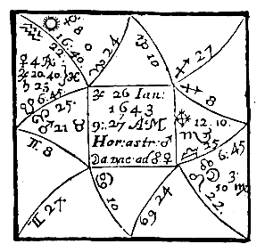

Compliments of http://mithras93.tripod.com

The Resolution of

CHAP. LXXVIII.

Terrible Dreames.

Jupiter and Saturn are Lords of the 9th accidentally posited in the 12th casting a Square aspect to the cuspe of the 9th: their position in the 12th according to the best Authors, intimates the vanity of the Dream, and rather a Person or fancy oppressed with various perturbations and worldly matters, then any other matter: But according to our judgment, Mars being the onely Planet in an Angle, shall best expresse the cause of the Dreame, and whether it will tend to good or evill; if we observe what house Mars is Lord of, we shall finde he is Lord of the ascendant and disposer of Part of Fortune, it being angular, I therefore acquainted him that the occasion of his Dreames might be construed two wayes; one, by his too great care of his Estate and Fortune intrusted out, and now desperate; because Mars was in Opposition to Part of Fortune; and that his minde ran so much thereupon, that his Fancy was disturbed, so that he could not enjoy that quiet and rest by night which nature affordeth all Creatures, In the next place, because Saturn is Lord of the 10th, which signifies Office, Command, &c.. and did afflict Jupiter Lord of the 9th, or did Impedite him at least; I told him I doubted he had lost the benefit of some good Place in the Commonwealth, and that now he was solicitous how to live in that credit he formerly did: howsoever, because Jupiter and Mars

436

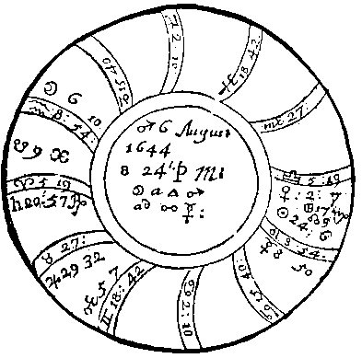

Compliments of http://mithras93.tripod.com

all manner of QUESTIONS.

were in Sextile, I judged no matter or perill to his person should come thereby, onely some dammage in Estate; and this really proved true.

CHAP. LXXIX.

If he should obtaine the Parsonage desired.

Judgement upon this Figure.

The Querent is signified by the signe ascending, Saturn therein posited, and Mars Lord of the ascendant in Gemini, an Ayery Signe, and Moon in Aquarius, of the same triplicity. The 9th 437

Compliments of http://mithras93.tripod.com The Resolution of

house and Jupiter Lord thereof are Significators of the Benefice.

1.

In the first place I finde no Conjunction betwixt Jupiter Lord of the 9th, and Mars Lord of the ascendant, or is the Moon in any aspect with Jupiter.

2.

I finde neither Mars Lord of the ascendant, or Moon posited in the 9th.

3.

There is no weighty Planet that translates or collects the light of Jupiter (who signifies the preferment) unto Mars.

4.

There is no reception betwixt Jupiter and Mars.

5.

Saturn is impedited in the ascendant, and by his presence infortunates the question, causing the Querent to despaire in the obtaining it.

6.

The Moon separates from a Trine of Mats, and applies to an opposition of Mercury, Lord of the 3rd: which intimated in my judgment, that some neighbour of the Querents, wither with letter, words, or crosse information would wholly destroy the Querents hopes, and that Mercuriall men, viz. Schollars, or Divines would be his enemies: and because I found Venus in Libra and 7th house, opposing the ascendant; I judged some Women would inform against him, or prejudice him in his suit, By all that hath been collected, I dehorted him from proceeding after the matter any further, as not to be obtained; but the Parson being covetous would proceed further in the matter; and so he did, and when he thought to have the matter absolutely on his side; Behold, a scurvey Letter revealing some manifest truths concerning a Female, dasht the good Mans hopes, &c. exit. The Querent was Saturn and Mars exactly, had wit and volubility of tongue; and as Mercury and the Moon are in Opposition, he under the Earth, she in the 12th, he could never discover which of his Neighbours it was that thus affronted him, nor would he aske me; if he had, it must have been Saturn Lord of the 12th, viz.

some Farmer, or dealer in Cattle, living North-east from him about fifteene Furlongs; a covetous repining Miser, Sickly, &c.

438

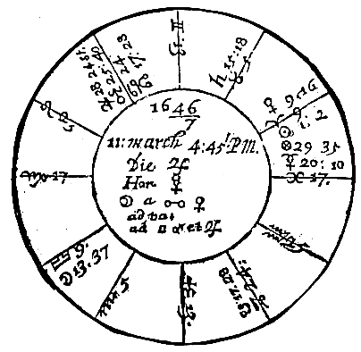

Compliments of http://mithras93.tripod.com

all manner of QUESTIONS.

CHAP. LXXX..

If Presberty shall stand?

Judgment upon the Figure abovesaid.

The angles of the Figure are common, and not fixed, but the Signe of the 9th, from which at present judgment must be naturally deduced, is Taurus, a fixed, stable Signe, and from Saturn in the Terms of Jupiter, who is therein posited, a slow and ponderous Planet; a generall Significator in Religion, Religious Rites and Ceremonies is now standing to Direction; and is departing out of 439

Compliments of http://mithras93.tripod.com The Resolution of

his Exaltation, having been a long time Retrograde therein, and now at present impedited by mars: after his transit out of Cancer, he enters the fixed Sign of Leo, and into the Terms of Saturn; but in the first six degrees thereof he meets with severall obnoxious fixed Starres, and thence passes into the Termes of Mercury, who is now in the Signe Pisces his Fall; yet angular, entred into the Decanate of Mars.

We find Venus Lady of the 9th house in Aries her Detriment, and in the 8th of the Figure, but 12th house from her own viz. Taurus, now the cusp of the 9th: and if you observe Venus well, she hath 21 degrees to passe through the Signe of Aries, and these degrees all in the 8th house, ere she get into Taurus where she may possible fix, or at least would; but before she fully gets out of this movable Signe Aries, she first hath occurse to the sinister Square of Jupiter, (The Gentry of England will oppose it.) then of Mars, (Mars Lord of the ascendant of England, the generality or whole Kingdome will distaste it.) all three in the Termes of Saturn: this might have produced some materiall effects, if Saturn had been essentially Fortified where he is, or if Presbytery had any relation to Monkery, or if it had been the first beginning of a Religious Order.

Let us take all the Planets as posited, and there’s not a Planet fixed except Saturn, not any essentially dignified but Jupiter, and he impedited by Mars; the Moon is entring Via Combusta, Mars is in his Fall, Mercury in his, Venus in her Detriment..

We have the Moon separating from Venus in the 8th, then going to be Vacua Cursus afterwards she Squares with Mars, (The Presbytery will struggle hard, and wrangle stoutly.) then with Jupiter: From those configurations we shall naturally frame our judgment, not positive or affirmative, but conjecturall, onely out of a desire that posterity may see there’s some verity in Astrology, and the Clergies just cause to carp at the Art if I lye: and we hope herein, that we shall no more offend in writing the Astrall intention of the heavenly bodyes, (deduced from reasons in Art) then those who daily (pleno ore) and publickly deliver amongst hundreds their conceptions, though repugnant to the opinion of very many now alive. The posture of Saturn in the 9th who is naturally of a severe, surly, rigid and harsh temper, may argue, the Presbytery shall be too strict, sullen and dogged for the English Constitutions, little gentle or compliant with the natures of the generality, and that there shall spring up amongst 440

Compliments of http://mithras93.tripod.com all manner of QUESTIONS.

themselves many strange and fearfull opinions and distractions even concerning this very Presbytery now mentioned, that they shall grow excessive covetous, contentious, and desirous of more then belongs unto them, worldly, envious and malicious one against another; that amongst them some Juniors represented by Venus, shall be but of light judgment, wave and decline the strictnesse of this Discipline; that the Elder, represented by Saturn, shall not be respected by reason of their too much rigidnesse, or shall their Orthodox opinions be consented unto.

Saturn is Peregrine, Occidentall, &c. fortified by no essentiall Dignity, or supported with the favourable aspect of either of the Fortunes; there’s Reception betwixt the Moon and him, but no aspect: Mercury Lord of the 10th signifying Authority, is separated and separateth apace from Saturn, as if the Gentry, or supreamest people of this Kingdome, doe in part decline from the severity of the too too austere Clergy or Presbytery, mistrusting a Thraldome rather then a Freedome to ensue hereupon.

[The Souldiery will distaste it.]

If you would know who shall most afflict, or who shall begin the dance, or most of all oppose it?

Saturn represents the Countryman, for he afflicting the house properly signifying Presbytery shewes the cause; this in few words expresses, it will not stand or continue (status quo:) Remove Saturn, Viz. Covetousnes, Rigidnes, Maliciousnesse, &c. then there may be more hopes that it might, but yet it will not stand (ita in fatis.) Three whole yeers from hence shall not passe, ore Authority it selfe, or some divine Providence informe our understanding with a way in Discipline or Government, either more neer to the former purity of the primitive times, or more beloved of the whole Kingdome of England, or Authority shall in this space of time moderate many things now stifly desired: For some time we shall not discover what shall be established, but all shall be even as when there was no King in Israel, a confusion among us shall yet a while romaine: the Souldery then, or some men of fiery Spirits wil arise, and keep back their Contribution from the Clergy, and will deny obedience or submission to this thing we call Presbytery; it will then come to be handled by the Magistrate, and taken into consideration by the grand Authority of the 441

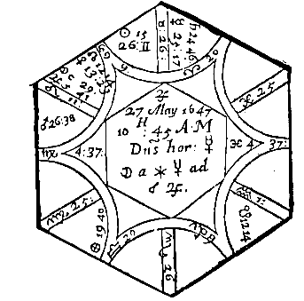

Compliments of http://mithras93.tripod.com

The Resolution of

Kingdome; yea, and by the plurality of the Clergy-men of England, or men of very sound judgments, it will be contradicted, disputed against, disapproved; and these shall make it manifest, this very Presbytery now maintained, is not the same the Commonwealth of England will entertaine, as a standing rule, for it to live under, or be governed by.

From what I doe find by this Figure, I conclude, that Presbytery shall not stand here in England (status quo) without refining and amending, and demolishing many scrupulous matters urged at present by the Clergy; for if we consider Jupiter as Lord of the 4th, we find the Moon, in plaine language, (after a little being voyd of course) run hastily to the Square of Mars and Jupiter; intimating, the Commonalty will defraud the expectation of the Clergy, and so strongly oppose them, that the end hereof shall wholly delude the expectation of the Clergy.

CHAP. LXXXI.

If attaine the Philosopher’s Stone?

An ingenious ma with much seriousnes propounded the Question above, viz. Whether he should obtain the Philosopher’s Stone? or, that Elixar by which such wonders are preformed? that there is such a thing in being I verily believe; that it may be attained I am confident: but as it is a blessing beyond all blessings upon

442

Compliments of http://mithras93.tripod.com all manner of QUESTIONS.

earth, so I hold, that it is given but to very few, and to those few rather by revelation of the good Angels of God, then the proper industry of man. This Question must admit of this manner of proposall; Whether the Knowledge of the querent is so able, or he so cunning, as to produce to effect by his Art what he desires?

The Querent is signified by the ascendant, and Mercury Lord thereof; his knowledge by Mars Lord of the 9th, and the aspects which may be cast unto him from the other Planets.

I find Mars Lord of the Querent’s Science in a cadent house, but in his owne Terme and Face.

Mars is in a Square aspect both of Mercury and Saturn, and they and he in fixed Signes, they in the Terms of Saturn, falling into the 9th house; I find Mercury lately Retrograde, and in Square or Mars, now moving slowly in his direct motion, and applying againe to a second Square of Mars: From hence I judged, the Querent had formerly spent some time in the search of this admirable Jewell the Elixar, but in vaine and to no purpose; his second application by Square happening not long after, while Mercury was in Gemini, and in his owne Terms, intimated a stronger desire, greater hopes and resolution to endeavour once more the attaining of the Philosopher’s Stone, but I advised the Querent to decline his further progresse upon that subject; and in regard of the former reasons, advised him how incapable he was, and the improbability of the thing he intended, according to naturall causes, and advised him to desist: I also said, that he erred in his materials or composition, working upon things terrene or of too grosse and heavy a substance; part of which judgment I collected by Saturn his Square unto Mars, part by the affliction of Mercury, his intellective part by the proximity of Saturn, both cohabiting in an earthly Signe, for in any operation where Mercury is corrupted, there the fancy or imaginative part is imbecill; but where the Lord of the Work it selfe is unfortunate (as here Mars Lord of the 9th is,) there the ground work or matter it selfe of the principall part of the operation is defective, as here it was: and that the Gentleman should think I spoke not in vaine, I acquainted him, he had more necessity to cure himselfe of a Consumption, he was entring into (nay entred) then of advancing his paines further in the scrutiny of this Laborinth.

443

Image 188

Image 189

Image 190

Image 191

Image 192

Image 193

Image 194

Image 195

Image 196

Image 197

Image 198

Image 199

Image 200

Image 201

Image 202

Image 203

Image 204

Image 205

Image 206

Image 207

Image 208

Image 209

Image 210

Image 211

Image 212

Image 213

Image 214

Image 215

Image 216

Image 217

Image 218

Image 219

Image 220

Image 221

Image 222

Image 223

Image 224

Image 225

Image 226

Image 227

Image 228

Image 229

Image 230

Image 231

Image 232

Image 233

Image 234

Image 235

Image 236

Image 237

Image 238

Image 239

Image 240

Image 241

Image 242

Image 243

Image 244

Image 245

Image 246

Image 247

Image 248

Image 249

Image 250

Image 251

Image 252

Image 253

Image 254

Image 255

Image 256

Image 257

Image 258

Image 259

Image 260

Image 261

Image 262

Image 263

Image 264

Image 265

Image 266

Compliments of http://mithras93.tripod.com

The Resolution of

For seeing Mercury Lord of the Ascendant, and Saturn in Conjunction in Taurus, Saturn being Lord of the 6th, of evill influence naturally, and finding Mars afflicting Mercury out of the 12th, and Mercury not receded from, but applying to a further evill Square of Mars, no Fortune interjecting his benevolent aspect betwixt Mercury and the two Infortunes, but that he stood single of himselfe without any assistance, and thereby was incapable of resisting their malevolent influence, I advised to have a care of his health speedily, &c.

THE TENTH HOUSE, and those QUESTIONS

properly belonging unto it.

CHAP. LXXXII.

Of Government, Office, Dignity, Preferment, or any place of Command or Trust, whether attainable or not?

The 1st house and his Lord are given to the Querent, the 10th house and his Lord shall signifie the Place, Office, Preferment, Command, Honour, &c. enquired after; if the Lord of the ascendant and the Moon be both joyned to the Sun, or to the Lord of the 10th, or either of them, and the Lord of the 10th behold the 10th, or be personally therein, the Querent shall then have the thing sought after, but not Gratis; nay, he must bestir himselfe, and use all the friends he can about it: if none of the Significators be joyned to the Lord of the 10th,, see if the Lord of the 1st or Moon be in the 10th, he shall then attain what he desires, if that Planet be not impedited: The Lord of the 10th in the 1st, so he be a lighter Planet then the Lord of the 1st, though no aspect be betwixt them, yet shall he attain the Place or Office desired; but with more ease and lesse labour when the Lord of the 10th is in the ascendant, and is either going to Conjunction , Sextile or Trine aspect with the Lord of the 1st.

If the Lord of the 10th be joyned to Jupiter or Venus by any 444

Compliments of http://mithras93.tripod.com all manner of QUESTIONS

aspect, and the Lord of the 10th be in the ascendant, it argues obtaining of the Office with ease and facility: If the Lord of the 10th be joyned to Mars or Saturn, and they or either of them in the ascendant, in their owne house or exaltation, and themselves Orientall and Direct, and not one opposite to another, this doth argue obtaining the Preferment, though with much importunity.

If the Lord of the 10th receive the Lord of the 1st or the Moon by any reception, or in any house, the matter will be effected with much content and profit.

If any Planet transferre the vertue of the Lord of the 1st to the Lord of the 10th, then the thing will be perfected, or Office obtained by meanes of another that labours in the matter, and not by himselfe: In this case, it’s best that he who would acquire the Dignity, observe if he know such a man as the Planet describes, that in probability is active, or of neer acquaintance to the person of whom he would have the Office, and let him imploy such a one in the businesse, for by his meanes it’s very like he may attaine the place desires.

If the Lord of the 10th doe not desire the Conjunction of the Lord of the 1st, but the Lord of the ascendant his, and doth really come to Conjunction of the Lord of the 10th, without the abscission of any other Planet before Conjunction, the Office will be obtained, but the Querent must labour hard for it.

No Conjunction being betwixt the Lord of the 1st and 10th, or either of them joyned to a Fortune, but to a malevolent, and this malevolent joyned to another malevolent, and this malevolent joyned to a Fortune, and this Fortune joyned to the Lord of the 10th; if the Conjunction of the 1st Infortune be with the Lord of the 1st, or the last Planet is joyned to the Lord of the 1st, or if their first Conjunction be with the Lord of the 10th, yet it imports acquisition of the Dignity, but with infinite perplexities, and solicitation of many and severall persons: you may easily distinguish the persons of those to be imployed, by the Planets before mentioned, and the houses they are Lords of; those Planets that are in Sextile or Trine to the Lord of the 10th are great with him: Let application or meanes be made to such, for those men may be great Friends to the Querent.

445

Compliments of http://mithras93.tripod.com The Resolution of

Behold if any of the preceding Planets be in the 1st, or in the 10th; if he be a Fortune, it notes obtaining the Dignity, whether he be in Reception or not: if the Planet so posited do receive the Moon or Lord of the 1st, the matter will be perfected, but without Reception, not.

If the 10th house be in the house or exaltation of that evill Planet, and he placed in that house, he performes the business, whether he receive the Lord of the ascendant or the Moon: In every Question you must observe, that what Planet soever is Significator of any thing, if he be in an angle, he hastens to effect the matter; in a succedant, the matter goes on slowly; in a cadent house, the matter goes backward, yet at last is performed.

See if an ill Planet behold the Lord of the ascendant or the Moon, with Square or Opposition, without Reception, for unlesse he then commit his disposition to another, he hinders and disturbs the Querent by meanes of that person who is to solicite the cause or businesse, and it’s probable they will fall out about it: if a Trifle or Sextile be betwixt them, he will not be angry with him, although he performe not what he expects.

If the Lord of the ascendant and 10th commit their disposition to any Planet by any aspect, with or with no Reception, whether the Receiver be a Fortune or Infortune (so that he be not Retrograde, Combust or Cadent, or goe out of that Signe wherein he is before the Conjunction of the Lord of the 1st or 10th, the Querent shall achieve the preferment expected.

It’s generally concluded by all Astrologers, that if the Lord of the ascendant and the Lord of the 10th be joyned together, and the Moon apply to either of them, the matter will be effected, but best of all when Moon separates from the Lord of the 10th, and applyes to the Lord of the ascendant.

Behold if the Lord of the 1st be joyned to the Lord of the 4th, or the Lord of the 4th to the Lord of the ascendant, it argues their perfecting of the thing: but if the Lord of the ascendant be joyned to the Lord of the 4th, and the Lord of the 4th be joyned to the Lord of the 10th, the matter shall be effected, but with so much strugling and delaying that it was absolutely despaired ever to be effected, yet at last it was perfected..

446

Compliments of http://mithras93.tripod.com all manner of QUESTIONS.

If one shall continue in the Office or Command he is in.

Behold herein the Lord of the 1st and the 10th, and see if they be in any aspect, or neer to a corporall conjunction; and see if the more ponderous Planet of the two, that is, the receiver of the Disposition be in any angle but the 4th; say then, he shall not be removed from his Office untill his appointed time comes out: but if that Receiver of the Disposition be under the earth, or in the descending part of heaven, it imports he shall depart from his Office, or for a time loose it; but shall returne thither againe more confirmed in his Place: and if the receiver of the Disposition be received againe, then he returnes with more honour then before, and also very speedily.

You may judge in the same manner if the Lord of the ascendant be joyned to the Lord of the 3rd or 9th, or to a Planet therein, and after separation from him, be joyned to a Planet in any Angle except the 4th.

But if they are separated from each other, then he returnes not againe to his government, but shall depart from it.

If the Lord of the 1st or 10th, or Moon commit their disposition to any Planet in an Angle (except he be in the 4th) and that Planet be slow in motion, he shall not be removed from his Office or place of trust, untill that Receiver become Retrograde or approach to Combustion, or goe out of the Signe wherein he is; for much about that time will be removed, If the Lord of the 1st be joyned to any Planet who is in a Sign opposite to the exaltation of the Planet who is in the Sign opposite to the exaltation of the Planet who now disposes him, the Officer will then carry himselfe ill in his place, and it may be feared he shall dye for it (but this is to be understood according to the quality of the place he hath.) If the Lord of the opposite house to the exaltation of the Lord of the 1st be joyned unto him; the men of that Kingdome, or people of that City or Countrey shall report ill of him, shall produce false witnesses against him; the ignorant shall beleeve those false reports, nor will they be easily beaten into any other opinion.

447

Compliments of http://mithras93.tripod.com The Resolution of

But if the Lord of the 10th be joyned to the Lord of the opposite house of his exaltation; the Countrey where he governs or governed, shall suffer great detriment, viz. by the said Governour.

If the Moon be joyned to the Lord of the 10th, and he in the 10th, the Governour or Officer shall not be put from his Office or Dignity.

If the Lord of the 1st or the Moon be joyned to the Lord of the 10th or either of them, and he more weighty then either of them, and be in a good place of heaven, viz. either in the 10th, 11th, or 5th free from all manner of impediments, though he behold not the 10th, yet withstanding if the Querent be then in any Command or Office, he shall be transferred to some other place of trust or Command: But if he behold the 10th house, then he shall continue where he is. If the Lord of the ascendant and the Moon be in Angles, and the Angles moveable Signes and Moon not joyned to the Lord of the exaltation of that Sign she is then in, it argues he shall goe from this present Command or Government: or if the Moon be joyned to any Planet who is not in any of his essential dignities, though he be received, unlesse it be from a fortune by Sextile or Trine, and that fortune in the 3rd or 9th, the Querent shall leave his Government or Office. In like manner the same thing will happen unto him, if either the Lord of the 4th or the Moon be in the 4th, and the Sign of the 4th be Aries, Cancer, Libra, Capricorn, the judgement will hold more certaine if the Moon be then joyned to the Lord of the 4th, and he Peregrine: and againe, the same will come to passe, if the Moon be joyned to a Planet, who is in the opposition to the Sign of the exaltation or house of her selfe; or if she be in Capricorn, or if the Moon be voyd of course.

CHAP. LXXXIII.

Whether a King expulsed his Kingdome, or an Officer removed from his government shall returne

to his Kingdome or Office

In these sad times of our Civill Distempers, many of the Gentry have propounded such Queries; Whether they should return and

448

Compliments of http://mithras93.tripod.com all manner of QUESTIONS.

enjoy once more their former estates, &c. that Question fals not to be judged by this house; the matter of this Question is of greater concernment; For Kings and Princes are now in this Chapter upon the Stage; and all manner of principall men cast out from former honours or preferments.

The 1st house in the Question and Lord thereof, are for the Querent, be he King, or other Officer,

&c. Lord, Marquesse, Duke or Gentleman..

Doe you well observe if the Lord of the 1st be in Conjunction with the Lord of the 10th, and see if the more ponderous of them who receives the disposition of the more light Planet behold the 10th house, then the King, Gentleman or Officer, shall returne and have power, or rule in the Kingdome or place he formerly had, and from whence at present he is suspended.

If that receiver of the disposition of the other significator do not aspect the 10th house, then observe the Moon, a generall Significatrix, and see if she be joyned to any Planet who is placed in the 1st or 10th, that signifies his returning or restoring: see if the Moon be in Aries, Cancer, Libra, Capricorn, he returnes the sooner: But if the Lord of the 10th be so joyned to a Planet in the 10th, it signifies the returne of a King to his Kingdome, or of one outed from his Office, to his place or command againe.

If the Lord of the 10th be more light then the Lord of the 4th, and be separated from him, these argue the same: If the Lord of the 10th be more light then the Lord of the 1st, and be joyned unto him, he shall returne and continue; so also, if the Moon be joyned to the Lord of the 10th, and she behold the 10th house, unlesse she commit her disposition to a peregrine Planet under the earth: if the Lord of the 1st be received of a Planet not impedited, he returnes: if not received, no returne.

The Moon joyned to a Planet in the 9th, signifies the King so expulsed (Or hath little desire to returne.) recedes from his Kingdome, unlesse the Planet be a Fortune: if the Planet to whom the Moon is joyned be a Fortune, and be in Aries, Taurus, Leo, Libra, Scorpio, Capricorn, Aquarius, the forlorne King or dejected Officer returnes: if the Planet to whom the Moon is joyned, be in Gemini, Virgo, Sagittarius or Pisces, the King obtains Soveraignty in another place, or the abjected a Command or Office in some other Country.

449

Compliments of http://mithras93.tripod.com The Resolution of

If you find the Lord of the 10th and the Moon impedited in any angle, by the corporall Conjunction of any Infortune, it imports that neither the distressed King, or expulsed Governour, or removed Officer, shall returne againe to their former Dignity, Rule or Command.

CHAP. LXXXIV.

Of the Profession, Magistery or Trade any one is capable of.

Country people many times have not the time of their childrens Nativities, yet being desirious to know what profession such or such a Sonne is fittest for, they may repair to the Astrologian for satisfaction herein: Upon the time of their demanding the Question, erect your Figure, and therein consider the ascendant and his Lord, the Lord of the 10th and 10th house, and especially the places of Mars and Venus; for these Planets are the Significators of Magistery, Trade or Profession: take which of the two you find most powerfull, and see in what Signe he is, if he be in Aries, consider the four angles, and whether you find a Planet in either of them, and if that Planet be in a fiery Signe, or of the nature of Aries, you may say, the Boy will prove a good Cart-maker, Coach-maker, Shepheard, Grasier or Drover to deale in Cattle, a good Groom, or Master of Horse, or Farrier, succesfull to deale in four-footed Beasts, or a good Butcher, Brick-maker, Smith, &c. but if Mars have any dignity in the place of the Significator, or the Sun, he will prove excellent in any Profession where fire is used, or of its nature: if the Significator be in his Exaltation, it’s pity the Child should be of any servile Trade, as aforesaid, he may doe better in serving the King, some Nobleman or Gentleman: After this manner consider in all those Signes which represent the shape of four-footed Cattle, according to the Angles, Aries, Taurus, Leo, Sagittarius, Capricorn, for these five signifying Fowle, or such like; but if no Planet be therein, then they import any thing of the nature of water .

450

Compliments of http://mithras93.tripod.com all manner of QUESTIONS.

But to the purpose, observe if the Significator of ones Profession be in Taurus, then Husbandry may be best for him, or planting Trees, Gardening, buying and selling Corne, or grazing Cattle, dealing in Oxen, Cowes, Sheep, Hogs, or he may be of such a Trade as hath affinity in Womens matters, or Huswifry, he would prove a good Soap-maker, a Fuller of Cloth, a Whitster, &c.

If the Significator be in Gemini, he will make a Scrivener, Clerk, Arithmatician, a Baily to gather Rents, a Geometrician or Surveyor, Astronomer, Astrologer, Painter, &c.

If the Significator be in Leo, he will make a good Serving-man, or to be of any Trade that useth fire or hot things, a good Hunts-man, a good Leech for Cowes or Cattle, a good Rider or Horse-courser, or Coach-man, or a Smith, Watch-maker, Glassemaker, If the Significator be in Virgo, he will make a good Secretary to a King or Nobleman, a School-master, an Accountant, a Stationer, or Printer, he will be an excellent Politian, a good Astrologer, and of a divining Soule.

If the Significator be in Libra, he will be a good Poet, a good Orator, a Song-man or Musitian, a Silkman or Linen-Draper, a good Pedagogue, or fit to redeem Captives.

If the principall Significator be in Scorpio, he may prove a good Chyrurgion, Apothecary or Physitian, a Brasier or Founder, a Brewer, Vintener, Water-man or Maltster.

If the Significator be in Sagittarius, he will make an excellent man to buy and sell Cattle, to study Chymistry, or to make a Church-man, or he may be a good Cook or Baker.

If the Significator be in Capricorn, he will prove a good Chandler, Victualler, Farrier, Cow-leech, Jeweller, Farmer, dealer in Wool, Lead or Country-commodities, a good Husband-man.

If the Significator be in Aquarius, he may be an excellent Ship carpenter; and if any Planet out of the watry Signe aspect him, he may prove an excellent Saylor, or Master of a Ship, a Trimmer or Painter of Ships, a good industrious Merchant.

If the Significator be in Pisces, he may be a Jester, Singer, a Gamester, a Brewer or Fish-monger; but for the most part in such like cases, the Genius is dull, and the child proves a moor Sot.

451

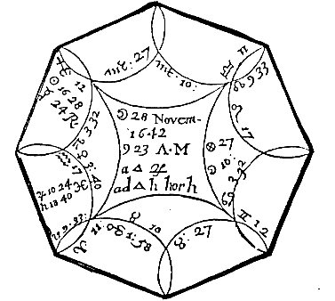

Compliments of http://mithras93.tripod.com

The Resolution of

CHAP. LXXXV.

If Prince RUPERT should get honour by our Warres, or worst the Earle of ESSEX? What should become of him?

Resolution of this Figure.

This Question fals not under the notion of vulgar rules, or must the Astrologian expect particular Rules to governe his Fancy in every Question; it was well said, Ate & a Scientia, for I doe daily resolve such Questions as come not into the vulgar Rules of Guido or Haly; and yet I was never to seek a sufficient reason in Art, whereby to give a good and satisfactory answer to the Proponent, &c. as many hundreds in this Kingdome well know, &c.. He that propounded the Questions was a very great wel-willer to

452

Compliments of http://mithras93.tripod.com all manner of QUESTIONS.

the Parliament, and involved himselfe and Fortune amongst us, therefore the ascendant and Lord thereof shall signifie the Querent; but in regard Prince RUPERT is a noble Man, or person of eminency, he is signified by the 10th house and Lord thereof; the Signe is Scorpio, the Lord thereof Mars: I must confesse, at first finding the Moon in Cancer, to cast her Trine Sinister to the cusp of the 10th; I judged, the person of the man would be in no great danger, and that many vulgar people, and some of better quality, would much honour him, and he find great respect amongst them, and have a special care of his owne person: and verily Jupiter doth also cast his Trine Dexter to the cusp of the 10th house, whereby I judged, that we should not destroy his person, for the heavens by this Figure intimated the contrary: The very truth is, I was twenty four hours studying the resolution of this Question, for much may be said in behalfe of the Prince, and the hopes might be expected from him; at last I came to this resolution, that he should gain no honour by this War, because neither of the Luminaries were in the 10th house, or in perfect aspect with his Significator, but at last fall into the hatred and malice of all or many, by his owne perversnesse and folly, and in the end should depart without either honour, love or friendship, but should not be killed: The Lord of the 10th in his Detriment, argue his depraved Fancy; and being in a fixed Signe, shewes his obstinatenesse, self-opposition, conceitednesse and continuance in his erronious judgment, for let all the Planets assist in a Question concerning Warre or Souldiery, if Mars himselfe, who is Significator thereof, be unfortunate, or not strongly supported by the Luminaries, it’s as good as nothing, the party shall be preserved, but doe no glorious work or action in War, though he be never so valiant.

If he should worst the Earle of ESSEX?

ESSEX is here signified by Venus, because she is Lady of Taurus, the opposite house to the Prince’s; we find Venus in Aquarius, in the Terms of Saturn, and the Lord of the Ascendant; in Reception with Saturn, for as she receives him in her Exaltation, so doth he her in him Joy and Terme: the Moon transferres the

453

Compliments of http://mithras93.tripod.com The Resolution of

influence of Jupiter to Saturn, by a forcible and strong aspect, viz. a Trine; Venus is in Square of Mars, but separated; as if not long before there had been some fight or warre betwixt them, (for you must understand we are not upon poynt of warre;) [and so there had:] For Edge-hill fight was above a moneth before, wherein Essex had the better; and this I prove because he kept the ground where the Battle was fought, when both the King and Prince Rupert left the Field. I know Posterity will beleeve me, sith I write now as an Artist, and upon a subject which must be left to Posterity: This I know by the testimony of many of the Kings owne Officer’s who have confessed as much unto me &c. But let it suffice, I positively affirmed, Rupert should never pervaile against the valiant Essex, &c. nor did he.

What should become of him?

His Significator, viz. Mars, being peregrine, and in the 3rd, I said, it should come to passe, he should be at our disposing, and that we should at last have him in our owne custody, and doe what we list with him: this I judged, because the gentle Planet Venus, Essex Significator, did dispose of Rupert: an errour in part I confesse it was, yet not much to be blamed, for (in totidem verbis) it was very neer truth, for in 1646, he was besieged in Oxford, and after surrender thereof, having unadvisedly repaired to Oatlands, contrary to Agreement and Covenant, he was then at the mercy of the Parliament, and in their mercy: but they of that house looking on him rather as an improvident young man, then any worthy of their displeasure or taking notice of, let him depart with his owne proper fate, heavy enough for him to beare; and so he escaped. So that the generall fate of this Kingdome, overcame my private opinion upon Prince Rupert. However, I am glad he escaped so, being questionlesse a man of able parts, but unfortunate, not in himselfe, but in the fate of his Family.

454

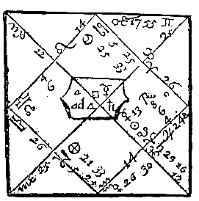

Compliments of http://mithras93.tripod.com

all manner of QUESTIONS.

CHAP. LXXXV.

If his MAJESTY should procure Forces out of Ireland to harme the Parliament?

If the QUEEN, then in the North, would advance with her Army? If she would prosper? When She and his Majesty should meet?

His Majestie is here signified by Moon in Cancer in the 10th house, who increasing in light, elevated and posited in her owne house, voyd of all infelicity, except slownesse in motion, did manifest at the time of the erecting of this Figure, his Majesty to be in an able condition, as indeed he was.

In this Judgment we find Sun Lord of the 11th (which house signifies assistance or aide in this manner of Judgment) posited in the 7th, in his Exaltation, and applying to the cusp of the 11th with a Trine aspect, but wants 6 degrees of being partill; forasmuch as the Moon being in her owne house, and Sun so well fortified, I did judge his Majesty should have ayde of Commanders out of Ireland (for Sun represents Commanders) and men, or common men, besides; because both Sun and Moon are friendly unto him: that they should harme us, I judged because Sun Lord of that assistance, was in the 7th, in direct Opposition to the ascendant, which representes the Parliament and their party: but because the Sun is so neer South Node, and beholds the cusp of the 10th with a Square Sinister, I did in the end lesse fear them, and judged they should produce much scandall, to his Majesty and his Party, and that they would cause many ill and 455

Compliments of http://mithras93.tripod.com The Resolution of

heavy reports to fall upon his Majesty by their meanes: I also then judged, that his Majesty was likely to improve his Forces, and augment them for some certaine time, but that it should not continue very long, for that neither the Sun or Moon were fixed. The truth is, he had Irish Forces come over, which much hardened the hearts of the English against him, but time cut them off,

&c. as we doe all well know, at the Siege of Namptwich, by valiant FAIRFAX.

Her Majesties Signifatrix is Saturn Lord of the 4th, for that is the 7th from the 10th, removing out of one Signe into another: Saturn being a ponderous Planet, made me more confident her Majesty would move forwards with her Army, with intention to meet his Majesty, which I said she should do about 3 or 4 moneths from the time of the Figure, because the Moon wanted 3 or 4

degrees of the Trine of Saturn, I intimated a great desire in his Majesty to see her, because his Significator applyed, The truth is, she met him about the 14. of July 1643. in Warwick-shire. I judged that she would not prosper but decline, because Saturn her Significatrix was going into Aries his Fall, and that Jupiter, viz. good Fortune, was separated, and did separate from Saturn.

Besides, I observed that Mars made haste to a Square of Saturn in Cancer, as if our Souldiery would quite destroy and bring to nothing her Army; and that she would be crossed at or neer the time of that aspect, which was the 11. April, when about Nottingham she lost some Forces, and more had, but that we had ever either some knaves or fools in our Armies.

CHAP. LXXXVI.

If attaine the Preferment desires?

At the same time within 4 or 5 minutes thereof, a Gentleman desired to know if he should obtaine an Office or place he looked after.

The ascendant and Venus are for the Querent, the 10th house for the Office or place of perferment he expects.

456

Image 269

Image 270

Image 271

Image 272

Image 273

Image 274

Image 275

Image 276

Image 277

Image 278

Image 279

Image 280

Image 281

Image 282

Image 283

Image 284

Image 285

Image 286

Image 287

Image 288

Image 289

Image 290

Image 291

Image 292

Image 293

Image 294

Image 295

Image 296

Image 297

Image 298

Image 299

Image 300

Image 301

Image 302

Image 303

Image 304

Image 305

Image 306

Image 307

Image 308

Image 309

Image 310

Image 311

Image 312

Image 313

Image 314

Image 315

Image 316

Image 317

Image 318

Image 319

Image 320

Image 321

Image 322

Image 323

Image 324

Image 325

Image 326

Image 327

Image 328

Image 329

Image 330

Image 331

Image 332

Image 333

Image 334

Image 335

Image 336

Image 337

Image 338

Image 339

Image 340

Image 341

Image 342

Image 343

Image 344

Image 345

Image 346

Image 347

Compliments of http://mithras93.tripod.com

all manner of QUESTIONS.

Finding the Moon placed in the 10th, which is in the house of the thing looked after, viz.

Preferment, it was one argument the Querent should have it.

In the next place, the Moon applyed to a Trine of Saturn, who hath Exaltation in the ascendant, and who receives Venus, and is received of her againe.

Besides, the Moon applying to Saturn, who is Lord of the 4th, argues that in the end he should obtaine the Office: but because Sun was in the 7th house in Opposition to the ascendant , and with South Node, and was Lord of the 11th, I judged he did employ as a Friend, a Solar man, who was false, and did rather envy them affect him. I concluded for the reasons above-named, that with some difficulty he should obtaine the Dignity, notwithstanding the opposition a pretended Friend did make; and so it came to passe within lesse three weeks, and he then discovered that his Friend was false, who had a great scarre in his Face, was not of bright or yellow Haire, but of a blackish dark colour, occasioned by Sun his neernesse to South Node: the separation of Moon from a Sqaure of Mercury, argued, he had delivered many Petitions about it, but hitherto without successe.

The ELEVEN HOUSE, and those QUESTIONS

properly belongong unto it.

It is the House of Friends, Hope,

Substance or Riches of Kings.

CHAP. LXXXVII.

Of good or ill questions concerning this House.

If the Lord of this house be strong, fortunate, and well aspected of the Lord of the ascendant, it foresheweth the obtaining of the

457

Compliments of http://mithras93.tripod.com The Resolution of

thing at present hoped for; as also, love and concord of Friends and Acquaintance, if the Question be thereof.

If a man shall have the thing hoped for?

Behold if there be any good aspect between the Lord of the ascendant and the 11th, or Reception or translation of light, or that the Lord of the 11th in the ascendant: all or any of these gives hope of obtaining the same. If there be none of those, behold Moon, and if she be not qualified with the Lord of the 11th, aforesaid, judge the contrary, Another Judgment concerning the former Question.

When any one asketh for a thing he hopes to have of his Prince, Lord, Master or Noble-man, as sone Dignity, &c. behold if the Lord of the 11th house doe apply unto the Lord of the ascendant, or the Lord of the ascendant to the Lord of the 11th, say then he shall have the thing hoped for; and if the aspect be by Trine or Sextile, he shall obtaine the same with great ease and speed: but if the aspect be with Square or Opposition, he shall get it with much labor and tediousnesse; yes, although there be Reception of Significators.

If you find the Lord of the 11th in an angle received, judge the thing shall come to passe as he would wish..

If you find the Receiver of the disposition of the Moon in a common Signe, judge he shall have but part of the thing hoped for: If the same Receiver be in a movable Signe, he shall onely have the name, or a probability of having thereof, or else very little of it: but if the same Receiver be in a fixed Signe, he shall have the thing whole and compleat: but if the Receiver of the Moon be infortunate, the matter shall receive damage or hurt, after that he hath the same, or is in possession thereof.

If you find the Receiver of the Moon received, he shall likewise obtaine the same, and more then he looked for: if you find the Lord of the ascendant received, he shall obtaine whatsoever he hoped for: this must be understood in things feasible and possible.

458

Compliments of http://mithras93.tripod.com all manner of QUESTIONS.

CHAP. LXXXVIII.

Of the agreeing of Friends.

If one aske, If he shall joyne, and be at Concord and Unity with his Friend, or not? behold the Lord of the ascendant and the Moon, if you find them applying to the Lord of the 11th house, say they shall both joyne and agree together; if the application be by Sextile or Trine they shall agree and joyne together with respect, desire, joy and love: but if the application be by Square or Opposition, in their joyning there shall be brawling and strife, and the one shall be irksome to the other; and note, that the application which is by Opposition, is worse then that which is by Square.

Note, if any one aske for a thing secretly, saying, Look I pray you for me, If I shall obtaine the thing I hope for, or not: consider if you find the Lord of the ascendant and the Moon applying to Fortunes, and in angles or Succedants, then he shall obtaine it, otherwise not, But if the Querent shall manifest the thing and name it, then you must behold the thing in its owne proper place pertaining to the same House, and so judge of the hopes or not hopes thereof, Of Love betwixt two.

If it be asked of the love of two, viz. If the one doe love the other or not? behold the Lord of the 11th. 7th and 3rd, and if the Lords of these houses doe behold the Lord of the ascendant with a Sextile or Trine aspect they love one another: but if the aspect be by Square of Opposition, they love not, or but teeth outward; chiefly if one of them be Lord of the 12th house; if neither of them shall have aspect thither, viz. to the 12th house or Lord thereof, the love of the two persons shall be the more firme and strong: if all three be there, viz. either in the 11th, 7th, or 3rd, or doe behold each other out of those houses, their love shall be the stronger, especially if the aspect be in fixed Signes.

459

Image 348

Image 349

Image 350

Image 351

Image 352

Image 353

Image 354

Image 355

Image 356

Image 357

Image 358

Image 359

Image 360

Image 361

Image 362

Image 363

Image 364

Image 365

Image 366

Image 367

Image 368

Image 369

Image 370

Image 371

Image 372

Image 373

Image 374

Image 375

Image 376

Image 377

Image 378

Image 379

Image 380

Image 381

Image 382

Image 383

Image 384

Image 385

Image 386

Image 387

Image 388

Image 389

Image 390

Image 391

Image 392

Image 393

Image 394

Image 395

Image 396

Image 397

Image 398

Image 399

Image 400

Image 401

Image 402

Image 403

Image 404

Image 405

Image 406

Image 407

Image 408

Image 409

Image 410

Image 411

Image 412

Image 413

Image 414

Image 415

Image 416

Image 417

Image 418

Image 419

Image 420

Image 421

Image 422

Image 423

Image 424

Image 425

Image 426

Compliments of http://mithras93.tripod.com

The Resolution of

Of the TWELFTH HOUSE, and those QUESTIONS

which properly appertain unto it.

Viz. Of Imprisionment, great Cattle,

Witchery, private Enemies, Labour,

banished Men, &c.

CHAP. LXXXIX.

Of Secret Enemies, not named.

If a Question be asked, concerning Enemies, and none named, see to the Lord of the 12th; but if any be named, then to the 7th house and the Lord thereof; diligently considering their applications to and with the Lord of the ascendant, and by what aspect, and out of what houses; for if the Lord of the 12th behold the Lord of the ascendant with Square or Opposition, out of the 8th, 6th or 12th, or out of those houses which have a Square aspect to the ascendant, or no aspect at all, then there is some that privately and secretly wish him ill, and doe him mischiefe, or some secret enemy unto him.

To know some Secret Enemy who he is.

If any man demand the state of a secret Enemy, behold the Lord of the 12th house, and how he is affected, and whether he be with good or evill Planets, and behold the ascendant or Lord thereof, for if he be in the 6th, or joyned to the Lord thereof, it shewes the secret Enemy is afflicted with some secret Disease or Malady; as also, if the Lord of the 6th be in the 12th: but if he, viz. Lord of the 12th, be with the Lord of the 10th, he is in favour 460

Compliments of http://mithras93.tripod.com all manner of QUESTIONS.

with the King, or is a man of good quality, or lives with some man of quality, and it is not good for the Querent to meddle with him, especially if at such time he behold the Lord of the ascendant with Square or Opposition: but if the Lord of the 12th be in the 4th or 8th, or with the Lord thereof, judge him sickly, or neer to dying, or even pining and repining. Consider and judge with discretion in such like cases, according to former Directions.

CHAP. XC.

Any man committed to Prison, whether he shall be soone Delivered?

[You must know your ascendant exactly, and what relation the party enquired of hath to the Querent, &c.]

Behold the Moon, if she be swift or slow of course: if she be swift, it shewes short tarrying in prison; the contrary if she be slow of course: if she give her strength to a Planet in the 3rd house or 9th, this shewes he shall soon come forth of prison; if she give power to the Lord of the 9th or 3rd, and be not in one of the angles, idem: and as you judge by the Moon so judge by the Lord of the ascendant.

You shall also note, that the Quarters of Heaven in the Figure, are of great strength and force; for the Significators in Quarters feminine, doe signifie a swift going out, the other more slow: so also common Signes shew a time betwixt both; for is the Significator be in one of them, it signifies he shall be imprisioned againe.

If you find the Lords of the angles in angles, he shall not come out of prison; and so much the worse, if the Lord of the ascendant be in the 4th, or that he give power to the Lord of the 12th, or the Lord of the 12th to the Lord of the ascendant; and yet worse, if the Lord of the ascendant give power to a Planet being in an angle; which if he be an ill Planet, it’s so much worse; if it be the Lord of the 8th house, he shall dye in prison: If the Moon give power to the Lord of the ascendant, it’s an evill Signe; and the worse, if a Planet being in an angle, and slow in motion; if he be swift, it diminisheth part of the evill, and shortneth the time.

461

Compliments of http://mithras93.tripod.com The Resolution of

Every Planet that is Retrograde, sheweth slownesse: If the Lord of the ascendant be Combust, he shall never come out; or if he be not then received of the Sun, he shall dye in prison.

Of the Imprisoned.

Moon and Mercury in movable Signes, aspecting a Fortune, or Mercury in aspect of a Fortune, notes enlargement: this is when Mercury is Lord of the ascendant.

Jupiter in the ascendant, or Mars or Moon at time if Arrest, or Venus in the ascendant with the Moon, or Mercury with Jupiter, aspecting the Moon, or Moon applying to Jupiter or Venus notes enlargement.

The Dispositor of Moon in aspect with a Fortune; any of these notes he shall be delivered in a short and convenient time.

If a Question be asked for a Captive or Prisioner.

Behold the Lord of the ascendant, and if he be separated from the Lord of the 4th house, or the Lord of the 4th house from him, it signifies he shall quickly goe out of prison: if the Lord of the ascendant in separating himselfe from the Lord of the 4th doe apply unto a Fortune, and he himselfe remove from an angle, it is a more sure and certaine signe that he shall escape and come forth of prison; when the Lord of the ascendant shall be in Cadents from the Angles, it is likewise a signe of escape.

If the Lord of the ascendant doe escape himselfe from the Sun, or if the Moon shall be existent under the Beames, it signifies escape and that especially if he be in the King’s Prison.

If at any time any of the ill Signs, viz. fixed, be ascending at the house of Imprisonment, or when the Question is taken for the Prisoner, or the Lord of the ascendant or Moon be unfortunate in any of these Signes Taurus, Leo, Aquarius, Pisces, it signifies long time of imprisonment, or in danger thereof by quarrelling: If the same Infortune be Saturn it signifies great Tortures, Irons, and grievous punishments, amongst us it notes wants, hard measure, small or no mercy, sicknesse: If an Infortune be in the

462

Compliments of http://mithras93.tripod.com all manner of QUESTIONS.

two latter Signes, it signifies long endurance in prison, but shortest time if in Pisces. If the Lord of the ascendant be cadent from his House or his Exaltation, and Moon in Aquarius, it signifies long imprisionment: The Lord of the ascendant or the Moon in the 8th, doe signifie the same. If Mercury be with any of the Infortunes, he addeth evill and misery to the Incarcerated, and an ill end to the Prisoner.

To be short, there can be nothing better to be wished for the Prisoner, then if the Moon be in her wane, descending unto her Septentrionall part, and applying unto Fortunes, and the ascendant and his Lord fortunate.

Note also, that Venus is more to be wished for the Prisoner then Jupiter, and delivereth sooner out of Prison; especially if she be joyned in signification with the Moon or Mercury: If the Moon be with Saturn, and Jupiter behold them with a Square, and Mars with a Trine, it signifies that after long imprisonment and misery, he shall break prison and escape.

CHAP. XCI.

Of a Captive or Slave.

Behold the 6th house or 12th, and if any Planet be therein, he is the Signifier of the Captive, because those houses are the houses of Captives or imprisonment. If you find none there, behold the Planet which is under the Sun-Beames, he is the Signifier.

Behold the hour at what time the Captive is taken in, and if the Lord of the hour be an Infortune, it signifies long imprisonment or Captivity.

The Ancients say, he that is taken in the hour of the Sun, shall escape within a moneth; in the hour of Venus, in 40 dayes; in the hour of Mercury, long imprisonment; in the hour of the Moon, his state shall change according to the applications of the Moon hath with the Planets, fortunate or infortunate; according to which you shall judge easie or slow deliverance: he that is 463

Compliments of http://mithras93.tripod.com The Resolution of

taken in the hour of Saturn, shall be long in prison; in the hour of Jupiter, he shall soon goe out, but he that is taken in the hour of Mars, much trouble shall happen unto him in prison, for he shall be put in Fetters or beaten; this you must understand of Fellons, or Souldiers, or men that break Prison, or of mad men, &c.

CHAP. XCII.

If one be Bewitched or not.

If the Lord of the 12th be in the 6th, or the Lord of the 6th in the 12th, or the Lord of the ascendant in the 12th, or the Lord of the 12th in the ascendant, or the Lord of the 8th in the ascendant, or the Lord of the ascendant in the 8th, in a Question where suspition of Witchcraft is, it is probable; otherwise not so: But the Judgment succeeding I have found more certaine.

It’s a received, generall Rule amongst those Artists that know the Cabalisticall Key of Astrologie, that if one Planet be Lord of the ascendant and 12th house, that then the Sicknesse is more then naturall: when Saturn is Lord of the ascendant and 12th, and in the 12th Retrograde, or in the 7th or 8th house in the same condition, and the Moon being Lady of the 6th, apply to Saturn, we constantly judge the party enquiring is Bewitched or Fore spoken, or that an evill Spirit hath power over him, and that the Infirm will be sore oppressed and disturbed in his Fancy, if not distracted.

If the Lord of the ascendant be Combust, or infortunate in the 12th, or joyned to the Lord of the 12th, there may be great feare, that the party enquiring or enquired for is Inchanted or Bewitched, or else some evill Spirits doe hant him, If the Lord of the ascendant be Lord of the 12th, and Combust, you must observe of what house the Sun is Lord, and in what Signe and quarter of Heaven he and the Lord of the ascendant are, and judge the Witch liveth that way; describe the Sun Sign as he is, and it represents the person.

If the Lord of the ascendant be Lord of the 12th, Combust, or 464

Compliments of http://mithras93.tripod.com all manner of QUESTIONS..

unfortunate by the Lord of the 3rd, it’s a Neighbour hath procured some Witch to doe this act, or one of the Kindred; see in what house the Lord of the ascendant fals to be in, and in what house the Lord of the 3rd is in, and infortunates him, you may judge the cause of the malice to proceed from something of the nature of that house; as if either of them be in the 6th, it’s for Pastorage of Cattle, or some difference about small Cattle, or for one hiring the others Servants, &c. and in like manner consider all twelve houses.

If the Lord of the ascendant be infortunate, as aforesaid, by the Lord of the 5th, it’s some Ale-wife, Nurse, or some drunken companion that occasions it, or hath procured this Witchery.

If the Lord of the 10th afflict the Lord of the ascendant in the 12th, it’s doubtlesse the hand of God, or by some supernaturall power or cause.

If the Lord of the ascendant be an unfortunate Planet, as Mars or Saturn, and be in the 12th house, Combust and infortunated by the Lord of the 12th, it imports the man is bewitched by a common Witch..

If the Lord of the 12th be in the ascendant it argues Witchcraft, or that some evill Spirit doth molest the party, or that some that are neer him or about him have evill tongues, or in plaine tearmes, have bewitched him.

In places where people are troubled with Witches, as in many places of this Kingdome they are, these Rules will hold: as also, if the Moon be in the 12th, in Opposition to the Lord of the ascendant or 12th. If people suspect their Cattle Bewitched, if they be great Cattle, make the 12th house their ascendant, and the 11th their 12th house, and vary your Rules with Judgment.

NATURALL REMEDIES FOR WITCHCRAFT.

Having by the Figure discovered and described the Party, either by that Planet who is Lord of the 12th, or posited in the 12th, and doth behold the Lord of the ascendant with a malicious 465

Compliments of http://mithras93.tripod.com The Resolution of

aspect, you must let one watch the party suspected, when they goe home to their owne house, and presently after, before any body goe into the house after him or her, let one pull a handfull of the Thatch, or a Tile that is over the Doore: and if it be a Tile, make a good fire and heat it red hot therein, setting a Trevet over it, then take the parties water, if it be a man, woman or child, and poure it upon the red hot Tile, upon one side first, and then on the other, and againe put the Tile in the fire, and make it extreamly hot, turning it ever and anon, and let no body come into the house in the meane time.

If they be Cattle that are bewtiched, take some of the Haire of every one of them, and mix the Haire in faire water, or wet it well, and then lay it under the Tile, the Trevet standing over the Tile: make a lusty fire, turne your Tile oft upon the Haire, and stir up the Haire ever and anon: after you have done this by the space of a quarter of an hour, let the fire alone, and when the ashes are cold, bury them in the ground towards that quarter of heaven where the suspected Witch lives.

If the Witch lives where there is no Tile but Thatch, then take a great handfull thereof, and wet it is the parties water, or else in common water mixed with some salt, then lay it in the fire, so that it may molter and smother by degrees and in a long time, setting a Trevet over it.

Or else take two new Horse-shooes, heat them red hot, and naile one of them on the Threshold of the Door, but quench the other in Urine of the party so Bewitched; then set the Urine over the fire, and put the Horse-shooes in it, setting a Trevet over the Pipkin or Pan wherein the Urine is; make the Urine boyle, with a little salt put into it, and three Horse-nails untill it’s almost consumed, viz. the Urine; what is not boyled fully away poure into the fire: keep your Horse-shooe and nailes in a cleane cloth or paper, and use the same manner three severall times; the operation would be farre more effectuall, if you doe these things at the very change or full Moon, or at the very hour of the first or second quarter thereof. If they be Cattle bewitched, you must mix the Haire of their Tailes with the Thatch, and moysten them, being well bound together, and so let them be a long time in the fire consuming. These are naturall experiments, and work by sympathy, as I have found by severall experiments: I could have perscribed many more, Multa creduntur ratione experintia, non quod videntur vera vi rationis.

466

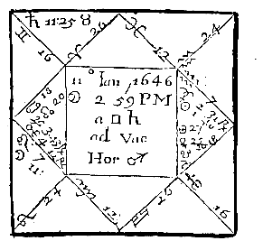

Compliments of http://mithras93.tripod.com

all manner of QUESTIONS.

CHAP. XCIII.

A Horse lost or stolen neer Henley, if recoverable or not?

Mercury Here Lord of the 12th signifies the Horse whom you see Retrograde, & hastening to a Conjunction of the Sun, Lord of the Querent's House of Substance; forasmuch as Mercury did by his Retrograde motion apply to the Lord of the Querent’s house of Substance, and that the Moon was locally in the 2nd and both Jupiter and Mars Retrograde, neer the cusp of the 2nd, I judged the Querent should have his Goods or Horse quickly and unexpectedly, within a day to two from the time of the Question asked; and because the 7th house was afflicted by South Node, I judged the Thief could not keep him.

I was asked, Which way he went? I considered the Signe of the 12th was Gemini, viz. West; the Signe wherein Mercury Lord of the .12th was in, was Aquarius, viz. West; though the quarter of Heaven was South, but much inclining to the West; and the Moon was in Leo, a North-east Signe: Besides, Mercury as he was Lord of the 4th, was in a West Signe. From whence I concluded, the Horse was gone Westward; but because Mercury was Retrograde, I judged the Horse would not proceed farre, but return againe to his proper owner; [and indeed the Horse did come home three dayes after, and had been full West.] However, I judged the Horse would have been at home a day sooner; but who shall more exactly consider of the Scheame, shall find, the Mercury Significator of the Horse, although he came to the body of Sun Lord of the Querent’s house of Substance, the same night the Question was 467

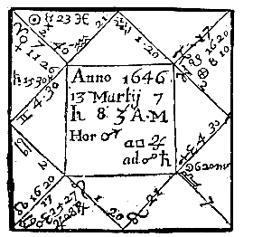

Compliments of http://mithras93.tripod.com

The Resolution of

asked, yet because the Sun had no Dignities where he was, the Horse came not home untill Wednesday or Thursday the 13th or 14th of January, at what time Mercury and Venus came to a partill Conjunction.

I must confesse, here were many good significations that the Querent should recover his lost Horse: first, North Node in the ascendant: next, Moon in the 2nd, arguing he should be discovered: thirdly, Mercury Lord of the thing lost Retrograde, importing a returning of the thing againe casually: fourthly, two Retrograde Planets upon the cusp of the 2nd, which usually shews quick and unexpected recovery; Jupiter and Mars peregrine, I took them for those that rode away the Horse, Jupiter especially; [and it was very true.]

CHAP. XCIV.

If Bewitched.

Wee must first consider if Mars Lord of the 12th afflict Mercury Lord of the ascendant, or if Mars afflict the Moon; or whether Mercury be Lord of the ascendant and 12th, or if Saturn Lord of the 8th doe mischieve the ascendant; for without the Lord of the ascendant or ascendant itselfe, or the Moon be afflicted by the Lord of the 12th, there’s no strong Witchcraft: Here finding the Moon going to Opposition of Saturn, both Planets in the 6th and 12th houses, it gave suspition of Witchcraft, and there seemed to those that asked for the Querent some reason for it, in regard

468

Compliments of http://mithras93.tripod.com all manner of QUESTIONS.

the Physitians had prescribed much Physick, and it wrought no effect, but the Patient was worse and worse: I positively affirmed he was not bewitched, because Mercury was in Trine to Jupiter and Mars, and Venus in the 12th, and Saturn much elongated from the cusp of the house, the Moon applying after her Opposition of Saturn, unto Mercury Lord of the ascendant, he above the earth, ascending towards the Meridian.

I directed them againe to advise with the Doctors, and civilly to aquaint them, that the Disease peccant was occult, and lay in the Reines and Secrets, and occasioned by too much Venerian sports, &c. That it was so, Libra is on the cusp of the 6th; Venus Lady of the Signe in the 12th; ergo, an occult secret Disease, and Venerian,

Moon in Scorpio in the 6th, in Opposition to Saturn in the 12th; this argues a Female Disease, closely obtained; for as it was a deed of darknesse, so doe neither Saturn or Moon behold the ascendant: I judged he was itchy, because Mercury was in Pisces, a moyst Signe, and because Libra the Signe of the 6th, and Gemini are ayery Signes, the Disease was all over his Bones, and in his joynts, and in his Blood, that being corrupted: I did not say it was perfect Lue Veneria, but I gave a caution to prevent it. This advice was followed, the course of Physick altered, and the afflicted party in or about three weeks perfectly recovered.

469

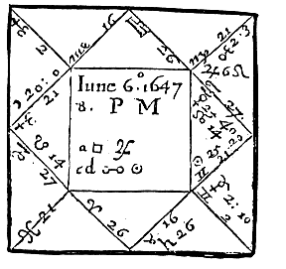

Compliments of http://mithras93.tripod.com

The Resolution of

CHAP. XCV.

A Prisoner escaped out of Prison, which way

he went, If Recoverable?

The person of the Prisoner is represented by Sagittarius the cusp of the 12th, and Jupiter in Leo.

The way he went and intended to go, is from the Signe of the 12th, viz. Sagittarius, and the Signe Leo wherein Jupiter is.

Quarter of Heaven & Sign where Moon is in.

All of them considered, they signified unanimously that the Prisoner would goe Eastward, or Ful East; [and so he did..] The neernesse of Moon to the ascendant, shewed he was not yet out of Towne, but Eastward from the Prison he brake out of; at least, that he could not be farre from Towne: and as Jupiter is in the 8th house, so I judged he lay obscurely for a while, viz. a night, but then would go away; [so he did.]

I confidently affirmed, he should be recovered againe, and taken by some man of authority; for the Moon separated from Trine of Jupiter his Significator, and applyed to Opposition of Sun, both in angles; for it never failes, but if either the Moon or Significator of the Prisoner or Fugitive be afflicted by an infortunate Planet out of the 7th, but that the Fugitive or Prisoner is againe taken.

In the next place I found Jupiter and Mercury in Sextile; Mercury in his owne house, and applying to Jupiter, therefore I judged the Querent should have newes of the Prisoner by Letter, or by some young man within six or seven dayes, or when the 470



Compliments of http://mithras93.tripod.com

all manner of QUESTIONS.

Significators came to a Sextile aspect, which was six dayes after. The truth is, the Friday after, he had a letter where he was, and the Sunday after apprehended him againe by authority, &c. This manner of judgment is the same with that of Fugitives, (Consideratis, considerandis.) CHAP. XCVI.

A LADY of her Husband imprisoned, when he

should be delivered?

Judgment upon this Figure.

This Question belongs to the 12th house; Jupiter Lord of the 7th signifies the Ladies Husband, in Cancer Retrograde, lately, or the day before, in Trifle with the Sun, the Moon applying to a Sextile of Saturn, Retrograde, then to a Trine of Jupiter, with a most forcible Reception; from hence I made not many words, but told the Lady, she should neither care to make Friends to his 471

Compliments of http://mithras93.tripod.com The Resolution of

Majesty or any else for delivery of her Husband, for I was assured he either was or would within three dayes be discharged of his imprisonment, by meanes of a Solar man, Commander, who would release him and furnish him with what was convenient for his necessity. The very truth is, he was released, and the Garrison where he was prisoner taken the same day before the Question was asked, by an honest Parliament-Colonell, who plentifully relieved him with Money, and all convenient necessaries .

Jupiter In Exaltation Retrograde, in a movable Signe, in Trine to Sun, short imprisonment, because Sun is Lord of the 4th, and in so perfect a Trine.

472

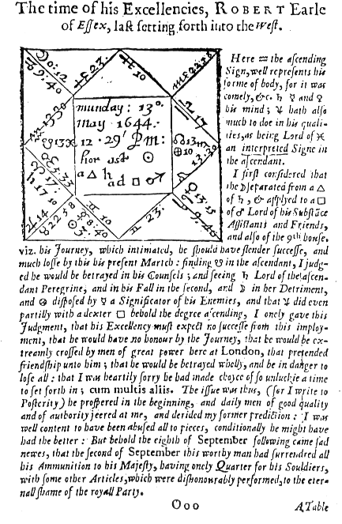

Compliments of http://mithras93.tripod.com

Figure 44

[A facsimile from the orignal text of Christian Astrology 473

Compliments of http://mithras93.tripod.com 0001

Place of The

A Table whereby to find the Planetary hours Place the Q. Sun's

Hours before Noon

of the

rising

Q.

1 2 3 4 5 6

S.D. H.M H.M. H.M. H.M. H.M. H.M. H.M. S.D.

A 0 6 0 7 0 8 0 9 0 10 0 11 0 12 0 F 30

3 5 54 6 55 7 56 8 57 9 58 10 59

0

27

6 47 47 51 54 56 58 0 24

9 41 44 47 51 55 57 0 21

12 35 39 43 48 53 56 0 18

A 15 5 28 6 33 7 39 8 44 9 49 10 55 12 0 F 15

18 22 28 35 41 47 54 0 12

21 16 23 31 38 45 53 0 9

24 10 18 27 35 43 52 0 6

27 3 13 22 32 40 51 0 3

B 0 4 57 6 8 7 18 8 29 9 39 10 50 12 0 F 0

3 51 3 14 26 37 45 0 27

6

45 5 58

10

23

35

49

0

24

9 40 52 7 20 33 48 0 21

12 34 48 3 17 31 47 0 18

B 15 4 28 5 42 6 59 8 14 9 29 10 45 12 0 E 15

18 23 39 55 12 28 44 0 12

21 18 35 52 9 26 43 0 9

24 12 30 48 6 24 42 0 6

27 8 27 45 4 23 41 0 3

C 0 4 2 5 23 6 42 8 2 9 21 10 41 12 0 E 0

3 3 59

19

39

0

20

40

0

27

6

55

16

37 7 58

18

39

0

24

9 51 13 34 56 17 39 0 21

12 48 10 32 54 16 38 0 18

C 15 3 45 5 8 6 30 7 53 9 15 10 38 12 0 D 15

18 43 6 29 52 14 37 0 12

21 41 4 27 51 14 37 0 9

24 40 3 27 50 13 37 0 6

27 39 2 26 50 13 36 0 3

C 30 3 38 5 1 6 25 7 49

13 10 46 13 0 D 0

474

Compliments of http://mithras93.tripod.com 0002

Place of A Table whereby to find the Planetary hours Place of the Q.

Hours before Noon

the Q.

7 8 9 10 11 12

S.D. H.M. H.M. H.M. H.M. H.M. H.M. S.D.

A 0 1 0 2 0 3 0 4 0 5 0 6 0 F 30

3 1 2 3 4 5 6 27

6 2 4 6 9 11 13 24

9 3 6 10 13 16 19 21

12 4 8 13 17 21 25 18

A 15 1 5

2 11 3 16 4 21 5 27 6 31 F 15

18 6 13 19 25 32 38 12

21 7 15 22 29 37 44

9

24 8 17 25 33 42 50

6

27 10 19 29 38 48 57

3

B 0 1 11 2 21 3 32 4 42

53 7 3 F 0

3 12 23 35 46 58 9 27

6

13

25

38

50 6 6

15

24

9 13 27 40 55 7 20 21

12 14 29 43 57 12 26 18

B 15 1 15 2 31 3 46 5 1 6 17 7 31 E 15

18 16 32 49 5 21 37 12

21 17 34 51 8 25 41

9

24 18 36 54 12 30 48

6

27 19 37 56 15 33 52

3

C 0 1 20 2 39 3 59 5 18 6 38 7 57 E 0

3

20

40 4 1

21

41 8 1

27

6 21 42 3 23 44 5 24

9 22 43 5 26 48 9 21

12 22 44 6 28 50 12 18

C 15

23 2 45 4 8 5 30 6 53 8 15 D 15

18 23 46 9 31 54 17 12

21 23 46 10 32 56 19

9

24 23 47 10 33 57 20

6

27 24 47 11 34 58 21

3

C 30 1 24 2 47 4 11 5 35 6 58 8 22 D 0

475

Compliments of http://mithras93.tripod.com 0003

Place The

A Table whereby to find the Planetary hours Place of the Sun's

Hours before Noon

of the

Q.

rising

Q.

1 2 3 4 5 6

S.D. H.M H.M. H.M. H.M. H.M. H.M. H.M. S.D.

G 0 6 0 7 0 8 0 9 0 10 0 11 0 12 0 L 30

3 6 5 4 3 2 1 0 27

6 13

11 9 7 4 2 0 24

9 19 16 13 10 6 3 0 21

12 25 21 17 13 8 4 0 18

G 15 6 32 7 24 8 21 9 16 10 11 11 5 12 0 L 15

18 38 30 25 19 13 6 0 12

21 44 37 29 22 15 7 0 9

24 50 42 33 25 17 8 0 6

27 57 48 38 29 19 9 0 3

H 0 7 3 7 53 8 42 9 32 10 21 11 10 12 0 L 0

3 9 58 46 35 23 11 0 27

6

15 8 3

50

38

25

12

0

24

9 20 7 53 40 27 13 0 21

12 26 12 57 43 29 14 0 18

H 15 7 32 8 17 9 1 9 46 10 31 11 15 12 0 K 15

18 37 21 5 49 32 16 0 12

21 42 25 8 51 34 17 0 9

24 48 30 12 54 36 18 0 6

27 52 33 15 56 37 19 0 3

I 0

57 8 38 9 18 9 59 10 39 11 20 12 0 K 0

3 8 1

41

21 10 1

40

20

0

27

6 5 44 23 2 41 21 0 24

9 9 48 26 4 43 22 0 21

12 12 50 28 6 44 22 0 18

I 15 8 15 8 53 9 30 10 8 10 45 11 23 12 0 J 15

18 17 54 31 9 45 23 0 12

21 19 56 33 10 46 23 0 9

24 20 57 33 10 47 23 0 6

27 21 58 34 11 47 23 0 3

I 30 8 22 8 58 9 35 10 11 10 47 11 24 12 0 J 0

476

Compliments of http://mithras93.tripod.com 0004

Place

A Table whereby to find the Planetary hours Place of of the

Hours before Noon

the Q.

Q.

7 8 9 10

11

12

S.D. H.M.

H.M. H.M.

H.M. H.M. H.M. S.D.

G 0 1 0 2 0 3 0 4 0 5 0 6 0 L 30

3 0 59 1 58 2 57 3 56 4 55 5 54

27

6 58 56 54 51 49 47 24

9 57 54 51 47 44 41 21

12 56 50 48 43 39 35 18

G 15 0 55 1 49 2 44 3 39 4 33 5 28 L 15

18 54 47 41

2

35 28 1 12

21 53 45 38 31 23 16

9

24 52 43 35 27 18 10

6

27 51 41 31 23 13 3

3

H 0 0 50 1 39 2 29 3 18 4 8 4 57 L 0

3 49 37 26 14 3 51 27

6

48

35

23

10 3 58

45

24

9 47 33 20 7 53 40 21

12 46 31 17 5 48 34 18

H 15 0 45 1 29 2 14 2 59 3 43 4 28 K 15

18 44 28 12 55 39 22 12

21 44 26 9

1

52 35 8

9

24 43 24 6 48 30 13

6

27 41 23 4 45 27 8

3

I 0 0 41 1 21 2 2 2 42 3 23 4 3 K 0

3

40

20

0

39

19 3 59

27

6

39

18 1 57

36

15

55

24

9 39 17 56 34 13 51 21

12 38 16 54 32 10 48 18

I 15 0 38 1 15 1 53 2 30 3 8 3 45 J 15

18 37 14 51 28 5 43 12

21 37 14 51 27 4 41

9

24 37 13 50 27 3 40

6

27 37 13 50 26 2

39

3

I 30 0 36 1 13 1 49 2 25 3 2 3 38 J 0

477

Compliments of http://mithras93.tripod.com 0005

Place The

A Table whereby to find the Planetary hours Place of the Sun's

Hours before Noon

of the

Q.

rising

Q.

1 2 3 4 5 6

S.D. H.M H.M. H.M. H.M. H.M. H.M. H.M. S.D.

A 0 6 0 7 0 8 0 9 0 10 0 11 0 12 0 F 30

3 6

5

4

3

2

1

0

27

6 13

11 9 7 4 2 0 24

9

1

9

16

13 10 6 3 0 21

12 25

21

17 13 8 4

0

18

A 15 6 32 7 24 8 21 9 16 10 11 11 5 12 0 F 15

18 38

30

25 19

13 6

0 12

21 44 37

2

29 2 15 7 0 9

24 50 42 33 25 17 8 0 6

4

27 57 8 38 29 19 9 0 3

B 0 7 3 7 53 8 42 9 32 10 21 11 10 12 0 F 0

3 9

58

46

35

23

11

0

27

6 15 8 3

50

38

25

12

0

24

9 20 7 53 40 27 13 0 21

12

1

26 2 57 43 29 14 0 18

B 15 7 32 8 17 9 1 9 46 10 31 11 15 12 0 E 15

18 37 21 5 49 32 16 0 12

21 42 25 8 51 34 17 0 9

24 48 30 12 54 36 18 0 6

27 52 33 15 56 37 19 0 3

C 0

57 8 38 9 18 9 59 10 39 11 20 12 0

E 0

8 1

3

41

21 10 1

40

20

0

27

6 5

44

23

2 41 21

0 24

9 9

48

26 4

43 22 0 21

12 12

50

28 6

44 22 0 18

C 15 8 15 8 53 9 30 10 8 10 45 11 23 12 0

D

15

18

1

7

54

31 9

4

5 23 0 12

21 19 56 33 10 46 23 0 9

24 20 57 33 10 47 23 0 6

27

5

21 8 34 11 47 24 0 3

C 30 8 21 8 50 9 25 10 11 10 47 11 24 12 0

D

0

478

Compliments of http://mithras93.tripod.com 0006

Place of A Table whereby to find the Planetary hours Place the Q.

Hours before Noon

of the

Q.

7 8 9 10

11

12

S.D. H.M.

H.M. H.M. H.

M. H.M. H.M. S.D.

A 0 1 0 2 0 3 0 4 0 5 0 6 0 F 30

3 0 59 1 58 2 57 3 56 4 55 5 54

27

6 58 56 54 51 49 47 24

9 57 54 51 47 44 41 21

12 56 52 48 43 39 35 18

A 15 0 55 1 49 2 44 3 39 4 33 5 28 F 15

18 54 47 41 35 28 22 12

21 53 45 38 31 23 16 9

24 52 43 35 27 18 10 6

27 51 41 32 22 13 3 3

B 0 0 50 1 39 2 29 3 18 4 8 4 57 F 0

3 49 37 26 14 3 51 27

6

48

35

23

10 3 58

45

24

9 47 33 20 7 53 40 21

12 46 31 17 5 48 34 18

B 15 0 45 1 29 2 14 2 59 3 43 4 28 E 15

18 44 28 12 55 39 23 12

21 43 26 9 52 35 18 9

24 42 24 6 48 30 13 6

27 41 23 4 45 27 8 3

C 0 0 41 1 21 2 2 2 41 3 23 4 3 E 0

3

40

20

0

39

19 3 59

27

6

39

18 1 57

36

15

55

24

9 39 17 56 34 13 51 21

12 38 16 54 32 10 48 18

C 15 0 38 1 15 1 53 2 30 3 8 3 45 D 15

18 37 15 51 28 5 43 12

21 37 15 51 27 4 41 9

24 37 14 50 27 3 40 6

27 37 13 50 26 3 39 3

C 30 0 36 1 12 1 49 2 25 3 2 3 38 D 0

479

Compliments of http://mithras93.tripod.com 0007

Place of The

A Table whereby to find the Planetary hours Place the Q. Sun's

Hours before Noon

of the

rising

Q.

1 2

3 4

5 6

S.D. H.M H.M.

H.M.

H.M. H.M. H.M. H.M. S.D.

G 0 6 0 7 0 8 0 9 0 10 0 11 0 12 0 L 30

3 5 54 6 55 7 56 8 57 9 58 10 59

0

27

6 47 47 51 54 56 58 0 24

9 41 44 47

5

1 54 57 0 21

12 35 35 43 48 52 56 0 18

G 15 5 28 6 33 7 39 8 44 9 49 10 55 12 0 L 15

18 22 28 35 41 47 54 0 12

21 16 23 31 38 45 53 0 9

24 10 18 27 35 43 52 0 6

27 3 13 23 39 41 51 0 3

H 0 4 57 6 8 7 18 8 19 9 39 10 50 12 0 L 0

3 51 3 14 26 37 49 0 27

6

45 5 58

10

23

35

48

0

24

9 40 52 7 20 33 47 0 21

12 34 48 3 17 31 46 0 18

H 15 4 28 5 43 6 59 8 14 9 29 10 45 12 0 K 15

18 23 39 55 12 28 44 0 12

21 18 35 52 9 26 43 0 9

24 12 30 48 6 24 42 0 6

27 8 27 45 4 23 41 0 3

I 0 4 3 5 23 6 42 8 2 9 21 10 41 12 0 K 0

3 3 59

19

39

0

20

40

0

27

6

55

16

37 7 58

18

39

0

24

9 51 13 34 56 17 39 0 21

12 48 10 32 54 16 38 0 18

I 15 3 45 5 8 6 30 7 53 9 15 10 38 12 0 J 15

18 43 6 29 52 14 37 0 12

21 41 4 27 51 14 37 0 9

24 40 3 27 50 13 37 0 6

27 39 2 26 50 13 36 0 3

I 30 3 38 5 1 6 25 7 49

13 10 36 13 0 J 0

480

Compliments of http://mithras93.tripod.com 0008

Place of A Table whereby to find the Planetary hours Place the Q.

Hours before Noon

of the

Q.

7 8 9 10 11 12

S.D. H.M. H.M. H.M. H.M. H.M. H.M. S.D.

G 0 1 0 2 0 3 0 4 0 5 0 6 0 L 30

3 1 2 3 4 5 6 27

6 2 4 7 9 11 13 24

9 3 6 10 13 16 19 21

12 4 8 13 17 21 25 18

G 15 1 5 2 11 3 16 4 21 5 27 6 31 L 15

18 6 13 19 25 32 38 12

21 7 15 22 29 37 44 9

24 8 17 25 33 42 50 6

27 10 19 29 38 48 57 3

H 0 1 11 2 21 3 32 4 42

53 7 3 L 0

3 12 23 35 46 58 9 27

6

13

25

38

50 6 3

15

24

9 13 27 40 53 7 20 21

12 14 29 43 57 12 26 18

H 15 1 15 2 31 3 46 5 1 6 17 7 31 K 15

1

18 6 32 49 5 21 37 12

21 17 34 51 8 25 41 9

24 18 36 54 12 30 48 6

27 19 37 56 15 33 52 3

I 0 1 20 2 39 3 59 5 18 6 38 7 57 K 0

3

20

40 4 1

21

41 8 1

27

2

6 1 42 3 23 44 5 24

9 22 43 5 26 48 9 21

2

12 2 44 6 28 50 12 18

I 15

23 2 45 4 8 5 30 6 53 8 15 J 15

18 23 46 9 31 54 17 12

2

21 3 46 10 32 56 19 9

24 23 47 10 33 57 20 6

27 24 47 11 34 58 21 3

I 30 1 24 2 47 4 11 5 35 6 58 8 22 J 0

481

Compliments of http://mithras93.tripod.com The Resolution of

CHAP. XCVII.

To find out what Planet ruleth every hour of the Day or Night by the preceding Table.

You must understand that as there are seven dayes of the Week, viz. Sunday, Monday, Tuesday, Wednesday, Thursday, Friday, Saturday; so there are seven Planets, viz. Saturne, Jupiter, Mars, Sol, Venus, Mercury, Luna: We appropriate to each day of the Week a severall Planet; as to Sunday, Sun; to Monday, Moon; to Thursday, Mars; to Wednesday, Mercury; to Thursday, Jupiter; to Friday, Venus; to Saturday, Saturn: and the first hour of every day we assigne to that Planet assigned for the day, beginning at Sun-rise ever, the second houre we give to the next Planet, the third hour to the third Planet from him; as if upon any Sunday I would know what Planet governeth the first, second, third, fourth, fift, sixt hour of that day, I say Sun governeth the first, Venus the second, Mercury the third, Moon the fourth, Saturn the fift, Jupiter the sixt, &c.

and so in order successively during that day and night subsequent: and if you account in order, you shall find by this continuall account, that Moon fals to rule the first hour upon Monday, Saturn the second, Jupiter the third, Mars the fourth, &c.

It is very true, some of the Ancients have Winter and Summer, made the day and night to consist of equall hours, I mean every hour to consist of sixty minutes equally; but Astrologians doe not so, but follow this method, viz. according to the motion of the Sun both Summer and Winter, so doe they vary their hours in length or shortnesse; for all that space of time which is contained from Sun rise to Sun-set, they divide into twelve equall parts, whereof the one halfe containes the hours before Noon, the rest the hours after Noon; so also, what space of time is from Sun-set untill Sun-rise againe the next day after, is equally divided into 12 parts; whereof every 12th part containes the space or time of one hour Astrologicall; and we doe ever begin to number from Sun-rise, and continue untill the next Sunrise, with that Planet who is assigned to the day, and so 482

Compliments of http://mithras93.tripod.com all manner of QUESTIONS.

numbering successively in order untill the next day; so that your Astrologicall hours are called unequall hours, as all the yeer long consisting of more or lesse then 60 minutes for the space of one hour, unlesse it be the day of the Sun his entrance into Aries or Libra, at what time an Astrologicall hour is just 60 minutes and no more.

Use of the Table.

Be the Sun in Aries, Taurus, Gemini, Cancer, Leo, Virgo, and you would know the Planetary hour of the day, first and second Pages serve your turne.

If you would know the Planetary hour of any day, the Sun being in Libra, Scorpio, Sagittarius, Capricorn, Aquarius, Pisces, the third and fourth Pages will serve you.

If you would know the Planetary hour of the night or after Sun-set, whilest the Sun is in Aries, Taurus, Gemini, Leo, Virgo, then you must be directed by the fift and sixt Pages of this Table.

If you would know the Planetary hour od the night, the Sun being in Libra, Scorpio, Sagittarius, Capricorn, Aquarius, Pisces, the seventh and eight Pages will satisfie you.

An Example.

If you would know when the Sun riseth, being in the third, fourth or fift of Aries, see to the first Column of the first Page, and there you find, Place of the Sun, under it, S.D. viz, Signes, Degrees, under these two letters, Aries 0, then under 0 3. on the right hand, 5 54. over it H.M.

viz. Houres and Minutes; so that it tels you, the Sun being in three deg. of Aries, riseth at 54

minutes after 5. proceed in the same line, and you see the Planetary houre; as, admit I would know at halfe an houre after nine in the morning, upon Monday the 15. of March 1646, the Sun at noon that day being in 4.. degr. 47.min. of Aries, which wanting so few min. of 5.degr. I enter with five whole degr. under the Signe Aries, and in the fourth line of the first Column I find 6.

for the whole Table of Signes goes by the continuall addition of three, and if I had entred with four or five degrees of Sun in Aries, I might have taken either three or six, and it 483

Compliments of http://mithras93.tripod.com The Resolution of

had bred little difference. But to the purpose, over against 6. on the right hand, I find, as aforesaid, 5 47. for the time of Sun-rising, then 6 47. then in order 7 5. then 8 54. then 9 56, my hour was 9 30. so then I begin and say, the Moon being the Planet of the day, beginneth to rule at 47.min. after 5. and governeth until 47.min. after 6. then Saturn ruleth the 2nd hour of the day, untill 51.min. after 7. then Jupiter ruleth the 3rd hour, viz. till 54.min. after 8. then Mars the fourth hour, until 56.min. after 9. which is the hour sought for, I say Mars ruleth at that hour; and so you must doe either day or night: And you must remember, that as you see onely in the first Column Aries, Taurus, Gemini, so in the ninth Column of the said page, Virgo, Leo, and Cancer, so when you enter with the place of the Sun in Virgo, Leo or Cancer, you must enter upward contrary to the former side; for the Sun being in 15. of Taurus, riseth at the same moment of time as he doth being in the 15. of Leo: or when in the 15. of Virgo, as when in the 15. of Aries. The length of the Planetary hour is thus known, let the Sun be in the 6th degree of Aries, he riseth then, as you may see, at 47.min. after 5.

In the third Column you find 6 47. which if you subtract from the next number on the right hand in the same line, viz.

7 51.

7 51

rests one hour and four minutes for

6 47

the length of the houre that day,

and so as your day-hour is more then 60 minutes, so much the nocturnall hour must want of 60

min. and this is a generall rule.

The above named 15. of March 1646, the Sun being in 4 47. of Aries, I would know what Planet reignes at 20 min. past 5. in the afternoon; I enter the first Column of the second Page, under the title of the Sun, in the fourth line under Aries I find 6. and accept of that without errour, because the place of Sun is 4 47. of Aries, and so is neerer 6. then 4. over against 6. on the right hand, I find 1 2. then 2 4.. then 3 6. then 4 9. then 5 11. then 6 13. these tels me, the first Planetary hour after noon ends at 1 2. that is, two min. after one, the second at two min. after two, the third at six min. after three, the fourth at nine min. after four, the fift at eleven min. after five, the sixt at thirteen min. after 6.. now my hour enquired after was 20 mm. past 5. which fals to be the last hour of the

484

Compliments of http://mithras93.tripod.com all manner of QUESTIONS.

day; and if you look over the head of 6 13. you may see the number 12 viz, it’s the twelft hour of the day; now if you begin in the morning at Sun-rise, accounting Moon the first, and so proceed, MOON SATURN JUPITER MARS

SUN VENUS MERCURY

1

2

3

4

5

6

7

MOON SATURN JUPITER

MARS

SUN

8

9

10

11

12

You shall find, that Sun begins his rule at eleven min. past five, and ends at thirteen min. past six. I need not be more copious in a thing so plaine and obvious to the eye; I shall onely propound one example more, viz..:

the said 15 of March 11 deg. 10 min. after noon, I would know what Planet rules; the Sun being in 4 47 of Aries, I now enter the fifth Page of the Table, I look to the 6. of Aries, against it on the right hand I find 6 13. then 7 11. then 8 9. then 9 7. then 10 4. then 11 2. then 12 0.

My hour is ten min. after 11, in the seventh Column you have 11 2.. my hour is included in the next; so then I conclude my hour is the last hour before mid-night, and consequently the 6th hour after Sun-set, but the 18th hour of the day, and being accounted as we formerly instructed, you shall find it the hour of Mars. Either in giving Physick, or performing many naturall conclusions, without exact knowledge of the Astrologicall planetary hour, no worthy work can be done, with it wonders, either in collecting Hearbs, framing Sigils, Images, Lamens, &c.

So now by the blessing of Almighty God, without whose providence we can performe no worthy act, I have produced to an end the second part of my intended Work, and could have willingly acquainted untill a further opportunity had been offered: but such is the desire and importunity of severall wel-affected to this study, that beyond my first intentions I againe adventure upon the succeding Traciate of NATIVITIES, wherein the pitifull and mercifull God of all the faithfull, whole brightnesse shines in our fraile understandings, assist me, that I may performe this Work with judgment and understanding, for the good of all honesthearted English, my most beloved Country-men. Assist me 0 glorious God, for my Task is difficult, and thy servant is of little understanding! few, nay none at all are the helps I expect from any man living (having hitherto had no assistance)

485

Compliments of http://mithras93.tripod.com The Resolution of

but what thy pleasure is, But the universall Anima Mundi, to infuse into my obscure intellective part, that will I candidly deliver without deceit or fraud and as my former two Parts have had neither the Head, Hand or Heart or assistance of any man, so neither now will I beg or begin to distrust that Providence, whereby I have waded through the former Treatise, but will like a valiant Champion enter the fields of Defiance, against all the world of Detractors, and performe what my present weaknesse is able, &c. not doubting but there wil some arise in all Ages, who will either amend my failings, or defend my sayings so farre as they may with modesty.

June 11. 1647.

WILLIAM

LILLY

486

Compliments of http://mithras93.tripod.com 487

Compliments of http://mithras93.tripod.com APPENDIX A

Lilly’s hand-drawn charts are often difficult to read. Using data provided by Anthony Louis in his excellent book, Horary Astrology Plain & Simple, I have redrawn the charts in a modern astrology program. All charts use the Regiomontanus house system.

There will be slight differences between the original charts, and the modern ones. Our modern day ephemeredes are more accurate than those Lilly had available to him.

Each chart is titled according to the page number on which the original, hand-drawn chart appears. The chart “Lilly 473” is followed by an adjusted chart that moves the moon into Capricorn, as in Lilly’s original.

The final chart—Lilly’s natal chart--is not from Christian Astrology.

i

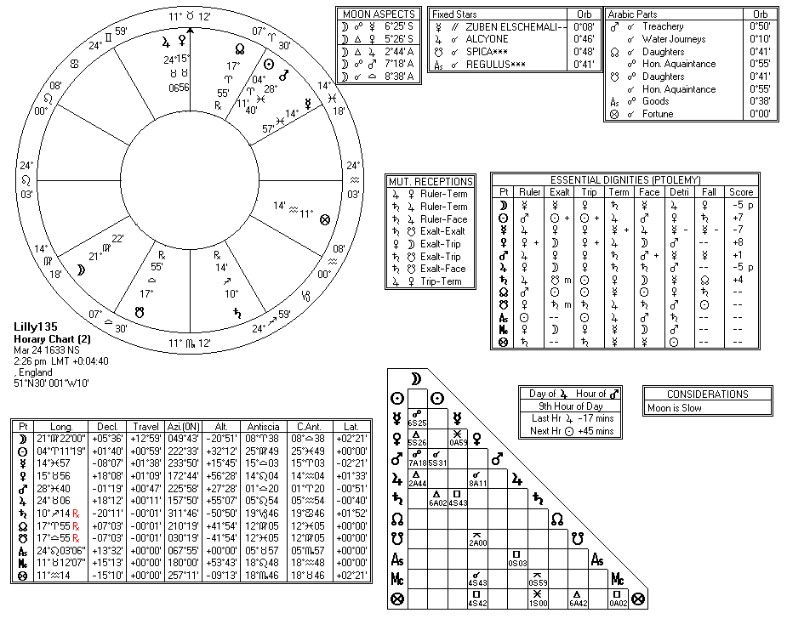

Compliments of http://mithras93.tripod.com

ii

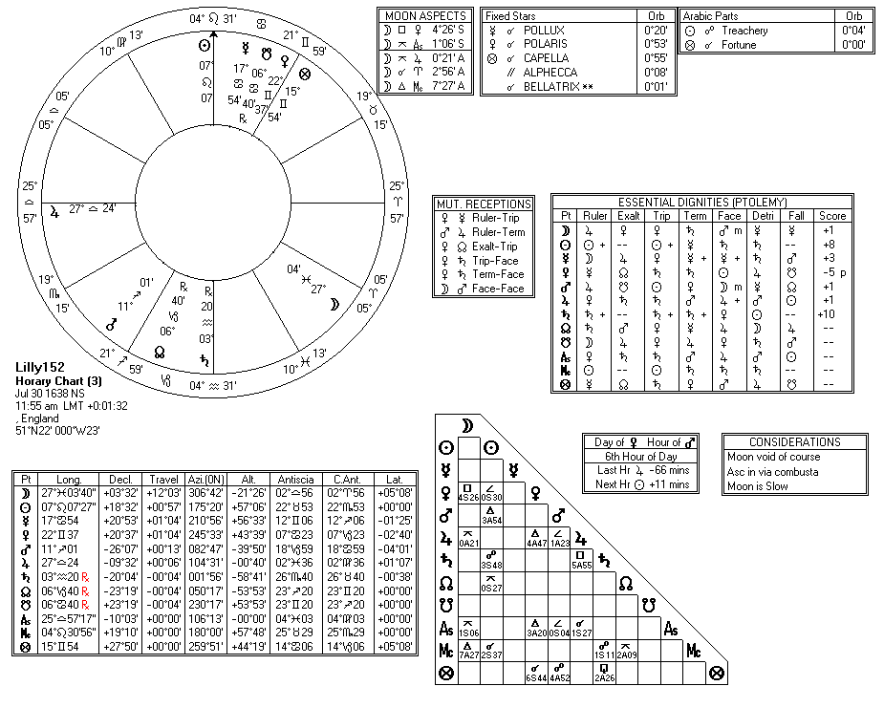

Compliments of http://mithras93.tripod.com

iii

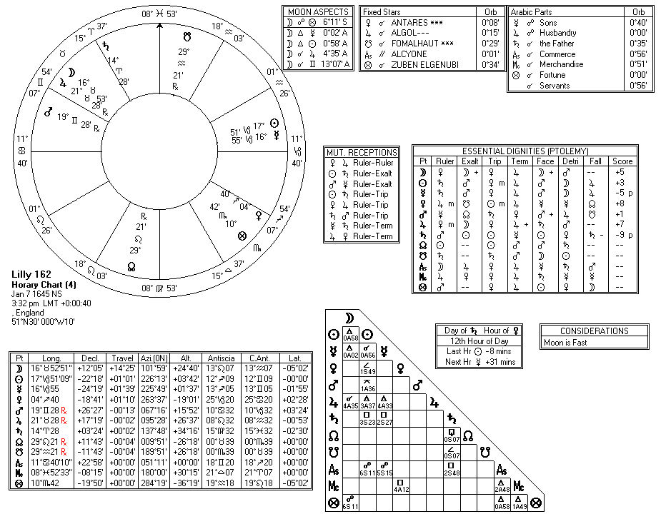

Compliments of http://mithras93.tripod.com

iv

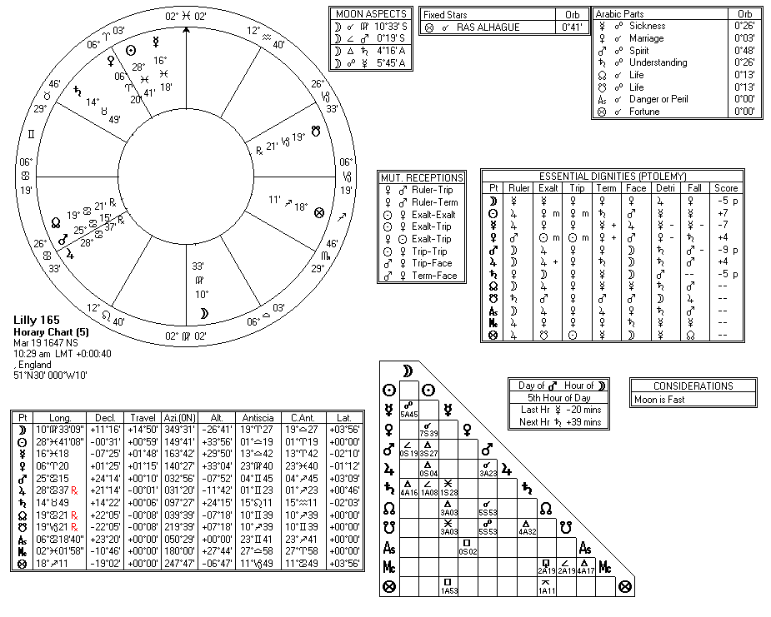

Compliments of http://mithras93.tripod.com

v

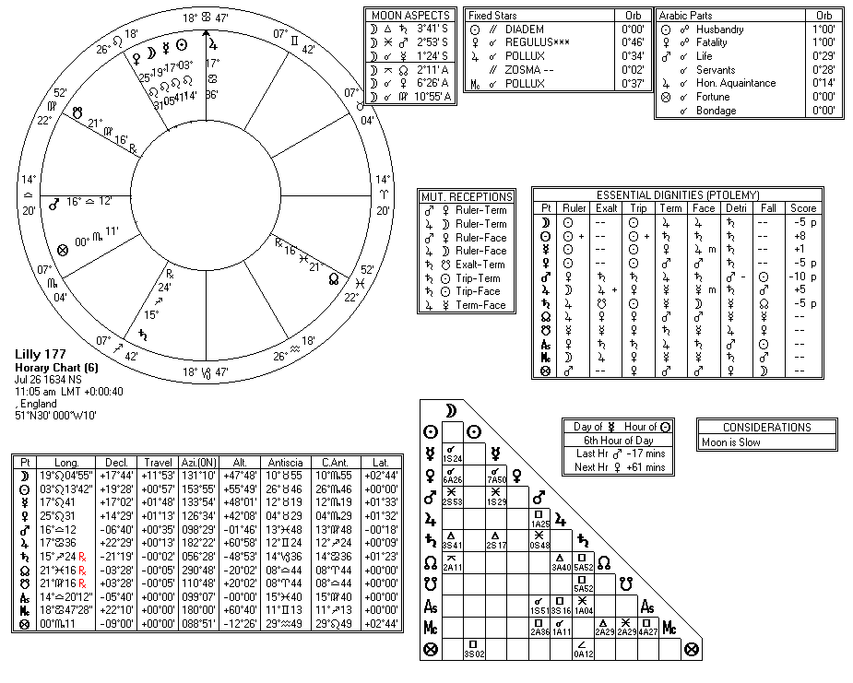

Compliments of http://mithras93.tripod.com

vi

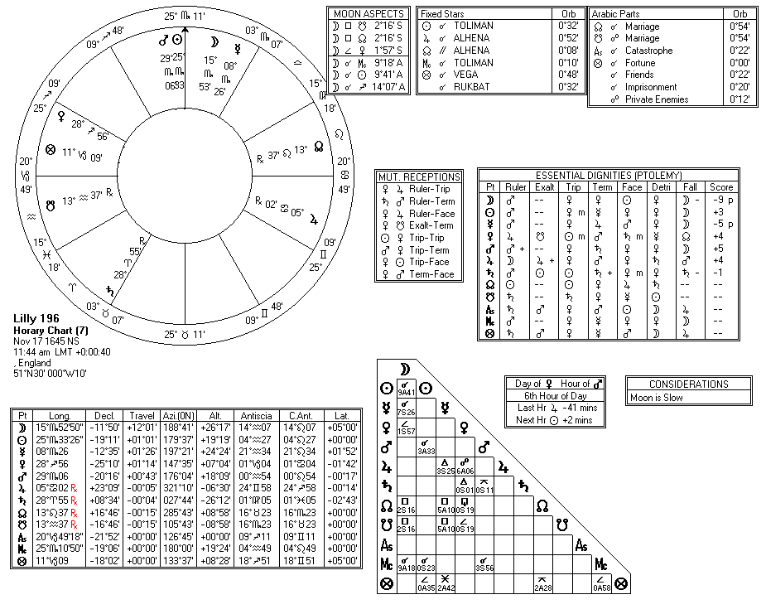

Compliments of http://mithras93.tripod.com

v ii

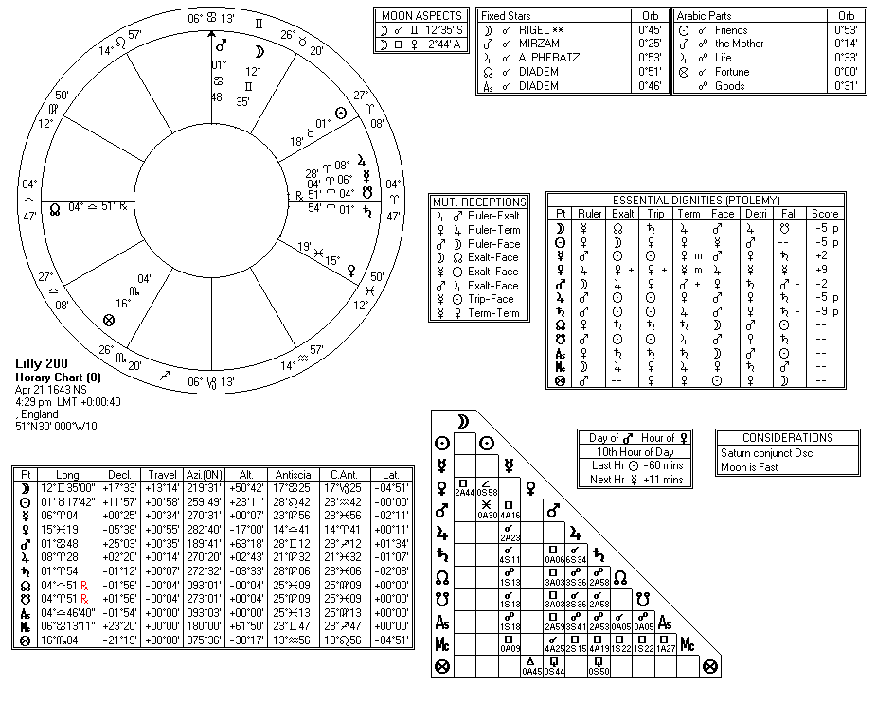

Compliments of http://mithras93.tripod.com

v iii

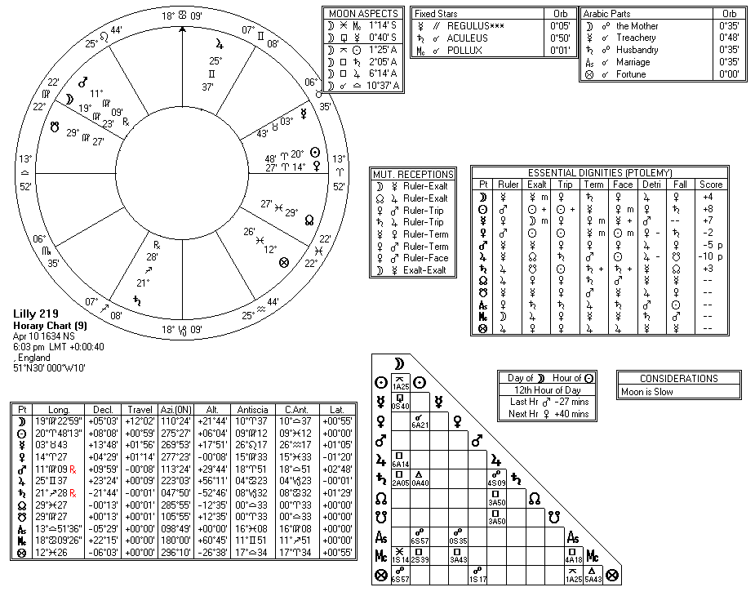

Compliments of http://mithras93.tripod.com

ix

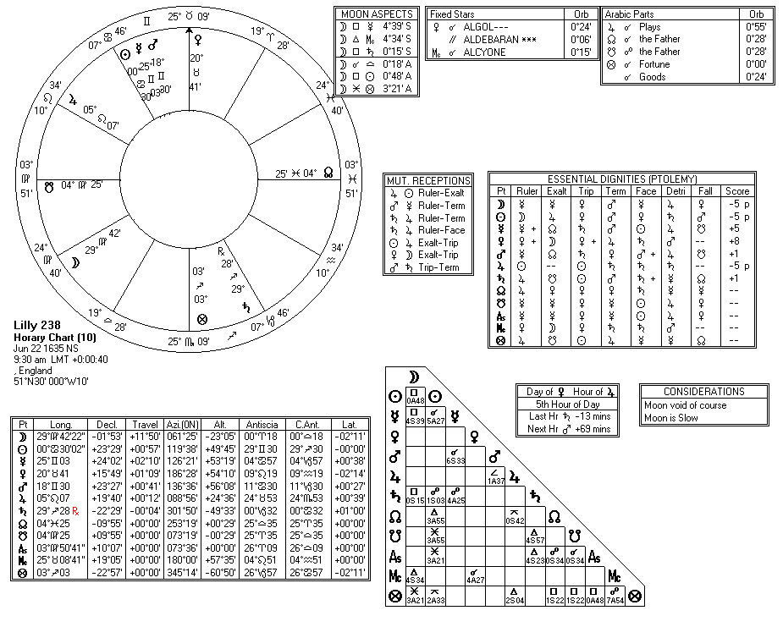

Compliments of http://mithras93.tripod.com

x

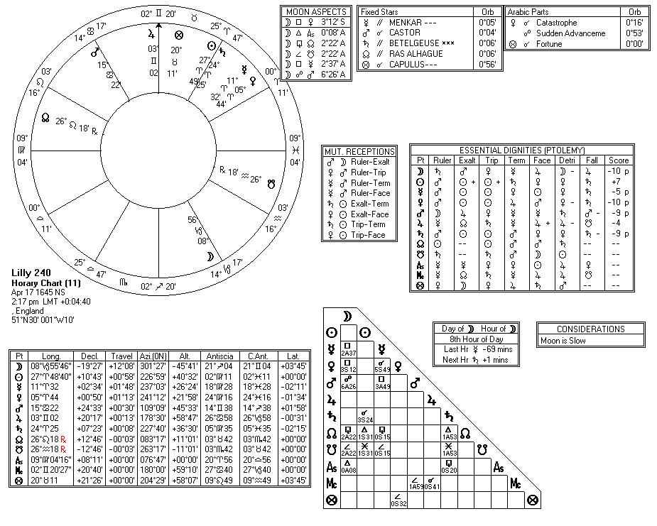

Compliments of http://mithras93.tripod.com

xi

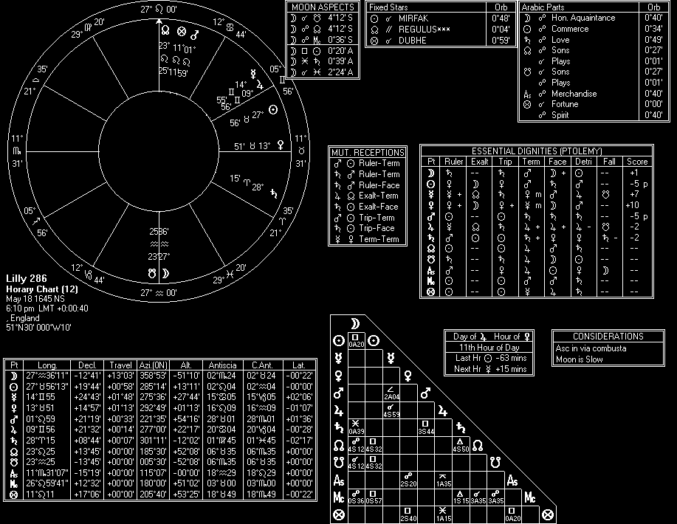

Compliments of http://mithras93.tripod.com

x ii

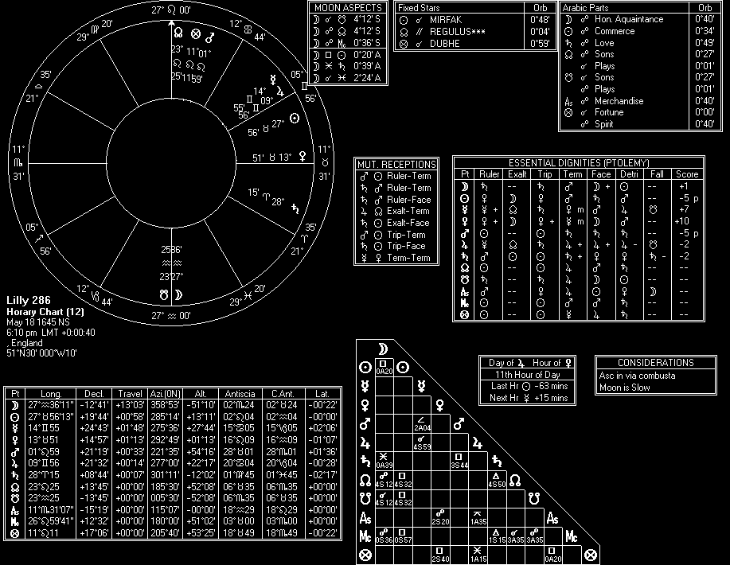

Compliments of http://mithras93.tripod.com

x iii

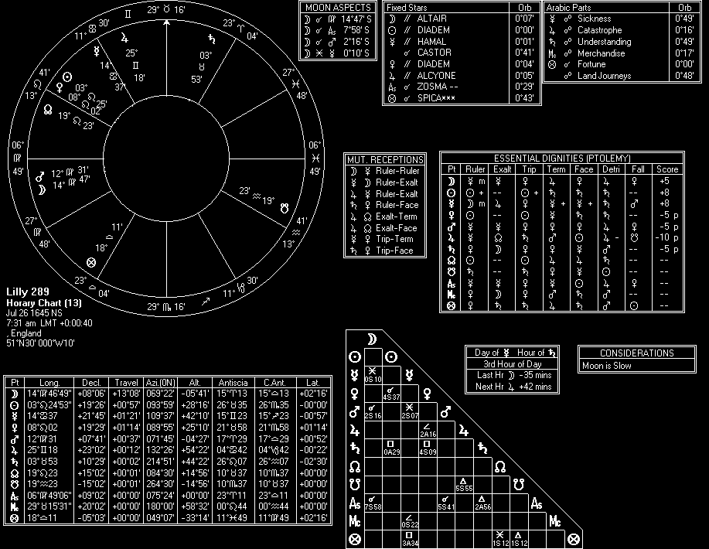

Compliments of http://mithras93.tripod.com

xiv

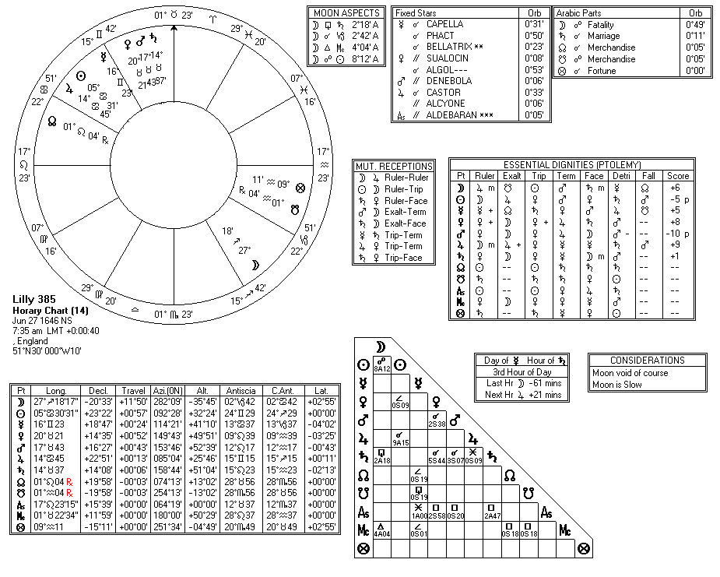

Compliments of http://mithras93.tripod.com

xv

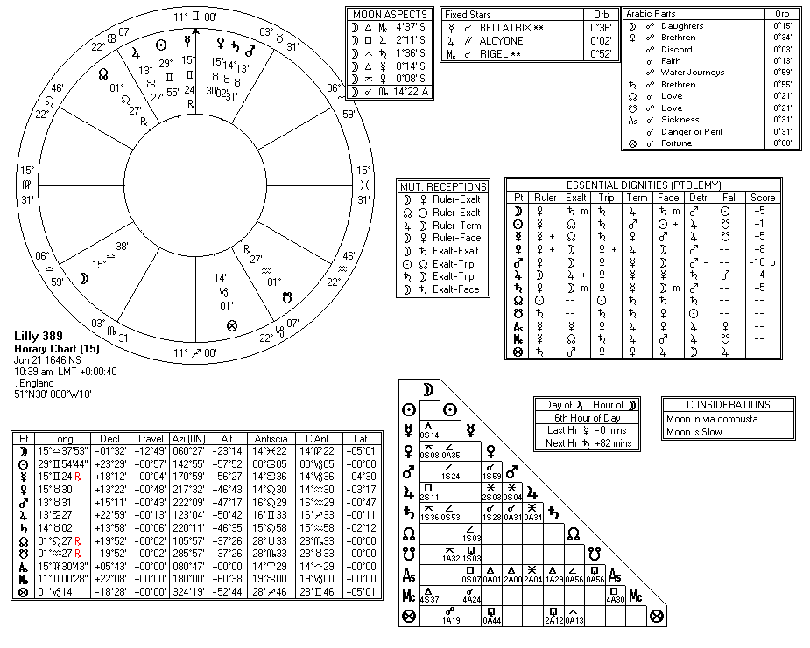

Compliments of http://mithras93.tripod.com

xvi

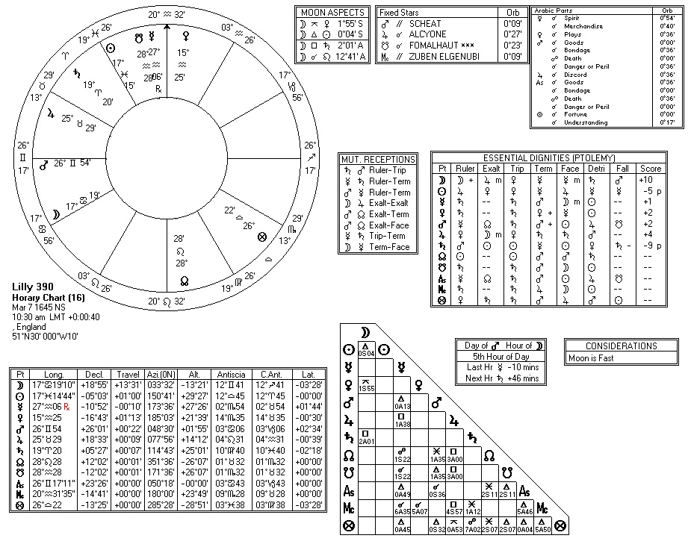

Compliments of http://mithras93.tripod.com

x vii

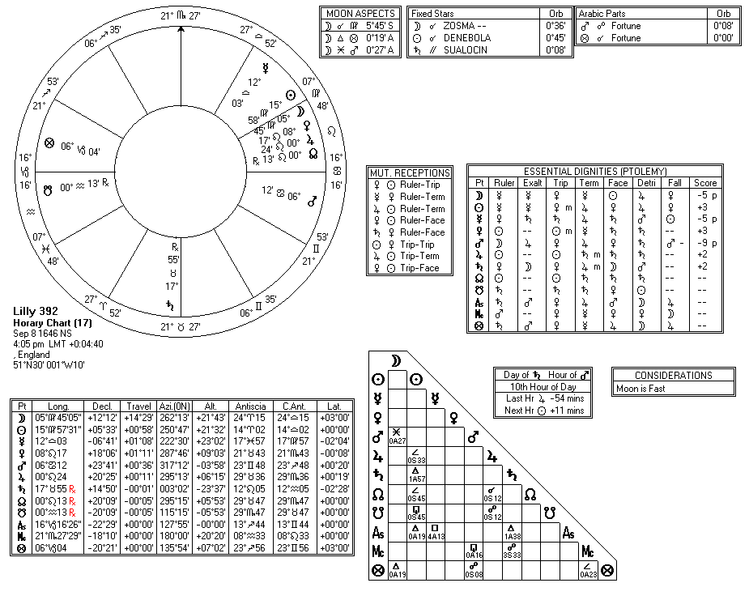

Compliments of http://mithras93.tripod.com

x

viii

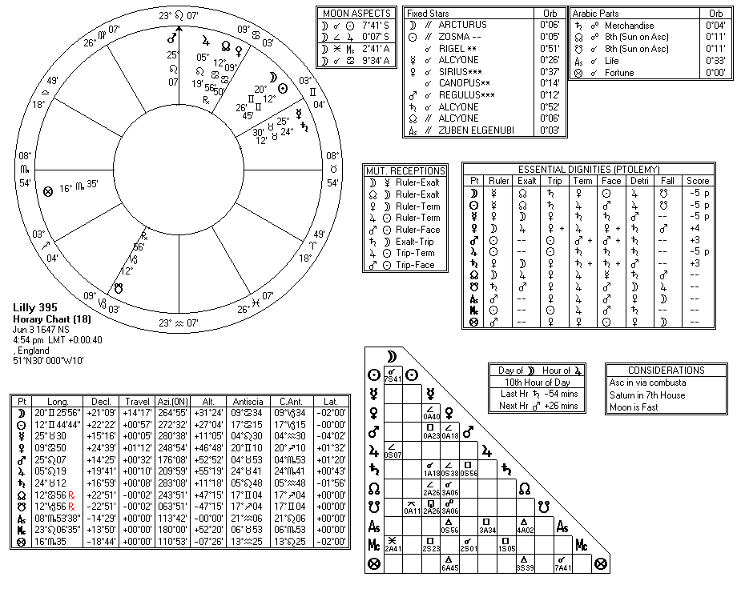

Compliments of http://mithras93.tripod.com

xix

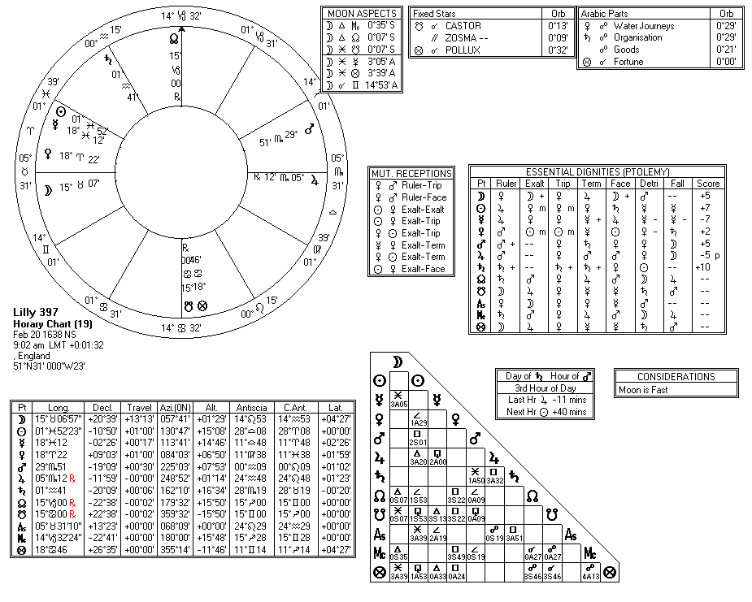

Compliments of http://mithras93.tripod.com

xx

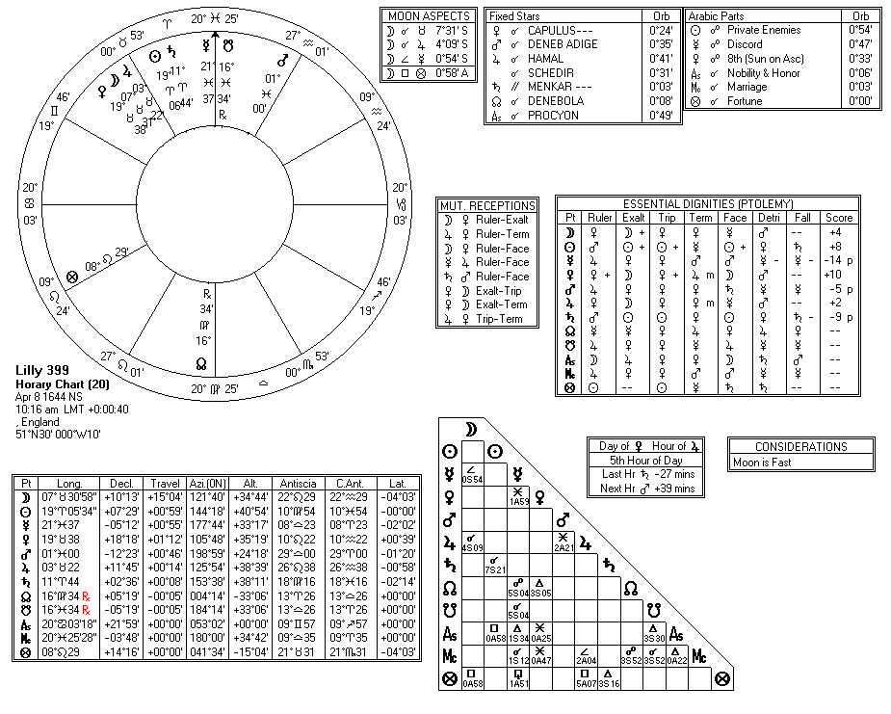

Compliments of http://mithras93.tripod.com

xxi

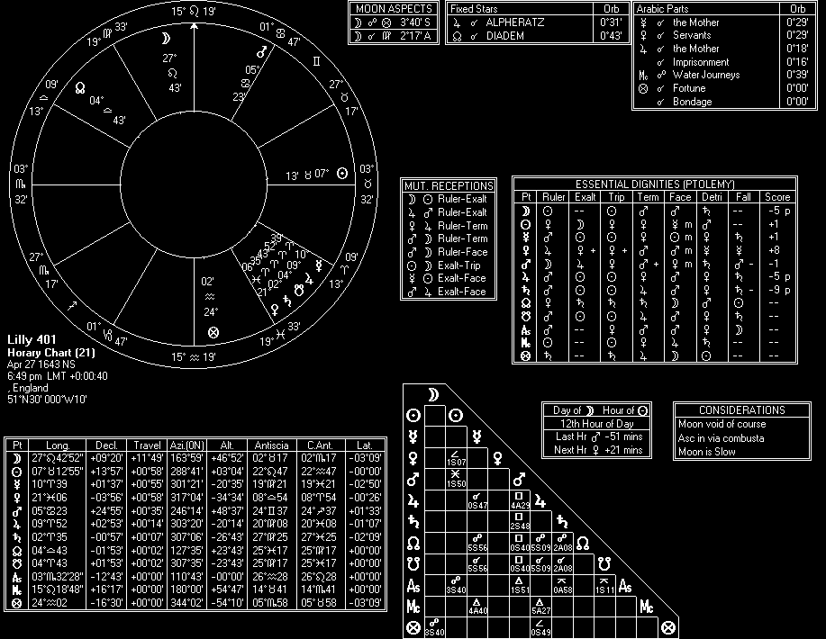

Compliments of http://mithras93.tripod.com

x xii

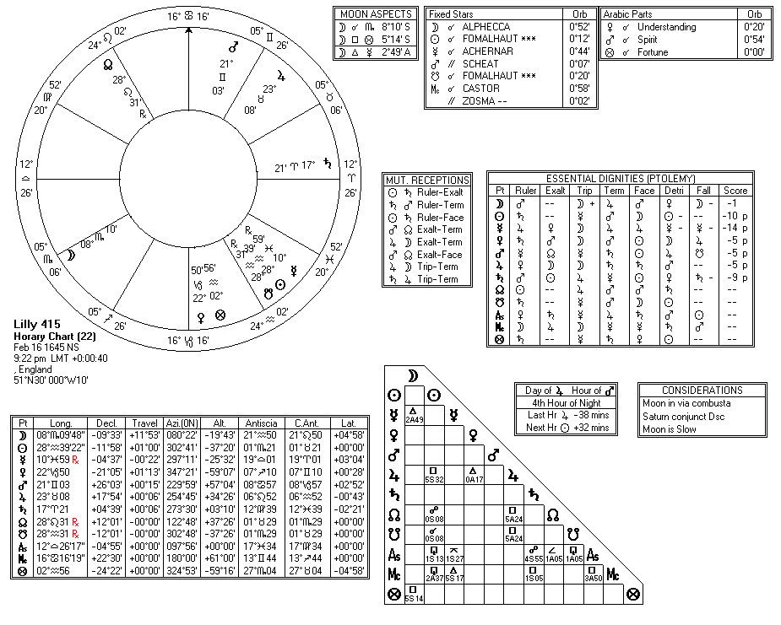

Compliments of http://mithras93.tripod.com

x

xiii

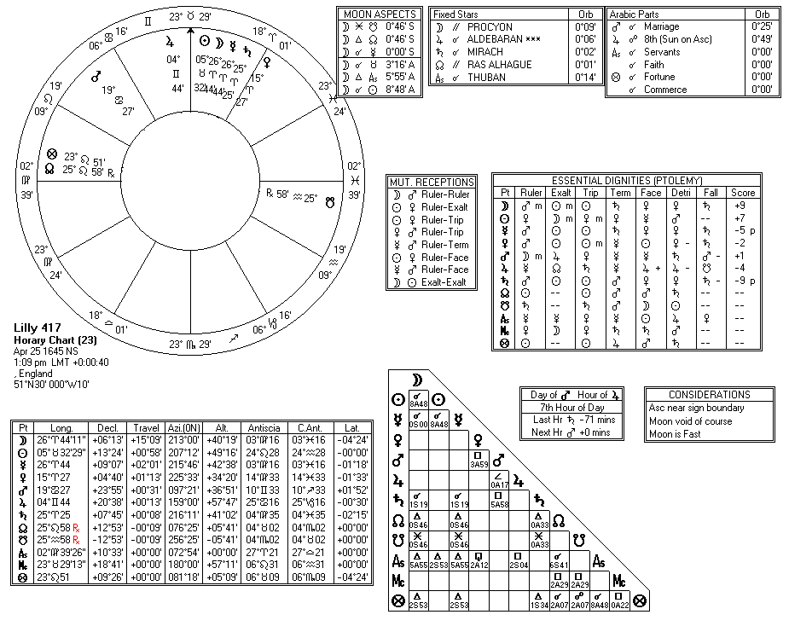

Compliments of http://mithras93.tripod.com

xxiv

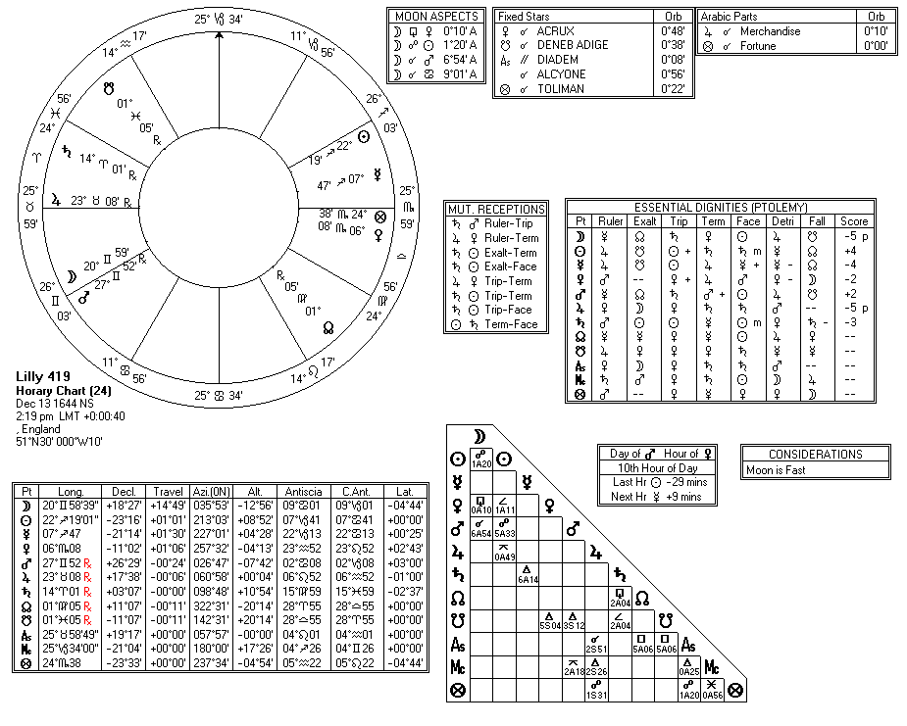

Compliments of http://mithras93.tripod.com

xxv

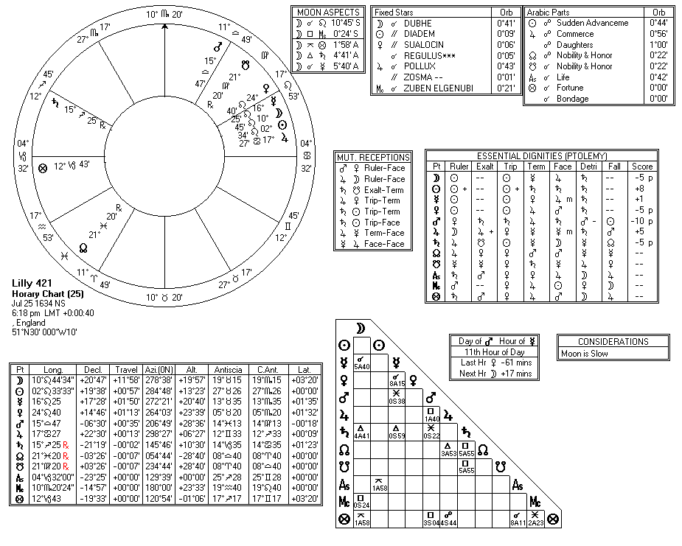

Compliments of http://mithras93.tripod.com

xxvi

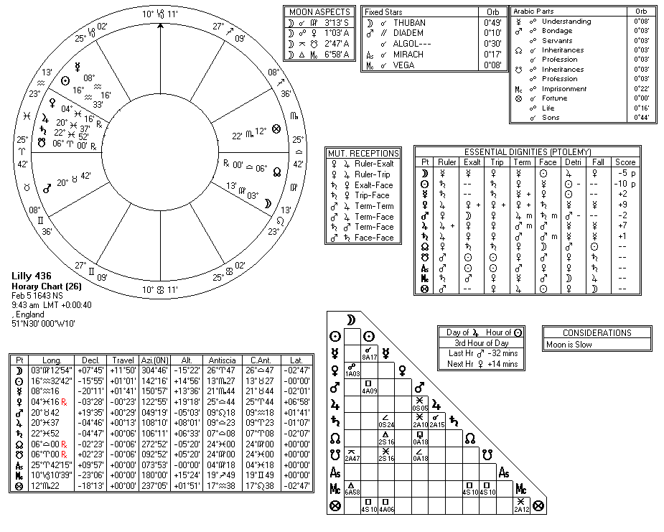

Compliments of http://mithras93.tripod.com

xx vii

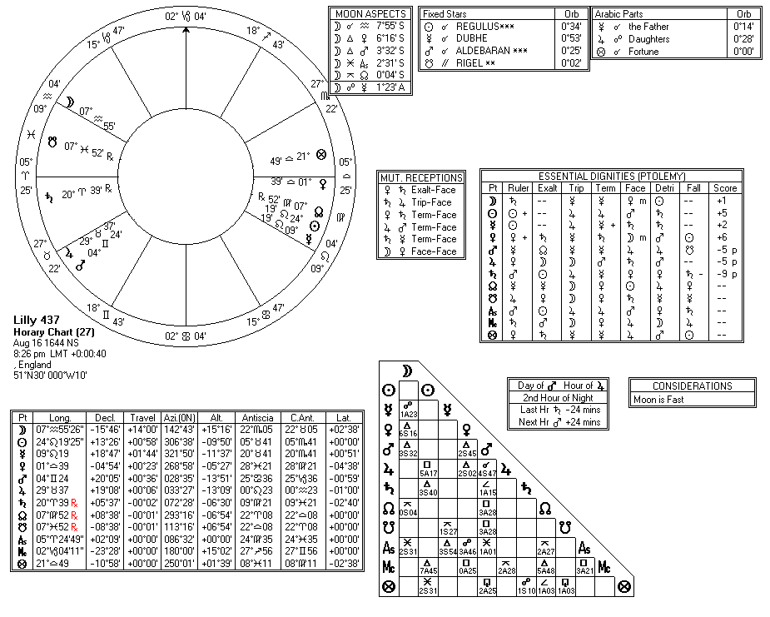

Compliments of http://mithras93.tripod.com

xx viii

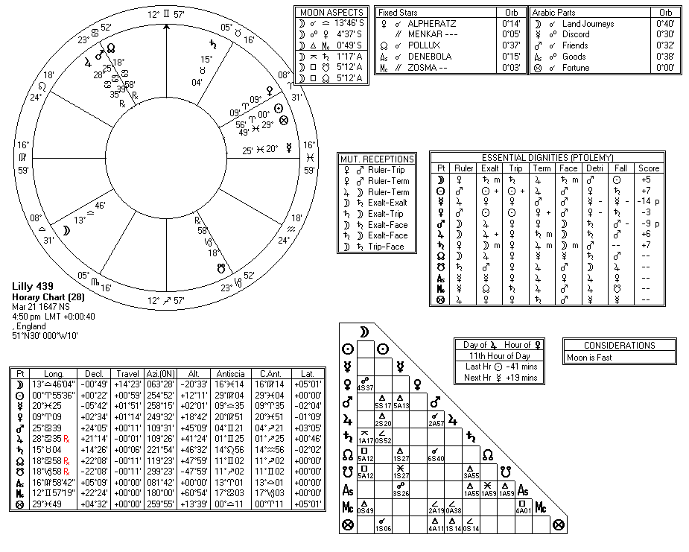

Compliments of http://mithras93.tripod.com

xxix

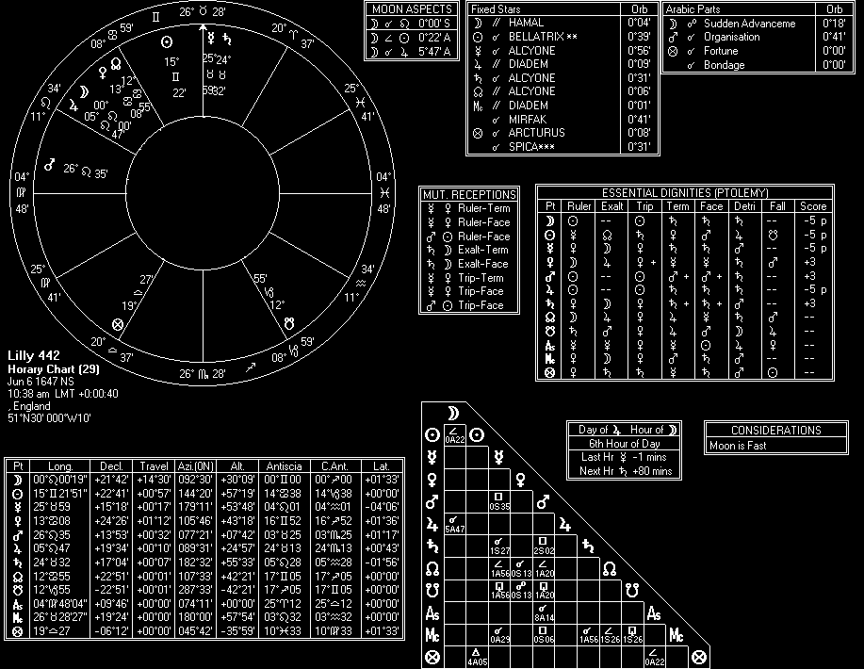

Compliments of http://mithras93.tripod.com

xxx

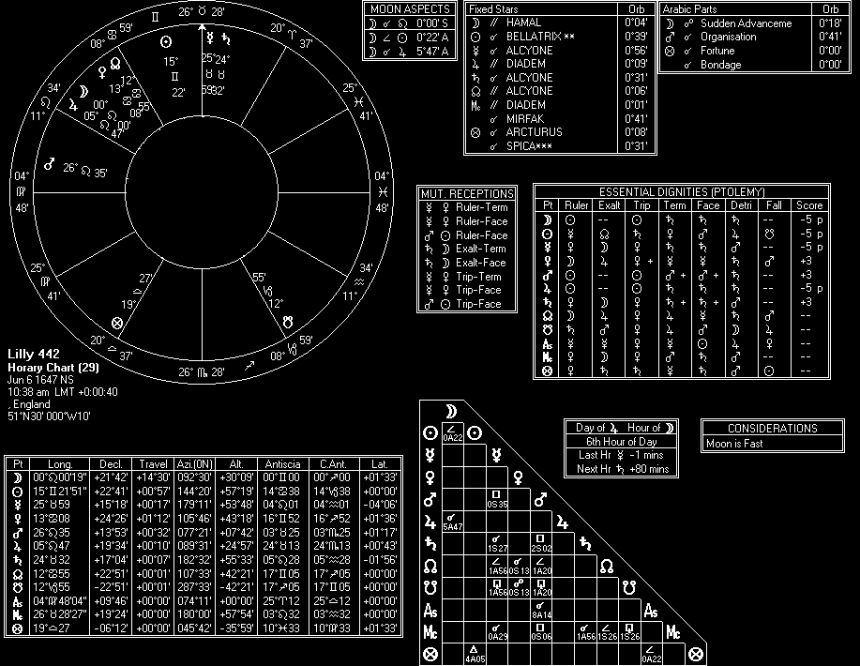

Compliments of http://mithras93.tripod.com

xxxi

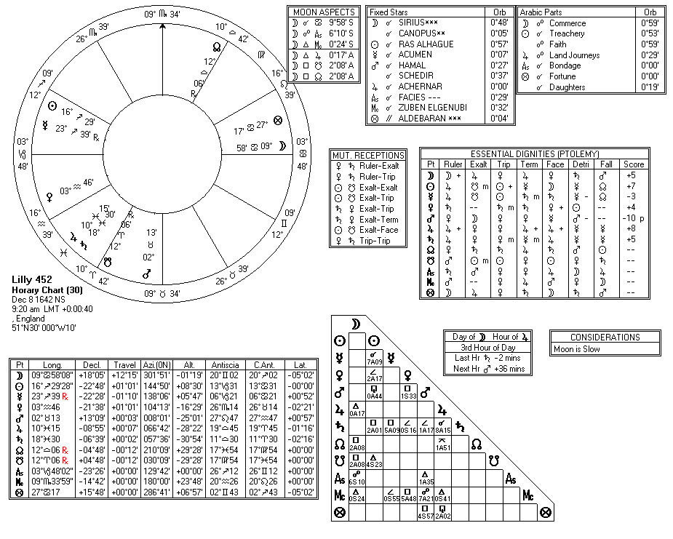

Compliments of http://mithras93.tripod.com

xx xii

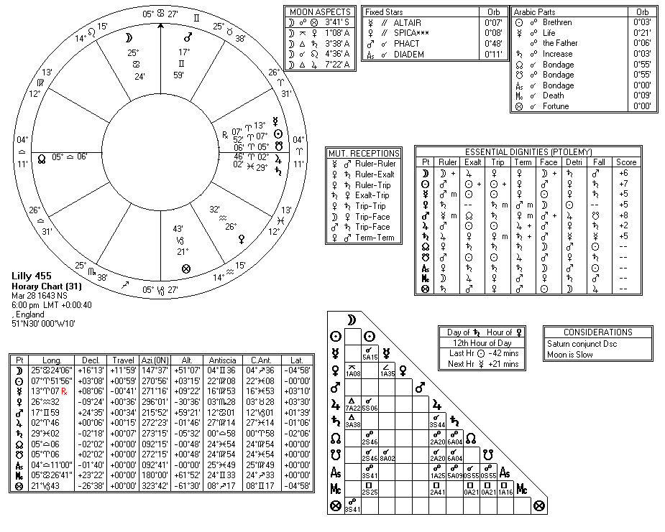

Compliments of http://mithras93.tripod.com

xx xiii

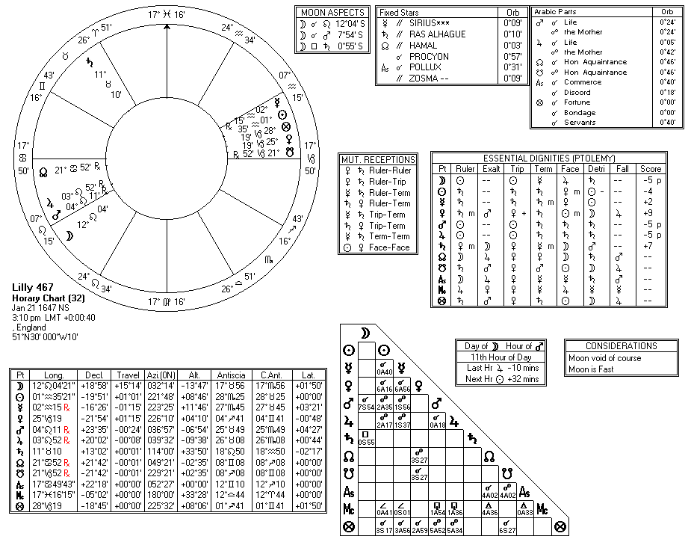

Compliments of http://mithras93.tripod.com

xx xiv

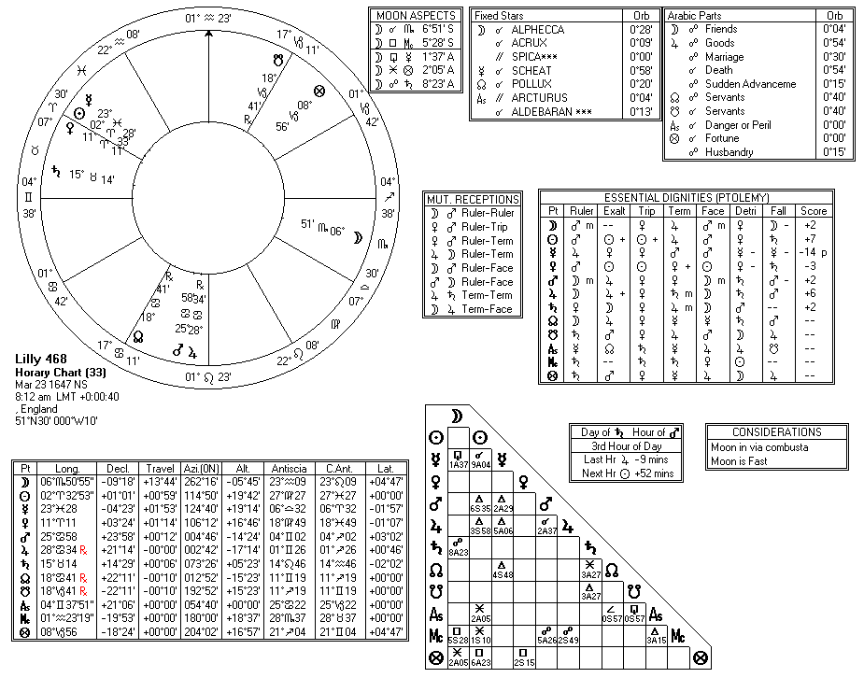

Compliments of http://mithras93.tripod.com

x

xxv

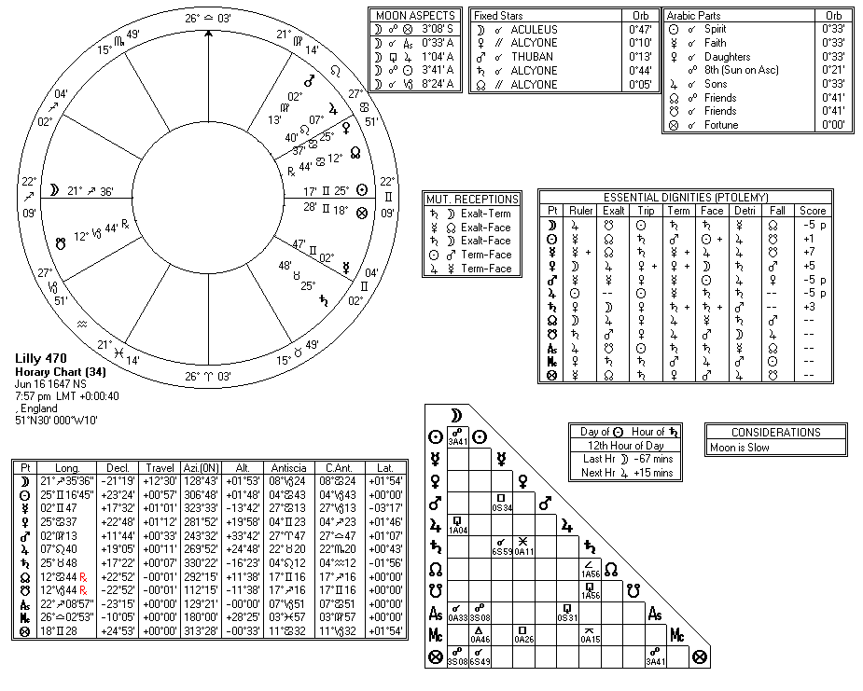

Compliments of http://mithras93.tripod.com

x

xxvi

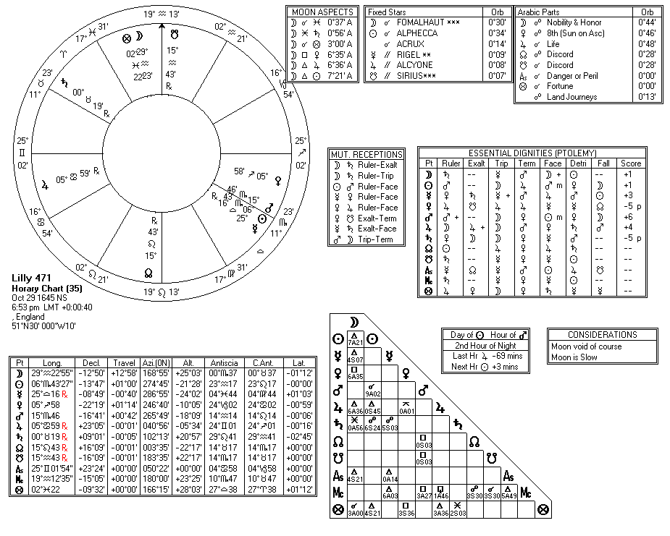

Compliments of http://mithras93.tripod.com

x

xxvii

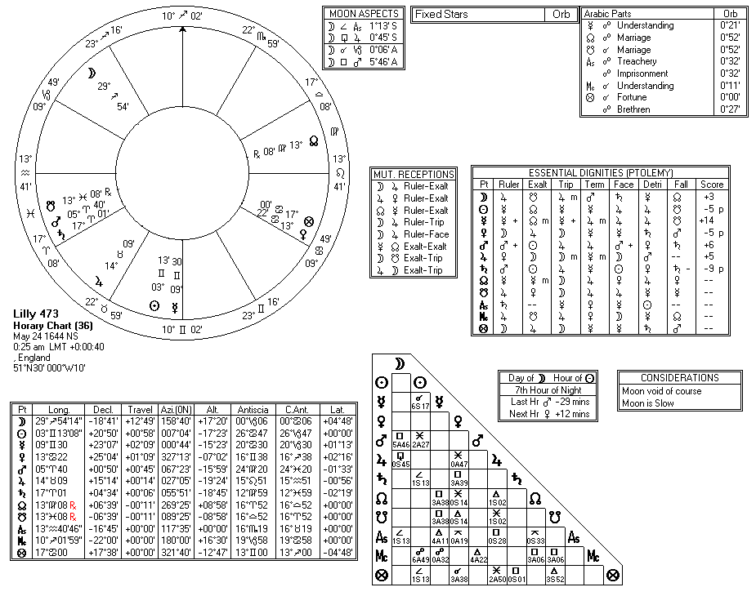

Compliments of http://mithras93.tripod.com

x

xxviii

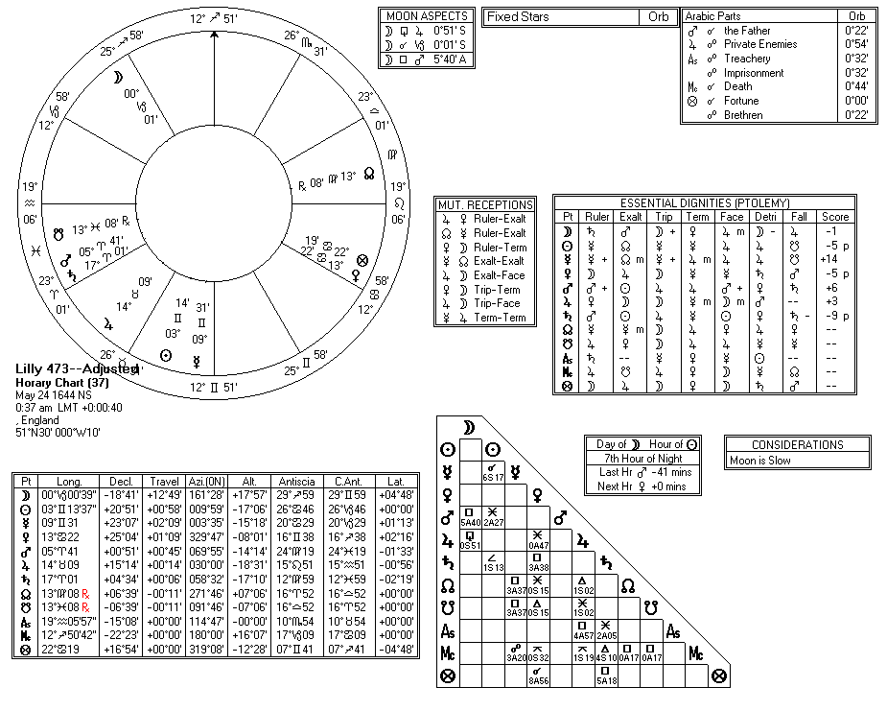

Compliments of http://mithras93.tripod.com

xx xix

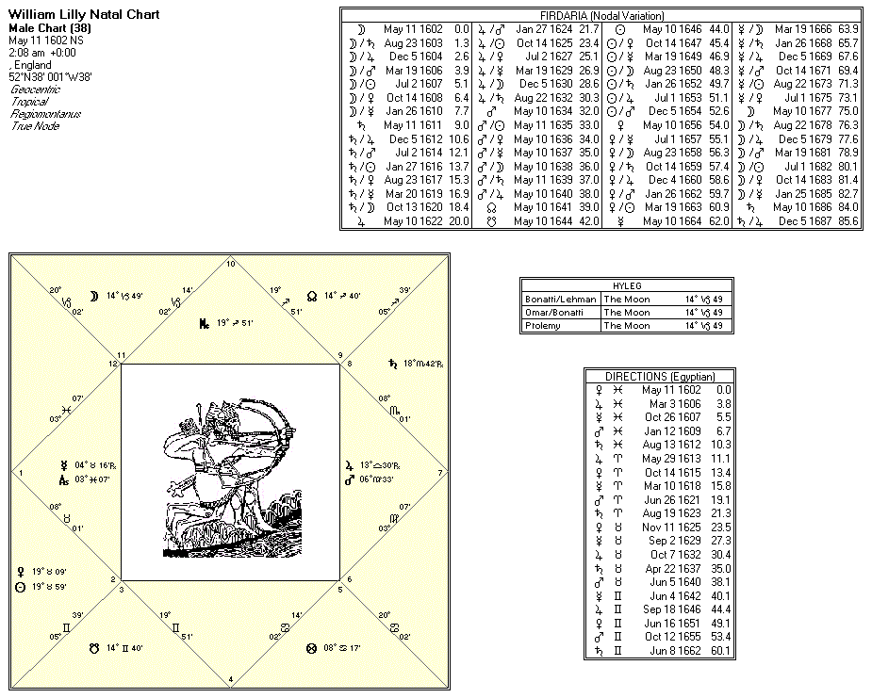

Compliments of http://mithras93.tripod.com

xl

# Document Outline

* Saturn—His Accidentaial Dignities
* Saturn—His Debilities
* Peregrine 5
* VirgoSigne of AscendingFeminine
  + All manner of QUESTIONS
  + The Resolution of
  + All manner of QUESTIONS
  + The Resolution of
    - DARIOT
  + The Resolution of
  + All manner of QUESTIONS
  + The Resolution of
  + The Resolution of
  + The Resolution of
  + The Resolution of
  + The Resolution of
  + all manner of QUESTIONS
  + Of the Signes and conjectures of the Disease, and of life or death
  + The Resolution of
* The sicknessewill continue a great space oftime;
* MOON IN VIRGO (CONJUNCT - SQUARE - OPPOSTION) SATURN
  + The Resolution of
  + all manner of QUESTIONS
* MOON IN LEO (CONJUNCT - SQUARE - OPPOSITION)MARS
* MOON IN VIRGO (CONJUNCT - SQUARE - OPPOSITION)MARS
* MOON IN LIBRA (CONJUNCT - SQUARE - OPPOSITION)MARS
  + Astrologicall Aphorismes beneficial
  + The Resolution of
  + All manner of QUESTIONS
  + Whether the Disease would be long or short?
  + The Resolution of
  + The Resolution of
  + The Resolution of
    - * FINIS SEXE DOMUS
* Aphorismes ofA L K I N D U S Touching
  + - * Of Marriage, whether it shall take effect or no?
* If a man ask, see the Lord of the 8th, or Planet in the 8th, for if they are strong, or Moon applying to the Lord of the 8th by a good aspect, then she is wealthy (&c., e contra, poor;) if the woman ask of the man, and of his estate, judge after the s
  + - * Which of the two shall live longest?
      * Hath she a Lover?
      * Another Judgment
      * Leane
      * If you see the Thief is domesticall, then
      * Whether one shall return: safe from Warre, or any